**Eduardo Guzman, Assignment 3, CSC-155, Section 2, Spring 2023**

1. 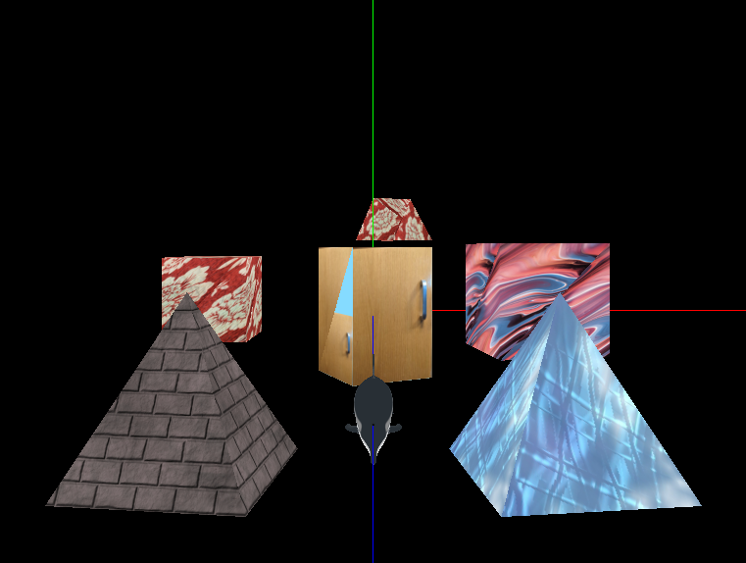
2. **Description of my lighting:**
   * **Types (Initial Location):**
     1. Global Ambient Light (Location = everywhere)
     2. Positional Light (Location = Vector3f(0.0f, 10.0f, 0.0f))
3. **Inputs for moving the Camera:**
   * “A”: Moves the camera left (strife).
   * “D”: Moves the camera right (strife).
   * “W”: Moves the camera forward.
   * “S”: Moves the camera backwards.
   * “Q”: Moves the camera down.
   * “E”: Moves the camera down.
   * “Left arrow”: Pan the camera left;
   * “Right arrow”: Pans the camera right;
   * “Up Arrow”: Pitches the camera up.
   * “Down arrow”: Pitches the camera down.
4. **Inputs for moving the Light:**
   * “Mouse Drag Up”: Moves the light in the -Z-direction.
   * “Mouse Drag Down”: Moves the light in the +Z-direction.
   * “Mouse Drag Left”: Moves the light in the -X-direction.
   * “Mouse Drag Right”: Moves the light in the +X-direction.
   * “Mouse Wheel scroll up”: Moves the light in the +Y direction.
   * “Mouse Wheel scroll down”: Moves the light in the -Y direction.
5. **A description of where in your scene the matrix stack was utilized**
   * The Matrix stack was used with a boat and a ***relaceThisWithChild***
6. **Incomplete Program Requirements:** None
7. **Source information for files:**
   * **Textures** 
     1. **Dolphin**
        + **assets/textures/Dolphin_HighPolyUV.png** – CSC165 TAGE assets to wrap around the dolphin
          1. The dolphin texture is aligned properly with the dolphin
     2. **Boat**
        + **assets/textures/boat/** **FineWood.jpg**
        + **assets/textures/boat/HullTexture.png**
        + **assets/textures/boat/Rope_SteelCable_height.jpg**
        + **assets/textures/boat/Rope_SteelCable_normal.jpg**
        + **assets/textures/boat/Rope_SteelCable_normal.jpg\**
     3. **WaterTank**
        + **assets/textures/water-tank/colour.jpg**
        + **assets/textures/water-tank/metal.jpg**
        + **assets/textures/water-tank/normal.jpg**
        + **assets/textures/water-tank/roughness.jpg**
   * **Models**
     1. **Dolphin** – retrieved from the CSC165 TAG-related files.
     2. **WaterTank** – retrieved from Free3D
        + <https://free3d.com/3d-model/low-poly-water-tank-for-use-in-games-2k-textures-49734.html>
     3. **MarlowBoat** – Retrieved from Free3D
        + <https://free3d.com/3d-model/marlow66-491092.html>
     4. **Pyramid(s)** – model pulled from the CSC-155 textbook.
        + *Called pyr1, pyr2 in the code*
     5. **Cube(s)** – model used from the CSC-155 textbook.
        + *Called cube1, cube2 in the code*
8. **Name of RVR-5029 Computers:**
   * METALSLUG

**SCREENSHOT PROOF OF WEB SOURCE:**

