**Eduardo Guzman, Assignment 3, CSC-155, Section 2, Spring 2023**

1. 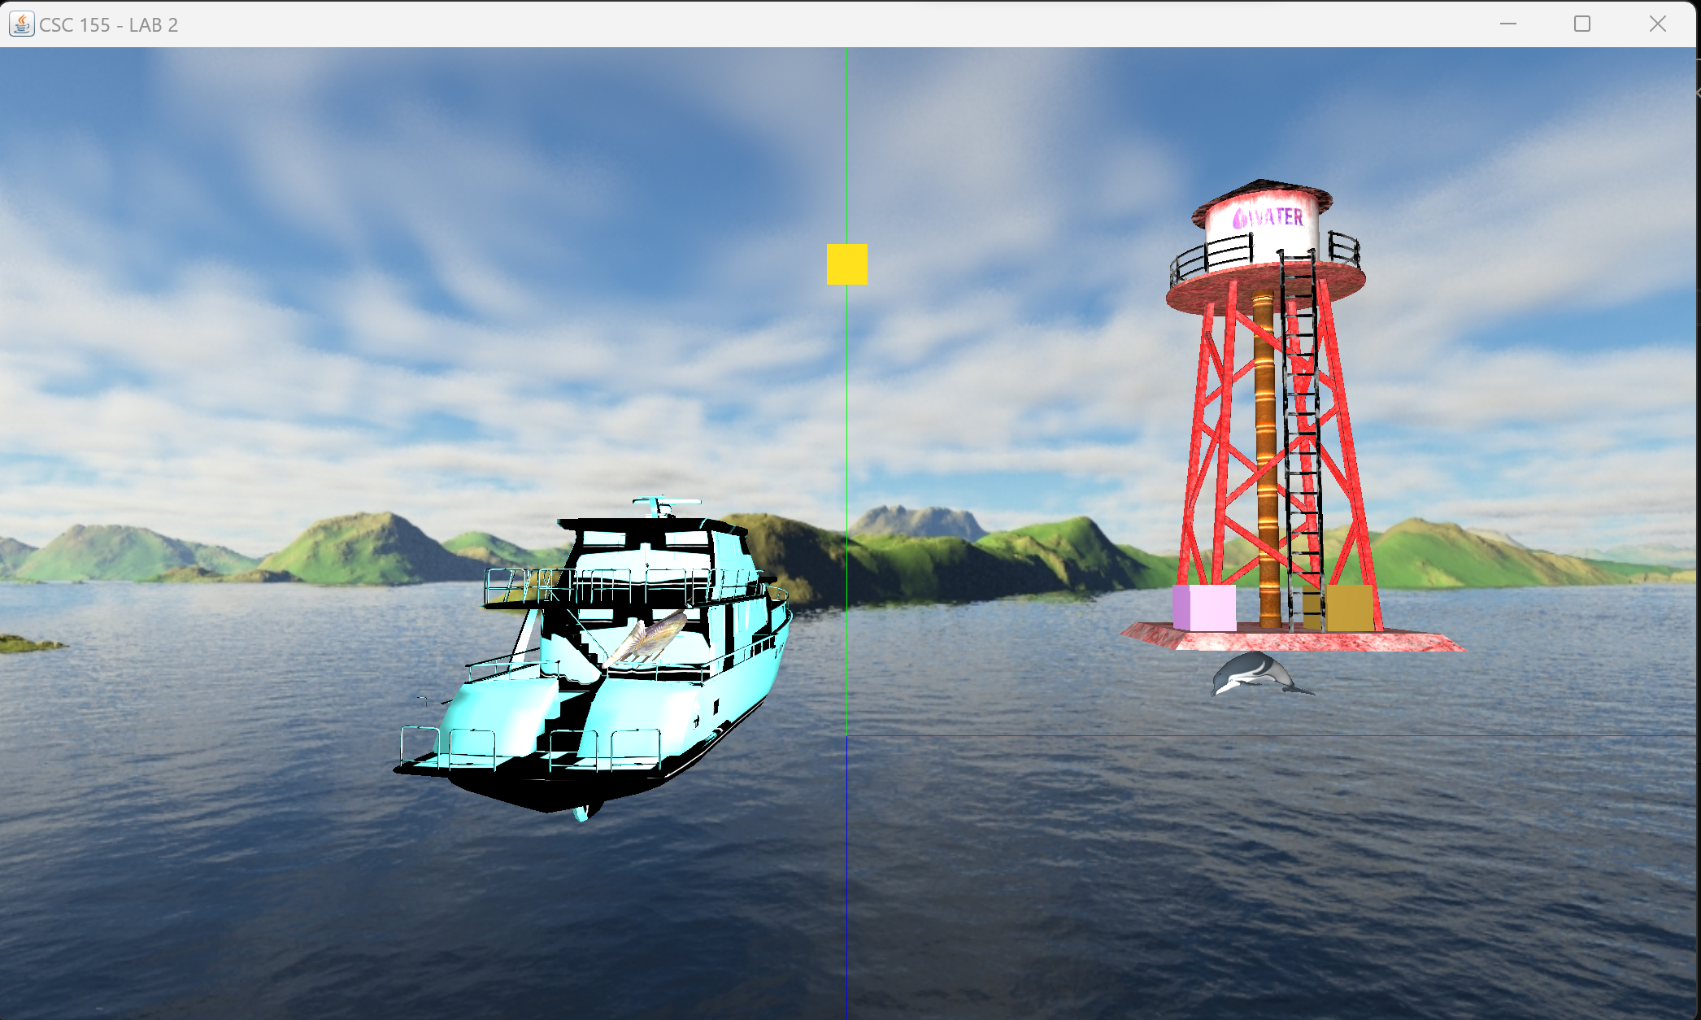
2. **Description of my lighting:**
   * **Types (Initial Location):**
     1. Global Ambient Light (Location = everywhere)
     2. Positional Light (Location = Vector3f(0.0f, 6.0f, 4f);
     3. I placed a big yellow point at the location of the positional light and it lighting can be toggled by pressing key “L”
3. **Inputs for moving the Camera:**
   * “A”: Moves the camera left (strife).
   * “D”: Moves the camera right (strife).
   * “W”: Moves the camera forward.
   * “S”: Moves the camera backwards.
   * “Q”: Moves the camera down.
   * “E”: Moves the camera down.
   * “Left arrow”: Pan the camera left;
   * “Right arrow”: Pans the camera right;
   * “Up Arrow”: Pitches the camera up.
   * “Down arrow”: Pitches the camera down.
4. **Inputs for moving the Light:**
   * “Mouse Drag Up”: Moves the light in the -Z-direction.
   * “Mouse Drag Down”: Moves the light in the +Z-direction.
   * “Mouse Drag Left”: Moves the light in the -X-direction.
   * “Mouse Drag Right”: Moves the light in the +X-direction.
   * “Mouse Wheel scroll up”: Moves the light in the +Y direction.
   * “Mouse Wheel scroll down”: Moves the light in the -Y direction.
5. **A description of where in your scene the matrix stack was utilized**
   * The Matrix stack was used with a boat and that sits on the back of the boat as if it was captured. The boat moves in forward backward direction and the fish stays on top of the boat.
6. **Incomplete Program Requirements:** None
7. **Source information for files:**
   * **Textures** 
     1. **Dolphin**
        + **assets/textures/Dolphin_HighPolyUV.png** – CSC165 TAGE assets to wrap around the dolphin
          1. The dolphin texture is aligned properly with the dolphin
     2. **Boat -** assets below were retrieved from Free3D
        + **assets/textures/boat/** **FineWood.jpg**
        + **assets/textures/boat/HullTexture.png**
        + **assets/textures/boat/Rope_SteelCable_height.jpg**
        + **assets/textures/boat/Rope_SteelCable_normal.jpg**
        + **assets/textures/boat/Rope_SteelCable_normal.jpg\**
     3. **WaterTank -** assets below were retrieved from Free3D
        + **assets/textures/water-tank/colour.jpg**
        + **assets/textures/water-tank/metal.jpg**
        + **assets/textures/water-tank/normal.jpg**
        + **assets/textures/water-tank/roughness.jpg**
   * **Models**
     1. **Dolphin** – retrieved from the CSC165 TAG-related files.
     2. **WaterTank** – retrieved from Free3D
        + <https://free3d.com/3d-model/low-poly-water-tank-for-use-in-games-2k-textures-49734.html>
     3. **MarlowBoat** – Retrieved from Free3D
        + <https://free3d.com/3d-model/marlow66-491092.html>
     4. **FIsh** – model pulled from the CSC-155 textbook.
        + <https://free3d.com/3d-model/3d-fish-model-low-poly-63627.html>
     5. **Cube(s)** – model used from the CSC-155 textbook.
   * **Materials**
     1. Gold materials from the book was used and ChatGPT was used to generate a value for an amethyst-like color.
     2. The materials were used on the cubes sitting at the WaterTank in the water.
8. **Name of RVR-5029 Computers:**
   * METALSLUG