Callum O’Neill - 20576144

Drawing Robot coursework

Outline of the Problem to be Solved
Read and store font data
- Create an array of each letter
- In each array, create a structure to hold each ASCII character
- In each ASCII character structure, hold its Value and have another structure holding it’s strokes.
Scale font
- Read user input
- Divide by 18 and store as a float
Read user’s input
- Read users input word by word and process
Make sure each word fits on the line
- Check if the total x displacement of the new word will make it exceed the 100mm limit
- If not, update robot position to the start of a new line then print the word
Generate the G-code
- Convert each word’s strokes into the G-code format
- Send to the robot
Reset the pen to (0, 0)

Key Data Items

Name | Data type | Rationale
FontData | Array of structures of structures | Struct of each line inside a struct of each letter inside an array of each letter. Then a pointer to array of letters
WordStrokes | Array | Holds all strokes for a word
UserFontSize | float | Holds the users font size as a float
ScaleFactor | Float | Scales the size of the letters by dividing a valid input by 18
x_offset | Float | Tracks pen’s position in x axis as a float
CurrentPosition | Array | Tracks pen’s position in x and y as a float
LineLimit | Float | Limit of how many units can be on a line stored as a float
Sentence | Character array | Stores users input as a string (array of characters)
Word | Character array | Stores word read from Sentence as a string (array of characters)
GCode | Character array | Stores G-code to display to screen as a string (array of characters
BUFFER |  | Temporary storage

Function Declarations

int LoadFontData(File* SingleStrokeFont.txt)
Parameters:
FontData – Array of structures of structures.
Return 0 – Font data loaded
Return 1 – Error loading font data

int CalculateScaleFactor (UserFontSize)
Parameters:
UserFontSize – User’s chosen font size
Return 0 – Valid font size
Return 1 – invalid font size

void ReadWord(char* Sentence, ScaleFactor)
Parameters:
Sentence – Character array of whole sentence
ScaleFactor – Float to scale strokes by

int NewLineChecker(char* WordStrokes)
Parameters:
WordStrokes – Sum of strokes for next word
Return 0 – New line needed
Return 1 – New line not needed

void SetNewLine(File* SingleStrokeFont.txt, char* WordStrokes)
Parameters:
File* SingleStrokeFont.txt – pointer to font data
WordStrokes – Sum of strokes for next word

void GenerateGCode(char* WordStrokes)
Parameters:
WordStrokes – Sum of strokes for next word

Int NewWordChecker(char* Sentence)
Parameters:
Sentence – Character array of whole sentence

Testing Information

Function | Test Case | Test Data | Expected Output
int main() | Has the pen reset at the end | Return value | 0
int LoadFontData | Are there 128 members in the array | Return value | 0
int CalculateScaleFactor | Is the input valid | Return value | 0
void ReadWord | N/A
int NewLineChecker | Is the updated position less than 100 | Return value | 0
void SetNewLine | N/A
void GenerateGCode | N/A
Int NewWordChecker | Is there another word | Return value | 0

Flowchart(s)
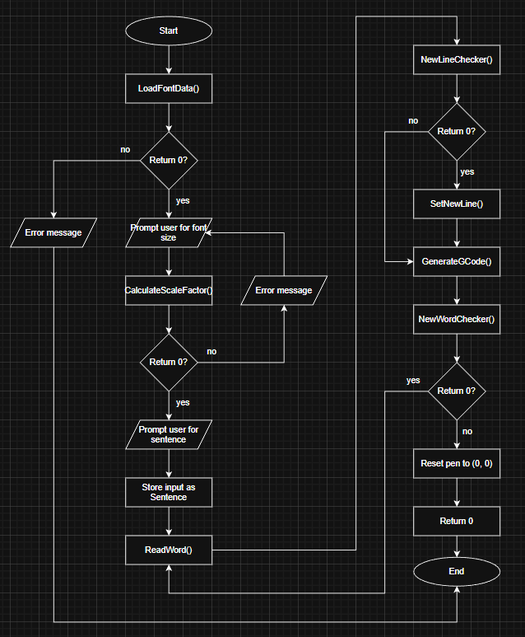
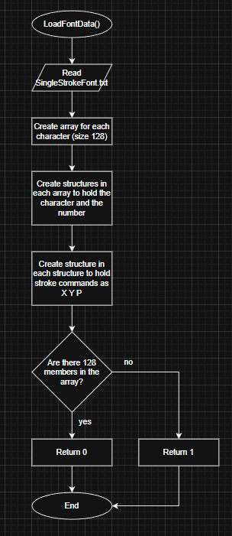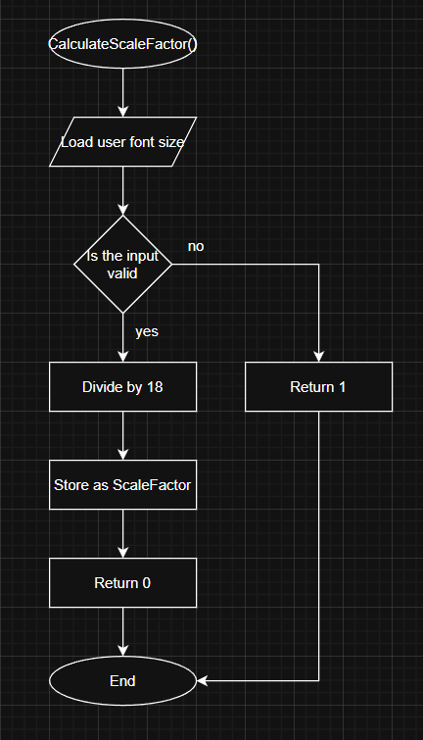

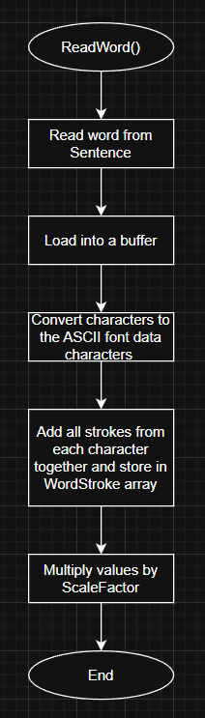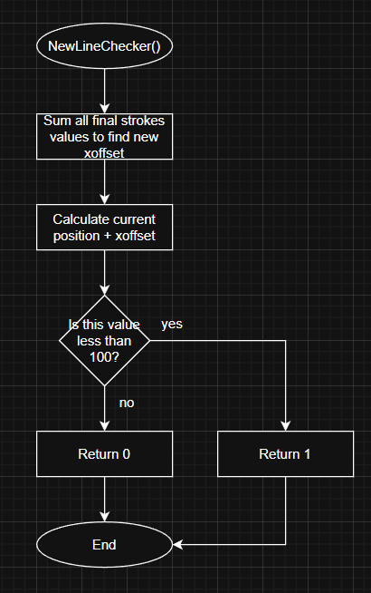

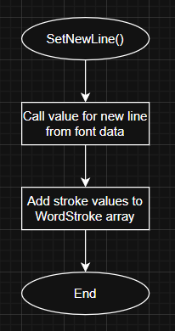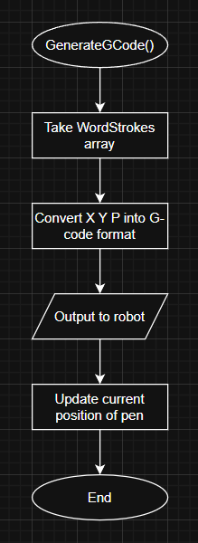

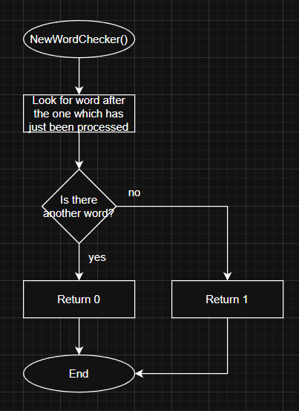

AI Statement

I used ChatGPT (GPT-5) to help me interpret the brief and explain key programming data types and syntax with the following prompts
- ‘Read the brief and explain to a beginner coder where they should start and some key points they should consider’
- ‘Explain what would be expected in the key data items section’
- ‘How would you get it to check if each word can fit on the line’
- ‘How to ensure the code processes one word at a time’
- ‘Explain syntax’
All work produced in this document has been solely written in my own words (and the flow charts created myself). AI has not been asked to produce any work for me, only to give guidance when required.

