Callum O’Neill - 20576144

Robot Writer – System manual

Software Description
Robot writer is a code written in the language of C, designed to make automate the writing of a given text onto a piece of paper via an Arduino controlled 2 axis robot. The program first reads input from a text file named ‘SingleStrokeFont.txt’ and commits it to memory. Each character has a number of strokes, each containing: X, Y, and Pen data. The user then inputs a font size in the range of 4-10 mm. From this, a scale factor is calculated to scale the font data by in order to achieve the correct height. The program then reads input from a text file names ‘TestData.txt’ and processes each word in turn by calculating the word’s width and checking if it will fit on the line ( and putting it on a new line if not) before generating the G-code to match these movements. The program then utilises its two mode options, Terminal mode 1 and 0. When the terminal mode is 1, the output G-code is sent to the terminal, allowing the G-code to be checked in a simulator. When the terminal mode is zero, the program sends the G-code to the robot via RS232 serial port communication. Finally the memory allocation is freed before the code is finished.

Project Files
- main.c
- rs232.c
- rs232.h
- serial.c
- serial.h
- SingleStrokeFont.txt
- TestData.txt

Key Data Items

Name | Data type | Rationale
Strokes | struct | Holds the X, Y and Pen data for each stroke of a character.
X, Y | float | Holds the horizontal and vertical coordinates of a given stroke for a given character.
Pen | Int | Holds the value determining if the pen should be up or down.
Character | struct | Holds the ascii value, stroke count and a pointer to the ‘Strokes’ struct.
ascii | int | Holds the ascii value for the character.
StrokeCount | int | Holds the number of strokes for each character.
pStrokes | pointer | Points to the address of the ‘Strokes’ struct.
FontArray | pointer | Points to the address of the ‘Character’ struct.
XOffset, YOffset | Float | Holds the current horizontal and vertical coordinates.
ScaleFactor | float | Holds the value used to scale the coordinates.
FontSize | float | Holds the users inputted font size between 4 and 10 mm.
Word | char array | Temporary storage to hold the current word being processed.
Marker | int | Temporary storage to store the integer in the ‘SingleStrokeFont.txt’ file one after the other.
WordWidth | float | Holds the scaled width of the word currently being processed
WordEnd | float | Holds the unscaled width of the word currently being processed.
WordIndex | int | Holds the number of the current character in a word that is being processed.
CurrentCharacter | int | Holds the ascii value of the current character that is being processed.
WordBuffer | char array | Temporary storage to hold a line of G-code being sent to the robot.

Functions
Int LoadFontData(void)
Loads stroke data from ‘SingleStrokeFont.txt’ into dynamically allocated storage.
Parameters:
- None
Return:
- 0 – Data loaded successfully
- -1 – ‘SingleStrokeFont.txt’ file not found
- -2 – Memory not allocated

Float GetFontSize(void)
Prompts the user for a font size between 4 and 10 mm and checks if the input is valid.
Parameters:
- None
Return:
- Users font size – If it is a valid input

Float CalculateScaleFactor(float FontSize)
Calculates the scale factor that should be used on the coordinates using the user’s font size.
Parameters:
- FontSize – The user’s selected font size
Return:
- ScaleFactor – FontSize / 18

Float CalculateWordWidth(const char *Word)
Calculates the scaled width of a word using the character stroke data.
Parameters:
- Word – A pointer to the address of the word string
Return:
- WordWidth – Scaled width of the word string

Int ProcessWord(float FontSize)
Reads characters in ‘TestData.txt’, forms words, manages line wrapping and calls G-code generation.
Parameters:
- pTestDataFile – A pointer to the address of ‘TestData.txt’
- FontSize – The user’s selected font size
Return:
- 0 – ‘TestData.txt’ processed successfully
- -1 – ‘TestData.txt’ file not found

Void GenerateGCode(const char *Word)
Generates G-code for each word and outputs to either the terminal or the robot depending on the mode.
Parameters:
- Word – A pointer to the word being converted into G-code
Return:
- None

Void SetNewLine(float FontSize)
Moves the position down to a new line when needed.
Parameters:
- FontSize – The user’s selected font size
Return:
- None

Void ResetPen(void)
Resets the pen’s position to zero after all G-code has been sent’
Parameters:
- None
Return:
- None

Void FreeFontData(void)
Frees the dynamically allocated stroke memory after it is no longer needed.
Parameters:
- None
Return:
- None

Testing Information

Function | Test Case | Test Data | Expected Output
Main | Has the full process been carried out? | Return value | 0
LoadFontData | Has the file ‘SingleStrokeFont.txt’ been found? | Return value | 0 – Yes  -1 – No
LoadFontData | Has the memory for the font array been allocated? | Return value | 0 – Yes  -2 – No
GetFontSize | N/A
CalculateScaleFactor | N/A
CalcualteWordWidth | N/A
ProcessWord | Has the file ‘TestData.txt’ been found? | Return value | 0 – Yes  -1 – No
GenerateGCode | N/A
SetNewLine | N/A
ResetPen | N/A
FreeFontData | N/A

AI Statement

All work produced in this system manual has been solely written in my own words (and the flow charts created myself). AI has not been asked to produce any work for me, only to give guidance when required. Some use of ChatGPT (GPT 5.0) occurred in troubleshooting linker errors and syntax clarification when producing the code, however it was not used to write large of the code in bulk.

Flowcharts

Main:
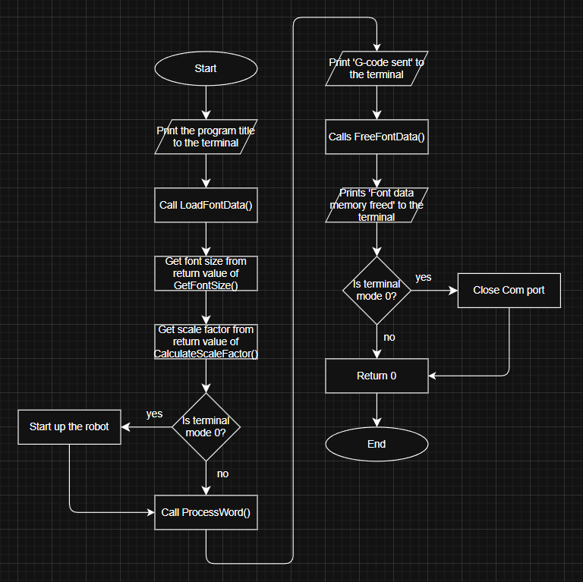

LoadFontData:
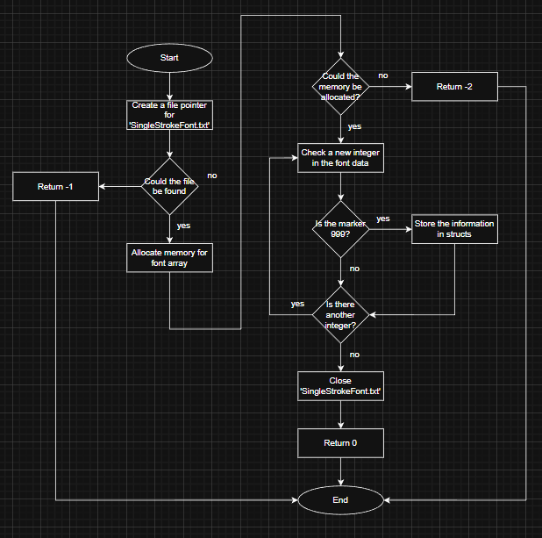

GetFontSize:
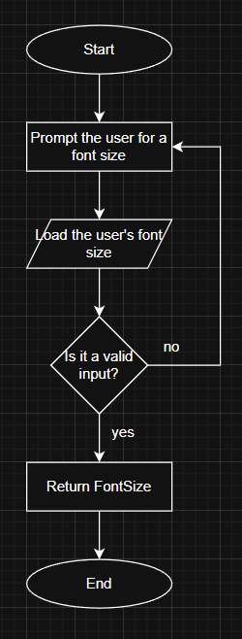

CalculateScaleFactor:
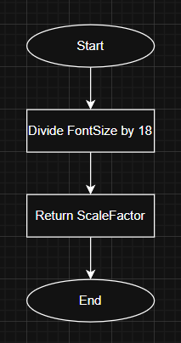

CalculateWordWidth:
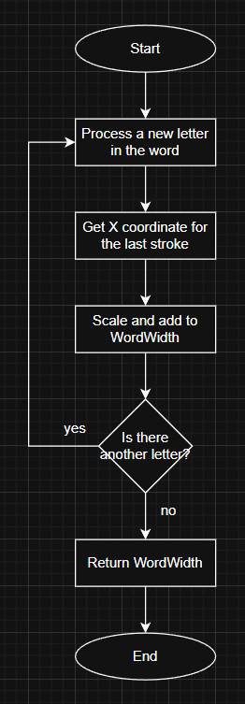

ProcessWord:
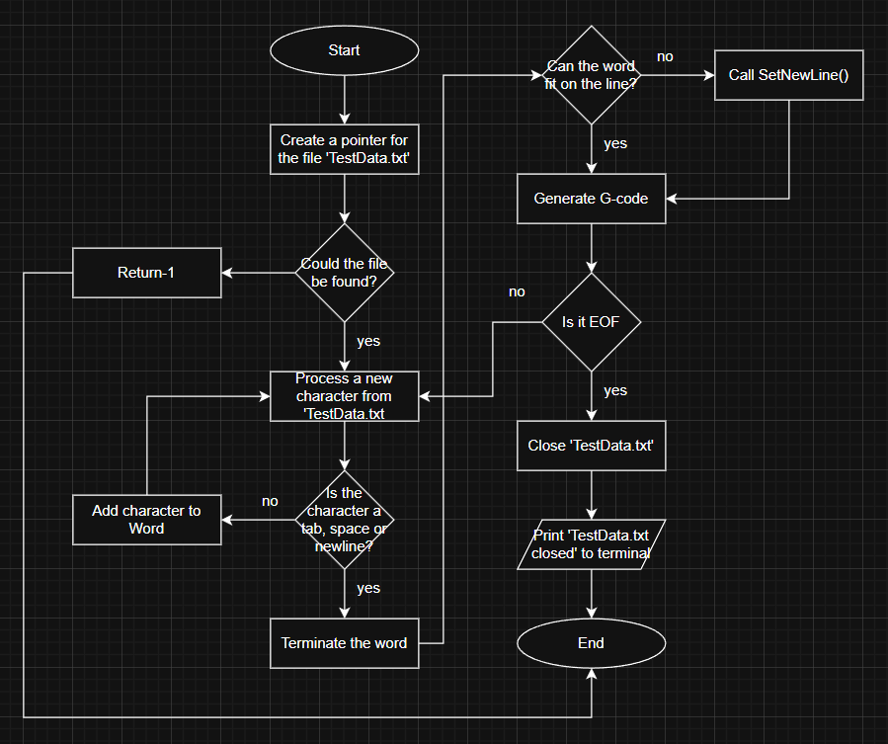

GenerateGCode:
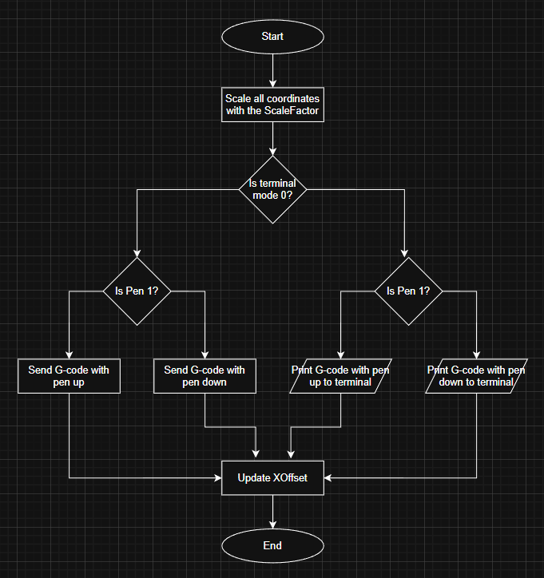

SetNewLine:
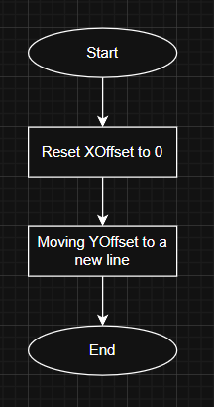
ResetPen:
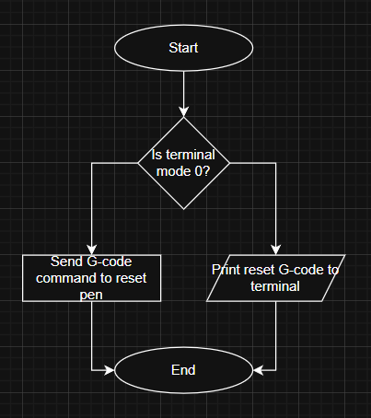

FreeFontData:
