Name & Student ID
Marcus Chow - 20576816

Title
Drawing Robot Software – System Manual

Software Description
- This program reads user input text and processes the text as G-Code, which will be transmitted to a writing robot.
- The robot is controlled by a RS232 microcontroller, which this program will be communicating with.
- This program is broken down in 4 sections:
  - Read single stroke font data and store it in memory
  - Read the text in the file and save as an array
  - Extract stroke data in order of the written text character
  - Convert the arranged stroke data into G-Code
- The program prompts for font size before writing as G-Code, so the writing text output can be modified. Below are 3 output G-Code instances with initial height of 4mm, 7mm and 10mm writing “The quick brown fox jump over the lazy dog”, running through a G-Code simulation program. [G-Code Simulator made by nraynaud in Github, https://nraynaud.github.io/webgcode/]
- This program also automatically line break when the word exceeds the writing area (default as 100mm, modify if needed), to make sure the entire word is written without any breaks.
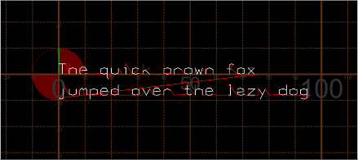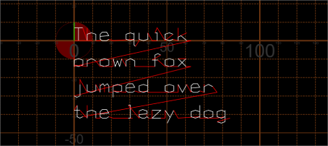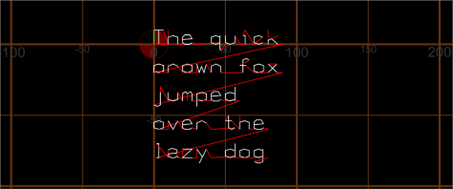

Project Files
Files:
- Main.c – The main program that sends the G-Code data
- Main_fn.c – The .c file that includes all the functions
- Main_fn.h – The header for the main_fn.c file
- Rs232.c – the program file that includes the functions to process communication to the RS232
- Rs232.h – header file of rs232.c
- Serial.c – program that configure the communication between the program and the RS232 microcontroller, which controls the drawing output.
- Serial.h – header file of serial.c
- SingleStrokeFont.txt – The file that stores the drawing data per ASCII code
- Test.txt – Input text sequence to be drawn by the robot
- SystemManual_MNYC.docx – The manual file you are currently reading
- RobotFlowchartMNYC_Updated.pdf – the flowchart that shows the program flow

Key Data Items

Name | Data type | Rationale
SingleStrokeFont.txt | Text file | The file that stores the drawing data per ASCII code
Test.txt | Text file | Input text sequence to be drawn by the robot
SSFdata | Int** | This forwards the SSF data as array obtained from SingleStrokeFont.txt
rows | int | Number of rows from SingleStrokeFont.txt
buffer_seq | Char* | The character sequence obtained by the text typed in test.txt
length | int | Length of the character sequence
Init_height | int | User input character height
Stroke_data | int | The arranged array returned by putting data from SSFdata 2D array in the buffer_seq character sequence
strokes | int | Total number of strokes to be processed to the robot, also the total number of rows of stroke_data
drawG | int | Integer variable to distinguish when to pen down
X_pos | Float | The x position extracted from stroke_data array to be output to G-Code sequence
Y_pos | float | The y position extracted from stroke_data array to be output to G-Code sequence

Functions
Here are the functions that are used to generate the G-Code sequence:
int** read_SSF(const char* filename, int* rows)
Parameters:
Filename – Input pointer of the file to be opened
Rows – Output pointer to return number of rows in the file
Return value – Returns the pointer SSF data array, 0 if file is unavailable or restricted

char* file_to_buffer(const char* filename, int* length)
Parameters:
Filename – Input pointer of the file to be opened
length – Output pointer to return number of characters in the file
Return value – Return pointer character buffer array, 0 if file is unavailable or restricted

int extract_and_print_strokes
(
const char* buffer,
int number_of_chars,
int** SSF,
int K,
int stroke_data[][3],
int init_height
)
Parameters:
buffer – Input pointer for the ASCII buffer array processed from the file_to_buffer function
number_of_chars – Input pointer to return number of characters in the file
SSF – Input pointer for input the SSF data array processed from the read_SSF function
rows_process – Input number of rows to process
Stroke_data[][3] – Output stroke data array processed in this function
Init_height – Input initial height in mm
Return value – returns stroke_index, number of strokes to be processed to robot

Testing Information

Function | Test Case | Test Data | Expected Output
Read_SSF() | Count the number of lines in text file | SingleStrokeData.txt,  int ch,  int k | k will be one less than the number of lines in .txt, as the last line doesn’t have line break
Read_SSF() | Write data from text file into 2D array | SingleStrokeData.txt,  int** SSF[][],  int* rows | Data in the array SSF should be identical to the text file
File_to_buffer() | Count the number of characters in text file | Test.txt, int c,  int total_chars | Total_chars will be the sum number of letters, spaces, enter and null written in the text file.
File_to_buffer() | Write data from text file into array of char | Test.txt,  char* buffer_f[],  int c | Data in buffer_f array should be the ASCII sequence of the text in test.txt
Extract_and_print_strokes() | New line char shifts | Int enter, int totat_chars_out, float current_width_mm,  const char* buffer | Line break character should shift Y downwards and reset X offset
Extract_and_print_strokes() | Space character | Int total_chars_out,  float current_width_mm,  const char* buffer | Space character should offset x value by one character
Extract_and_print_strokes() | Measure word width | int number_of_chars,  float word_width_mm,  const char* buffer,  int init_height | Word_width_mm should show the width of the current word by 18 * initial height per character
Extract_and_print_strokes() | Check if the word fits | float current_width_mm,  float word_width_mm,  const float max_width_mm,  int enter,  int totat_chars_out | Line break and reset x offset if total width exceeds max width
Extract_and_print_strokes() | Search index row | const int sep_value = 999  int** SSF[][]  const char* buffer  int rows_process | For 999 C N, search for 999 and character within buffer = C, output N, number of rows to be read
Extract_and_print_strokes() | Write N rows of SSF | int stroke_data[][3]  int** SSF[][]  int totat_chars_out  int enter  int stroke_index | Stroke_data array should have the corresponding SSF data assigned to the character.
main() | Pen down pen up G-Code association | int drawG  int stroke_data[][] | Third column of stroke data array should assign with S1000 and G1 when = 1 and S0, G0 when = 0
main() | X and Y G-Code association | Float x_pos  float y_pos  int init_height  int stroke_data[][] | First and second column of stroke data should be scaled by the initial height and first column as X, second column as Y
main() | Output G-Code coordinates | Float x_pos  float y_pos  int drawG | If both 2 tests above succeed, the output column should comply to the G X Y G-Code format.
main() | Output G-Code to “RS232” | All variables above | The G-Code output should output the text in test.txt in the G-Code simulator or the writing robot.

Flowchart(s)
- The flowchart is included within this repository as a separate PDF document

