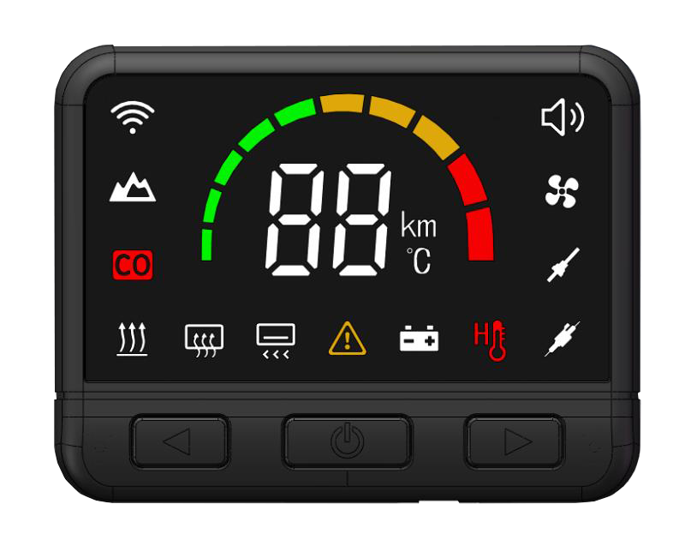
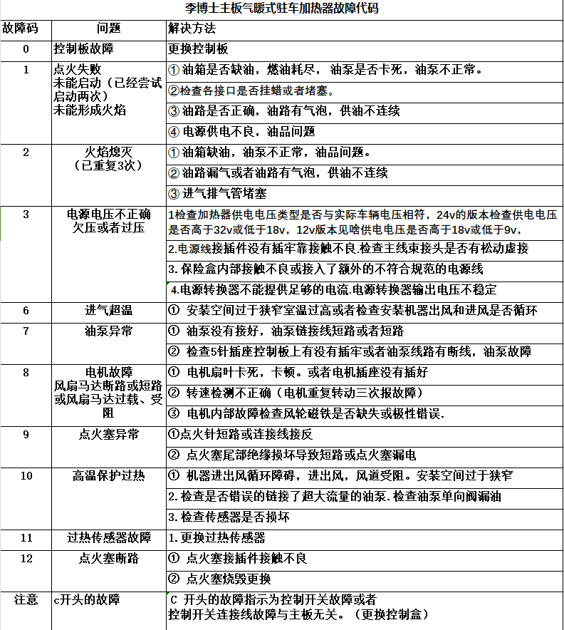
C24 Three-Key Digital Controller User Manual

Quick Remote Matching:： When the device is off, press and hold the up and down buttons simultaneously. The screen will display a 10-second countdown, entering remote control matching mode. Within 10 seconds, press any button on the remote to successfully pair it.
1—3 Operations in Power-On State
1.Power On/Off：Press the Power On/Off button once to turn the device on. Press it again to turn it off.
2. Air Conditioning Mode (Temperature Mode)：While the device is on, press and hold the Power On/Off button for 3 seconds to switch to Temperature Mode, with a range from 10°C to 35°C. Use the Gear Increase and Decrease buttons to set the desired temperature. The set temperature must be higher than the current ambient temperature. When the device reaches the set temperature, it will reduce to a lower combustion speed. If the temperature is not reached, the device will increase the combustion speed to meet the set temperature.
3. Power Mode：In Air Conditioning Mode, press and hold the Power On/Off button for 3 seconds to switch back to Power Mode. Adjust the power level using the Gear Increase and Decrease buttons, with levels P1 to P5 (5 levels).

Following Functions in Power-Off State

4. Normal Power-On：In the off state, press and hold the Power On/Off button for 5 seconds. The screen will display “ON”. Release the button to power on normally.
5 Automatic Oil Pump Start: In the off state, press and hold the Power On/Off button for 5 seconds until the screen displays “Po”. Release the button; the ignition plug will preheat for 1 minute before the oil pump starts. Once the oil line is full, the device will automatically ignite and enter normal combustion. If the oil line is not filled after one attempt and the fan is still running, the screen will display “Po” flashing. Press the Power On/Off button again to start a second oil pumping attempt.
6. Ventilation Function： Press and hold the Power On/Off button until the screen displays “Fn”. Release the button; the screen will show “F1” to “F5” which can be adjusted to provide ventilation for the cabin.
7. Remote Control Matching：Press and hold the Power On/Off button until the screen shows “R1”. Release the button, and within 10 seconds, press any button on the remote to successfully pair it.
8. Manual Oil Pumping via Remote：Long press the 5th display icon on the screen of the power key, “rp”. Release the button, and the screen will display “20”, indicating the function will turn off after 20 minutes. Press the remote’s power button to start oil pumping; press the remote’s power button again to stop oil pumping. Note: 1. This function does not support ignition. Monitor the oil line and stop pumping once it is full. 2. After using this function, the paired remote needs to be re-matched.
9. Language Selection and Do Not Disturb Mode：Long press the 6th display icon on the screen of the power switch, “LA”. Release the button, then use the Gear Increase and Decrease buttons to select the language. The screen will display options such as “CH” (Chinese) or “BP” (Silent). Select the desired language by adjusting the knob to set it successfully.

10. Emergency Start: If the device switch is damaged, first disconnect three switch wires (black, blue, and red). Short the black and blue wires together at a regular frequency 7 times (1-2-3-4-5-6), then do not release on the 7th time but hold for 1 minute. If the mainboard is not damaged, the device will start normally.

11. Setting Temperature Mode and Oil Pump Flow: Disconnect the power switch wire. Then, press and hold the power switch button without releasing it. Next, reconnect the power switch wire. The screen will display “CF” followed by a number. Release the button. Multiply the displayed number by 5 and add 1. For example, if the number displayed is 2, then 2 * 5 + 1 equals 11. Press the up button to select the last digit (in this case, 1), then press the power switch button to enter the settings function.
The first screen that appears is: Power Voltage, which sequentially shows 24V Power, -12V Power, and 0A Automatic Voltage. Press the power switch button to confirm in the 0A state. The voltage will automatically match.
Next, the screen will show 22, which indicates a 22 oil pump. Press the up button to display 28, which indicates a 28 oil pump. Press the up button again to show 0A, which is for automatic oil pump matching. Select the desired oil pump flow rate and press the power switch button to confirm the oil pump setting.
Once the oil pump is set, the screen will display “t5” to indicate the temperature mode shutdown function. “t----” turns off the temperature mode shutdown function. If you want to enable it, in the “t5” state, press the power switch button to confirm.
After all settings are completed, the screen will display “5u” after 5 seconds and then shut down, indicating that all settings are completed.
12. Clear Current Remote Configuration: Disconnect the switch wires, press and hold the Power On/Off button, and reconnect the switch wires. The screen will display “CF”. Release the button, then press the Power On/Off button to clear the configuration.

Fault Code
