FACTORY SIMULATION — PROGRESS REPORT
OOP with C++ GIST EECS

1. Team Information
Team name | BBANG
Factory domain | Smart Farm Bakery
GitHub repository | https://github.com/eh-rud/BBANG.git

Member | Student ID | Primary responsibility
김도경 | 20255021 | Leader & Frontend Architecture & Interface Design (Developing Dear ImGui UI layouts, prototyping View layers, and implementing UI-to-Controller Command/Snapshot DTO bindings)
황서현 | 20255243 | Backend Core Logic & State Machine (Designing the Factory Simulation Object hierarchy, implementing concrete machine process timers, and managing core update loops)

2. Class Inventory
List every class you have defined or plan to define. Mark its layer and whether it is abstract or concrete.

Class name | Layer (Model/View/Controller) | Abstract / Concrete | Inherits from | Status (Planned/In progress / Done)
SimulationObject | Model | Abstract |  | In progress
Source | Model | Abstract | SimulationObject | In progress
AbstractMachine | Model | Abstract | SimulationObject | In progress
Sink | Model | Abstract | SimulationObject | In progress
Worker | Model | Abstract | SimulationObject | In progress
StorageUnit | Model | Abstract | SimulationObject | In progress
Product | Model | Abstract |  | In progress
Order | Model | Abstract |  | In progress
SeedInput | Model | Concrete | Source | Planned
OrderGenerator | Model | Concrete | Source | Planned
SmartFarmGrower | Model | Concrete | AbstractMachine | Planned
Harvester | Model | Concrete | AbstractMachine | Planned
MillMachine | Model | Concrete | AbstractMachine | Planned
DoughMixer | Model | Concrete | AbstractMachine | Planned
Oven | Model | Concrete | AbstractMachine | Planned
PackagingMachine | Model | Concrete | AbstractMachine | Planned
ParcelSorter | Model | Concrete | AbstractMachine | Planned
OrderMatcher | Model | Concrete | AbstractMachine | Planned
DispatchStation | Model | Concrete | Sink | Planned
Technician | Model | Concrete | Worker | Planned
WheatSeed | Model | Concrete | Product | Planned
GrownWheat | Model | Concrete | Product | Planned
WheatBatch | Model | Concrete | Product | Planned
FlourBatch | Model | Concrete | Product | Planned
DoughBatch | Model | Concrete | Product | Planned
Bread | Model | Concrete | Product | Planned
BreadParcel | Model | Concrete | Product | Planned
SortedParcel | Model | Concrete | Product | Planned
DispatchedParcel | Model | Concrete | Product | Planned
BreadOrder | Model | Concrete | Order | Planned
WheatStorage | Model | Concrete | StorageUnit | Planned
FlourSilo | Model | Concrete | StorageUnit | Planned
DoughQueue | Model | Concrete | StorageUnit | Planned
BreadStorage | Model | Concrete | StorageUnit | Planned
ParcelQueue | Model | Concrete | StorageUnit | Planned
OrderQueue | Model | Concrete |  | Planned
EventLog | Model | Concrete |  | Planned
Factory | Controller / Model | Concrete |  | In progress
MainLoop | Controller | Concrete |  | Planned
UIManager | View | Concrete |  | Planned
SimulationCmd | Controller / View DTO | Struct |  | Planned
MachineCmd | Controller / View DTO | Struct |  | Planned
FactorySnap | Model / View DTO | Struct |  | Planned
MachineSnap | Model / View DTO | Struct |  | Planned
StorageSnap | Model / View DTO | Struct |  | Planned
MachineState | Model | Enumeration |  | Planned
ScenarioType | Model | Enumeration |  | Planned
SimulationController | Controller | Concrete |  | In progress
MainWindow | View | Concrete |  | In progress
FactoryView | View | Concrete |  | In progress
ControlPanelView | View | Concrete |  | In progress
EventLogView | View | Concrete |  | In progress
InspectorView | View | Concrete |  | In progress
StatisticsView | View | Concrete |  | In progress
MachineWidget | View | Concrete |  | In progress
StorageWidget | View | Concrete |  | In progress

Layer: Model/View/Controller Status: Planned / In progress / Done

3. Class Diagram (first version)
Attach or paste your current UML class diagram below. Hand-drawn is fine at this stage. Must show: class names, inheritance arrows, and key methods.

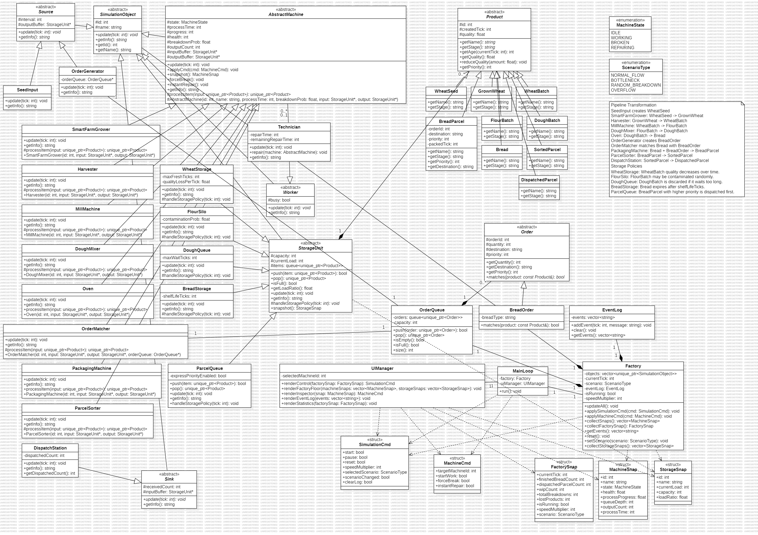
1. Code UML
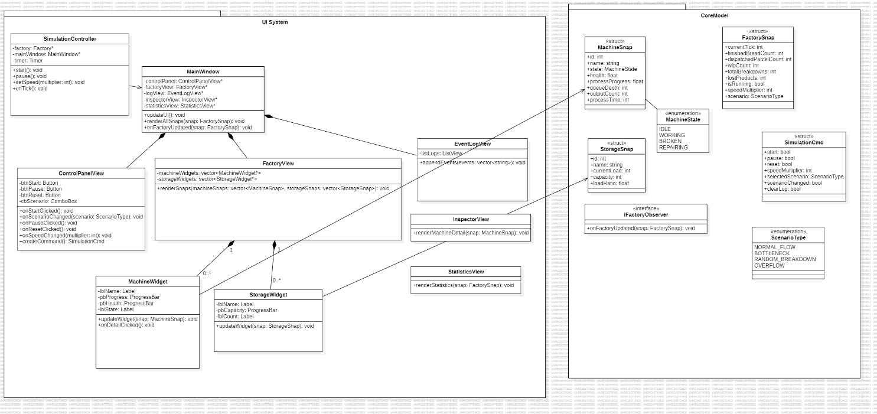
2. UI UML

4. UI Screenshots
Paste 1–3 screenshots of your current UI. Add a one-line caption below each one explaining what it shows.

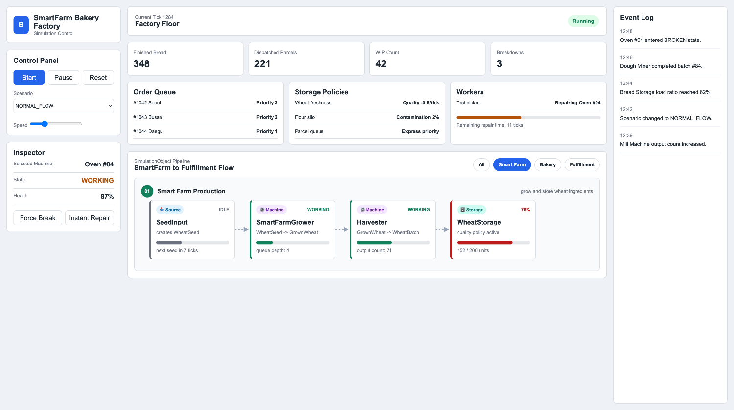
Caption: Smart Farm production view, monitoring the initial agricultural process from seed input to wheat storage.

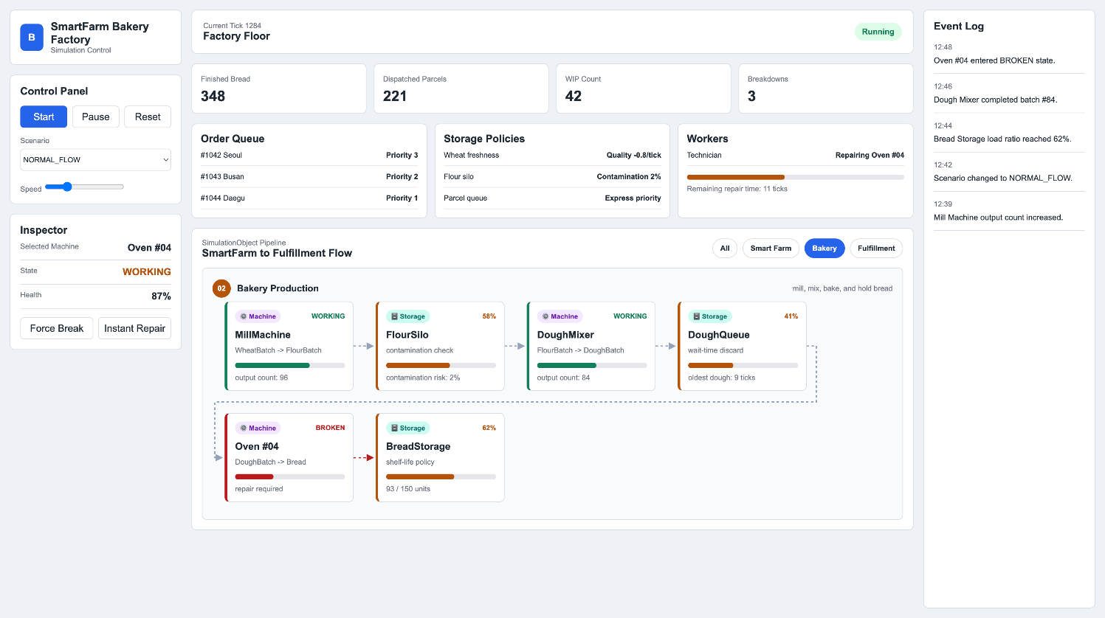
Caption: Bakery production view, illustrating color-coded machine states such as the BROKEN status of the oven.

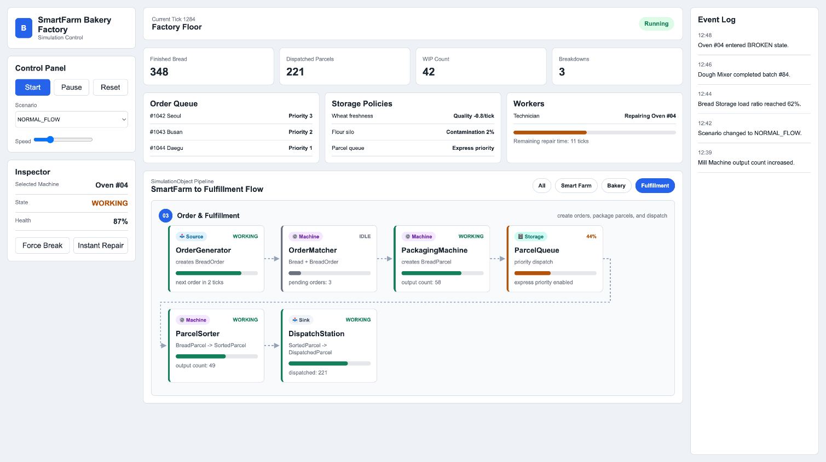
Caption: Order and fulfillment view, detailing order matching, packaging, and final dispatch metrics.

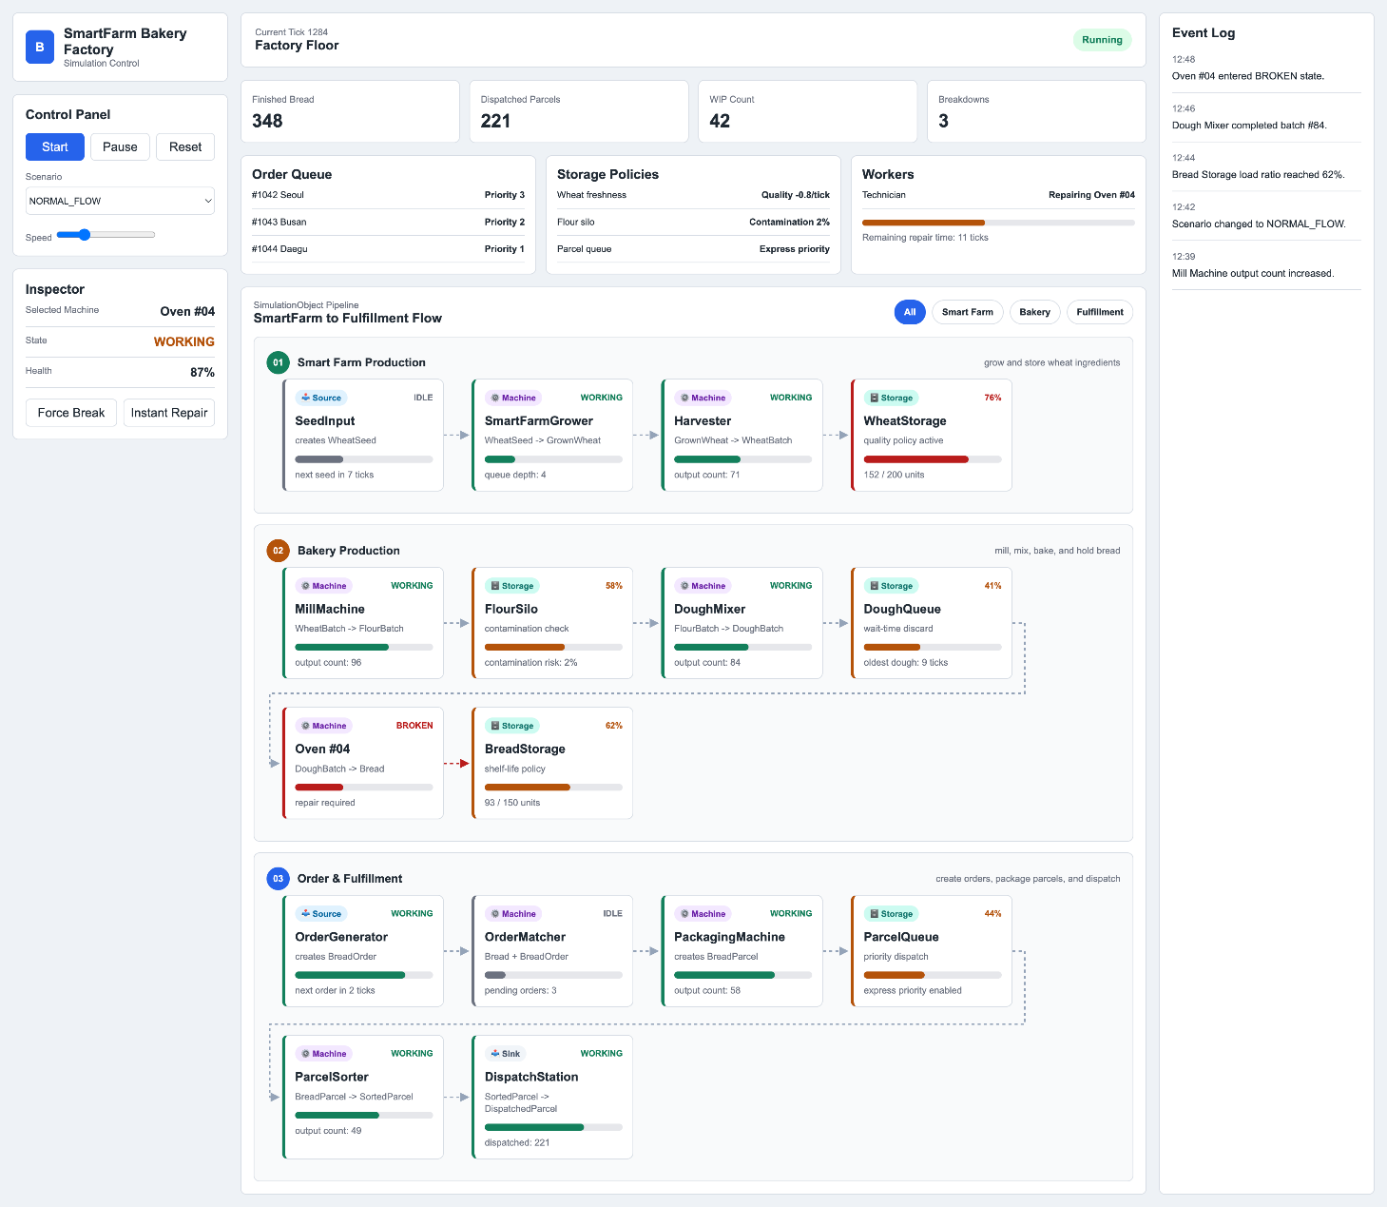
Caption: Main dashboard overview displaying the complete Smart Farm Bakery pipeline, control panel, and real-time event log.

5. Project Completion Roadmap
List your remaining tasks with target dates. Be specific — one task per row.

# | Task | Owner | Target date | Done?
1 | Draft the comprehensive Code UML class diagram, defining the complete backend domain model including the SimulationObject hierarchy, and core factory logic. | 황서현 | May 24 | ■
2 | Draft the detailed UI System UML class diagram, mapping out the View layer composition, Dear ImGui component hierarchy, and the decoupling structure via SimulationController. | 김도경 | May 24 | ■
3 | Complete the core ImGui UI layout and component prototyping (Smart Farm View, Inspector, Event Log, Statistics) without backend linkage | 김도경 | May 24 | ■
4 | Define SimulationCmd and MachineCmd structures and implement event bindings for UI-to-Controller command delivery | 김도경 | May 26 | □
5 | Connect the initial pipeline (SeedInput ➔ SmartFarmGrower ➔ Harvester ➔ WheatStorage) and verify the pure model update(tick) loop | 황서현 | May 28 | □
6 | Implement core state machine logic and processing timers for late-stage bakery machines (MillMachine, DoughMixer, Oven, PackagingMachine, etc.) | 황서현 | May 30 | □
7 | Implement snapshot structures (MachineSnap, StorageSnap) to extract and capture real-time backend state data for the UI layer | 김도경 | June 1 | □
8 | Map scenario selection logic and implement backend policy branching for the 4 major scenarios (NORMAL_FLOW, RANDOM_BREAKDOWN, etc.) | 황서현 | June 3 | □
9 | Conduct full system integration testing (debugging real-time UI data updates, checking for memory leaks) and configure GitHub Pages | Joint | June 5 | □
10 | Prepare the final presentation materials, record the simulation demo video, finalize the progress/final report, and push to GitHub | Joint | June 6 | □

6. Instructor Feedback
(This section is for instructor use only.)
Progress rating | □ On track □ Minor delays □ At risk □ Needs discussion
Architecture check | □ Frontend / backend correctly separated □ Needs revision
UML quality | □ Satisfactory □ Incomplete □ Incorrect — resubmit
Comments
Date reviewed

