# **Task 4.1 Adding numerical integration methods**

Three numerical integration methods were implemented within the **Cosmology** class: the Rectangle rule, the Trapezoid rule, and Simpson’s rule. These methods were applied to calculate the cosmological distance $D(z)$, where $z$ is the redshift. The distance $D(z)$ is calculated in **Megaparsecs [Mpc]** based on the constant $H_{0}$ ​ and the speed of light $c = 3×{10}^{5}$ km/s. The following results were obtained for $z=1$, with $H_{0}=72$ km/s/Mpc, $Ω_{m}=0.3$, and $Ω_{λ}=0.7$:

* **Distance (Rectangle Rule)**: 3214.33 Mpc
* **Distance (Trapezoid Rule)**: 3214.28 Mpc
* **Distance (Simpson’s Rule)**: 3214.28 Mpc

These results are consistent with the expected value of approximately 3200 Mpc, validating the implementation of the numerical integration methods.

# **Task 4.2 Convergence testing**

We compare the convergence and accuracy of three numerical integration methods—Rectangle Rule, Trapezoid Rule, and Simpson's Rule—by calculating the cosmological distance to redshift $z=1$. We test how the accuracy of each method changes as the number of integration steps increases. Additionally, we determine a good target accuracy for the calculation based on physical reasoning, which is plotted alongside the results.

I evaluated the performance of the Rectangle, Trapezoid, and Simpson's Rule by varying the number of integration points from $n=10$ to $n={10}^{4}$, and calculated the absolute fractional error for each method.

Given the typical precision of cosmological measurements, an absolute fractional error of ${10}^{-6}$ strikes a good balance between precision and practicality. This level of accuracy ensures that we are well within the margin of error required for meaningful results while not pushing the computations to the point of diminishing returns. This choice reflects physical reasoning because achieving better precision would likely exceed the uncertainties inherent in observational data, making further computational effort redundant.

The results are plotted in the graph titled **Convergence of Numerical Integration Methods**, which shows the absolute fractional error as a function of the number of steps for each method:

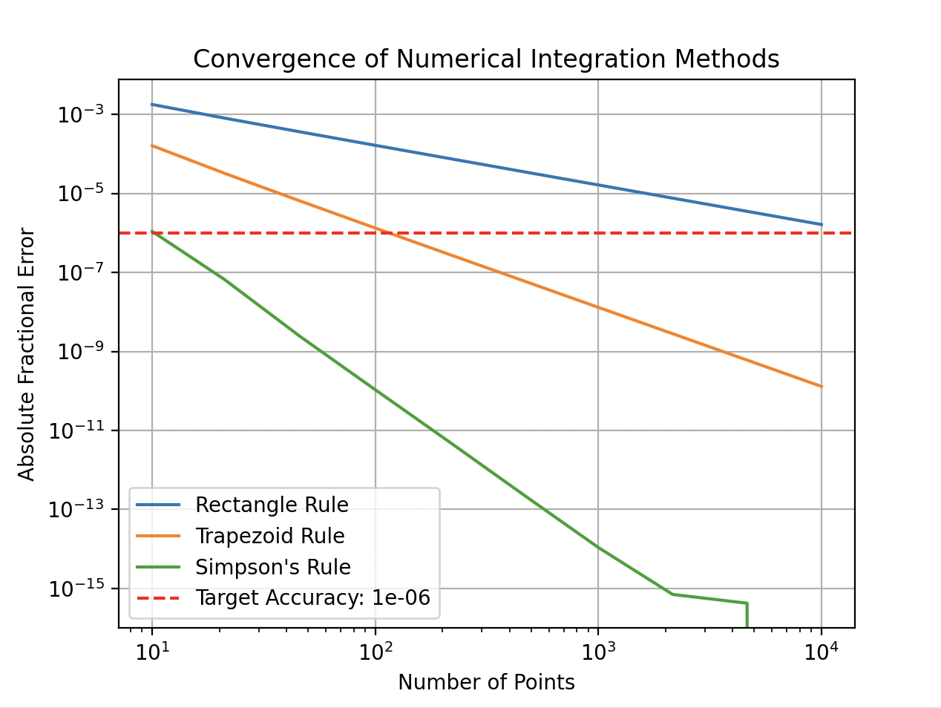

**Simpson's Rule** (green line) converges quickly, achieving very high accuracy with a relatively small number of steps. The error drops below ${10}^{-14}$ with around 1000 steps, making it the most accurate method in this comparison. I recommend using 10 steps.

**Trapezoid Rule** (orange line) converges more slowly than Simpson's Rule but still performs reasonably well (better than the rectangle rule), reaching fractional errors below ${10}^{-8}$ with approximately 1000 steps. I recommend using 100 steps.

**Rectangle Rule** (blue line) is the least accurate and converges slowly. It doesn’t reach an accuracy better than ${10}^{-6}$ within the tested range of steps, requiring significantly more steps to achieve similar precision to the other methods. I recommend 10,000 steps, but it doesn’t reach the target accuracy with 10,000 steps, so this method might not be an option to use for high-precision calculations.

# **Task 4.3 Cumulative version**

A cumulative version of the Trapezoid rule was implemented to compute the cosmological distance for a range of redshifts from $z=0$ to $z=1$. The resulting plot shows the cumulative distance as a function of redshift: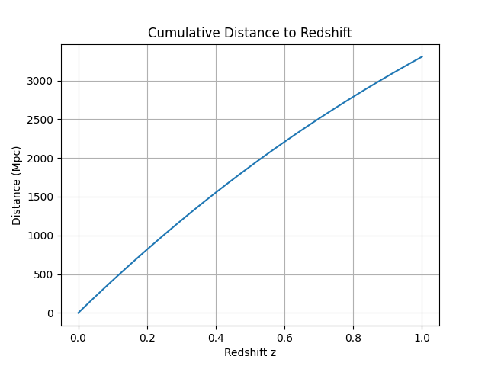

The plot demonstrates that the cosmological distance increases non-linearly with redshift, as expected in the cosmological model.

Additionally, the SciPy interpolator was used to calculate the distance modulus $μ(z)$, which is a logarithmic measure of the distance. The distance modulus for a range of redshift values was computed and plotted, considering variations in $H_{0}$, $Ω_{m}$, and $Ω_{λ}$.

# **Task 4.4 Exploration**

In this task, the effect of varying the parameters $H_{0}$, $Ω_{m}$, and $Ω_{λ}$ ​ on the distance modulus $μ(z)$ was explored. The following plot shows the distance modulus as a function of redshift, demonstrating how changes in these parameters affect the cosmological distance:

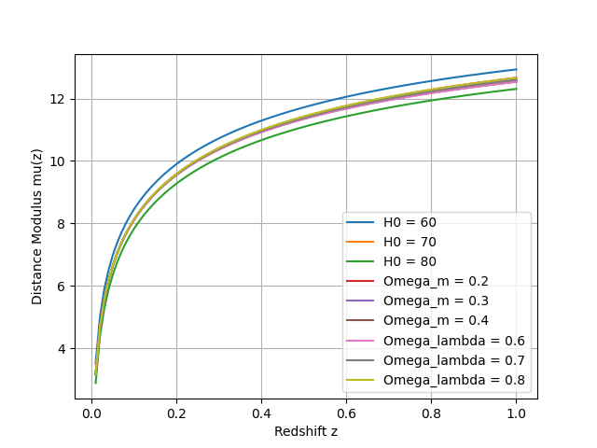

The plot indicates that higher values of $H_{0}$ result in lower distance moduli, as a larger $H_{0}$ constant leads to smaller distances for the same redshift. Variations in $Ω_{m}$ and $Ω_{λ}$ ​ also have noticeable effects, with higher matter densities $Ω_{m}$ producing slightly higher moduli.