Aggregate Report
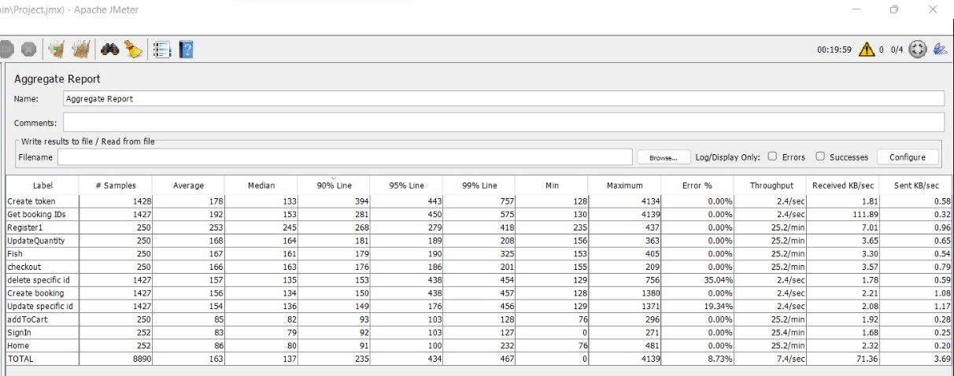

The total error percentage for all samples | 8.73%
90% of the total issued requests | 235 ms
99% of requests | 467 ms

