Hunting For Process Injection & Proactive API Monitoring

LAB 8

Scenario
Attackers love hiding/injecting malicious code into processes. In this lab, you will learn how to hunt for various process injection techniques and how to leverage userland API monitoring for more effective hunts.

Goals
The learning objective of this lab is to practice detecting

What you will learn
You will learn an alternative way of detecting process injection and how proactive API monitoring can result in better hunting for process injection.

Recommended tools
- https://github.com/marcosd4h/memhunter
- https://github.com/y3n11/Captain
All the tools are present in the C:\Users\Administrator\Desktop\Tools folder

Tasks

Task 1. Practice detecting process injection using memhunter, minjector & Process Hacker 2
According to the Memhunter developer: "The detection process is performed through a combination of endpoint data collection and memory inspection scanners. The tool is a standalone binary that, upon execution, deploys itself as a windows service. Once running as a service, memhunter starts the collection of ETW events that might indicate code injection attacks. The live stream of collected data events is feed into memory inspection scanners that use detection heuristics to down select the potential attacks. The entire detection process does not require human intervention, neither memory dumps, and it can be performed by the tool itself at scale."
memhunter and minjector reside at C:\Users\Administrator\Desktop\Tools\memhunter
Perform a process injection through minjector.exe (use option 1) against notepad.exe and detect the attack through memhunter.exe and Process Hacker 2 (available on the Desktop)

Task 2. Practice detecting process injection through proactive API monitoring
According to the Captain developer:"Captain is an endpoint monitoring tool that aims at spotting malicious events through API hooking, improving the process of threat hunting analysis . When a new process is created, Captain will inject a dll into it hooking some Windows API functions."
- Close the notepad.exe process where you injected a DLL during Task 1.
- As an administrator, start the monitoring PowerShell script (Monitor.ps1) of the Captain detection tool. The script resides at: C:\Users\Administrator\Desktop\Tools\Captain
- Open a new notepad.exe process and perform a process injection through minjector.exe, using option 5 this time (Reflective DLL Injection)
- Navigate to C:\ProgramData\Captain\Reporting and read the content of events.json.

SOLUTIONS
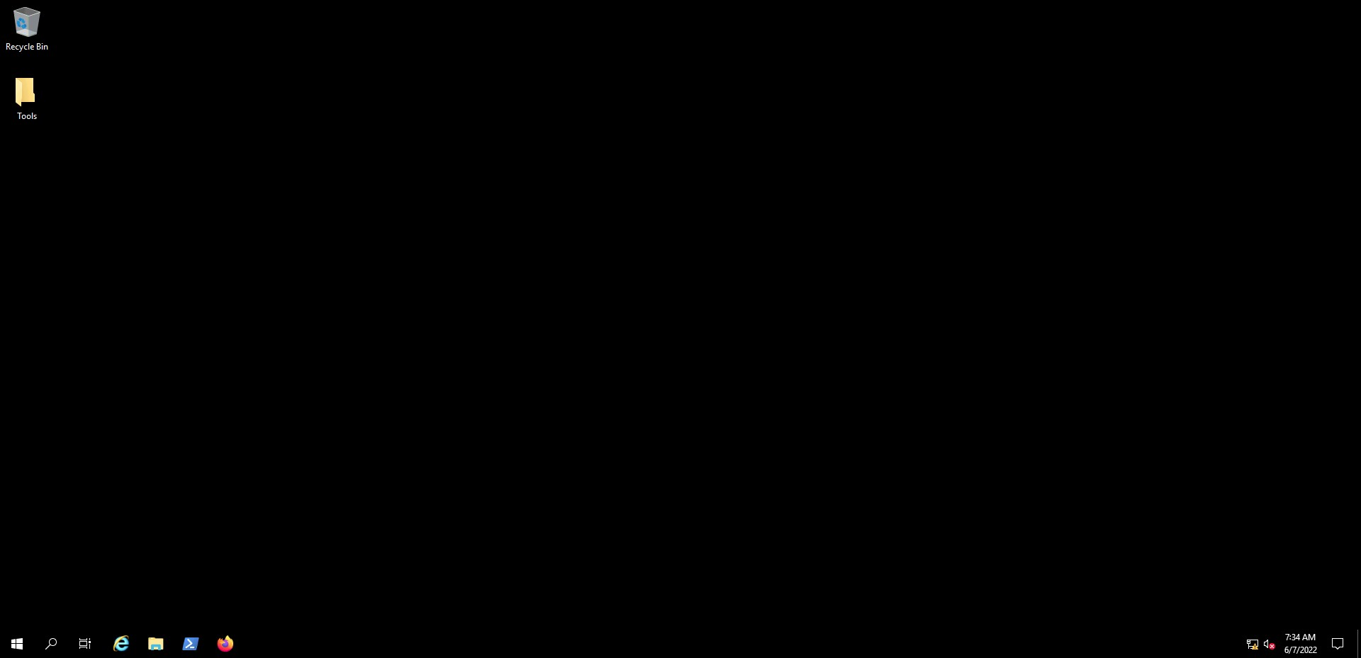
Below, you can find solutions for each task. Remember though, that you can follow your own strategy, which may be different from the one explained in the following lab.

Task 1. Practice detecting process injection using memhunter, minjector & Process Hacker 2
To perform a process injection against notepad.exe, perform the following.
- Run Process Hacker 2 as an administrator.
- Run notepad.exe and identify its PID through Process Hacker 2
- Open cmd.exe as an administrator and execute:
cd C:\Users\Administrator\Desktop\Tools\memhunter
minjector.exe -m 1 -s C:\Users\Administrator\Desktop\Tools\memhunter\msimplepayload.dll -t PID_of_notepad_exe
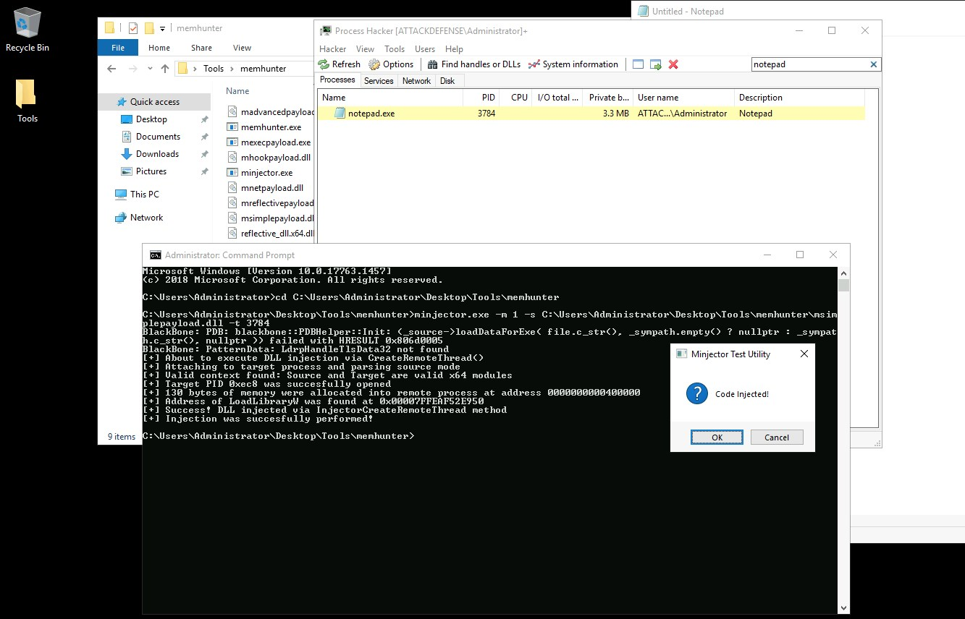
By double-clicking the notepad.exe process inside Process Hacker 2 and browsing the "Modules" tab, we can see the injected dll.
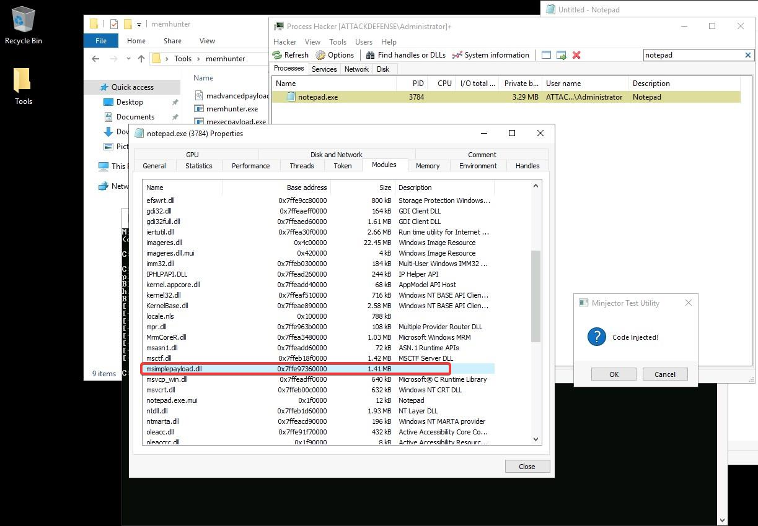
We could have detected the process injection activity through memhunter.exe, as follows.
Don't close the notepad.exe process where you injected the DLL previously!!!
Open cmd.exe as an administrator and execute:
cd C:\Users\Administrator\Desktop\Tools\memhunter
memhunter.exe -r
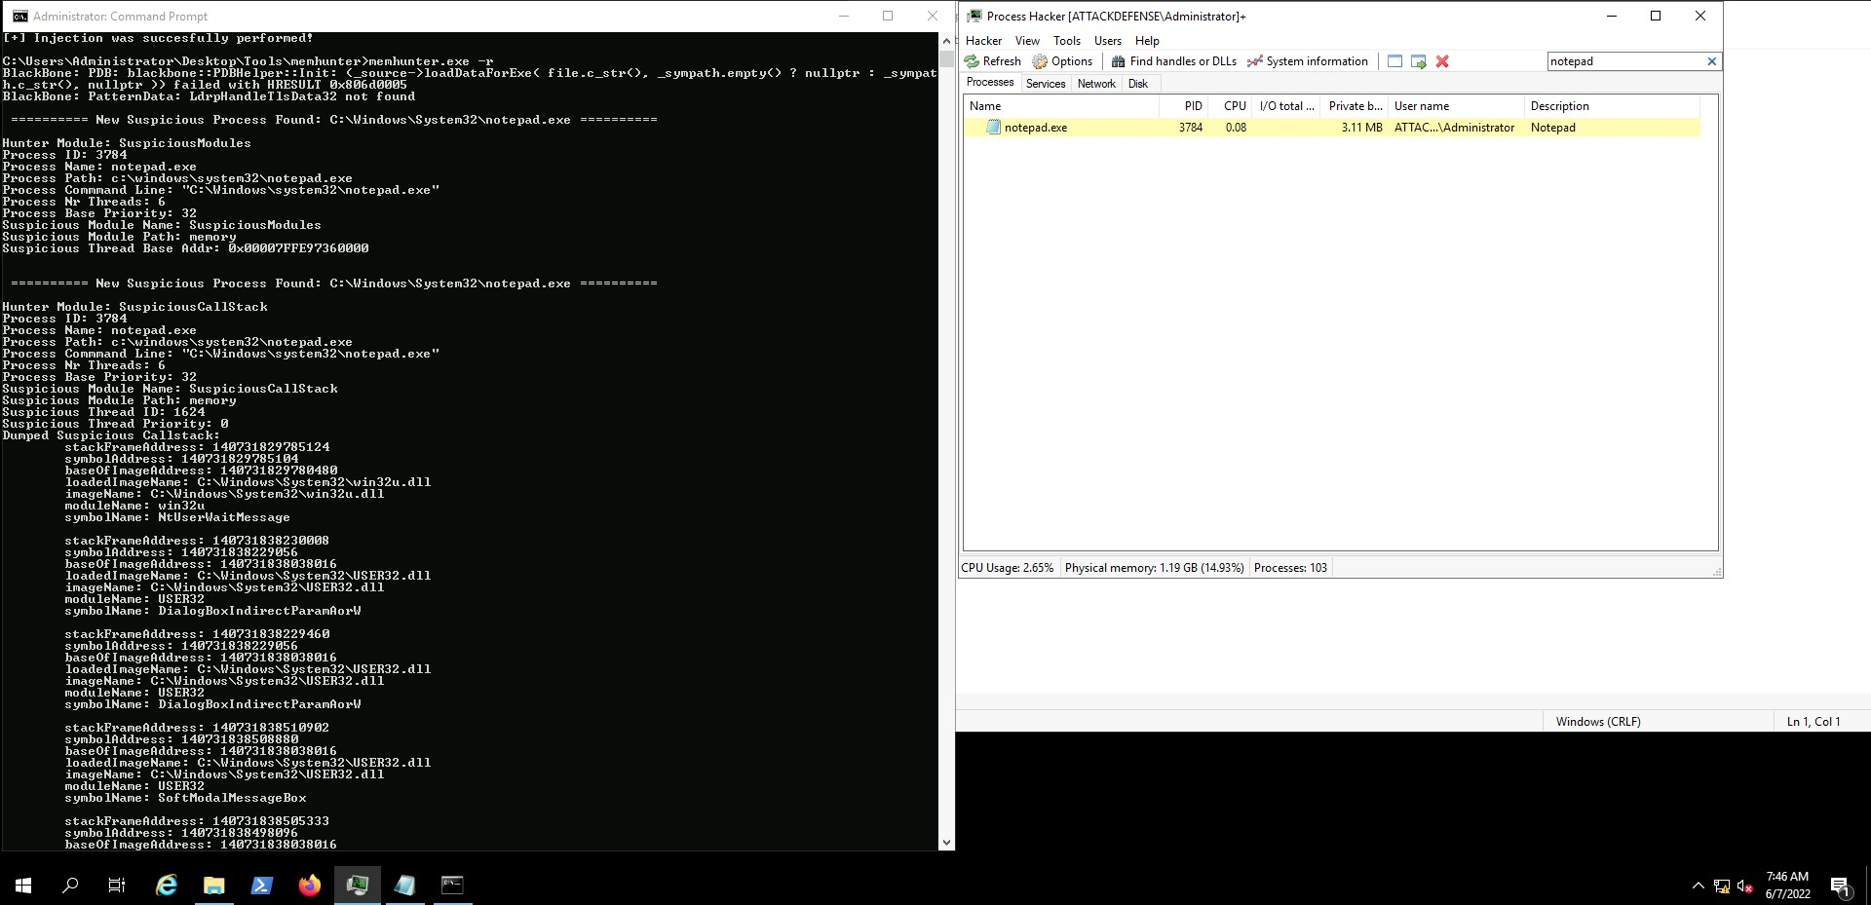
Wait for 2-3 minutes.
Memhunter successfully identified the process injection activity.
Try to detect process injection through the Reflective DLL injection and Process Hollowing options of minjector.exe with both Memhunter and Process Hacker 2.
- Regarding Reflective DLL injection, focus on the "Threads" tab of Process Hacker 2
- Regarding Process Hollowing, focus on the "General" and "Modules" tabs of Process Hacker 2

Task 2. Hunt for suspicious network connections
Let's first start Captain's monitoring script, as follows.
Open PowerShell as an administrator, and execute.
powershell -ep bypass
cd C:\Users\Administrator\Desktop\Tools\Captain
.\Monitor.ps1
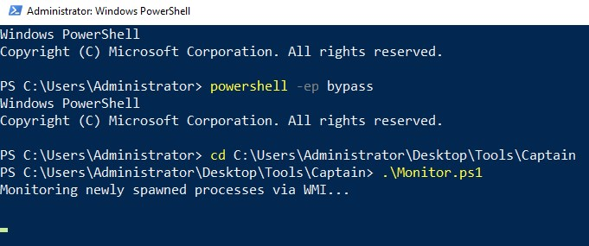
Now, let's run a new notepad.exe process. Once we do that, we should see the below inside Captain's monitoring script.
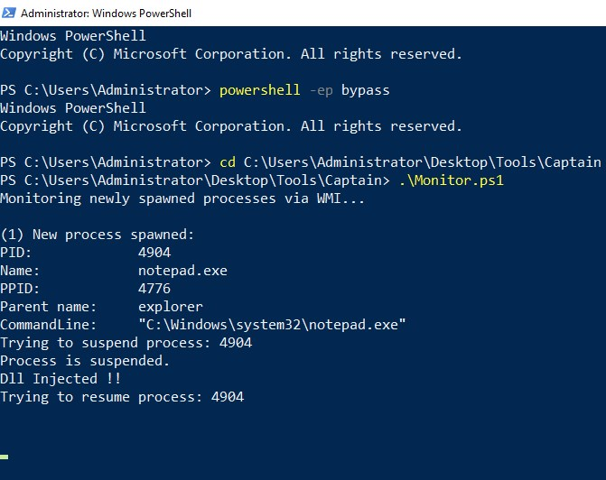
It is time we perform our Reflective DLL injection against notepad.exe, using minjector.exe.
Open cmd.exe as an administrator and execute:
cd C:\Users\Administrator\Desktop\Tools\memhunter
minjector.exe -m 5 -s C:\Users\Administrator\Desktop\Tools\memhunter\reflective_dll.x64.dll -t PID_of_notepad_exe
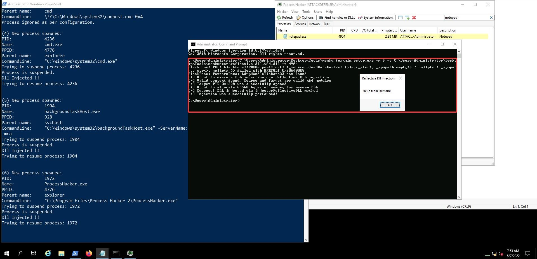
The reflective DLL injection attempt should be successful and a message box mentioning "Hello from DllMain" should be visible (click on the notepad icon on the taskbar if it is not visible).
Finally navigate to C:\ProgramData\Captain\Reporting and read the content of events.json. You should notice functions that are related with process injection being called and used against notepad.exe.
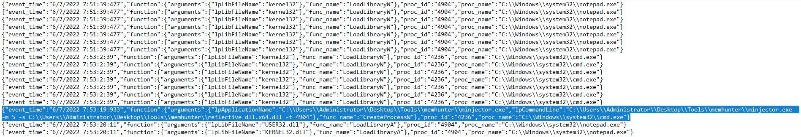
Feel free to explore all functionality of the Captain tool. It will give you a nice idea of how actual EDR work.
https://github.com/y3n11/Captain

