“Cultist” Character Model Documentation

Introduction
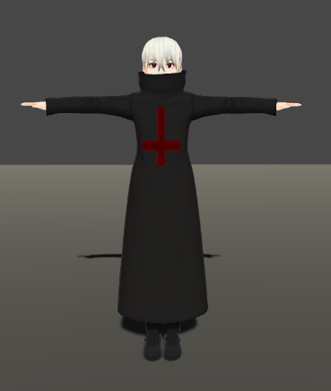
The “Cultist” character package contains one anime inspired character as you can see here:
Different body parts have different texture files, which makes changing the eye colour for example easy! Simply open the corresponding texture in a photo editor and you can edit it right away. The texture resolution varies between 256x256 and 2048x2048 depending on the size of the body part.
Installation
The model can be found in the “Prefabs” folder and can be dragged into your scene without further setup!

Animations
- If you want to add animations to your character I recommend Mixamo.com! Simply press the button “upload character” and drag and drop the .fbx file found in the “prefabs” folder into your browser
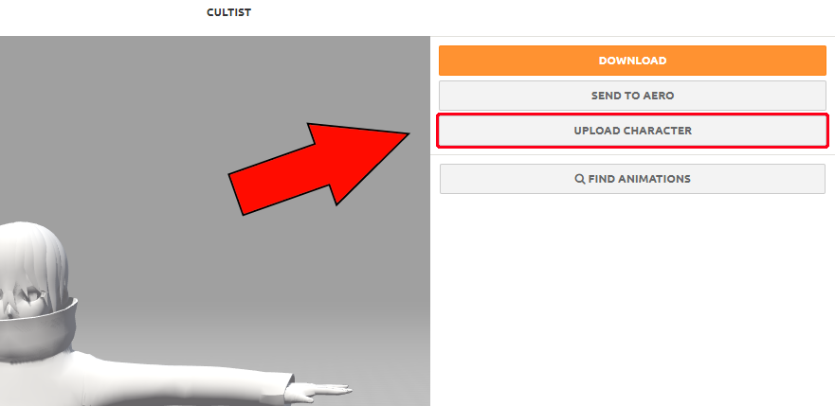
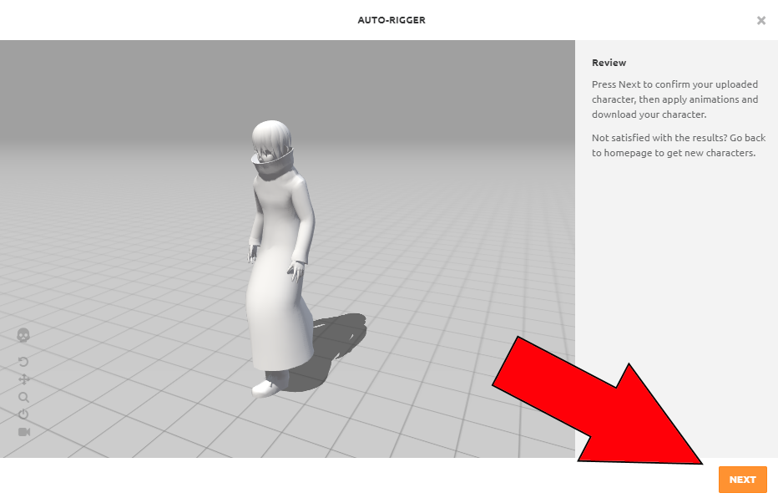
- Now click the “Next” Button on the Auto Rigger Window! (Don’t worry if the character has no colour here)
- Finally, you can choose any animation from their massive library for free!
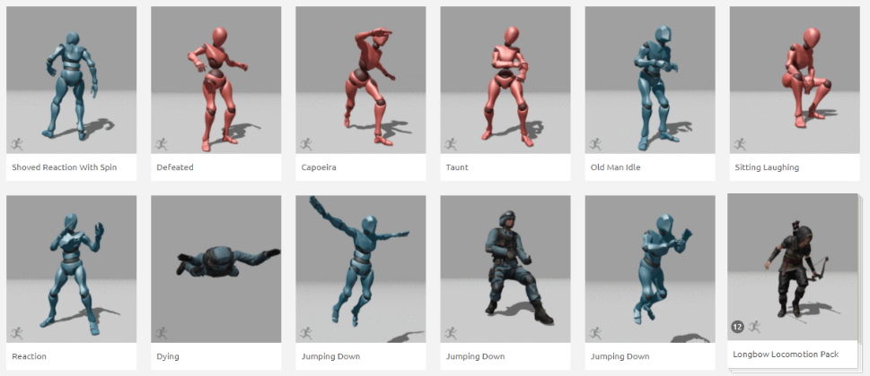

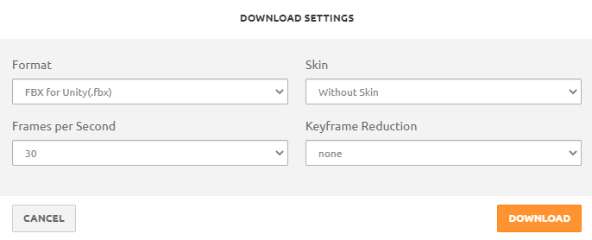
- At the end hit the download button and download your animation with the following settings (the two at the bottom are irrelevant):

- Now in Unity make sure that you animation import settings look like this:
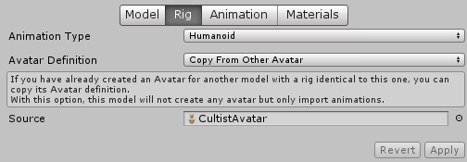

- Done!

Contact
You have further questions or have problems? Simply send me an Email (Celtrius@gmx.de) or join my support Discord server:
https://discord.com/invite/2gJY9Mm
or https://www.celtrius.tk/discord

