Haggard CSIS27 Sp26 Wk4 Lab Screenshot
- Queue
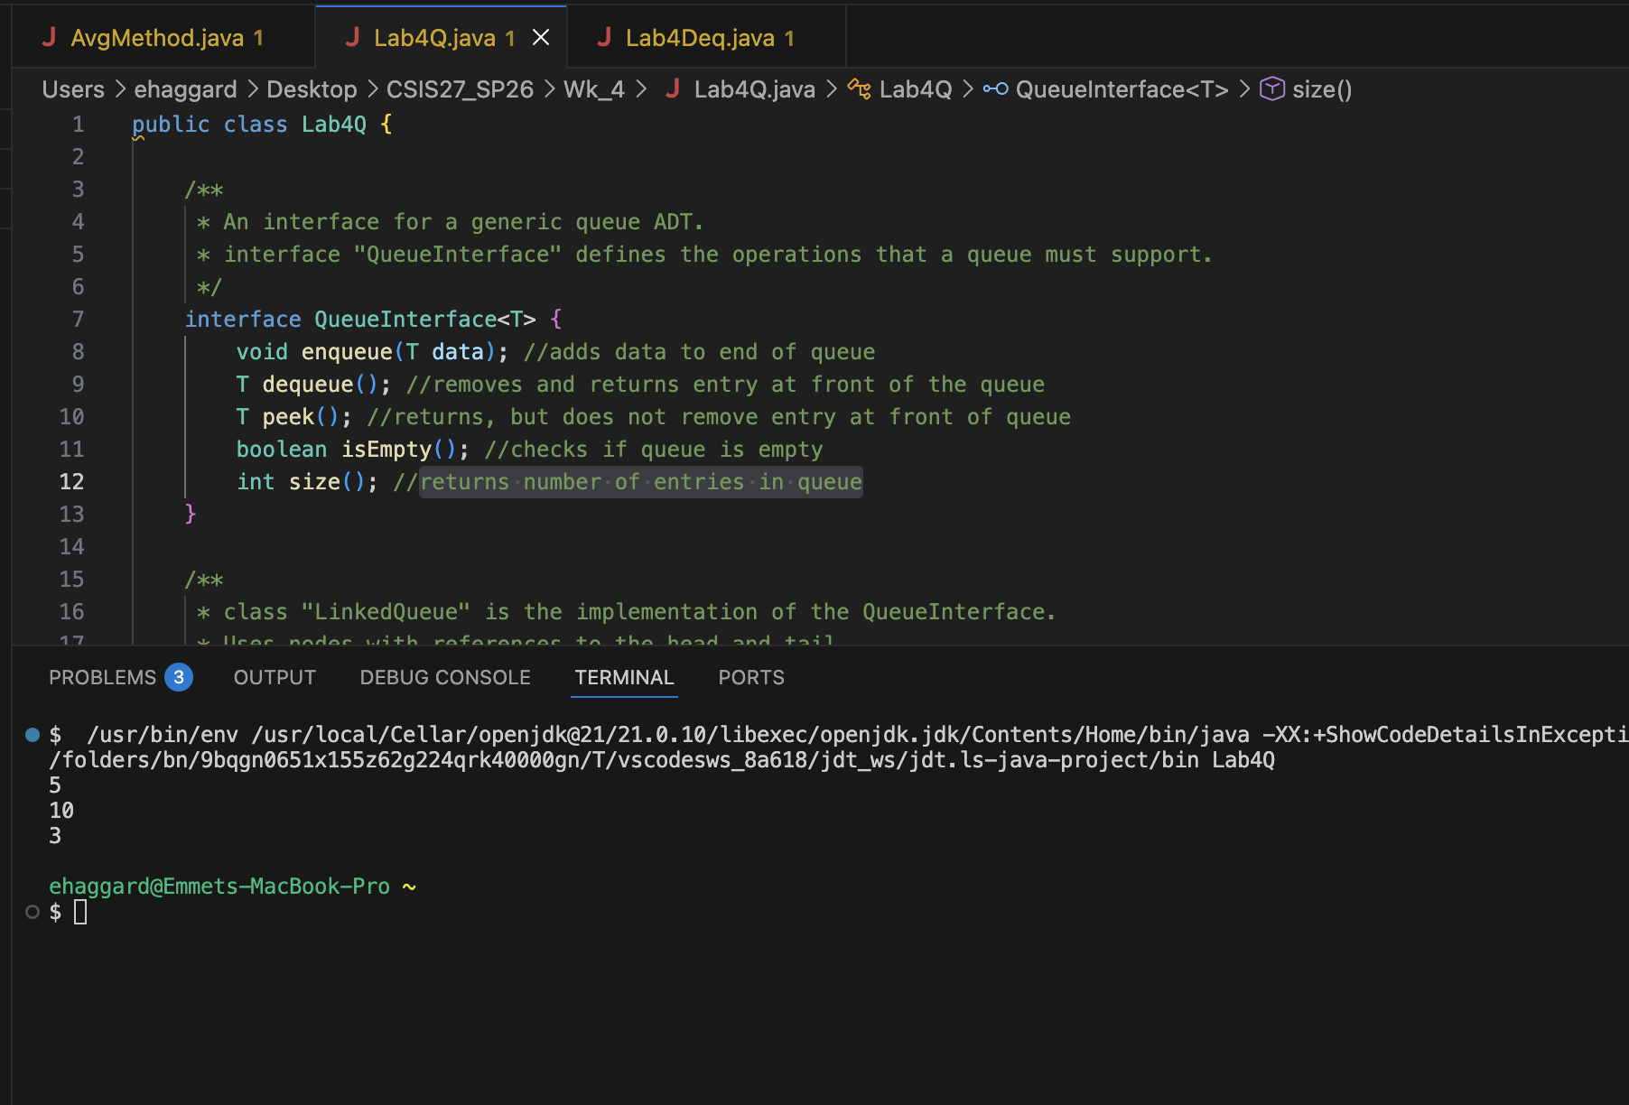
- Deque
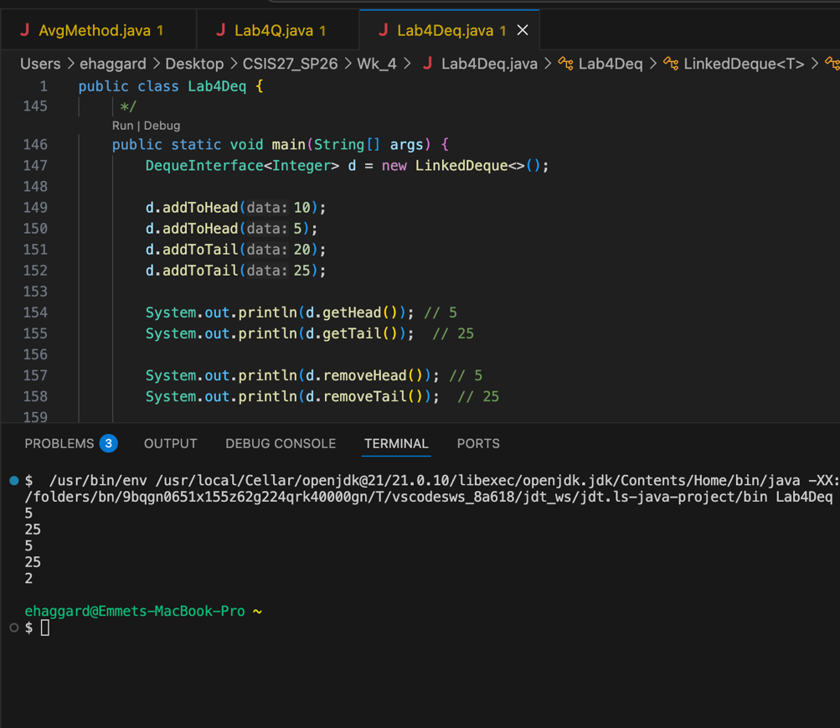
Big O complexity
In each case the memory grows linearly (O(n)), because adding a new entry, or removing one involves a single node. Deque has two pointers per node (next and prev) vs one pointer per node for Queue (just next). But the time complexity is just O(1) for each operation, no transversal, so the time complexity is not technically different between Lab4Q and Lab4Deq.

