**Edgar Hakobyan**

**SER 316 – Assignment 4**

**Git**

When we merge StaticAnalysis to Whitebox, nothing special should happen. In my opinion the deleted file will get restored in Whitebox. There should not be any conflicts or issues

**GitHub Actions**

Main, Blackbox, Review branches fail GitHub actions. The primary reason that all these branches fail is because GamePlay class is not implemented for the Whitebox test.

**Task 1: Checkstyle**

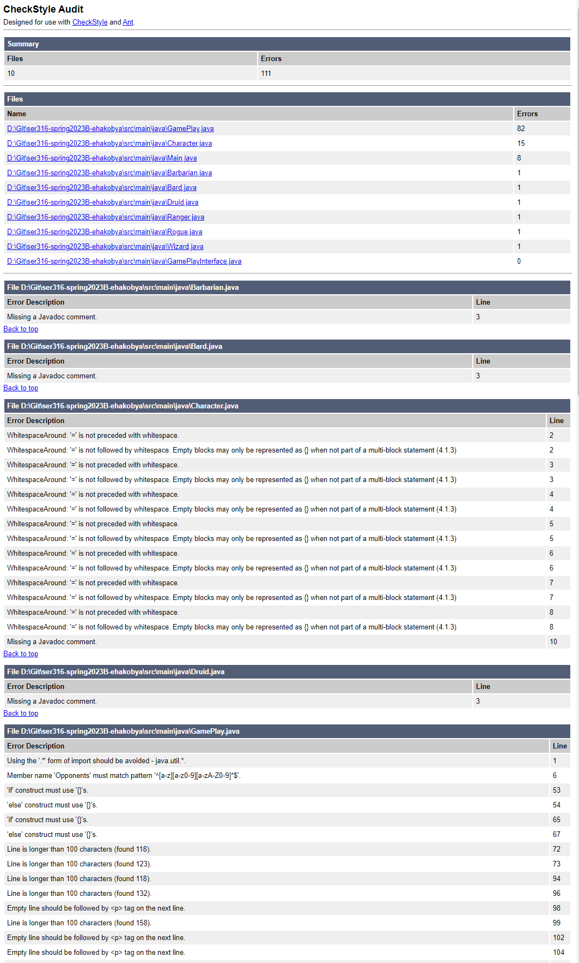

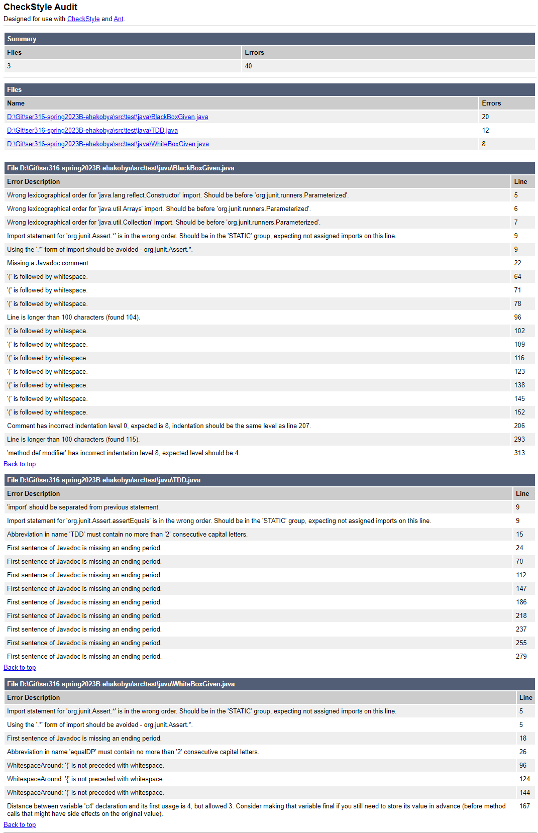

Q5:

In main checkstyle found **111 errors in main**, and **40 errors in test**.

Q7:

Number of violations did not change. IntelliJ was already configured not use tabs (“use tab character” toggle was already turned off in Settings -> Editor -> Code Style -> Java)

Also, applying conversion to spaces (From Edit-> Convert Indents -> To Spaces) results in a message “All lines already have requested indentation” for every java file.

Q9:

Main

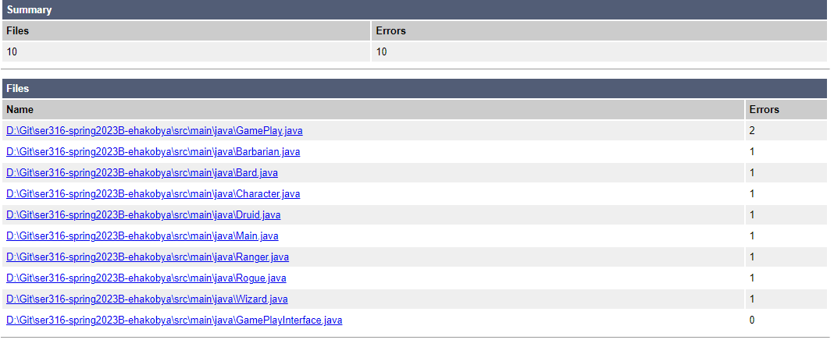

Test

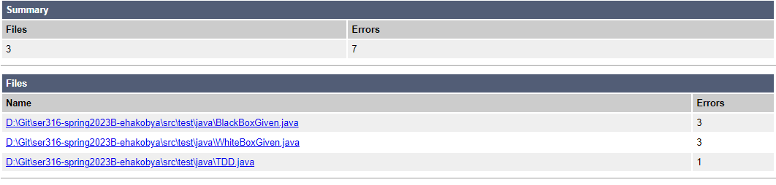

Q10:

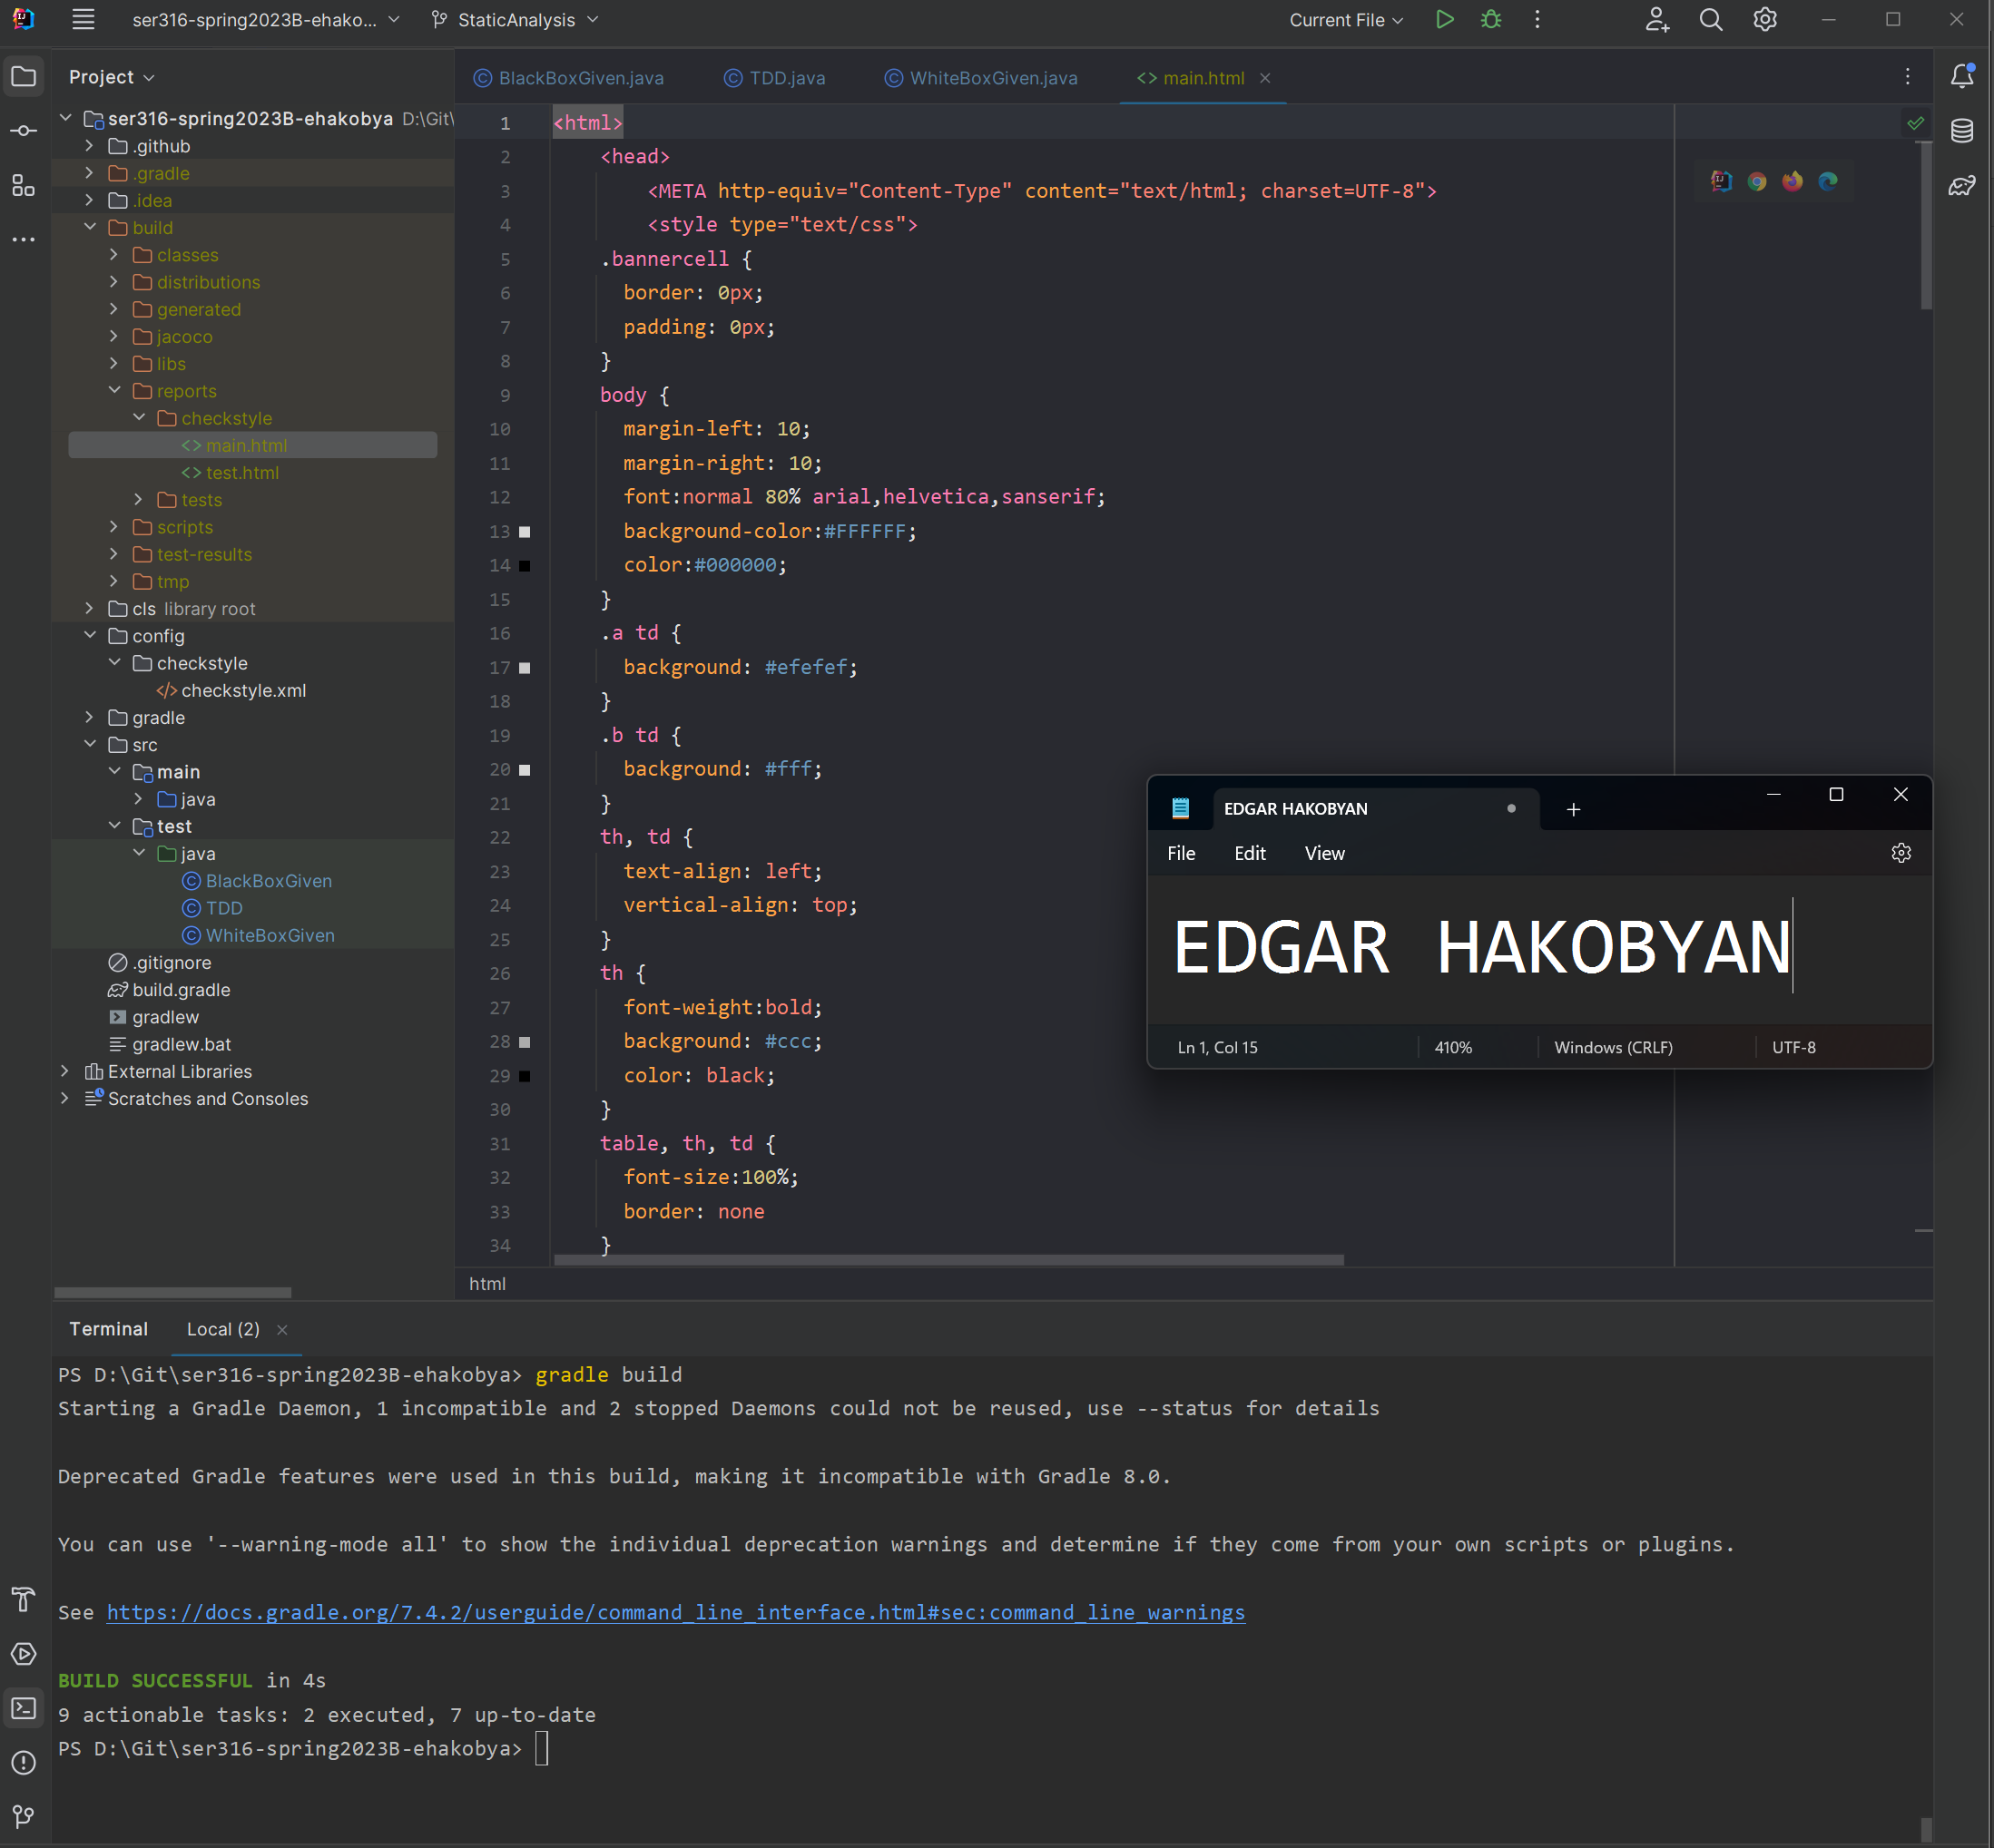

**Task2: Spotbugs**

2.1

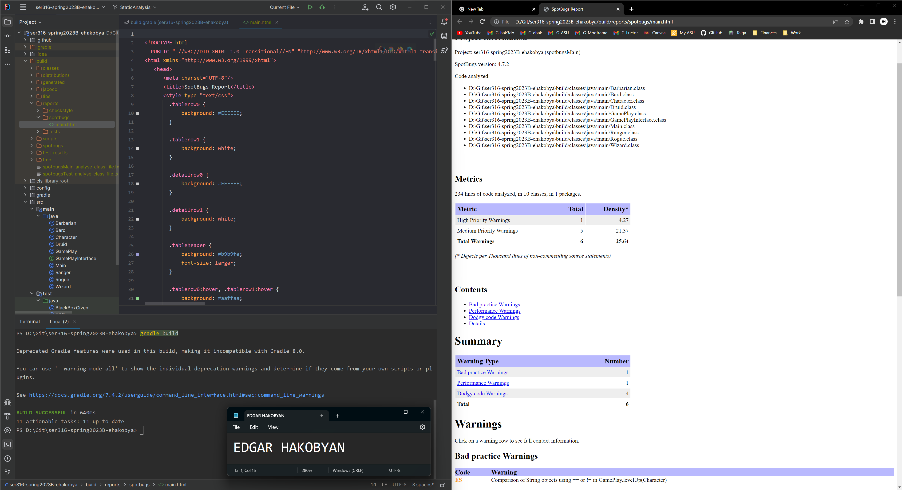

2.2

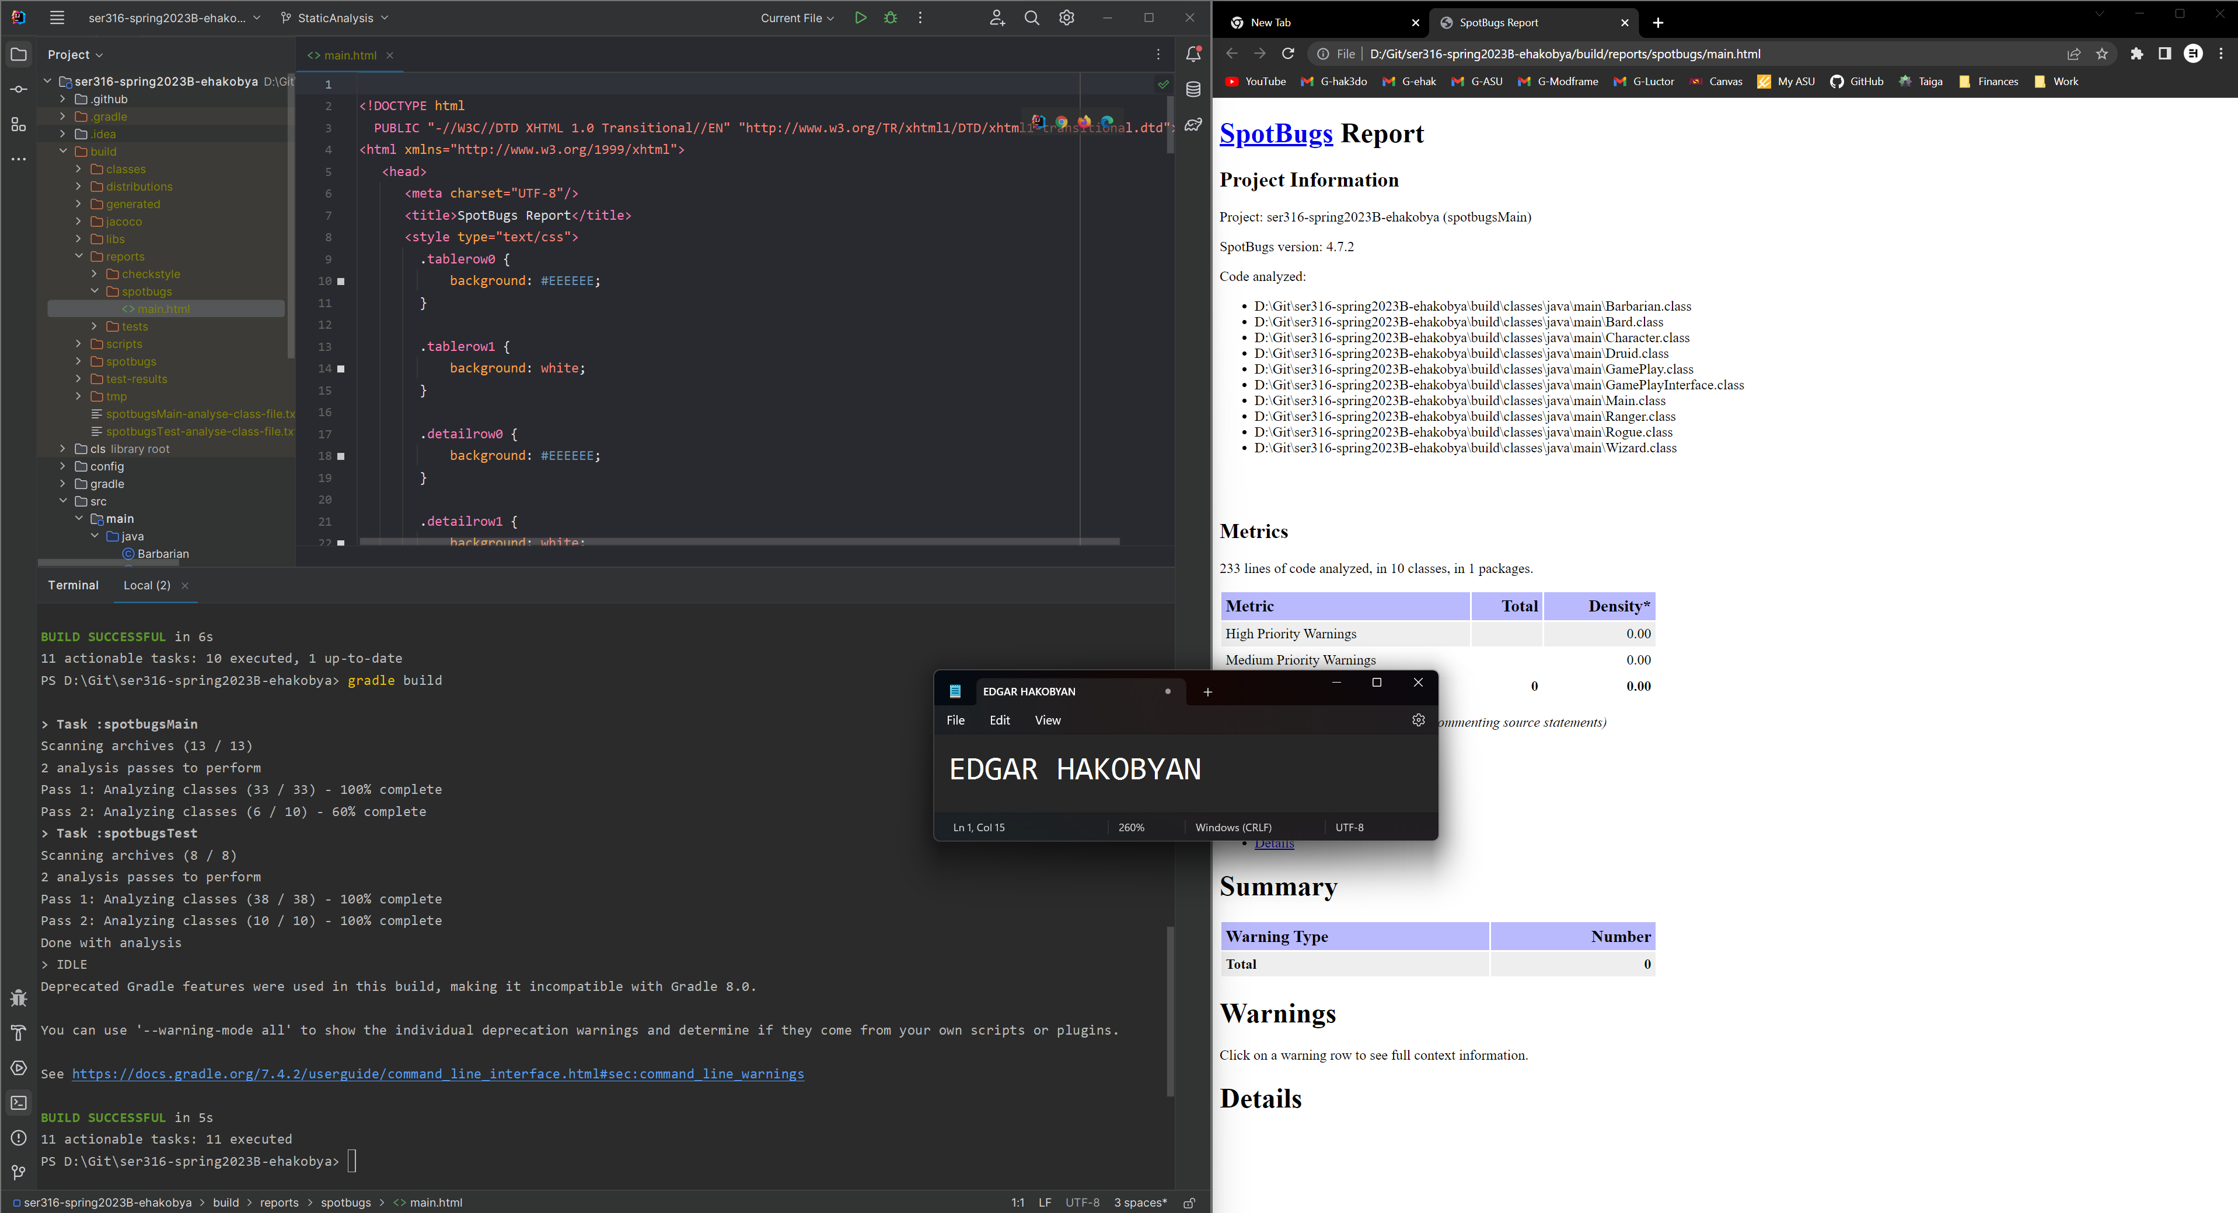

**Task 3: Comparing**

Comparison of initial checkstyle and spotbug reports

|  |  |  |  |
| --- | --- | --- | --- |
| Branch | Checkstyle | | Spotbugs |
| Main | Test |
| StaticAnalysis | 111 | 40 | 6 |
| Blackbox | 111 | 23 | 4 |
| Review | 111 | 23 | 7 |

After StaticAnalysis fixes

|  |  |  |  |
| --- | --- | --- | --- |
| Branch | Checkstyle | | Spotbugs |
| Main | Test |
| StaticAnalysis | 10 | 7 | 0 |

Reports clearly show improvement for StaticAnalysis before and after the fixes. Number of errors was reduced by at least 10 times. The only errors that were left were the JavaDoc comments.

**Task 4**

The report got a little worse but not by a lot. Only 7 more checkstyle issues in main and 0 more issues in Test. Spotbugs still shows 0 errors. Most of the changes that happened were in the whitebox branch (implementations) and corrections to bugs and checkstyles were done in StaticAnalysis. But static analysis was branched off whitebox. Therefore it contained the implementations in it, and we reduced and fixed errors on this branch. Therefore, it seams logical that after mergin all branches, dev would still have the best version of the code from staticanalysis.

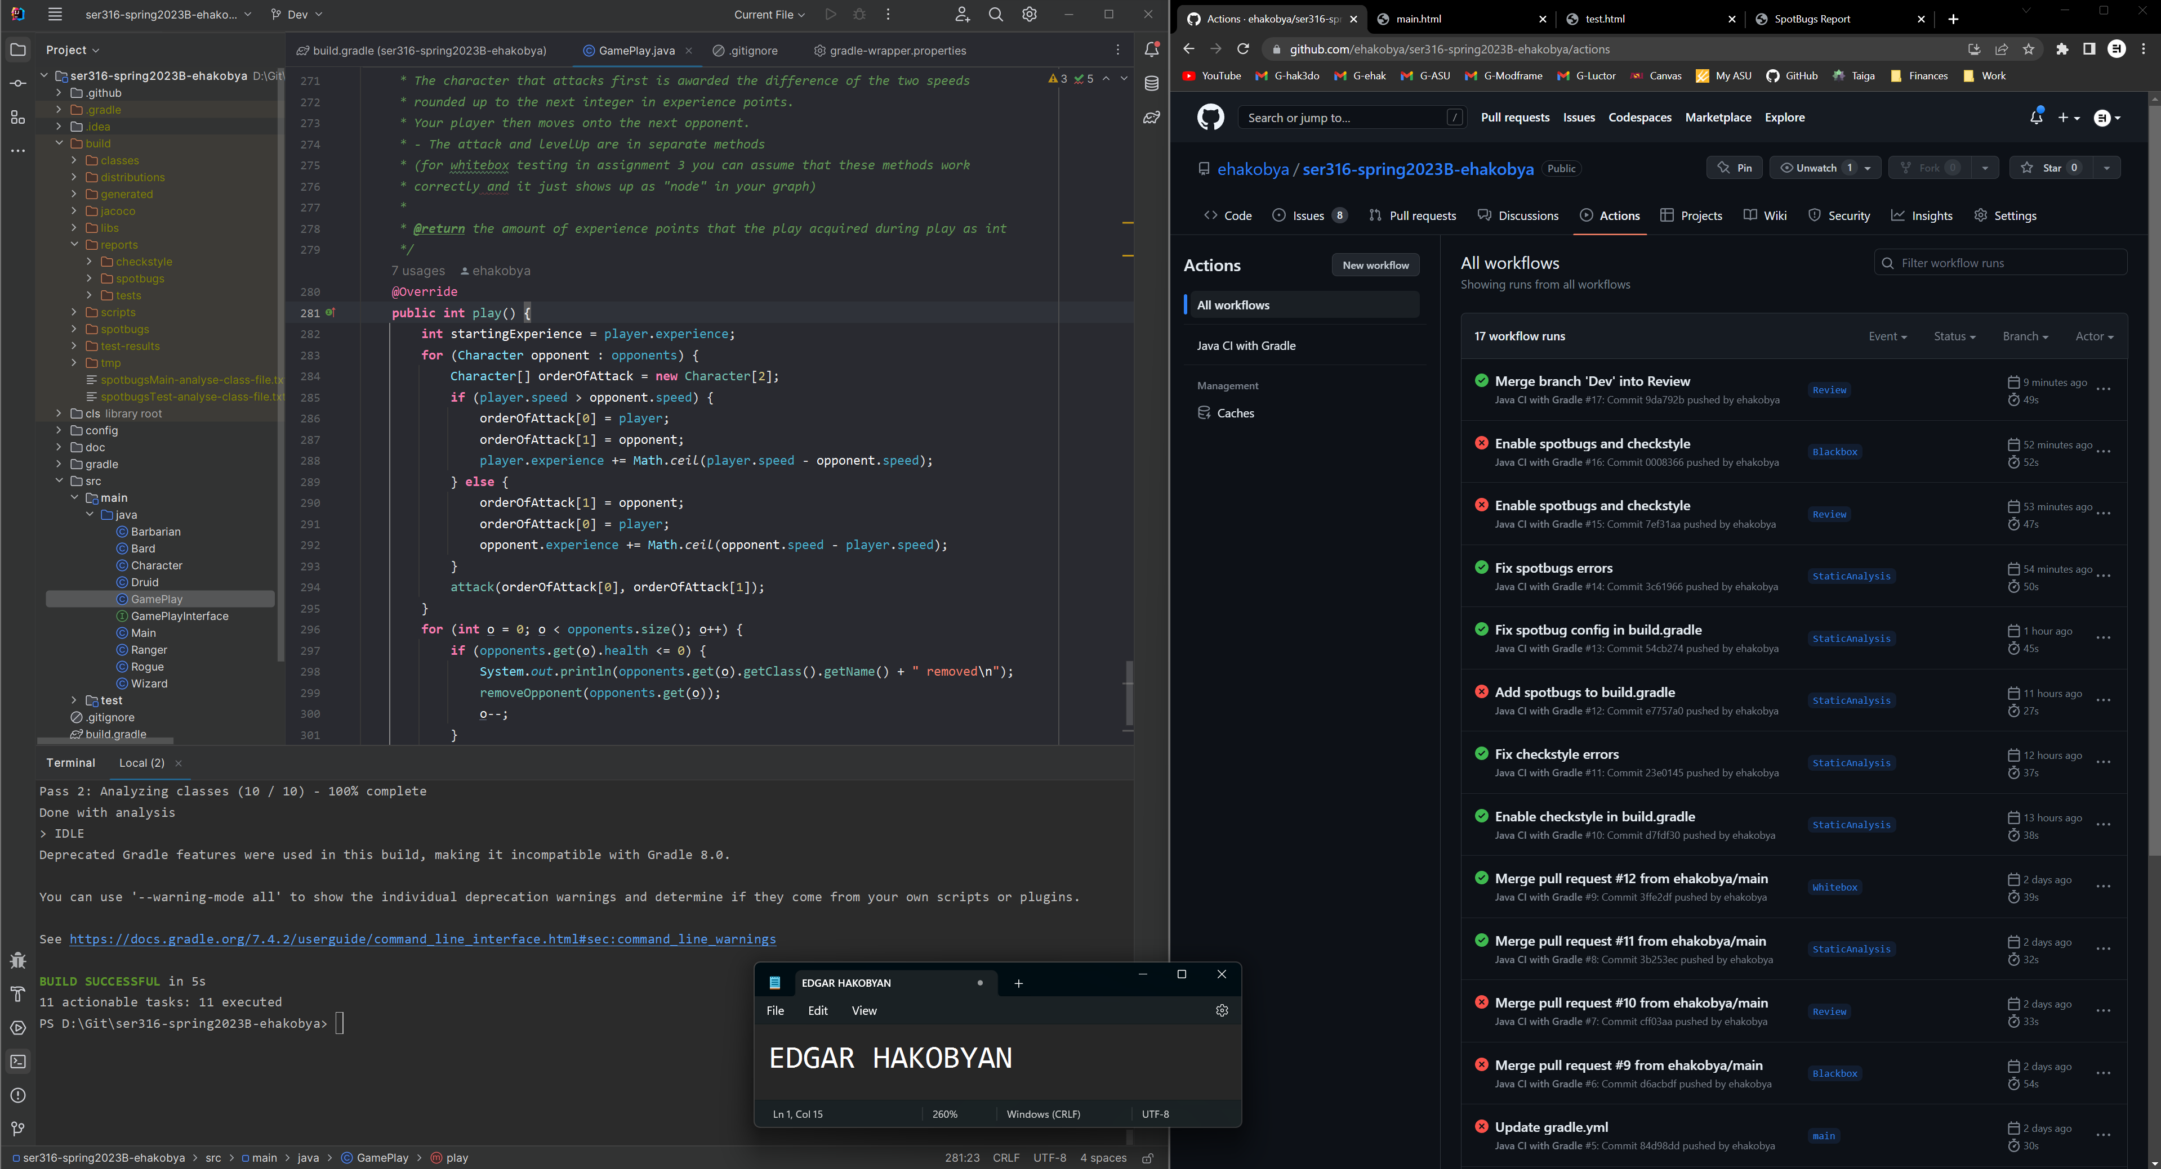

I would fix first spotbugs errors since errors leading to potential bugs are more important that stylistic changes. Then I would apply checkstyle fixes.

**Task 5: Final code review**

No changes necessary