##### WEEK 1

###### Algorithm:

1.Supervised: Give a set of data and right answer

1).Regression : continuous valued output

2).Classfication: predict a discrete value output

2.UnSupervised:

approach problems with little or no idea what our results should look like.

We can derive structure from data where we don't necessarily know the effect of the variables

###### Cost Function:

1.Mean Squired error cost function: 最常见的在linear regression问题中：

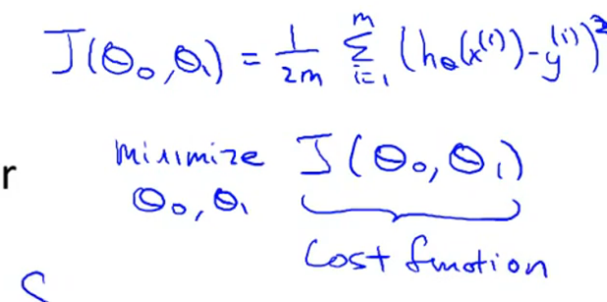

M : # of training set

相当于是差的平方和 平均数/2

除以二是因为有 gradient descent 问题， 有的地方不需要除以二

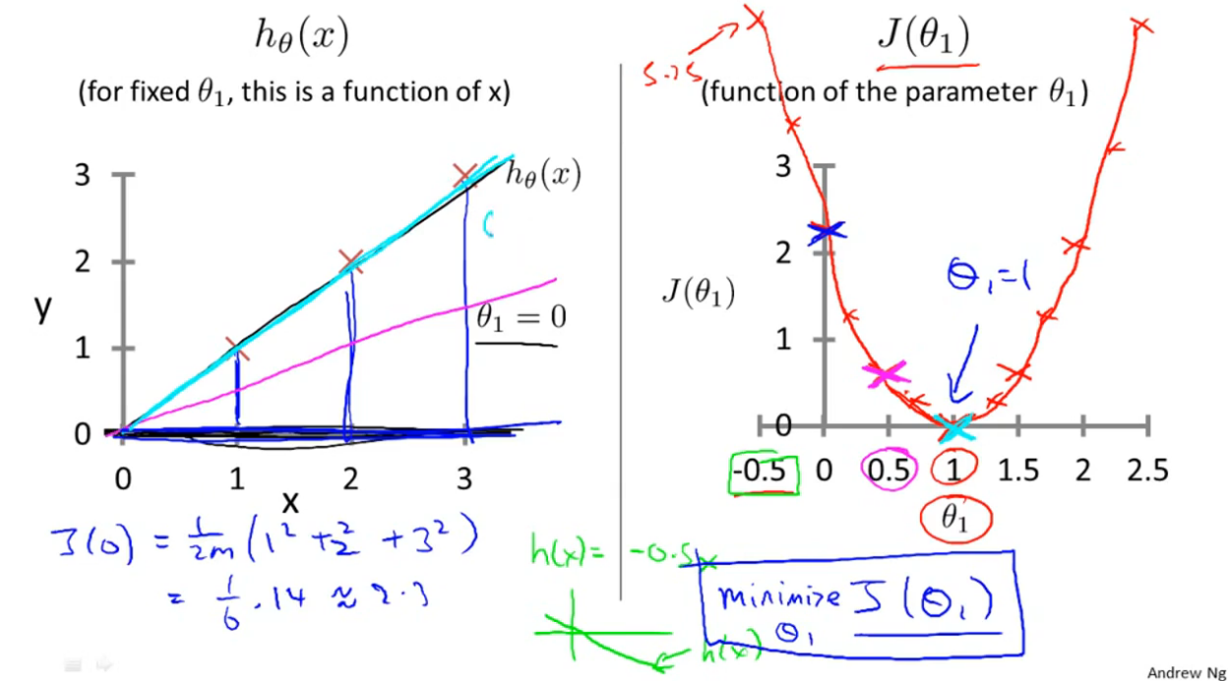

J() 就是cost function 可以看见在参数 = 1 的时候 J()最小。 所以这个参数就是1

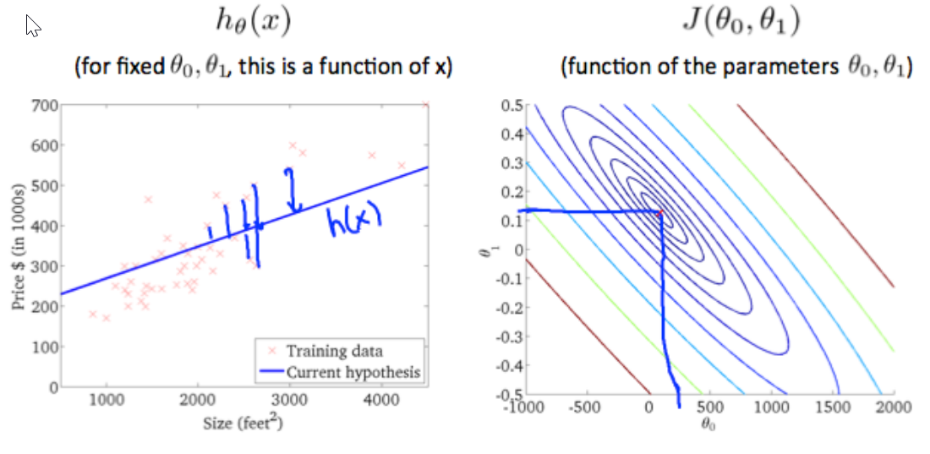

Y = a + bx 这样的cost function就是一个碗状图

###### Gradient Descent algorithm

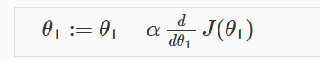

相当于每次参数减去alpha*斜率 所以参数会越来越接近最低点

但是前提是alpha不能 too large！！！！！

a := b 赋值 a = b （判断a==b）这里和java不一样

梯度递减就是一步一步往下走，直到j(a,b)的值最小

It is Simultaneous update

同步更新参数

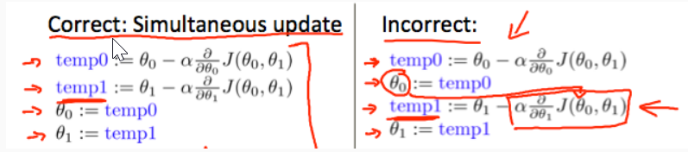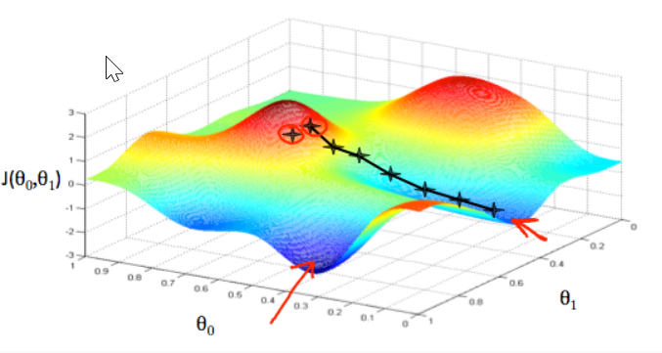

###### Gradient Descent for Linear Regression

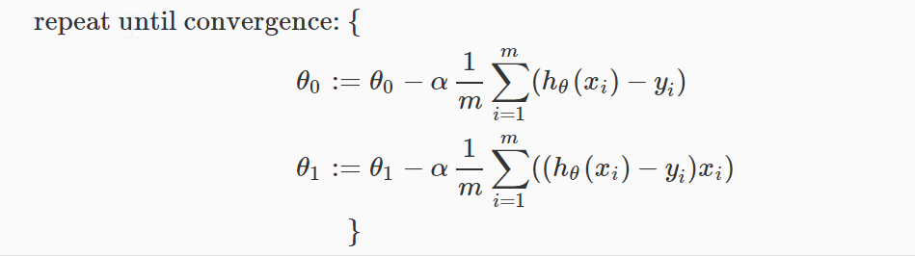

通过分别求导得出来的结果。（牛逼啊！！）

Derivative process：

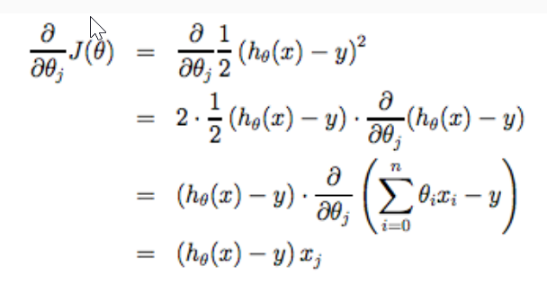

###### Matrix Matrices are not commutative: A∗B≠B∗A

If B is Identity matrix , AB = BA

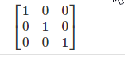

Matrix Inverse:

A * A-1  = identity matrix

*pinv*(*A*) inv(A)都可以，有细微差别

Matrix transposition

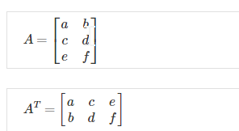

##### WEEK2

###### Multiple Features

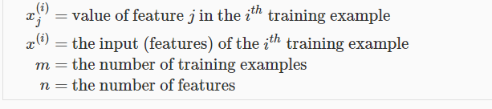

所以

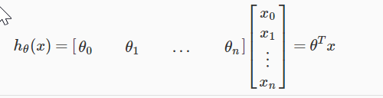

变为h(x) = θ0 * X0 + θ1 * X1 + …..

让X0 = 1 即可

[θ0，θ1，θ2] [1, X1, X2]

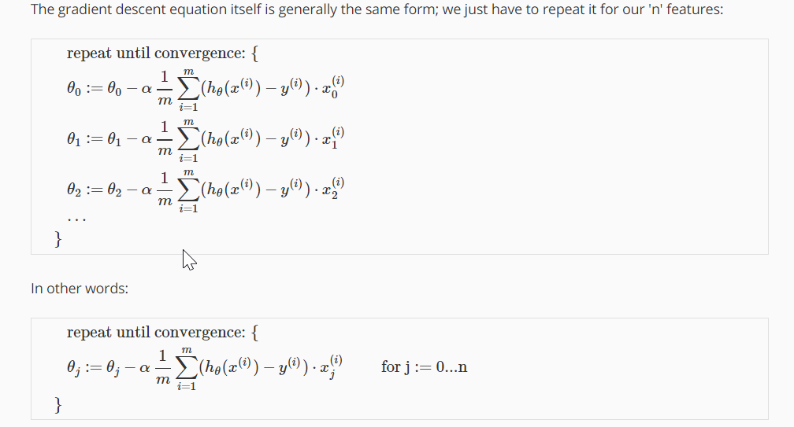

###### Feature Scaling

Approximately -1<= x <= 1 range

X1 = X1 / s

###### Mean Normalization

x1 = (x1 – ave) /s

S = max – min (The range)

###### Learning Rate

If *α* is too small: slow convergence.

If *α* is too large: ￼may not decrease on every iteration and thus may not converge.

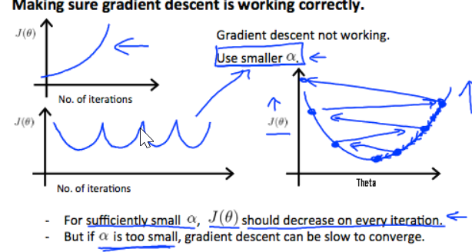

Alpha 太大，cost Function就会出现左边的情况，可能不是每次都减小

所以我要找到最大的可能值。 可以这样找： 1， 0.3 ，0.1， 0.03， 0.01， 0.003， 0.001这样。

###### Polynomial Regression

We can **change the behavior or curve** of our hypothesis function by making it a quadratic, cubic or square root function (or any other form).

多项式回归

自己创建新的x 比如用X2也当做一个X

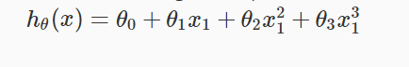

**但是这样做需要注意，需要做feature scaling. 因为数值差距太大**

###### **Two way to decreate J(**θ**)**

1. gradient descent
2. Normal Equation (Only can used in linear regression)

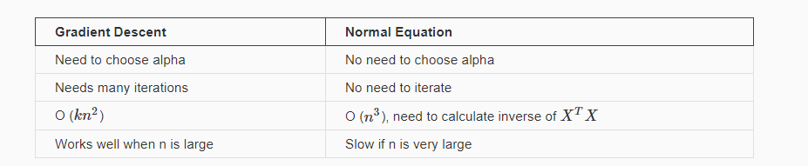

So, if n < 10000, use Normal Equation

Else use Gradient descent

Plus：Use Normal Equation , feature scaling is not necessary!!!

For Normal Equation: This table n = 5

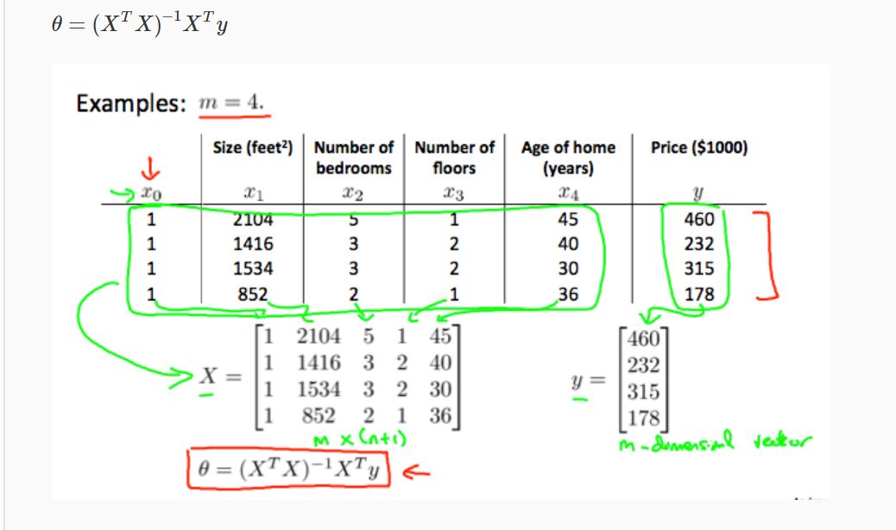

这样计算就得出了所有参数的值。暂时我并不知道公式的来源，先这么记着

###### Normal Equation Noninvertibility

1. Redundant features, where two features are very closely related (i.e. they are linearly dependent)

比如两个属性 x1(m2) x2(feet2) 都是面积，实际上是一样的意思，他们是linearly dependent

X1 = 3.28*3.28*X2

所以删去一个属性就好

2.Too many features (e.g. m ≤ n). In this case, delete some features or use "regularization"

###### Octave

结尾加；就不会打印

1 == 2

1 ~= 2 不等于

a = 3.1416

disp(sprint(‘2 decimals : %0.2f’,a)) 小数点后面两位

format long

format short

v = 1:0.1:2 [1,1.1,1.2…2]

ones(2,3) 就是一个全是1的2*3数组

rand(1,3) 随机数组

randn(1,3)有负数

hist（w,30） 画图统计个数

eye(4) identity matrix

help eye

A=[1,2;3,4;5,6]

size(A) = 3 , 2

length(A) = 3 因为最大的维度是3

load filename.dat

用who查看当前所有variable

Whos 查勘details

clear A 删除

v=princY(1:10) 取前十个

save hello.mat v; 保存文件了且在当前路径