**ASSIGNMENT-1**

**1.create three instance**

**a. Attach one EFS to two instance**

**b. attach one EBS to TWO instance**

1. **Create Three Instance**

**Step 1: Sign in to the AWS Management Console**

**Step 2: Click On The Launch Instance**

**Step 3:  Provide a name of your instance**

**Step 4: Choose an Amazon Machine Image (AMI)**

**Step 5: Choose an Instance Type**

**Step 6: Create a key pair**

**Step 7: Configure Security Group**

**Step 8: Add Storage**

**Step 9: Review and Launch**

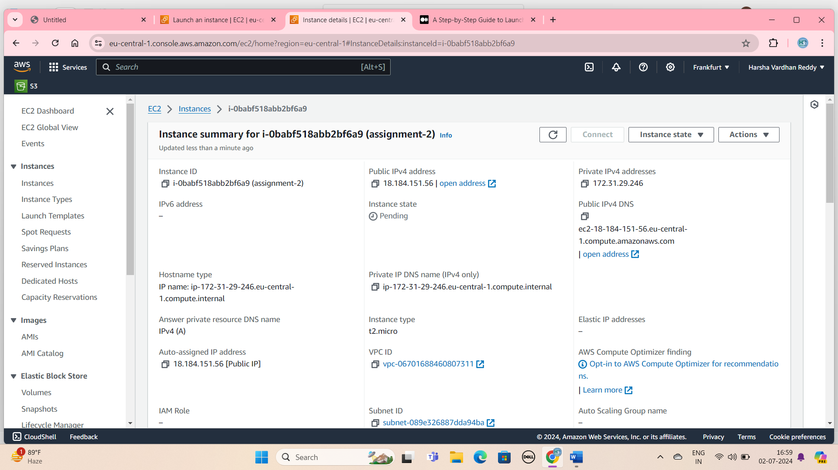

CREATE INSTANCE

1. **ATTACH ONE EFS TO TWO INSTANCE**

**Create EFS**

## Step1:  Create Your Security Groups.

## Step2: Create our EFS file system.

## Step3: Click on the customize.

## Step4: Mount targets & update create security group is apply.

## Step5: click on the create button

**Step 6: Click On The Launch Instance**

**Step 7:  Provide a name of your instance**

**Step 8: Choose an Amazon Machine Image (AMI)**

**Step 9: Choose an Instance Type**

**Step 10: Create a key pair**

**Step11: Network setting go to edit option**

**Step12:Subnet Choose Availability zone is select.**

**Step13:Click on the Security Group & Choose the Own Security Group Select.**

**Step 13: Click On The Launch Button.**

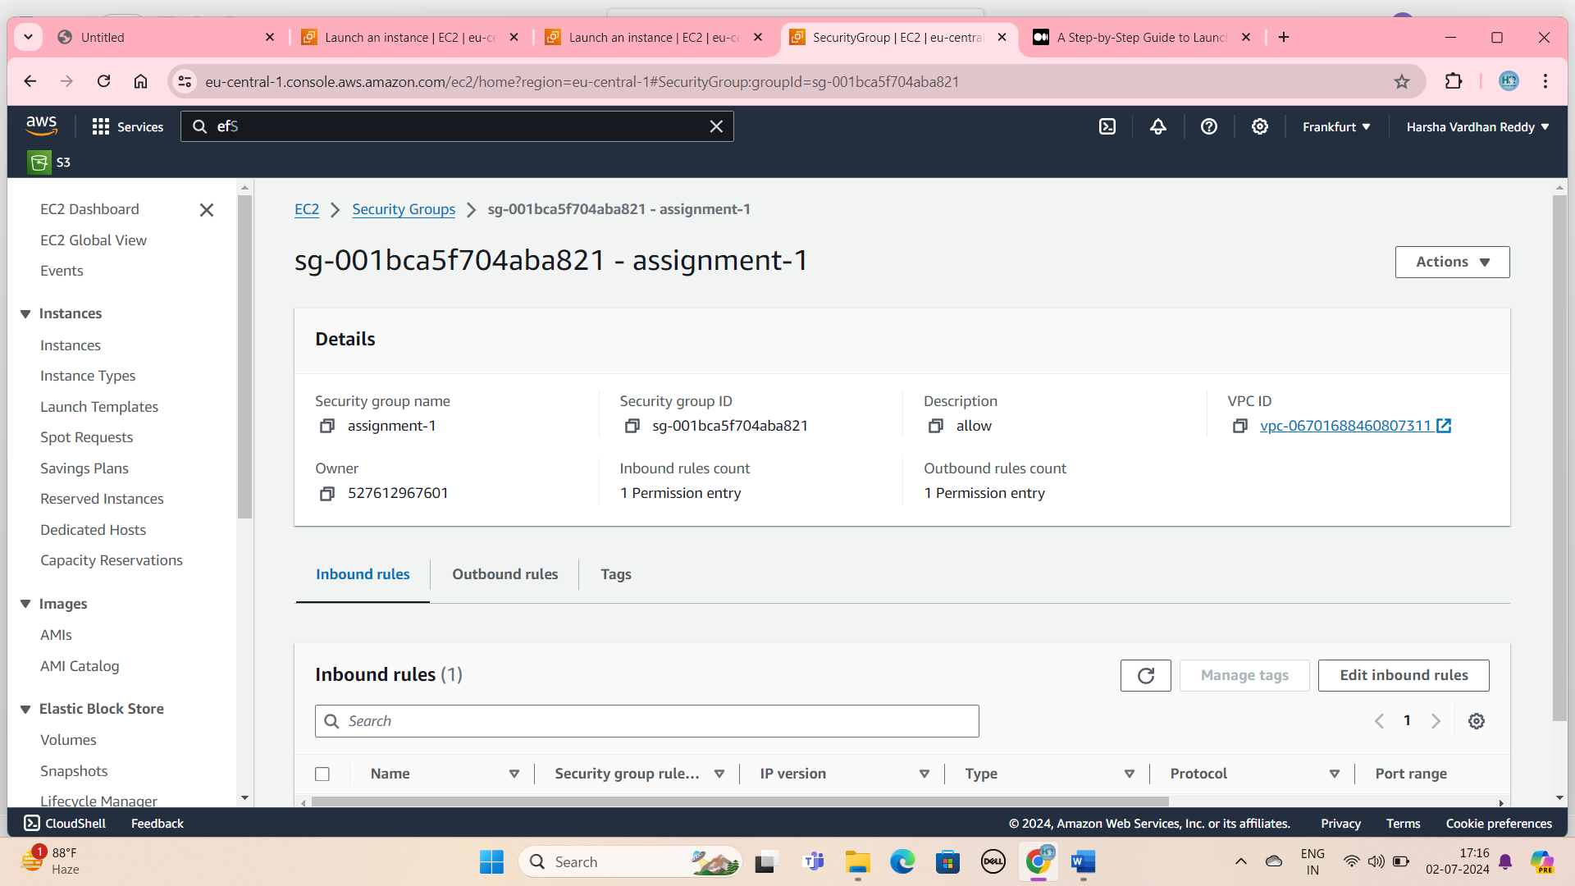

**Create security group**

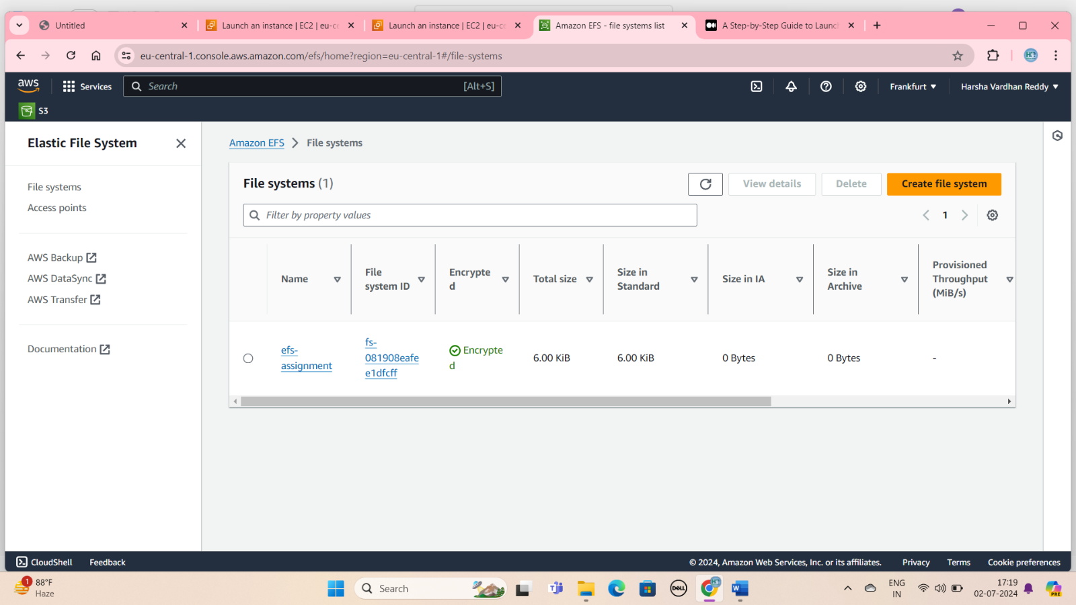

## EFS create file system

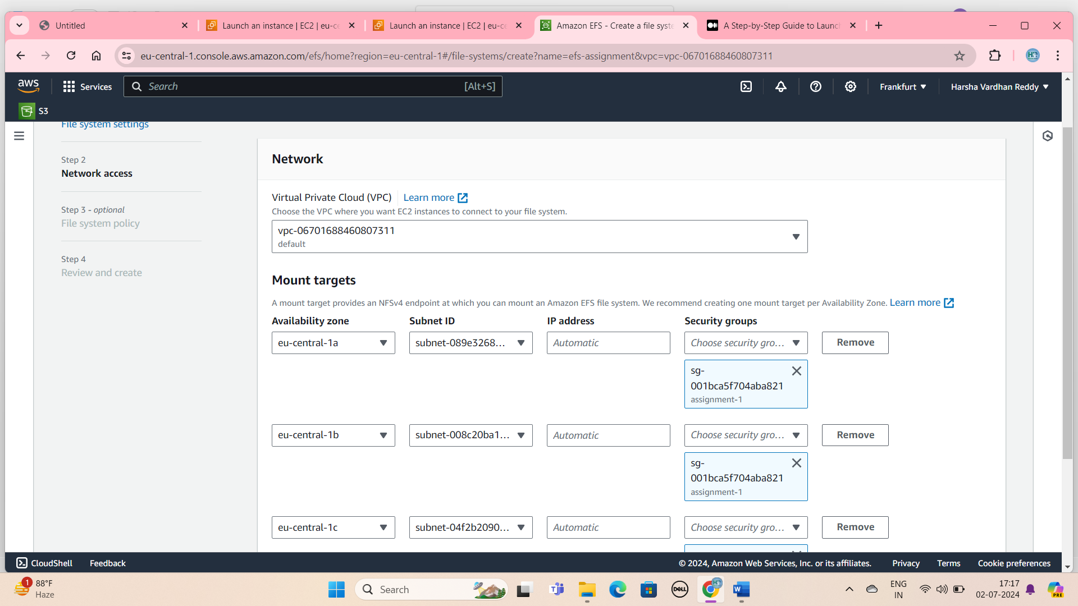

## Mount targets & update create security group is apply

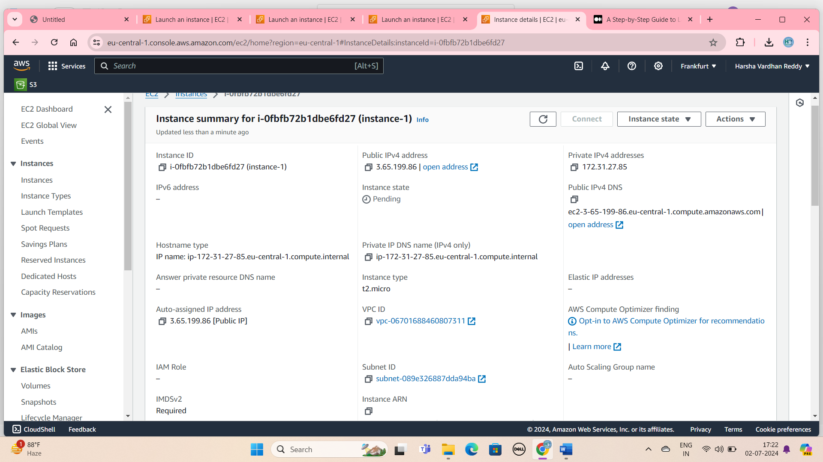

## First ec2 instance is add to the efs and security group

OUTPUT:

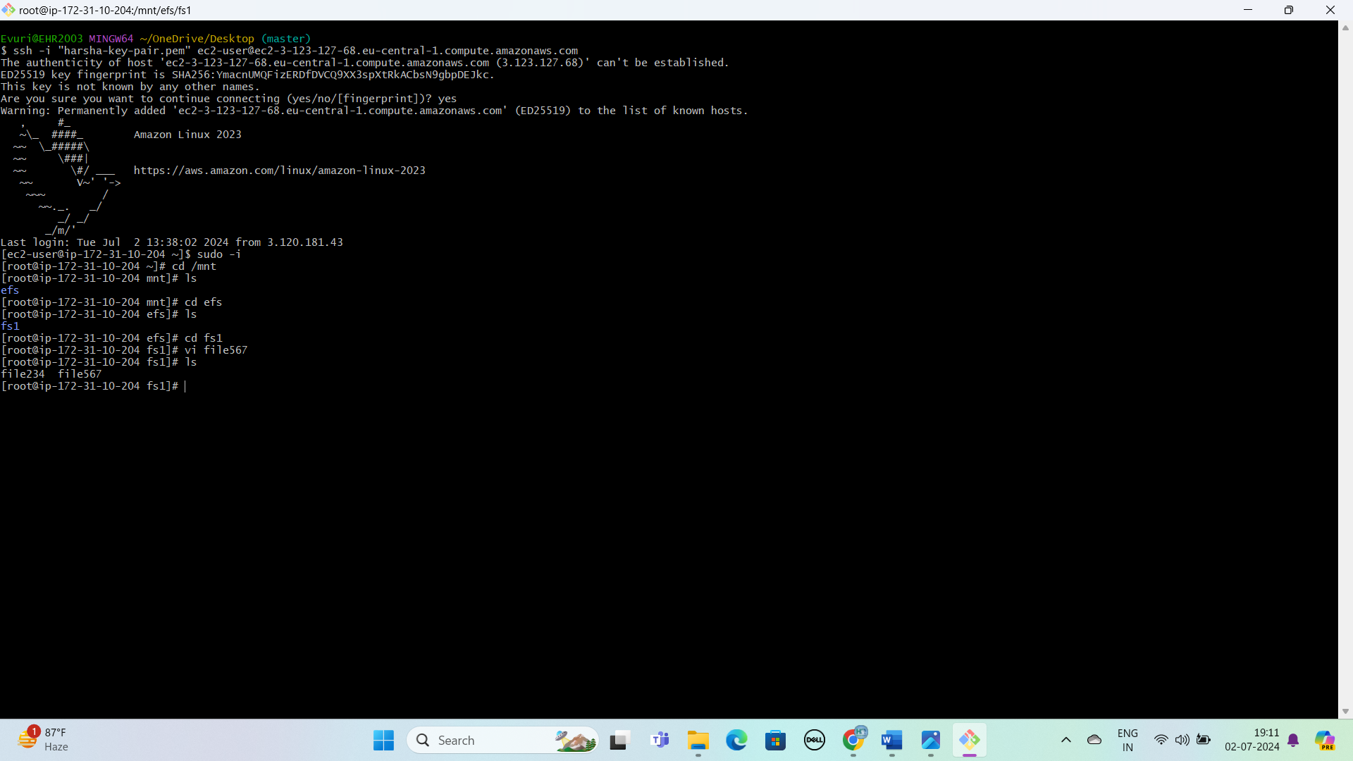

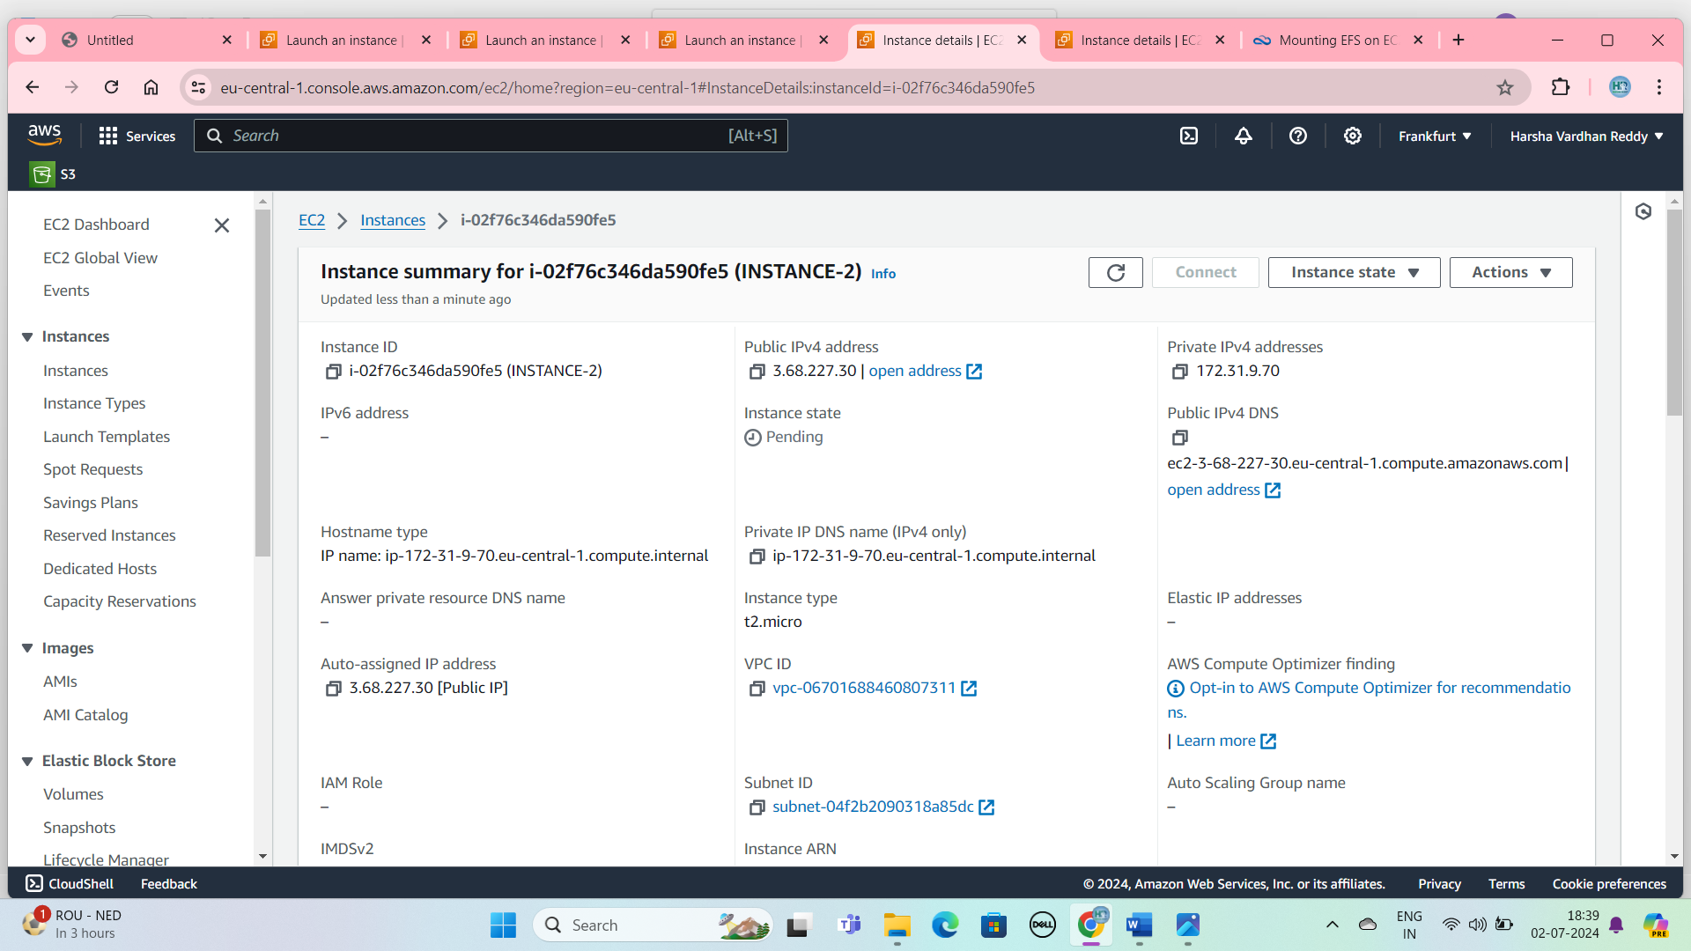

Second ec2 instance

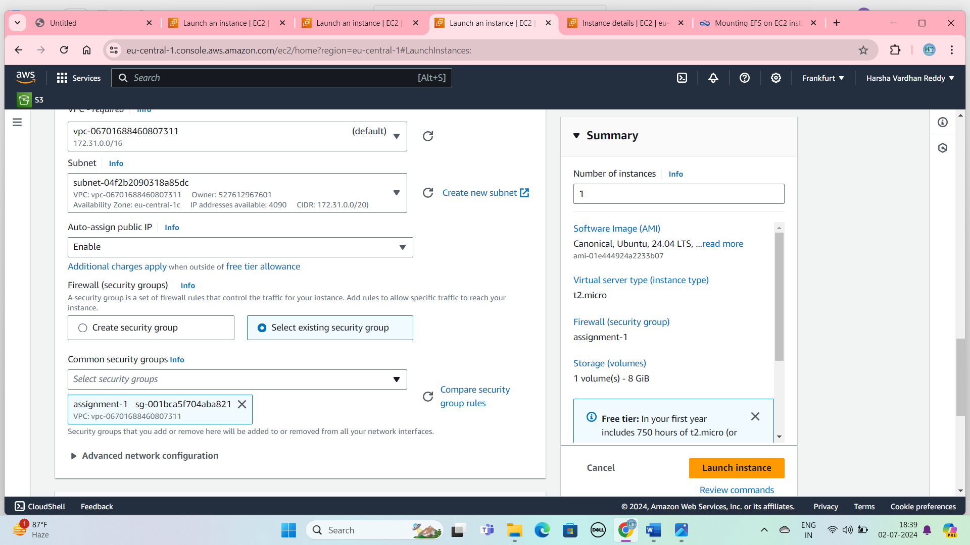

Second ec2 instance add the one efs security group

Output: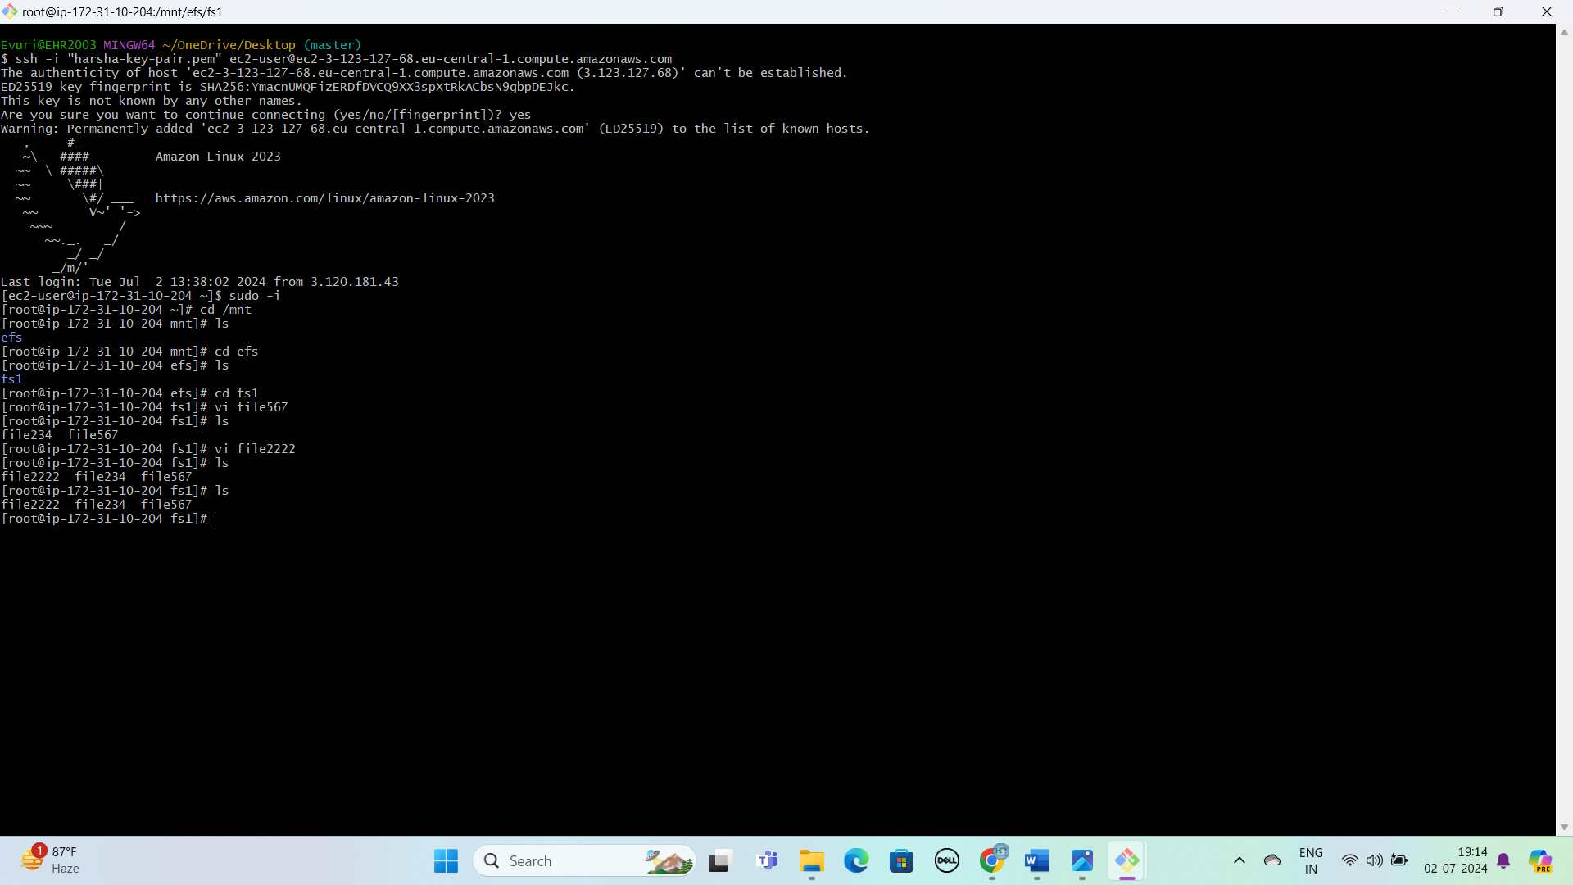

**B.Attach one EBS to two instance**

CREATE EBS PROCESS

Step1: First go to ec2 instance.

Step2: Elastic Block Store Select The Volumes.

Step3:Click The Create Volume Button.

## Step4:  Attach the EBS Volume to an Instance

## Step5: Click on “Actions” and select “Attach Volume”.

## Step6: create the ec2 instance.

## Step7:increase the volume. Go to “Actions”and select “modify Volume”.

## Step8: increase the Size and click on the Modify.

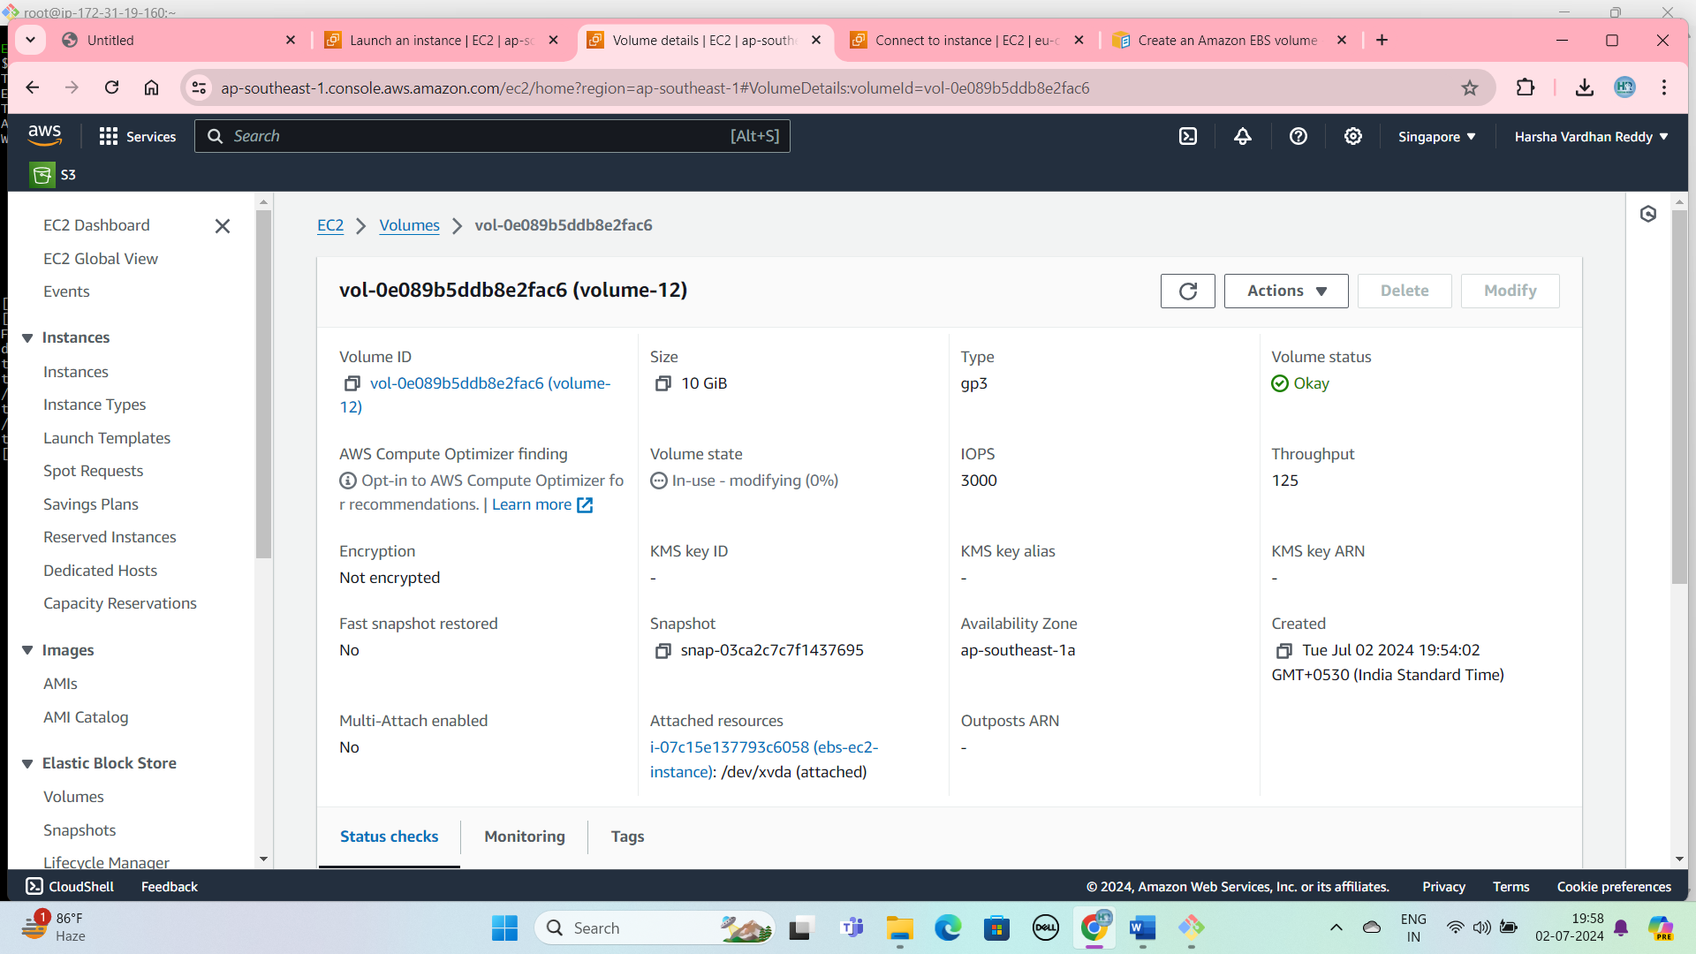

## Volume is created

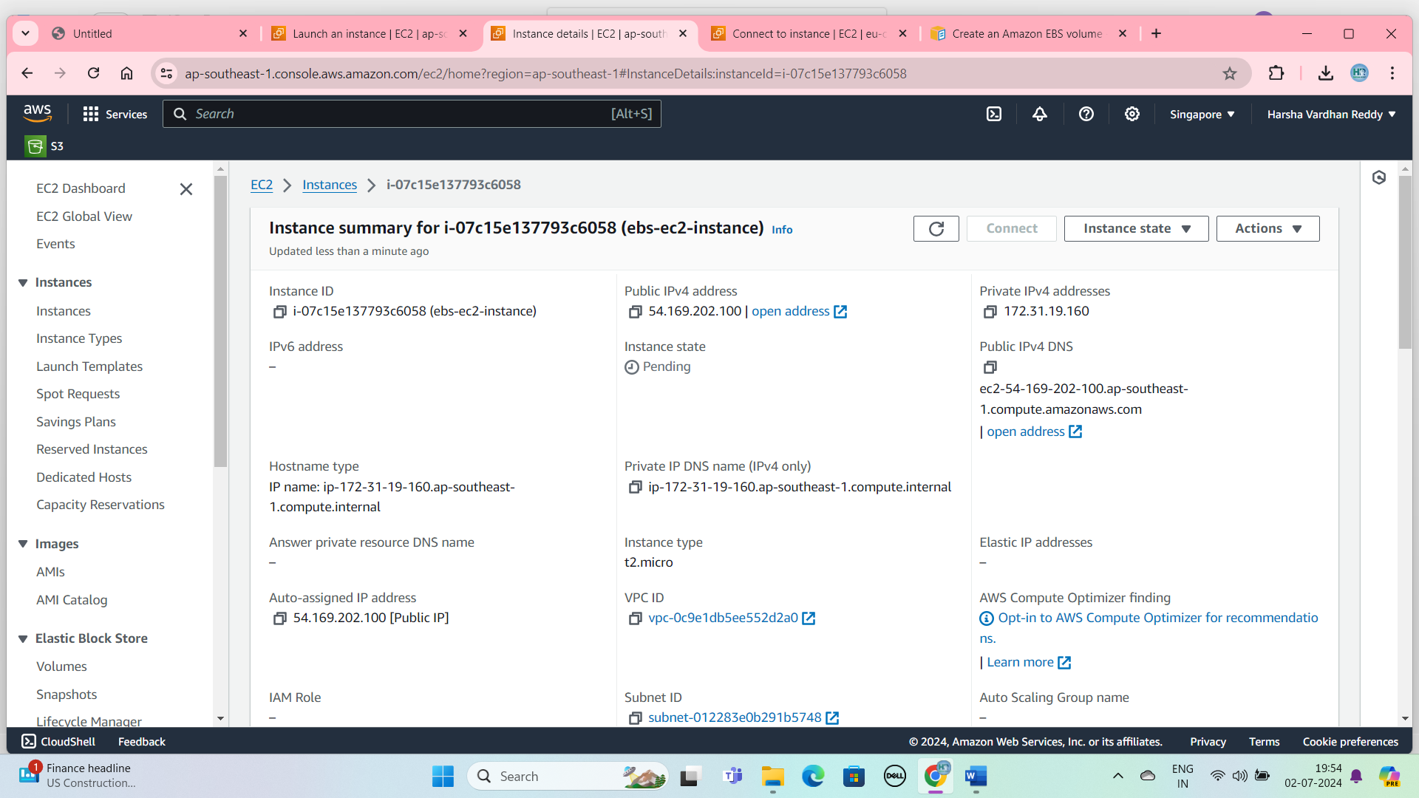

First Instance Is Create And Ebs Is Attach To Ec2

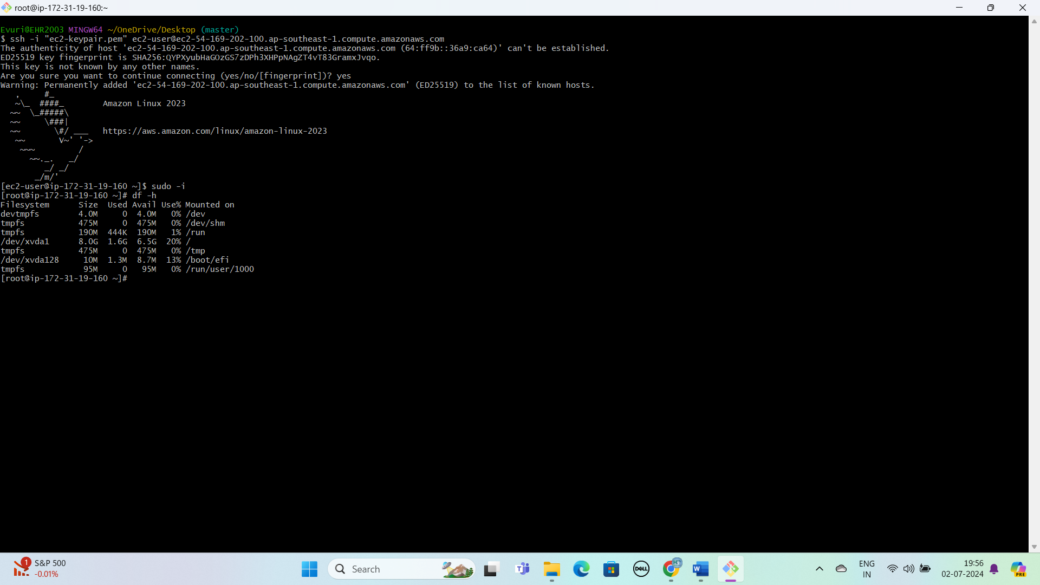

Before the increase the volume

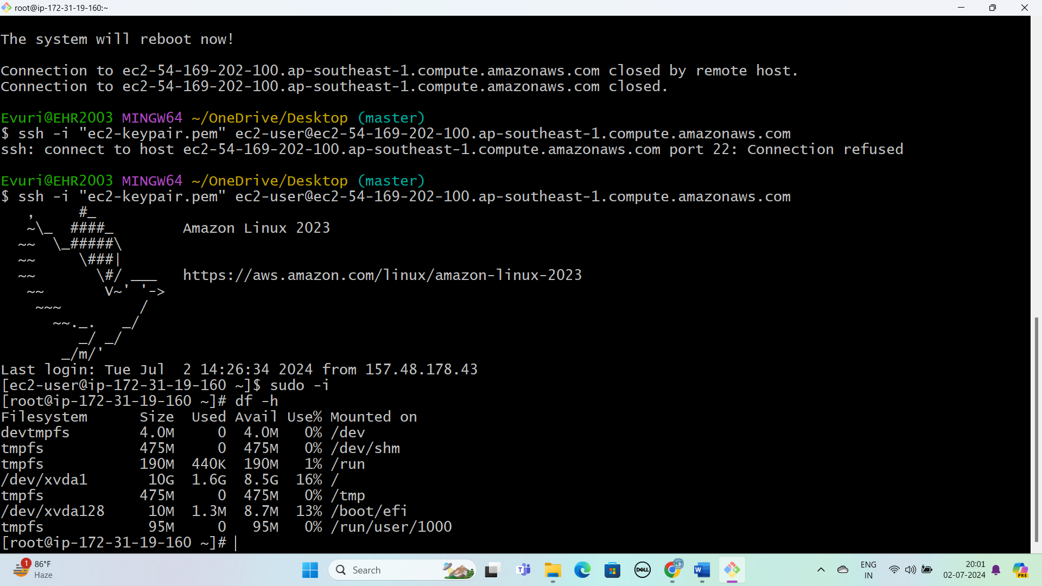

After the increase the volume

second ec2 instance is not connect reason are

* Two EC2 Instance Cannot Directly Connect To The Same EBS Volume Same Time Because EBS Volumes are designed to be mounted to single instance at any given time.
* An Ec2 Instance Can Connect to An EBS Volume If They are in the Same Avilability Zone ,But it Cannot Connect to an EBS Volume in a Different Availability Zone