ASSIGNMENT-2

SECURITY GROUPING

Step1: Go To Networking &security.

Step2: click on the “security Grouping”

Step3: create the security group

Step4: enter the name and inbound rule

Step5: lanch the security Group.

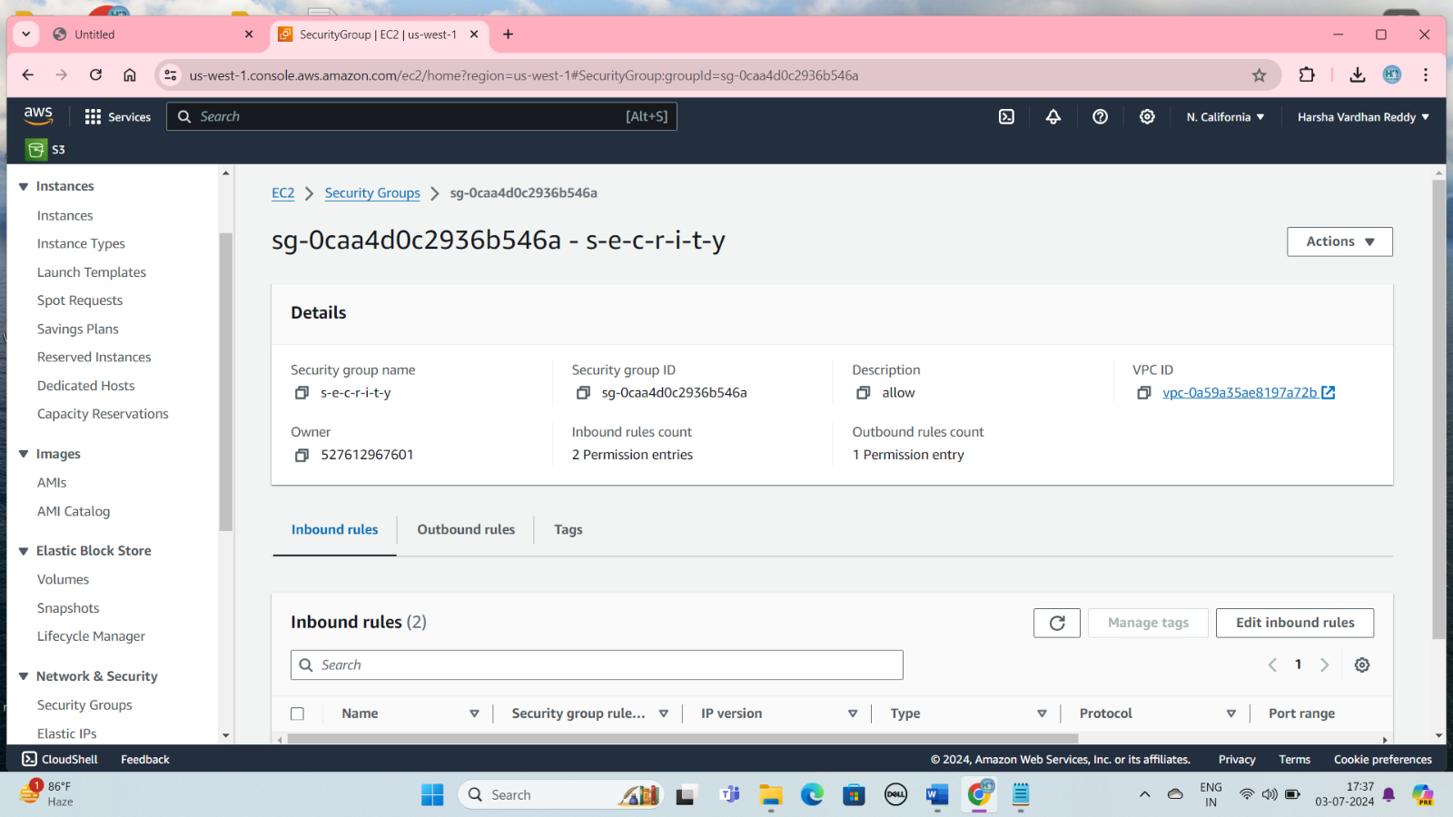

Create Three Instance

**Step 1: Sign in to the AWS Management Console**

**Step 2: Click On The Launch Instance**

**Step 3:  Provide a name of your instance**

**Step 4: Choose an Amazon Machine Image (AMI)**

**Step 5: Choose an Instance Type**

**Step 6: Create a key pair**

**Step 7: Configure Security Group**

**Step 8: Add Storage**

**Step 9: Review and Launch**

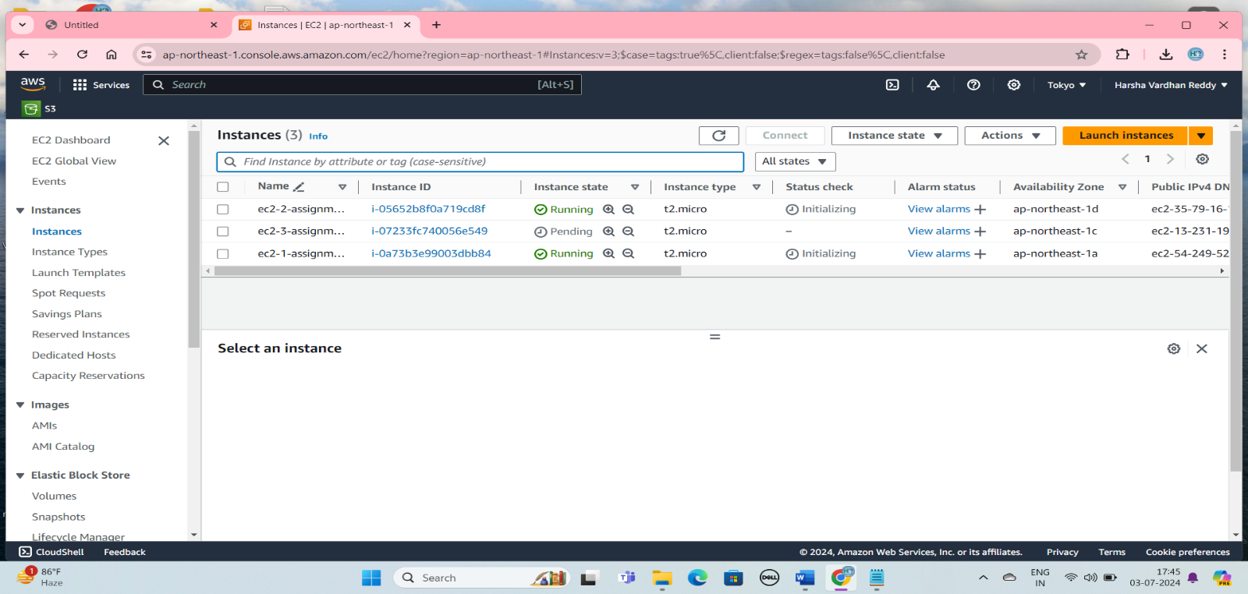

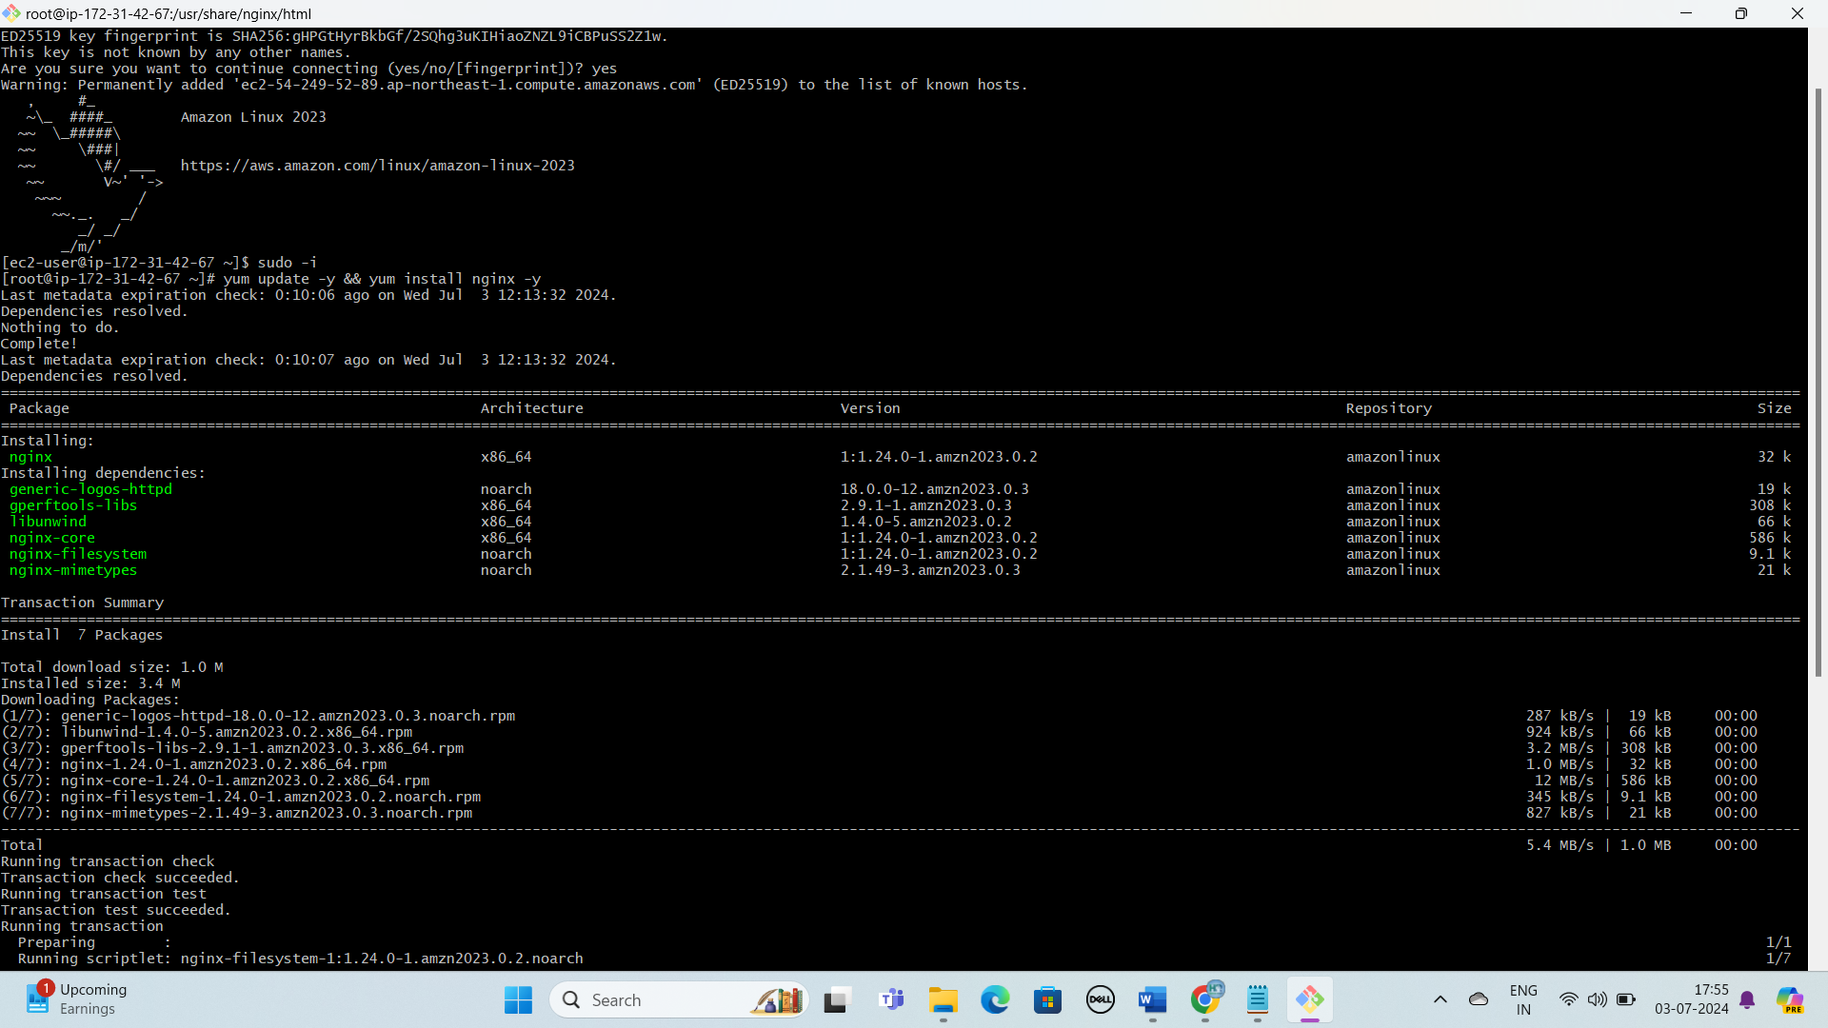

Install the nginx application in linux

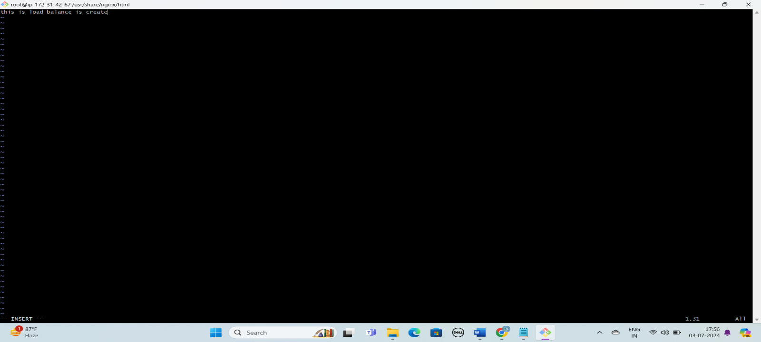

Create a vi file is create and enter command

**Create Application Load Balance**

**Step1:** Open the Amazon EC2 console

Step2: Go to load balancing

Step3: click the target groups and create the target groups

Step4:Below The Click The Include Ass Pending Button And Click The target group

Step4:Create the load Balance and Select The “Application Load Balance”.

Step5: Go to Network Mapping and select the availability zone. And select the security Group.

Step6:click on the create Load balancer

Step7:copy the DNS name

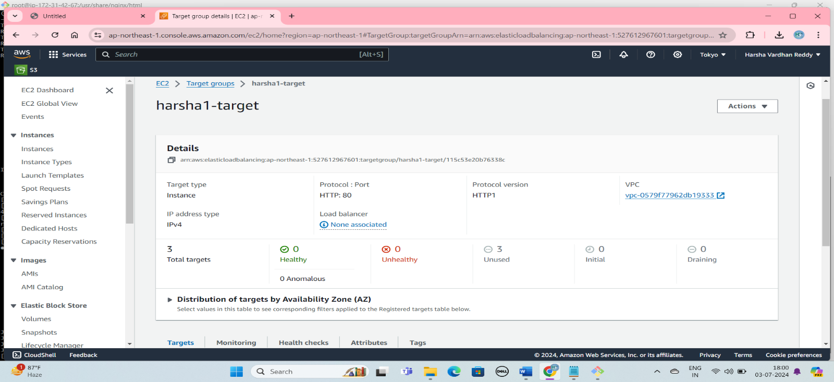

Target Group is create and launch the include as Pending below 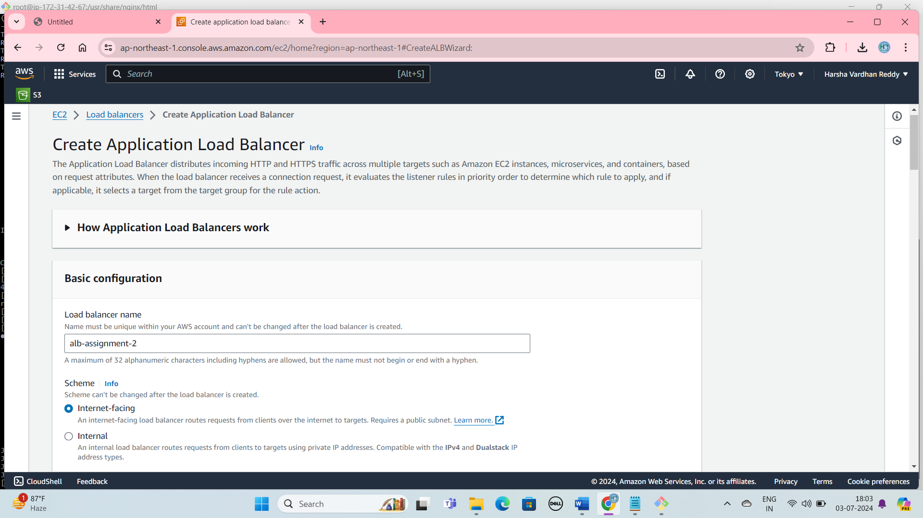

Create Application load Balancer

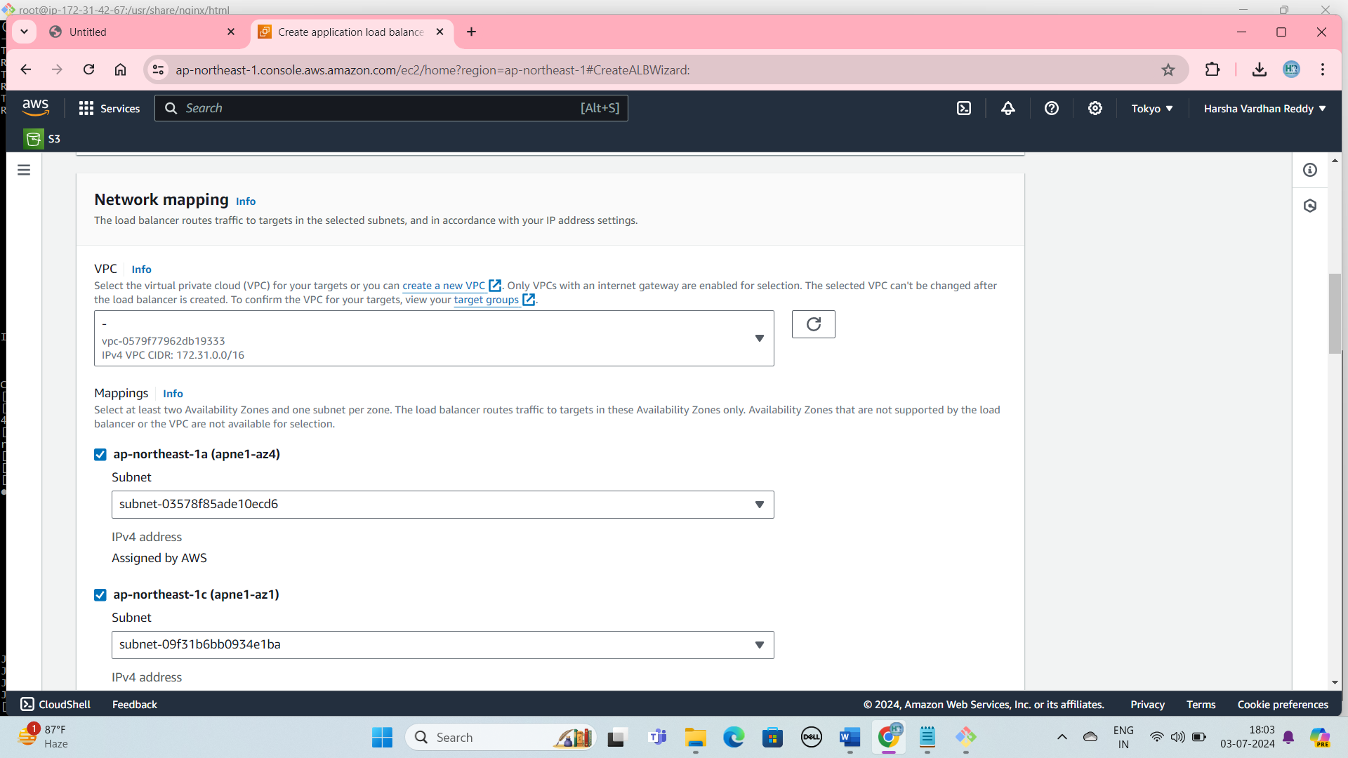

Network Mapping

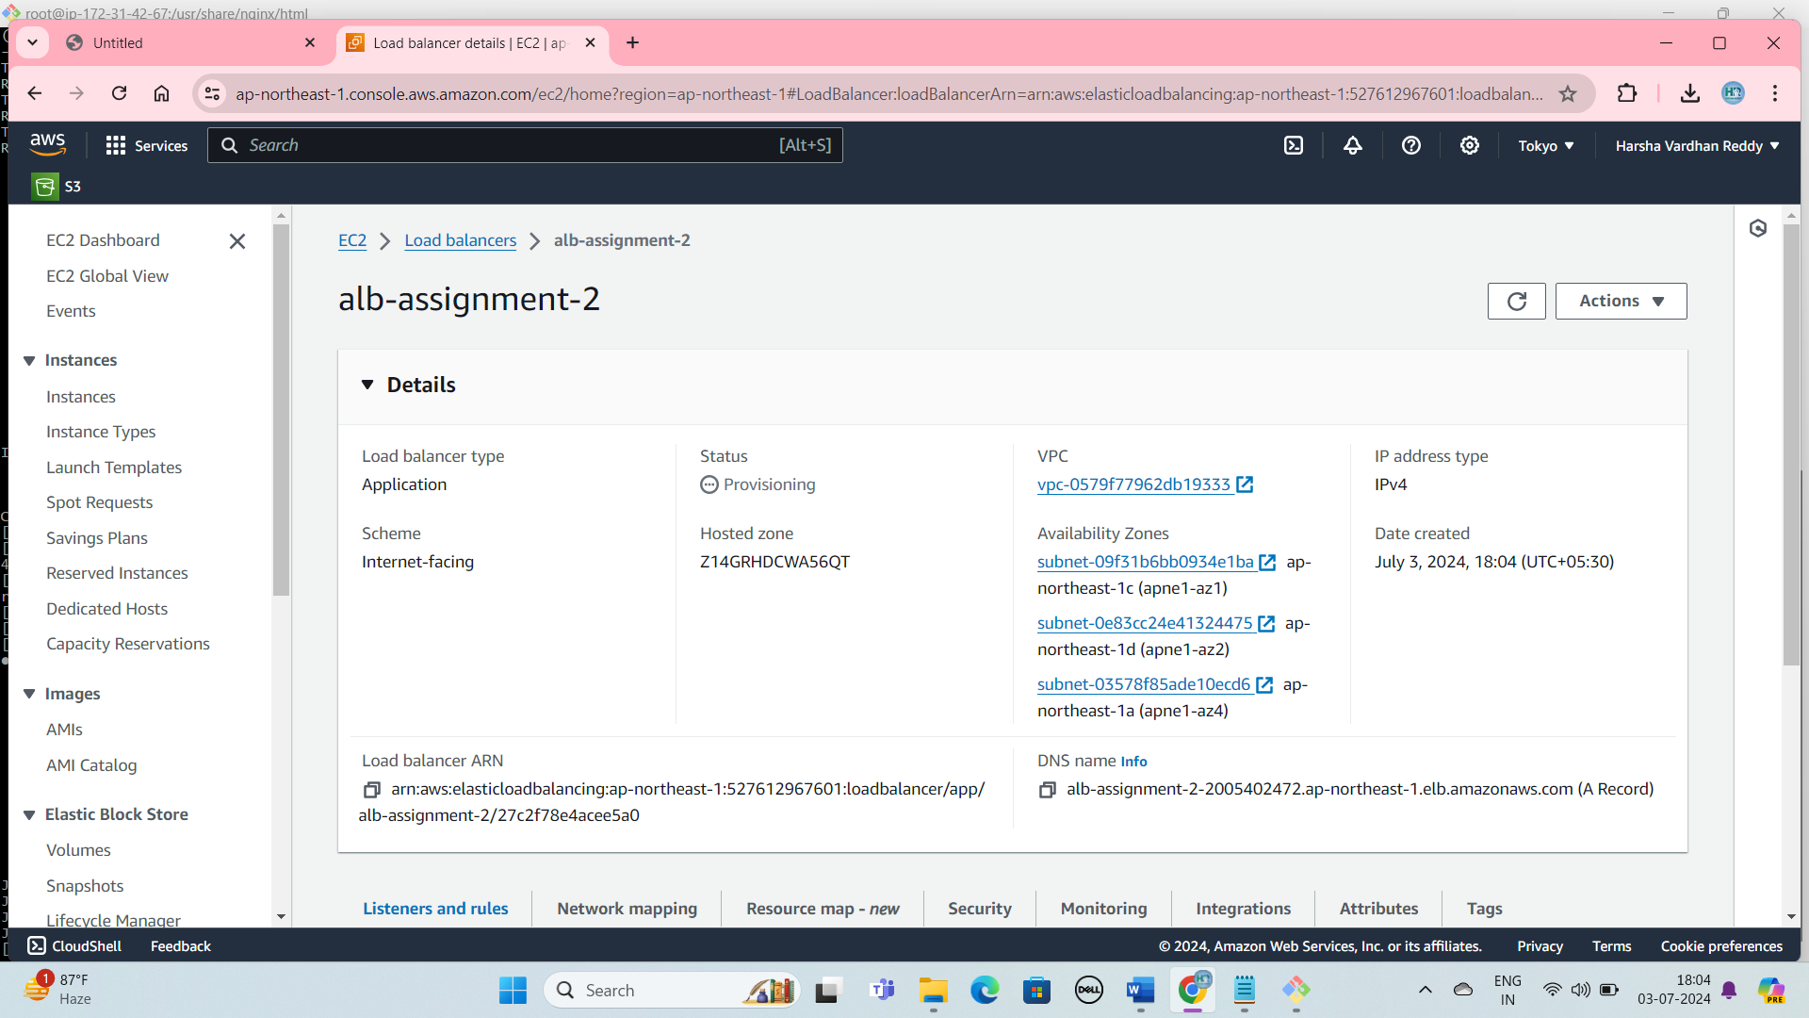

Create a load Balance