## Diffusion Tensor-Guided Docking (ELMDOCK)

This module performs a rigid-body docking of macromolecular complexes guided by experimental rotational diffusion tensors using the program ELMDOCK [7,8].

Caution: this part is currently designed only for 2-domain/component systems.

Please use the examples “diUb_AB_relax.txt” and “diUb_AB.pdb” to go through the process.

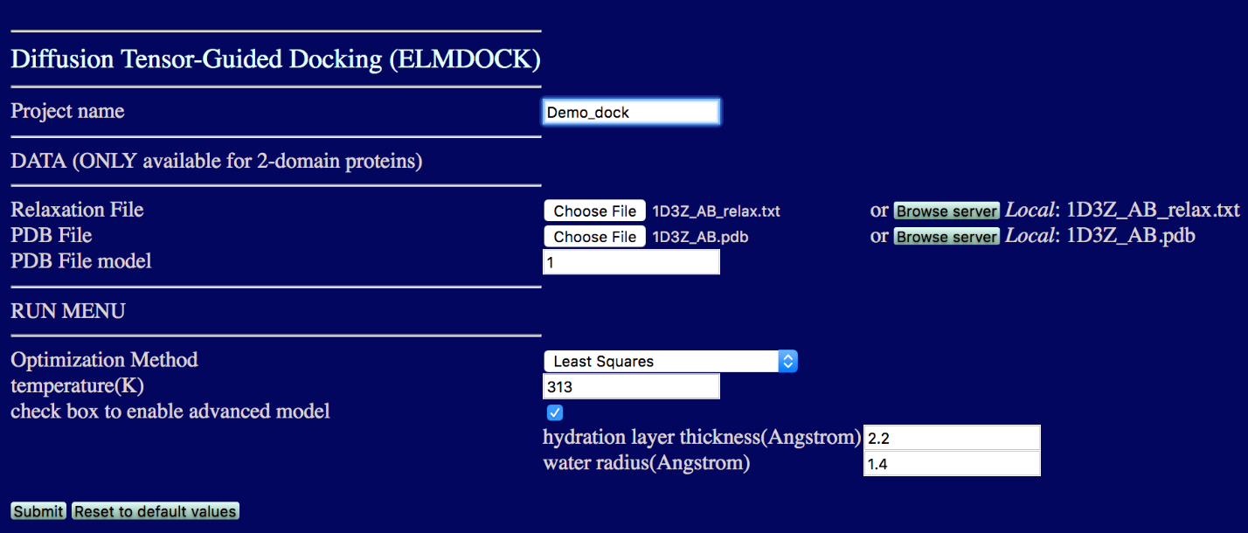

* **Project name:** The name of the folder to store all the results
* **Relaxation File:** Upload a text file containing spin relaxation data. The format of the data file is the same as spelled above in the ROTDIF & Dynamics Analysis, except that it has to contain data for two molecules (chainID), and the chainID letters must match those in the PDB file.
* **PDB File:** Upload the starting coordinate file to be used for the docking. The file must contain coordinates for both molecules (chainID) listed in the relaxation data file.
* **PDB File model:** If the coordinate file contains more than one structural model, please specify the model you want to analyze. The default model number is 1.
* **Temperature:** The desired temperature (in K) of the aqueous medium. The value of the temperature could vary from complex to complex and might need to be adjusted to avoid steric clashes. For the diUb_AB example provided we suggest 301 K
* **Advanced model:** As in the ELM Predictor, these options are designed for advanced adjustment of the hydration layer thickness and the water radius. It is recommended that you use the default values.

After you uploaded all the files, click the Submit button. You can download the following 3 files after the docking is finished.

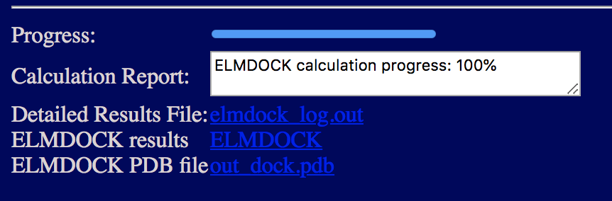

* **Detailed Results File:** elmdock_log.out. This file contains the records of all the details.
* **ELMDOCK results:** ELMDOCK. This file contains the following information on the found solutions:

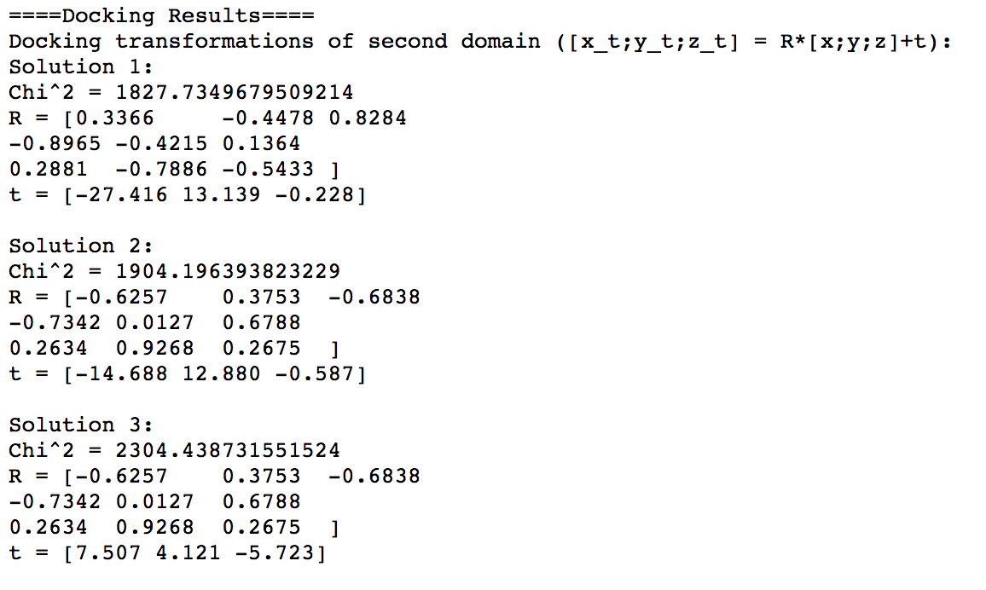

* **ELMDOCK PDB file:** out_dock.pdb. After the docking is completed ELMDOCK will start *Jmol* viewer that allows you to visualize the results. Alternatively, you can download this coordinate file and view it in a molecular viewing program. Here is the view from PyMol. The temperature is set to be 301K.

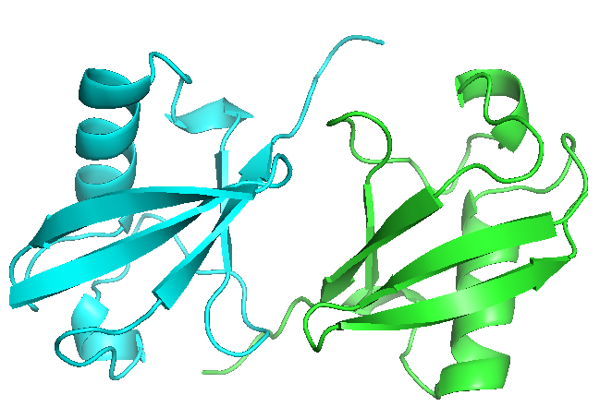

# Exercise

This exercise includes diffusion-guided rigid-body docking of two ubiquitin molecules using 15N relaxation data for K48-linked di-ubiquitin [7, 9]. Use files “diUb_AB.pdb” (starting coordinates) and “diUb_AB_relax.txt” (relaxation data) to run ELMDOCK. (Note that diUb_AB.pdb contains two arbitrarily positioned ubiquitin molecules. The atom coordinates for each ubiquitin molecule are from PDB ID 1D3Z)

# References:

1. O. Walker, R. Varadan, D. Fushman,”Efficient and accurate determination of the overall rotational diffusion tensor of a molecule from 15N relaxation data using computer program ROTDIF,” J. Magn. Reson. (2004) 168, 336-345.

2. K. Berlin, A. Longhini, T. K. Dayie, D. Fushman, “Deriving Quantitative Dynamics Information for Proteins and RNAs using ROTDIF with a Graphical User Interface”, J Biomol NMR (2013) 57, 333-352.

3. D. Fushman, S. Cahill, D. Cowburn, “The main chain dynamics of the dynamin Pleckstrin Homology (PH) domain in solution: Analysis of 15N relaxation with monomer/dimer equilibration,” J. Mol. Biol. 266 (1997) 173-194.

4. J. B. Hall, and D. Fushman, “Characterization of the overall and local dynamics of a protein with intermediate rotational anisotropy: Differentiating between conformational exchange and anisotropic diffusion in the B3 domain of protein G,“ J. Biomol. NMR (2003) 27, 261-275.

5. J. B. Hall, D. Fushman, “Variability of the 15N chemical shielding tensors in the B3 domain of protein G from 15N relaxation measurements at several fields. Implications for backbone order parameters,” J. Am. Chem. Soc. (2006) 128, 7855-70.  
6. Y. Ryabov, C. Geraghty, A.Varshney, D. Fushman, “An efficient computational method for predicting rotational diffusion tensors of globular proteins using an ellipsoid representation,” J. Am. Chem. Soc. (2006) 128, 15432-15444.

7. Y. Ryabov, D. Fushman, “Structural assembly of multidomain proteins and protein complexes guided by the overall rotational diffusion tensor,” J. Am. Chem. Soc. (2007) 129, 7894-7902.

8. K. Berlin, D. P. O’Leary, D. Fushman, “Fast Approximations of the Rotational Diffusion Tensor and their Application to Structural Assembly of Molecular Complexes”, Proteins (2011) 79, 2268-2281.

9. R. Varadan, O. Walker, C. Pickart, D. Fushman, “Structural properties of polyubiquitin chains in solution,” J. Mol. Biol. (2002) 324, 637-647

10. D. Fushman, R. Ghose, D. Cowburn, “The effect of finite sampling on the determination of orientational properties: A theoretical treatment with application to interatomic vectors in proteins,” J. Am. Chem. Soc. 122 (2000) 10640-9

11. D. Fushman, “Determining protein dynamics from 15N relaxation data by using DYNAMICS”, in Protein NMR Techniques, Third Edition, Eds. A. Shekhtman, D. S. Burz; Methods in Molecular Biology, 2012, Volume 831, 485-511, Springer Science, DOI: 10.1007/978-1-61779-480-3_24. PubMed: PMC4361738

12. R. C. Weast, Handbook of Chemistry and Physics, 59th ed.; CRC Press: West Palm Beach, FL, 1978.