## Diffusion Tensor Prediction Module (ELM)

This module performs *ab initio* prediction of the rotational diffusion tensor of a macromolecule directly from the atom coordinates using an ellipsoid model (ELM) representation [6].

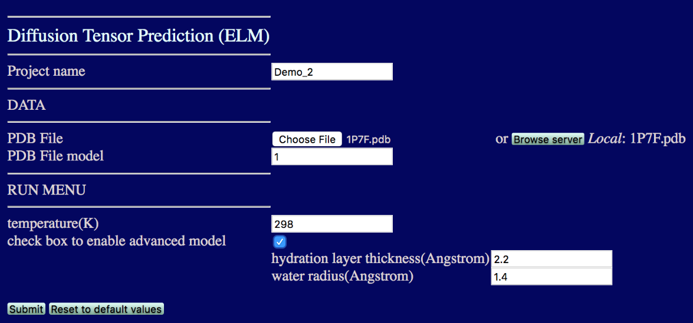

* **Project name:** The name of the folder to store all the results
* **PDB File:** Upload the coordinate file to be used for diffusion tensor prediction
* **PDB File model:** If the coordinate file contains more than one structural model, please specify the model you want to analyze. The default model number is 1.
* **temperature:** The desired temperature (in K) of the aqueous medium. Please note that the program assumes that molecule of interest is tumbling in water, and the empirical formula for the water viscosity used here [6, 12] is valid in the range from 273K to 373 K.
* **check box to enable advanced model:** These options are designed for advanced adjustment of the hydration layer thickness and the water radius. It is recommended that you use the default values.

Click . After the progress has completed, you should be able to see and download a file “ELM prediction” containing the output of the diffusion tensor prediction.

It looks like:

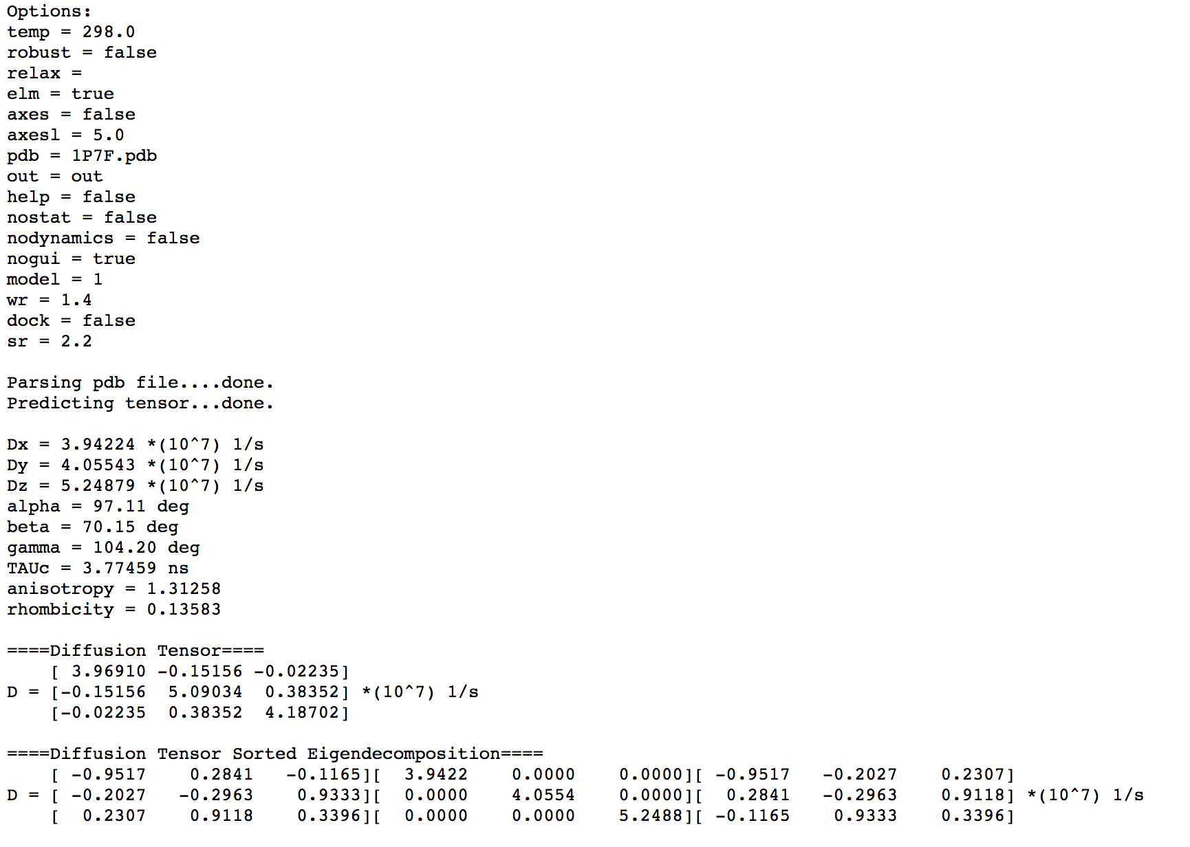

# Exercise

This exercise includes prediction of the rotational diffusion tensor for the B3 domain of protein G (GB3). Use coordinate file “1P7F.pdb” to run the ELM module.

# References:

1. O. Walker, R. Varadan, D. Fushman,”Efficient and accurate determination of the overall rotational diffusion tensor of a molecule from 15N relaxation data using computer program ROTDIF,” J. Magn. Reson. (2004) 168, 336-345.

2. K. Berlin, A. Longhini, T. K. Dayie, D. Fushman, “Deriving Quantitative Dynamics Information for Proteins and RNAs using ROTDIF with a Graphical User Interface”, J Biomol NMR (2013) 57, 333-352.

3. D. Fushman, S. Cahill, D. Cowburn, “The main chain dynamics of the dynamin Pleckstrin Homology (PH) domain in solution: Analysis of 15N relaxation with monomer/dimer equilibration,” J. Mol. Biol. 266 (1997) 173-194.

4. J. B. Hall, and D. Fushman, “Characterization of the overall and local dynamics of a protein with intermediate rotational anisotropy: Differentiating between conformational exchange and anisotropic diffusion in the B3 domain of protein G,“ J. Biomol. NMR (2003) 27, 261-275.

5. J. B. Hall, D. Fushman, “Variability of the 15N chemical shielding tensors in the B3 domain of protein G from 15N relaxation measurements at several fields. Implications for backbone order parameters,” J. Am. Chem. Soc. (2006) 128, 7855-70.  
6. Y. Ryabov, C. Geraghty, A.Varshney, D. Fushman, “An efficient computational method for predicting rotational diffusion tensors of globular proteins using an ellipsoid representation,” J. Am. Chem. Soc. (2006) 128, 15432-15444.

7. Y. Ryabov, D. Fushman, “Structural assembly of multidomain proteins and protein complexes guided by the overall rotational diffusion tensor,” J. Am. Chem. Soc. (2007) 129, 7894-7902.

8. K. Berlin, D. P. O’Leary, D. Fushman, “Fast Approximations of the Rotational Diffusion Tensor and their Application to Structural Assembly of Molecular Complexes”, Proteins (2011) 79, 2268-2281.

9. R. Varadan, O. Walker, C. Pickart, D. Fushman, “Structural properties of polyubiquitin chains in solution,” J. Mol. Biol. (2002) 324, 637-647

10. D. Fushman, R. Ghose, D. Cowburn, “The effect of finite sampling on the determination of orientational properties: A theoretical treatment with application to interatomic vectors in proteins,” J. Am. Chem. Soc. 122 (2000) 10640-9

11. D. Fushman, “Determining protein dynamics from 15N relaxation data by using DYNAMICS”, in Protein NMR Techniques, Third Edition, Eds. A. Shekhtman, D. S. Burz; Methods in Molecular Biology, 2012, Volume 831, 485-511, Springer Science, DOI: 10.1007/978-1-61779-480-3_24. PubMed: PMC4361738

12. Weast, R. C. Handbook of Chemistry and Physics, 59th ed.; CRC Press: West Palm Beach, FL, 1978.