What’s an N.E.S Anyway?
An N.E.S, or Non-linear Energy Sink, is a general term for any device that when added to a system takes some of the input energy to one part of a system and transfers it to another, lower-energy part of the system (the sink) to be dissipated. In more scientific terms, an N.E.S is a device that takes lower frequency, higher amplitude vibrations and converts them into higher frequency, lower amplitude vibrations. This conversion is often advantageous and therefore desired in many mechanical systems, as it provides two simultaneous benefits;

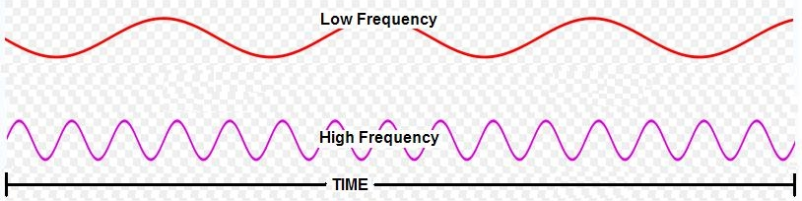

Higher frequency vibrations can be dissipated much more quickly and efficiently than lower frequency vibrations, and lower amplitude vibrations generally put less mechanical stress on a system than higher amplitude vibrations.


High Frequency, Low Amplitude
Low Frequency, High Amplitude


Which would you rather swim through?

How Do You Make an N.E.S?

How an N.E.S is created/implemented in a given system depends entirely on the specifics of that system. In the simulations on this website, the N.E.S is a small mass attached to the center of the sprung cylinder that is allowed to rotate freely around the cylinder.

