……………………………………………………………………………………………………….

Setting Up the Problem
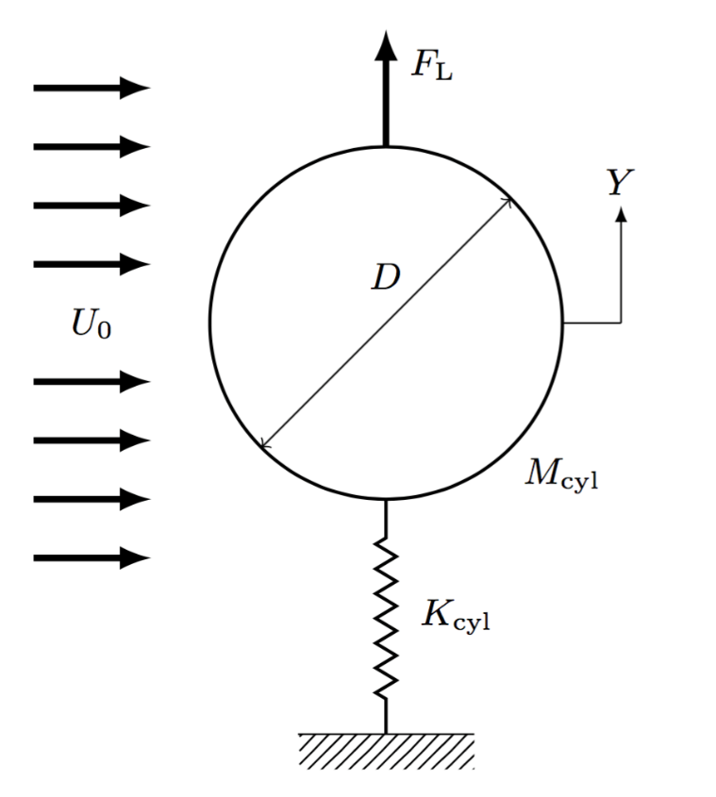
In an experiment, the cylinder necessarily has a nonzero length in the z-direction. Even though the cylinder seems like a two-dimensional body, there are two potentially important sources of three-dimensionality in the flow. First, if a particular dimensionless parameter called the “Reynolds number” (defined below) is too large, the flow will be “turbulent,” and necessarily three-dimensional. Second, if the cylinder ends at walls, there will be three-dimensional effects even if the flow is not turbulent, because the flow near the central span of the cylinder will be different than the flow near the walls. This three-dimensionality persists up to ratios of the cylinder length to the cylinder diameter as high as 75.
But three-dimensional computations are much more complex, and consume significantly more computational resources and are beyond the scope of what is practical for a website like ours. So in what follows, we consider two-dimensional flow, which reveals most of the important aspects at a more reasonable computational cost.
Now, to perform these simulations, we must do two things to set up the problem.
First, we need equations that describe the fluid motion. For the flow of a fluid with constant density and viscosity, the appropriate equations are the so-called “Incompressible” Navier-Stokes equations, which can be written in two dimensions as
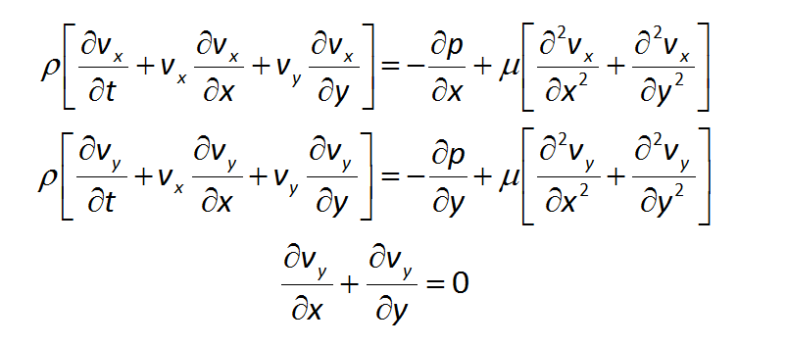

This is a system of simultaneous nonlinear, partial differential equations where the fluid density issρ and the viscosity issμ. Herest,sx, andsy are the time and thesx- andsy-coordinates,sv_{x} andsv_{y} are thesx- andsy-components of the velocity vector, andsp is the pressure. The first two equations are versions of Newton’s Second Law (F=ma) for a fluid, whereas the third equation ensures that mass is conserved.

Second, we must write down the equation of motion for the cylinder. Using Newton’s second law and the picture above, we obtain
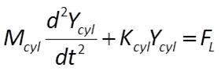

Next, the two-dimensional Navier-Stokes equations should be nondimensionalized. We do this by defining new variables that relate dimensional quantities (e.g., velocity, with dimensions of length per unit time and units of, say, feet per second) to dimensionless parameters, which have no units or dimensions.
In these equations, we have six dimensional parameters
space
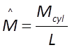
wheresM_{cyl}sandsL are the mass and length of the cylinder in the z-direction
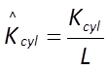
wheresK_{cyl} is the spring constant of the cylinder and 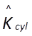 has dimensions of mass / (time² . length)
U₀ - The upstream fluid velocity, with dimensions of length / time
D - The diameter of the cylinder, with dimensions of length
μ - Viscosity of the fluid, with dimensions of mass / (length . time)
ρ - Density of the fluid, with dimensions of mass / length³
space
and seven dimensional variables
space
v_{x}(x,y,t) , v_{y}(x,y,t) - The x- and y- components of the fluid velocity, with dimensions of length / time
p(x,y,t) - Pressure in the fluid, with dimensions of mass / (length . time²)
x , y - Cartesian coordinates, with dimensions of length
t - time, with dimensions of time
Y_{cyl} - Vertical displacement of the cylinder, with dimensions of length

By the “Buckingham Pi Theorem”, we select three of our dimensional parameters whose dimensions “span the space” of the three “fundamental dimensions” (mass, length, and time), and use them to represent the dimensional variables.
Here, we selectsD,sρ, andsμ as our scaling variables and, after doing some quick dimensional analysis, define our dimensionless parameters
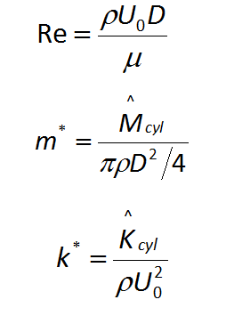
and variables
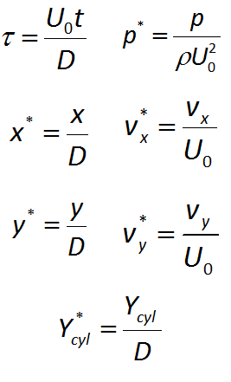

where Re is the symbol for Reynolds number
m*= dimensionless mass
k*= dimensionless spring constant
sτ = dimensionless time
Y_{cyl}* = dimensionless vertical displacement
p* = dimensionless pressure
v_{x}* , v_{y}* = dimensionless fluid velocities
x* , y* = dimensionless x- and y-coordinates
space
With these dimensionless parameters and variables, the two-dimensional incompressible Navier-Stokes equations can be nondimensionalized!
space
For more on nondimensionalization:
https://en.wikipedia.org/wiki/Nondimensionalization
https://en.wikipedia.org/wiki/Buckingham_%CF%80_theorem
https://en.wikipedia.org/wiki/Dimensional_analysis
……………………………………………………………………………………………………….

