Teaching Statement

Teaching philosophy – Entomology, insect biodiversity and conservation provide key gateways for organizing learning opportunities that promote student interest in solving environmental and societal challenges. Fundamental to my teaching philosophy is the need for students to gain experience outside of the classroom, deepening experiential learning by providing students with opportunities to apply knowledge attained in classrooms, make observations, and develop questions which will drive their curiosity for intellectual gains. The second tenet of my teaching philosophy is the importance of peer-to-peer teaching. Here, I will seek opportunities for undergraduate students to gain instruction experience, springboarding their careers as educators and communicators. More broadly, my research views conservation and biodiversity through socio-ecological lenses. Thus, the third component of my philosophy is to offer interdisciplinary training that enables students to tackle the complex challenges of today and the future.

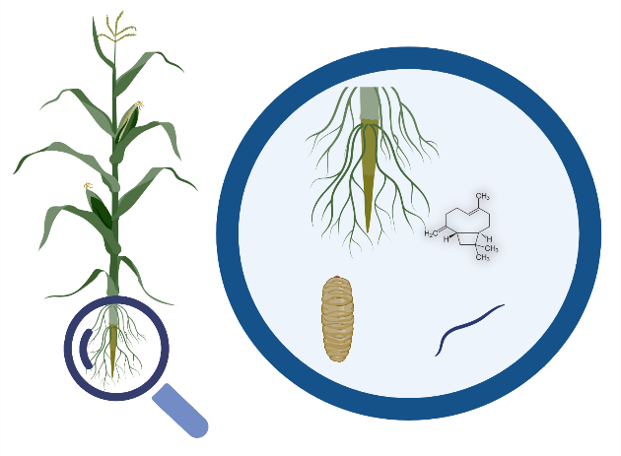
Advanced training - I recently trained in Scientific Teaching, a rigorous pedagogical approach, and developed a lesson plan on plant-pest-predator interactions (Fig. 1). In the lesson students explain how plants use chemical defenses to protect themselves from herbivores and design a descriptive model. This lesson plan demonstrates my pedagogical interests and will be published in the second edition of Scientific Teaching by Diane Ebert May.

Curriculum – I am qualified to instruct foundational curriculum in quantitative ecology; data carpentry, modeling, statistics, and coding; and insect ecology. I am also eager to develop courses in conservation through the lens of socio-ecological modeling.
Figure 1. Example of components used for instructing students in modeling, a transferrable skill that students apply across the sciences.

Advanced Coursework
Insect Ecology in a Changing World: International initiatives to conserve global biodiversity signal the need for training the next generation of students in approaches that promote insects under globally changing abiotic, biotic, and societal pressures. In the lecture section, students will gain foundational competencies in insect biodiversity quantification, spatial configuration, and long-term status and future trends. Moreover, I will invite guest speakers representing leaders in conservation for insects including the Xerces Society, demonstrating employment opportunities in conservation. Lecture curriculum will be complemented by laboratory sections conducted in the field with a focus on plant-insect interactions; application of biodiversity theory; and the role of insects in food webs. Students will interact with land managers to gain experiences in stakeholder-driven research, conduct co-created experiments that leverage methods from observational techniques to molecular toolkits, contribute to insect community science projects, and extend research to the public, gaining information delivery skills.

Human-nature Interactions: My course in socio-ecological modeling will bridge the theoretical foundations of the social and ecological sciences. Lecture topics will highlight computational approaches, including agent-based modeling. Laboratory sections will focus on stakeholder engagement, including survey instrument design, semi-structured interviews, and policy development. Students will leverage spatially referenced datasets to build socio-ecological models coupling insect macroecology and human behavior. Taken together, my instruction will offer an education distinguished by interdisciplinary curriculum, where students gain tools needed to tackle the complex, evolving social and ecological challenges of today, and the future.

