1. 

The rate of change of free enzyme E is given by:



The rate of change of substrate S is given by:



The rate of change of enzyme-substrate complex ES is given by:



The rate of change of product P is given by:



1. The code is as follows:
2. import numpy as np
3. import matplotlib.pyplot as plt
4. *# Define the rate constants*
5. k1 = 100  *# 1/min/µM*
6. k2 = 600  *# 1/min*
7. k3 = 150  *# 1/min*
8. *# Define the initial concentrations*
9. E0 = 1    *# µM*
10. S0 = 10   *# µM*
11. ES0 = 0
12. P0 = 0
13. *# Define the time step and simulation duration*
14. dt = 0.001   *# min*
15. t_max = 0.5   *# min*
16. *# Define the initial conditions*
17. y0 = np.array([E0, S0, ES0, P0])
18. *# Define the function*
19. def f(t, y):
20. E, S, ES, P = y
21. dEdt = -k1*E*S + k2*ES + k3*ES
22. dSdt = -k1*E*S + k2*ES
23. dESdt = k1*E*S - k2*ES - k3*ES
24. dPdt = k3*ES
25. return np.array([dEdt, dSdt, dESdt, dPdt])
26. *# Define the function for the fourth-order Runge-Kutta method*
27. *# traditional classical runge-kutta*
28. def rk4_step(f, t, y, dt):
29. k1 = f(t, y)
30. k2 = f(t + dt/2, y + k1*dt/2)
31. k3 = f(t + dt/2, y + k2*dt/2)
32. k4 = f(t + dt, y + k3*dt)
33. return y + (k1 + 2*k2 + 2*k3 + k4)*dt/6
34. *# Perform the simulation*
35. t_vals = np.arange(0, t_max+dt, dt)
36. y_vals = np.zeros((len(t_vals), len(y0)))
37. y_vals[0, :] = y0
38. for i in range(len(t_vals)-1):
39. y_vals[i+1, :] = rk4_step(f, t_vals[i], y_vals[i, :], dt)
40. *# Plot the results*
41. plt.figure('Runge Kutta numerical results')
42. plt.plot(t_vals, y_vals[:, 0], label='E')
43. plt.plot(t_vals, y_vals[:, 1], label='S')
44. plt.plot(t_vals, y_vals[:, 2], label='ES')
45. plt.plot(t_vals, y_vals[:, 3], label='P')
46. plt.xlabel('Time (min)')
47. plt.ylabel('Concentration (µM)')
48. plt.legend()
49. plt.show()

The calculation result as follows:

|  |  |  |  |  |  |  |  |  |  |
| --- | --- | --- | --- | --- | --- | --- | --- | --- | --- |
|  | T=0  (μM) | T=0.05  (μM) | T=0.1  (μM) | T=0.15  (μM) | T=0.2  (μM) | T=0.25  (μM) | T=0.3  (μM) | T=0.35  (μM) | T=0.4  (μM) |
| E | 1 | 0.56 | 0.69 | 0.83 | 0.91 | 0.96 | 0.98 | 0.99 | 0.99 |
| S | 10 | 5.84 | 3.19 | 1.56 | 0.69 | 0.29 | 0.12 | 0.04 | 0.02 |
| ES | 0 | 0.43 | 0.30 | 0.17 | 0.08 | 0.04 | 0.01 | 0.006 | 0.002 |
| P | 0 | 3.72 | 6.50 | 8.27 | 9.22 | 9.67 | 9.86 | 9.94 | 9.98 |

The Runge Kutta numerical results figure as follows:

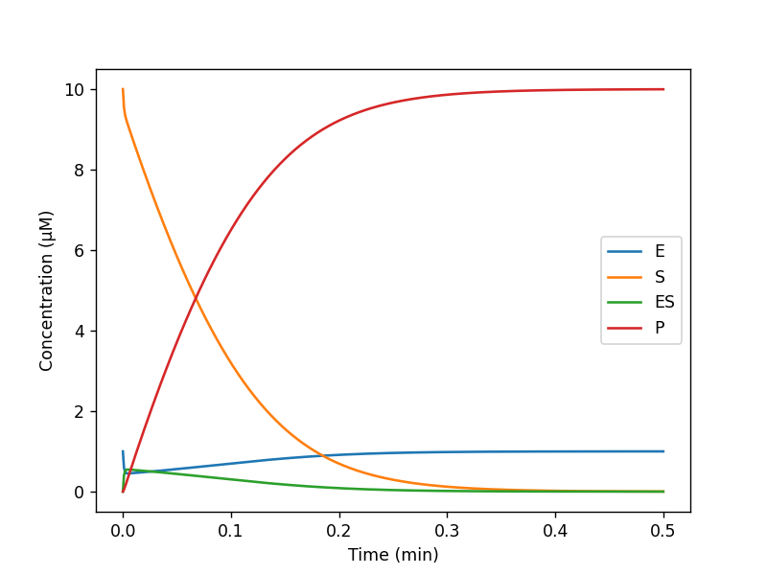

1. **.** According to the Michaelies-Menten equation, the relationship between the velocity V and the concentration of substrate S can be described as follows:

 [1]

where  is the maximum velocity of the reaction, [S] is the concentration of the substrate, and  is the Michaelis-Menten constant which represents the concentration of substrate required to achieve half of the maximum velocity.

From the formula [1], when the concentration of S is low, the formula can be simplified to:

** [2]**

This relationship is approximately linear, meaning that the velocity increases proportionally with the concentration of the substrate.

However, as the concentration of S increases, the term [S] becomes the denominator of the formula [1] and the velocity V saturates to the maximum value . the formula can be simplified to:

** [3]**

The figure is as follows:

