Automatic Testbench - User Guide

Table Of Contents

Table Of Contents
Introduction
SW Requirements
HW Requirements
Versioning
Autotesting Framework Installation
User Installation
Developer Installation
Acquisition Profiles Configuration
Instruments engine acquisition profile
Board engine acquisition profile
Autotesting Framework Usage
The configuration file
Starting the test
AIDA Setup
User: Start the tests
Developer: Python Setup
Output Files

Introduction
This document aims to describe the steps required to set up the environment for the automatic testbench framework tool, and how to use it.

SW Requirements
The following SW are required:
- Eclipse with RTC integration: here;
- Python environment: follow the instructions on this document;
- AIDA;
- The required drivers for the testbench instruments are needed in order for the communication to work. Install the required National Instruments drivers from this link.

HW Requirements
The following HW tools are needed to run the tests:
- A board with an available serial communication interface. The board FW must be configured for the Autotesting;
- A TTL - RS232, optoisolated communication cable. You may need a USB - RS232 converter in case the PC you are using for the acquisition doesn’t provide a RS232 serial port;

Versioning
The framework is under version control system.
The latest working version is located in the RTC stream _Debug_Tesing_Lib.
This user guide is based on the following components baselines:
- AUTOTESTING FRAMEWORK baseline 7
- PYTHON_COMMUNICATION_LIB baseline 2*
- PYTHON_UTILITIES_LIB baseline 2

Autotesting Framework Installation

User Installation
A basic installer can be downloaded from here.
In case the installer cannot be used, it is possible to download a zipped version that can be unzipped wherever the user wants. This version can be downloaded from here.

Developer Installation
The Autotesting Framework can be downloaded from RTC.
From Eclipse, go to the Jazz Administration perspective, and follow the steps reported below:
- Create a new Repository Workspace based on the _Debug_Testing_Lib stream:

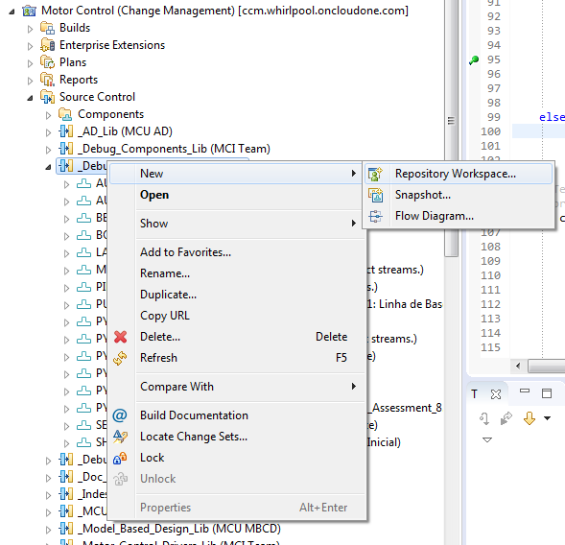
- When loading the workspace, choose to Load from a Load Rule File;
- Then select the autotesting_pydev.loadrule file, located in the AUTOTESTING_FRAMEWORK component:
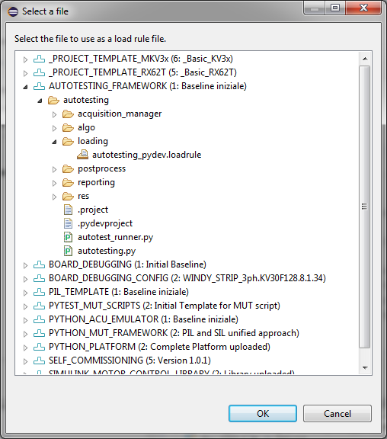

When the loading is finished, a new Python project should appear on the C/C++ perspective, (or in the PyDev one):
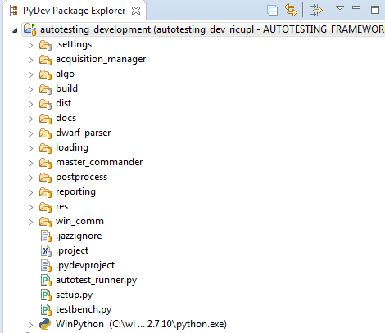

Acquisition Profiles Configuration
The Autotesting Framework relies on two acquisition engines for its operation:
- The board acquisition engine;
- The instruments acquisition engine.
Each acquisition engine needs to know the tracks to acquire. The set of tracks to acquire is known as an Acquisition Profile. Basically, it is a file with apfx extension with all the information related to the tracks to acquire.

AIDA provides a useful tool to create and edit acquisition profiles: the Profile Editor.
With the Profile Editor the user can create the acquisition profiles needed by the acquisition engines.

Instruments engine acquisition profile
The instrument acquisition profile can be created using directly the AIDA profile editor.
As the tracks are already available for all the supported instruments, simply select the tracks to acquire and add them to the profile. Obviously, the choice of which tracks include in the profile is related to the testbench configuration and to the test to execute.
Once the acquisition profile is created, save it as a apfx file.

Board engine acquisition profile
Creating an acquisition profile for the board acquisition engine is more complicated compared to the instrument engine case. This is because the tracks are not pre-configured, so they need to be created first.
Tracks can be created with the Tracks Editor tool, included in AIDA.

Suppose that we want to create an acquisition profile that includes the board Torque track. We need to create this track, and in order to do that, the exact name of the FW variable associated to that track needs to be known. Let the track name be Foc_Interface.Torque. To create the track, follow the steps reported below:
- Open the AIDA Track Editor;
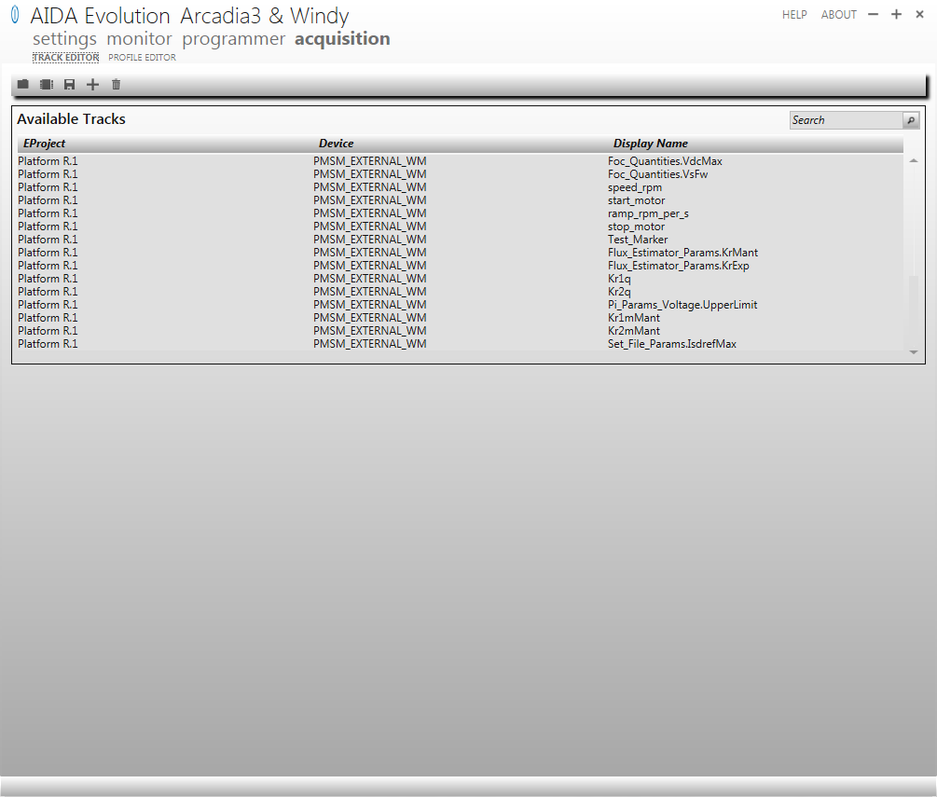
- Push the plus button on top to create a new track. The Track Details will open:
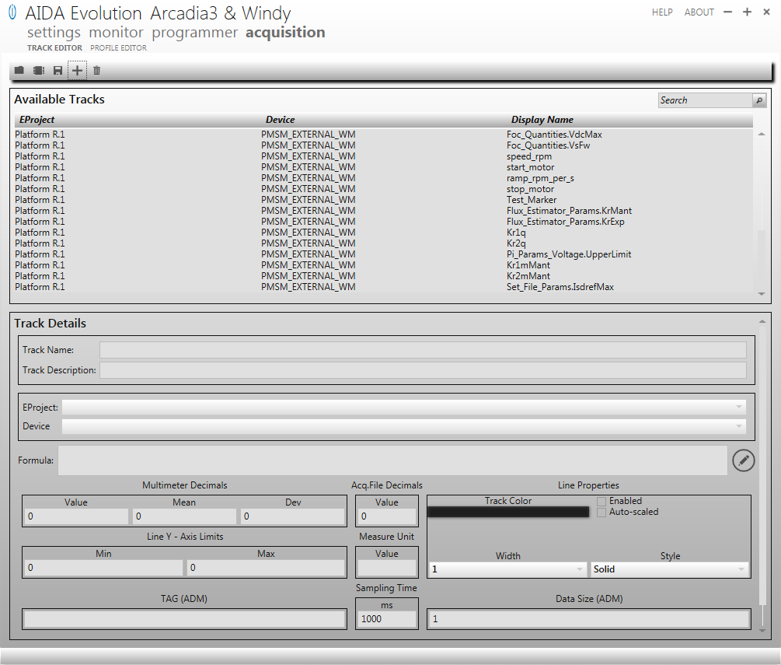
- In the Track Name, put the name of the variable associated with the track: Foc_Interface.Torque;
- Make sure that the Track Description is empty.
Tip: If the name of the variable won’t fit in the Track Name (because it’s too long), you can put it in the Track Description field.
- Select Platform R.1 in the EProject field;
- Select PMSM_EXTERNAL_WM in the Device field;
- The Formula field can be used to convert the read track’s value in a custom way. This is particularly useful in case the C variables are expressed in fixed point notation, and we want to use the physical values instead. For the Torque case, let’s suppose that the variable is in Q1.15 notation, with a base value of 4. Use the formula editor to type the conversion formula: MEM_STR['Foc_Interface.Torque']/32768*4
- The resulting track configuration is shown below:
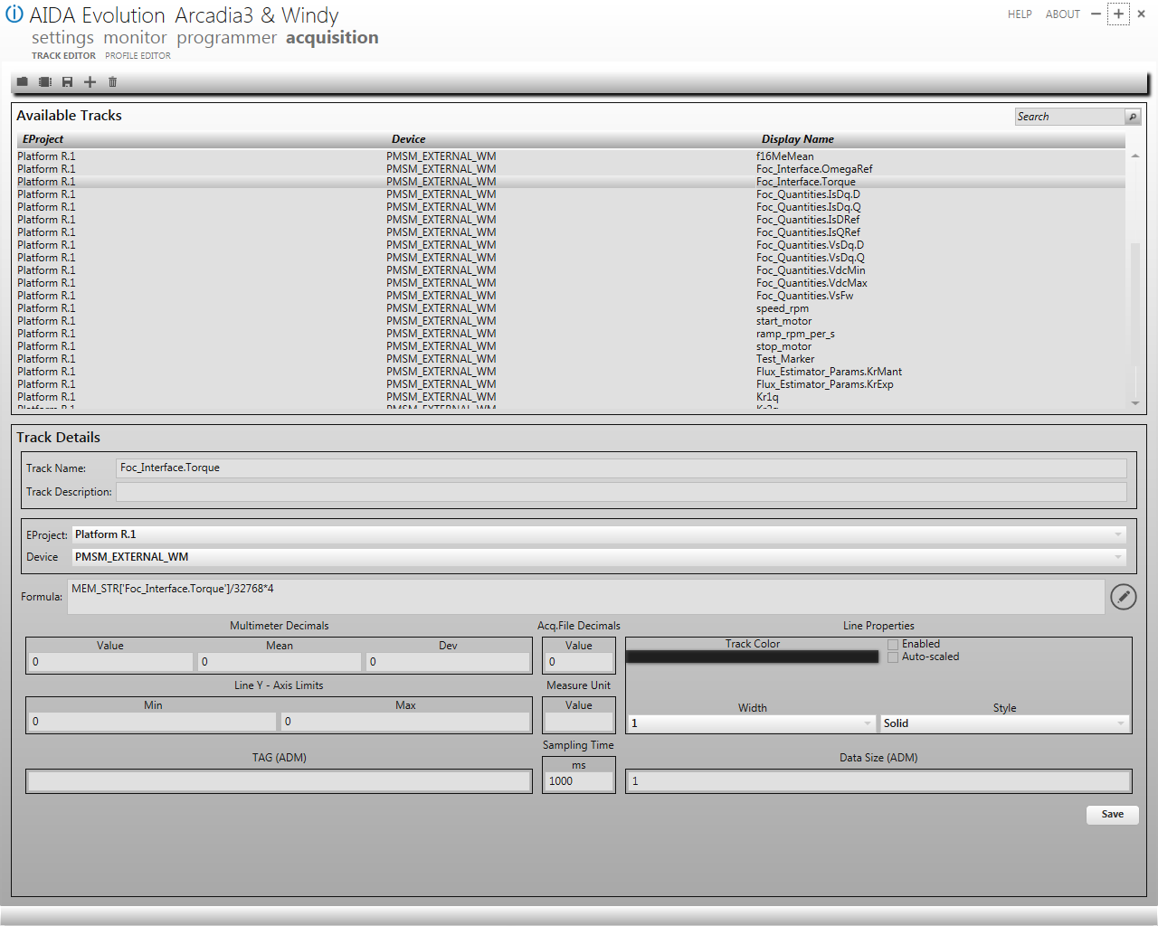
- Click on the Save button to save the created track.

The process shown above needs to be repeated for each track one wants to acquire. AIDA custom tracks can be saved into a file for convenience.

Once the tracks are created, it is possible to create the Acquisition Profile from the Profile Editor window, in the same way as described in the previous section.
Once the acquisition profile is created, save it as a apfx file.

Autotesting Framework Usage

The configuration file
The main interface for the Autotesting Framework is its configuration file. You can find a sample configuration file in the res directory of the autotesting project. It is a documented text file divided in sections, each with some key - values pairs.
Make a copy, rename it, and start modifying it according to your application.

The first section you’ll find there is the [Project] section, where you can choose a ProjectName and select the automatic test that you want to execute. For example, set TestAlgo as SPEED_TORQUE to execute some Speed Torque acquisitions. Another important parameter to set is the path to the ELF file loaded in the MCU. A sample path is provided, but of course you’ll need to change it.

In the [Board] and [instruments] sections you simply define the used board and the instruments that are connected to the testbench.

The [EnginesEnable] sections can be left as it is.
In the [EnginesAssignment] section the parameters that you need to change are InstrumentEngineApfx and BoardEngineApfx, where you need to specify the paths to the AIDA acquisition files related to the Instruments and to the Board respectively. See the Acquisition Profiles Configuration section for further details on how to create those files. Anyways, some of these files are already in the res directory, for reference.

The [MASTER_COMMANDER] section deals with the configuration of the MasterCommander acquisition engine, used to acquire data from the selected board via serial communication. Modify the ElfPath parameter with the path to the ELF file loaded in the MCU. Set the proper SerialPort number and SerialBaud (according to the FW configuration). Make sure that the SerialArch is the one of the MCU you are using.

The [AIDA_TCPIP] section deals with the configuration of the AIDA acquisition engine. You may leave this section as it is.

The sections that follow are related to the specific test you have selected in the [Project] section. So for example you do not need to configure the [OptimalTrTuning] parameters if you have selected the SPEED_TORQUE test. All the parameters related to the test you want to execute are well documented in the configuration file itself so they won’t be explained in this document.

Starting the test

AIDA Setup
The first step needed to execute the test is to make sure that AIDA is communicating with the connected instruments.
Follow the instructions in this document for some guidelines.

Make sure that the AIDA Server is up and running. To do that, go to Settings → Server and press the Start button:
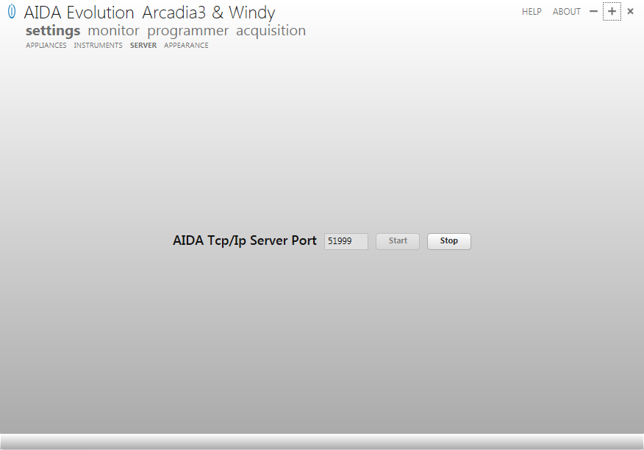

Go to the Acquisition → Profile Editor window and make sure that the Instruments Acquisition profile is selected. You can open the relevant apfx file, pressing the proper button:
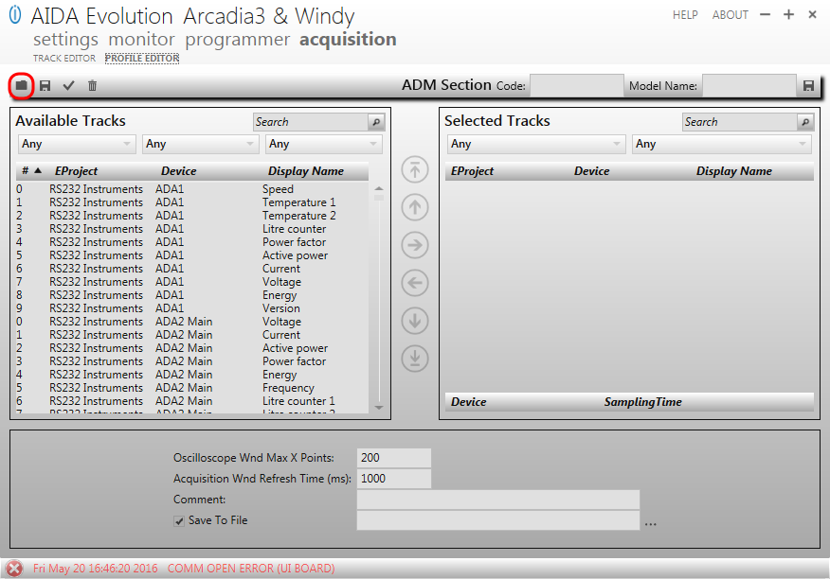

Once the apfx file is selected, the tracks will appear in the Selected Tracks display.

Tip: Make sure that all the tracks are there, as AIDA will automatically remove the tracks whose instruments are not connected! So, if one or more tracks are not there, typically this is because AIDA doesn’t see the associated instrument connected.

User: Start the tests
The test can be run by simply calling the automated_testbench.exe executable, passing the configuration file as argument:

automated_testbench.exe <path_to_config_file>

For convenience, a batch file can be created with the line above and a pause instruction at the end, just to make sure that the window is not closed automatically at the end of the test.

Developer: Python Setup
The test can be run by simply calling the autotest_runner.py script, passing the configuration file as argument:

python autotest_runner.py <path_to_config_file>

It can be convenient to launch the script from Eclipse. In order to do that, a Run Configuration needs to be created:
- Go to Run → Run Configurations, and double click on the Python Run icon on the left;
- Select the autotesting project;
- Select the autotest_runner.py module
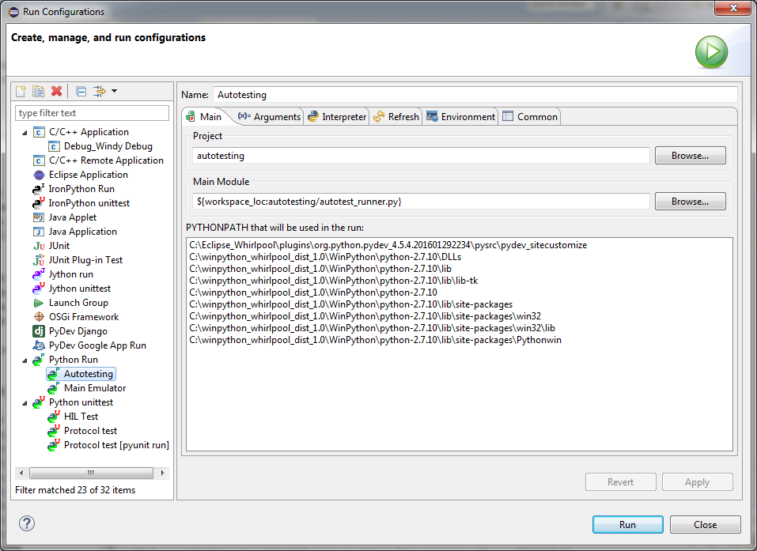
- Switch to the Arguments tab. In the Program arguments, type in the path to the configuration file:
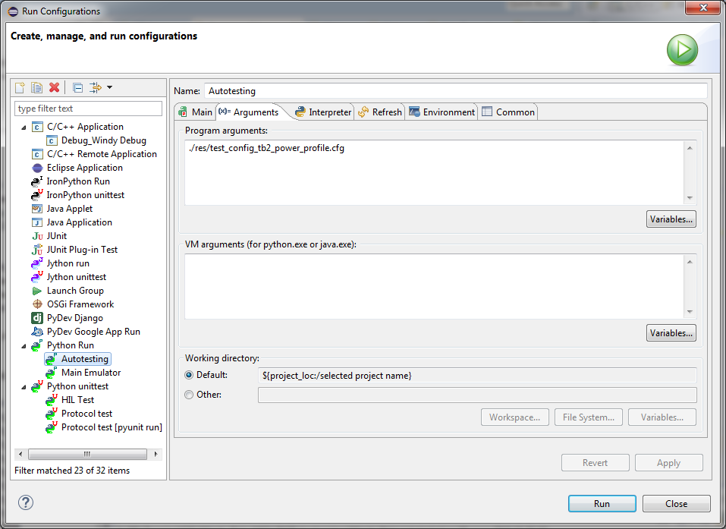

Click on Run to launch the script.

Output Files
Once a test is completed, the generated output files are put by default in the ./out/ProjectName_CurrentDate directory.

