Table of Contents
1. PURPOSE 2
2. SCOPE 2
3. TERMS, DEFINITIONS, ABBREVIATIONS, AND ACRONYMS 2
4. PLANT MODEL IN MODELICA 3
4.1 ARCHITECTURE 3
4.2 INTERFACE 4
4.3 MODEL FORMULATION 7
4.3.1 CORE ELECTRICAL MODEL (1) 8
4.3.2 MECHANICAL DYNAMICS (2) 9
4.3.3 POWER BALANCE (3) 10
4.3.4 STATOR INDUCTANCE VARIATION (4) 10
4.3.5 ROTATIONAL LOSSES POWER (6) 12
4.3.6 ROTATIONAL LOSSES TORQUE (7) 13
4.3.7 POLE TO PHASE VOLTAGE CALCULATION (9) 13
4.3.8 TEMPERATURE VARIATION (10) 14
5. INTEGRATION OUTSIDE MODELICA ENVIRONMENT 15
5.1 CORE INTERFACE 15
5.2 INTEGRATION IN THE ELECTRIC DRIVE LIBRARY 15
6. MODEL VARIANTS 17

PURPOSE
This document describes the transient electro-mechanical model for Brushless Permanent Magnet Motor (BPM) and how to apply them in various simulation environments.

SCOPE
This library includes global models of BPM motors. The application can be used in motor control algorithm development for various platforms (laundry, dish, refrigeration, dryer) with the usage of MIL, SIL, PIL, RT-PIL or HIL.

TERMS, DEFINITIONS, ABBREVIATIONS, AND ACRONYMS

TERM | DEFINITION
BPM | Brushless Permanent Magnet Motor
MIL | Model in the Loop
SIL | Software in the Loop
PIL | Processor in the Loop
RT-PIL | Real-Time Processor in the Loop
HIL | Hardware in the Loop

PLANT MODEL IN MODELICA

ARCHITECTURE
At the top level, all model variants follow the same architecture pattern. The model consists of a complete BPM motor electro-mechanical transient model (1) and a mechanical load model (2).

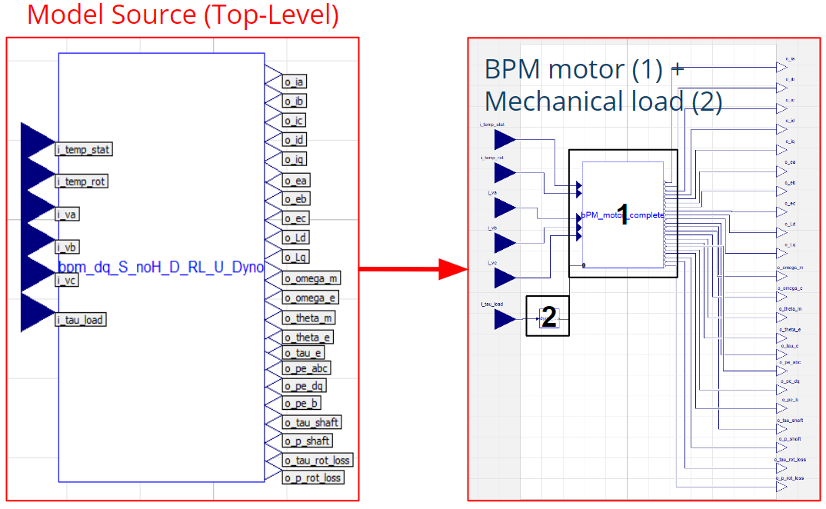

Top-Level variants due to mechanical load
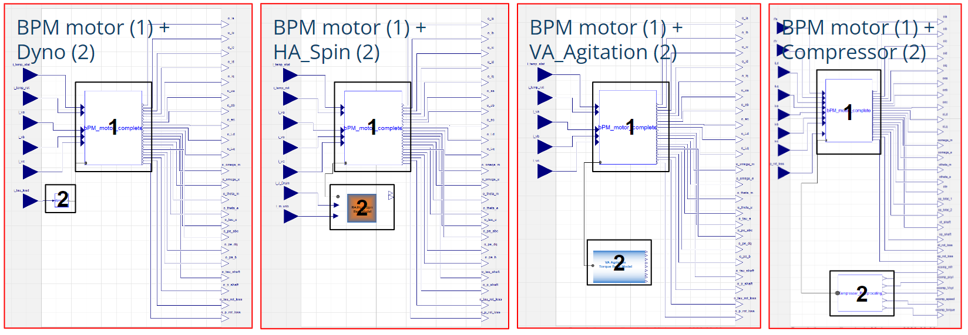

INTERFACE

The core interface remains the same for all top-level model variants.

Inputs
Signal name | Description | Unit | Data type
i_va | Input voltage, phase a | V | Real
i_vb | Input voltage, phase b | V | Real
i_vc | Input voltage, phase c | V | Real
i_tau_load | Load torque | Nm | Real
i_temp_stat | Stator temperature | degC | Real
i_temp_rot | Rotor temperature | degC | Real

Outputs
Signal name | Description | Unit | Data type
o_ia | Output current, phase a | A | Real
o_ib | Output current, phase b | A | Real
o_ic | Output current, phase c | A | Real
o_id | Output current, axis d | A | Real
o_iq | Output current, axis q | A | Real
o_Ld | Stator inductance, axis d (debug output) | H | Real
o_Lq | Stator inductance, axis q (debug output) | H | Real
o_ea | Back-electromotive force, phase a | V | Real
o_eb | Back-electromotive force, phase b | V | Real
o_ec | Back-electromotive force, phase c | V | Real
o_omega_m | Rotor mechanical rotational speed | rad/s | Real
o_omega_e | Rotor electrical rotational speed | rad/s | Real
o_theta_m | Rotor mechanical position | rad | Real
o_theta_e | Rotor electrical position | rad | Real
o_tau_e | Electromagnetic torque | Nm | Real
o_tau_shaft | Torque delivered to the shaft | Nm | Real
o_tau_rot_loss | Output Rotational Losses torque | Nm | Real
o_pe_b | Motor total power - calculated using power balance equation | W | Real
o_pe_dq | Motor total power - calculated by v*i in dq coordinates | W | Real
o_pe_abc | Motor total power - calculated by v*i in abc coordinates | W | Real
o_p_shaft | Power delivered to the shaft | W | Real
o_p_rot_loss | Output Rotational Losses | W | Real

Parameters
Name | Description | Unit | Data type
Rs0 | Initial stator winding resistance | Ohm | Real
Ld0 | Initial stator inductance in the d axis | H | Real
Lq0 | Initial stator inductance in the q axis | H | Real
phiPM1 | Initial PM flux amplitude of the fundamental harmonic | Vs | Real
NPP | Number of pole pairs | - | Real
Jrotor | Rotor's inertia | kg*m2 | Real
B | Friction coefficient | - | Real
Ts | Step size of the internal delay block (if used) | s | Real
TsRef | Reference temperature of the rotor (PM) | degC | Real
TrRef | Reference temperature of the stator | degC | Real
alpha_s | Stator resistance temperature coefficient | 1/degC | Real
d_magnet | Magnets temperature coefficient | 1/degC | Real
Rsa_aux | Additional stator winding resistance, phase a | Ohm | Real
Rsb_aux | Additional stator winding resistance, phase b | Ohm | Real
Rsc_aux | Additional stator winding resistance, phase c | Ohm | Real
Ls_Sat_enable | Stator inductance saturation enable | - | Real
I_pk0 ... I_pk7 | Stator inductance LUT input coefficients | A | Real
Ld_a0 ... Ld_a7 | Stator inductance LUT coefficients to estimate Ld = f(id) | H | Real
Lq_b0 ... Lq_b7 | Stator inductance LUT coefficients to estimate Lq = f(iq) | H | Real
Rot_Loss_enable | Rotational losses calculation enable | - | Real
Rot_Loss_omega_th | Rotational losses calculation speed threshold | rad/s | Real
Rot_Loss_Speed0 ... Rot_Loss_Speed7 | Rotational losses LUT input coefficients | rpm | Real
Rot_Loss_Power0 ... Rot_Loss_Power7 | Rotational losses LUT coefficient to estimate power_rot_loss = f(speed) | W | Real

MODEL FORMULATION

This document describes in detail only the complete BPM motor electro-mechanical model (1). Mechanical load models are not covered in this guideline - please refer to other available documentation. As shown on the diagram below, the Complete BPM model consists of several functional modules (components). Selected of them are described in detail in the following sections.

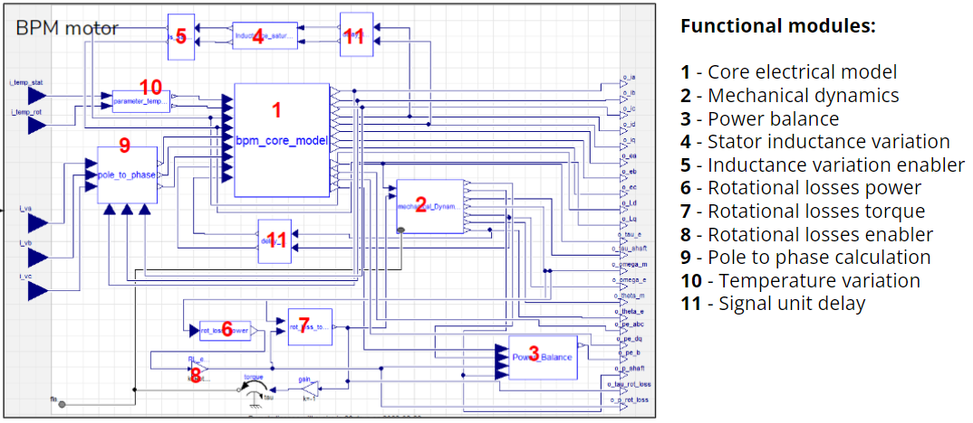

CORE ELECTRICAL MODEL (1)

A first-principles model describing the electrical dynamics of a motor. Essential outcomes are the motor currents and the generated electromagnetic torque. Also, this module calculates the total motor power and Joule losses. Motor equations are expressed in the DQ reference frame, therefore the Clarke-Park transformation of selected signals is required to apply, in order to transform the model reference frame from ABC to DQ coordinates.

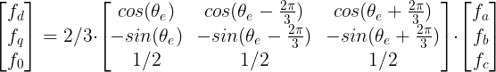

The inverse transformation can be easily derived from the above equations. It is mainly required for calculating motor phase currents. As for now, the zero (f₀) component is not used in the model. Therefore, the implemented motor equations are based solely on the D and Q components:
- voltage equations

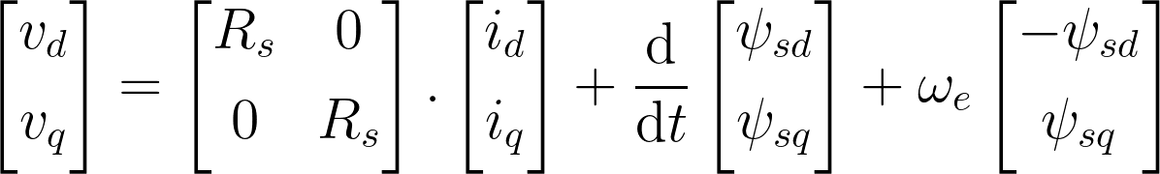

- permanent magnet flux equations (the PM flux is aligned to the D axis)

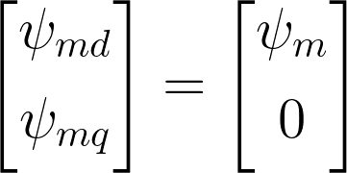

- stator flux equations

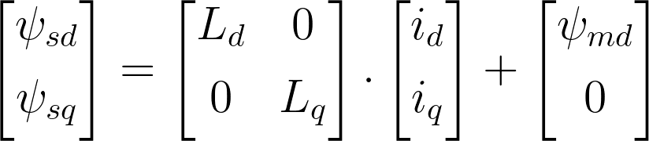
- currents dynamics

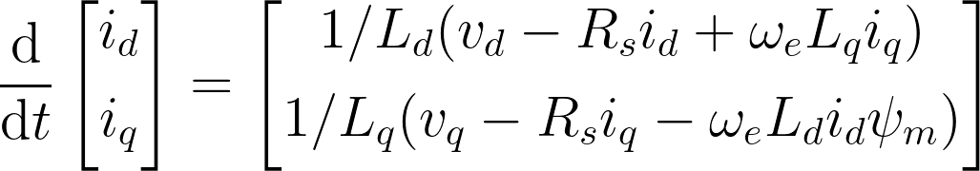

*Rs, ψm - can vary due to temperature,
*Ld, Lq - can vary due to the saturation effect.

- electromagnetic torque generation

- power calculations
  - total power in DQ reference frame
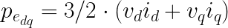

  - total power in ABC reference frame (more as a debug signal)
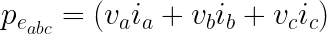

  - Joule power losses
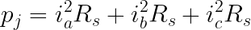

MECHANICAL DYNAMICS (2)

A first-principles model to calculate:
- mechanical rotor speed and position

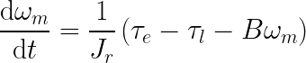

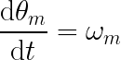

- electrical rotor speed and position

- mechanical torque and power delivered to the shaft

POWER BALANCE (3)

This module calculates the total power of the motor based on the power balance equation. According to theoretical considerations, the output power from this block should be equal to the total power calculated by the core model (1).

STATOR INDUCTANCE VARIATION (4)

Stator inductance may vary during motor operation e.g. due to a saturation effect. An empirical approach is used to model this phenomenon. The approach relies on look up tables (LUTs) which calculate each inductance based on coefficients I_pk0 ... I_pk7, Ld_a0 ... Ld_a7, Lq_b0 ... Lq_b7 which are derived by identification procedures performed on the laboratory test bench. Inductance values in D and Q axis are calculated separately based on instantaneous i_{d} and i_{q} currents values respectively.
In general, inductances can be described as $L_{d} = f\left(\left|i_{d}\right|\right)$ , $L_{q} = f\left(\left|i_{q}\right|\right)$ where the function f is a linear interpolation of LUT points.
Ipk [A] Ld [H]  Ipk0 Ld_a1  Ipk1 Ld_a2  Ipk2 Ld_a3  Ipk3 Ld_a4  Ipk4 Ld_a5  Ipk5 Ld_a6  Ipk6 Ld_a7  Ipk7 Ld_a8 | Ipk [A] Lq [H]  Ipk0 Lq_b1  Ipk1 Lq_b2  Ipk2 Lq_b3  Ipk3 Lq_b4  Ipk4 Lq_b5  Ipk5 Lq_b6  Ipk6 Lq_b7  Ipk7 Lq_b8

- L_{d}, L_{q} calculation example
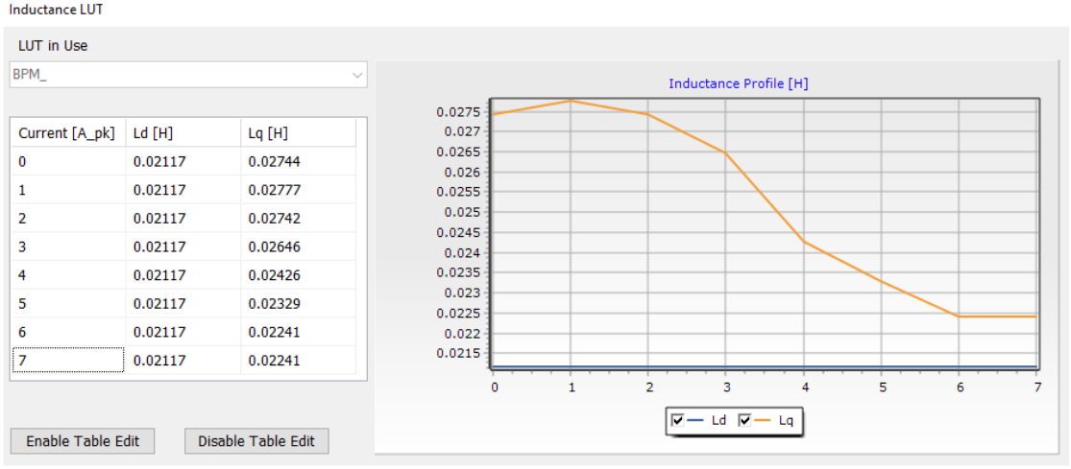

ROTATIONAL LOSSES POWER (6)

Rotational losses power calculation also relies on the lookup table approach. In this case, the coefficients are also derived from test procedures performed on the laboratory test bench.
In general, the rotational losses power can be described as $p_{RL} = f(\left|n\right|)$where the function is the linear interpolation of rotational losses LUT coefficients.

n [rpm] | p_RL [W]
n0 | p_RL0
n1 | p_RL1
n2 | p_RL2
n3 | p_RL3
n4 | p_RL4
n5 | p_RL5
n6 | p_RL6
n7 | p_RL7

- rotational losses power calculation example
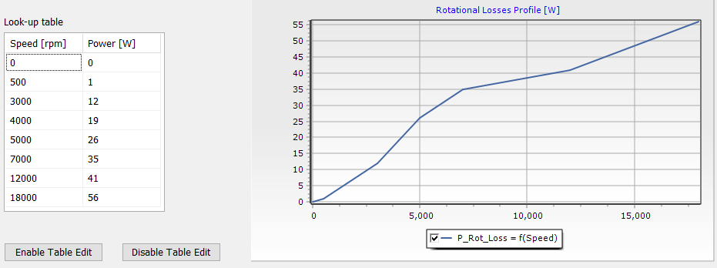

ROTATIONAL LOSSES TORQUE (7)

Loss torque is considered as opposing torque in the mechanical dynamics of the motor as shown on the figure.

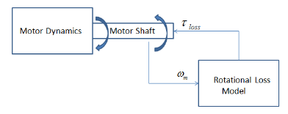

It is derived from:
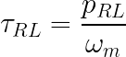

POLE TO PHASE VOLTAGE CALCULATION (9)

This module reconstructs the pole into the phase voltage passed to the core electrical BPM model. Also, it enables to simulate phase unbalance conditions by injecting additional resistances to each phase separately. Picture below shows a typical diagram of connecting a BPM motor with a voltage source inverter.
From a standpoint of the BPM input voltage, this electrical circuit can be described following equations:

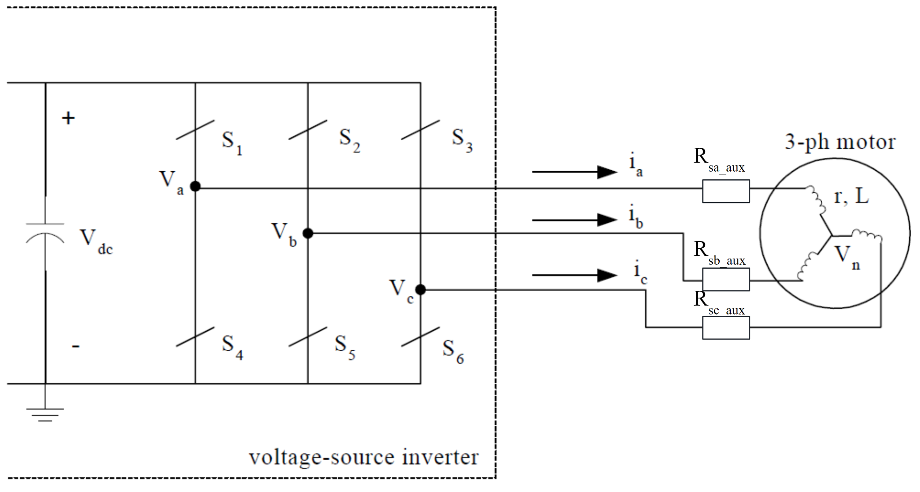
where:
- V_{a} ,V_{b} ,V_{c} - pole voltages
- V_{an} ,V_{bn} ,V_{cn} - phase voltages
- V_{n} - potential in the neutral point
- i_{a} ,i_{b} ,i_{c} - motor phase currents

TEMPERATURE VARIATION (10)

This module calculates changes of the stator resistance and permanent magnet flux amplitude due to stator and rotor temperature variations. The outputs are multiplication coefficients (k_temp_Rs, k_temp_phiPM) passed to the core electrical model. Input temperatures are converted from degC to K.

INTEGRATION OUTSIDE MODELICA ENVIRONMENT

In order to integrate the model outside the Modelica environment, a binary needs to be generated. Two basic binary forms are used in the case of the BPM model: FMU and S-Function.

CORE INTERFACE

After binary generation the core interface remains the same as in the top-level Modelica model (section 6.2). All model inputs, outputs and parameters are exposed.

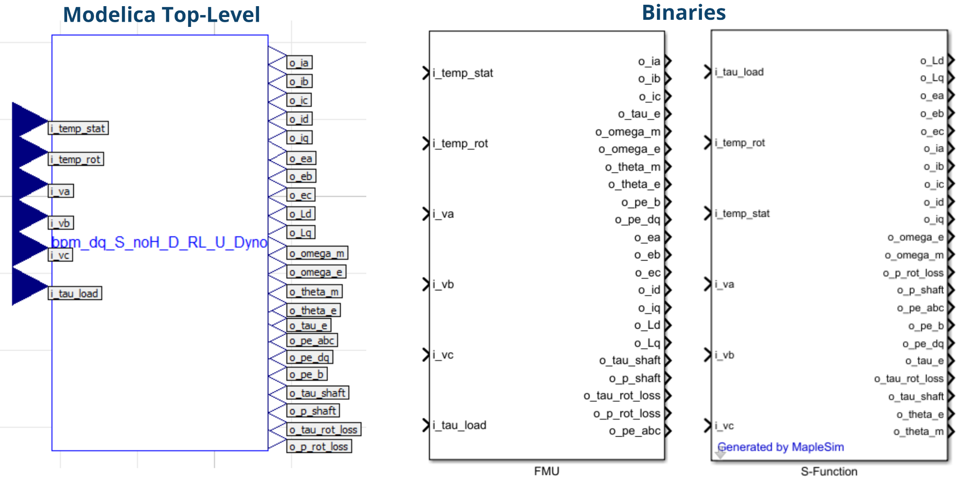

INTEGRATION IN THE ELECTRIC DRIVE LIBRARY

Ultimately the model is embedded into the Electric Drive Library. Due to specific requirements, the model is integrated there by using customized methods.
In the Matlab/Simulink environment, the Simulink Top-Level models have an optimized interface, limited only to essential signals. Binaries are integrated at the Low-Level. In terms of models parameterization, customized Top-Level block masks have been designed as well.

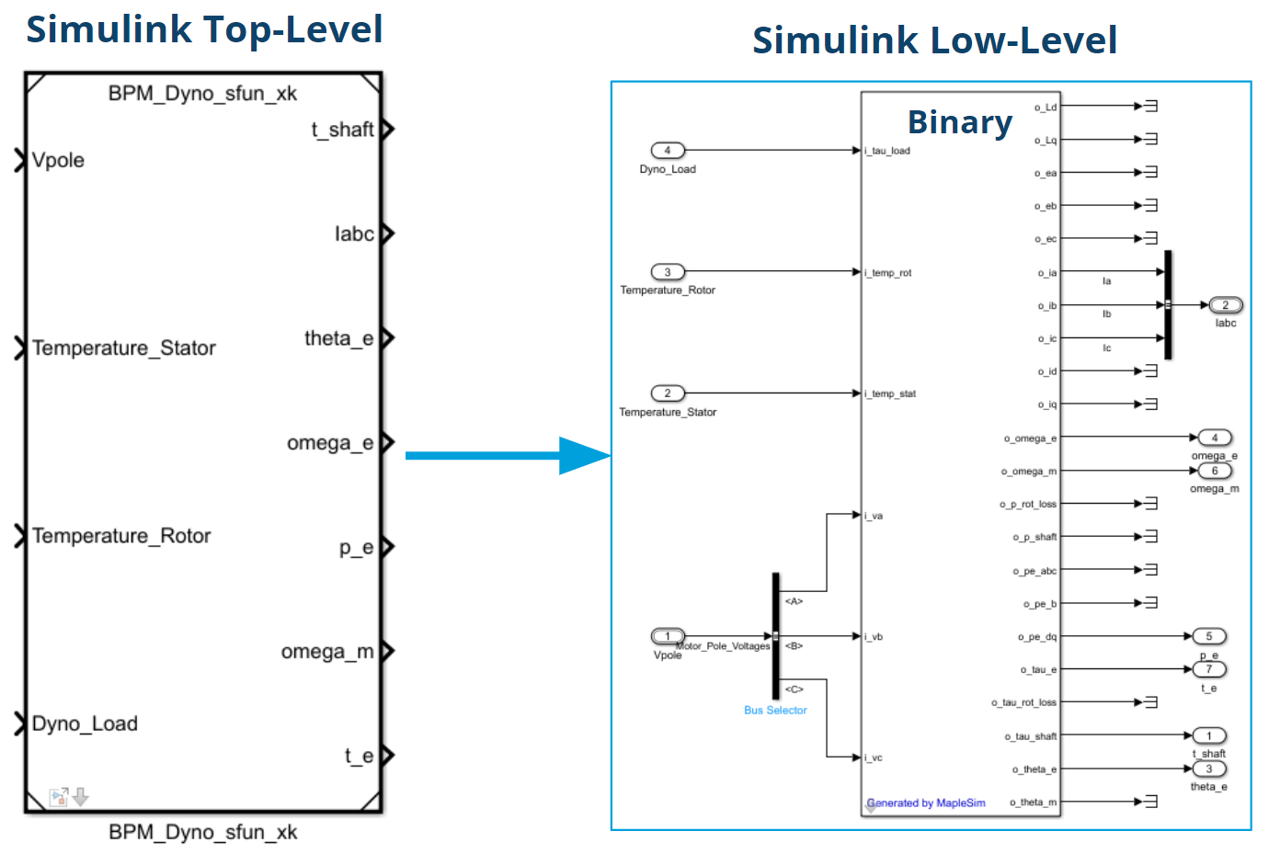

Top-Level Model Mask
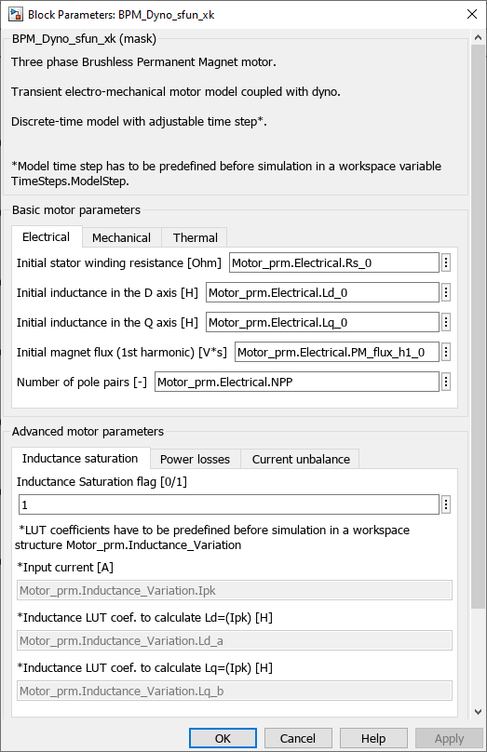

MODEL VARIANTS

The BPM motor model has several core, top-level variants, which are mainly determined by:
- coupled mechanical load (Dyno, VA, HA, Compressor),
- binary form (FMU, S-Function),
- special use case (e.g. high speed range, PM flux harmonics).

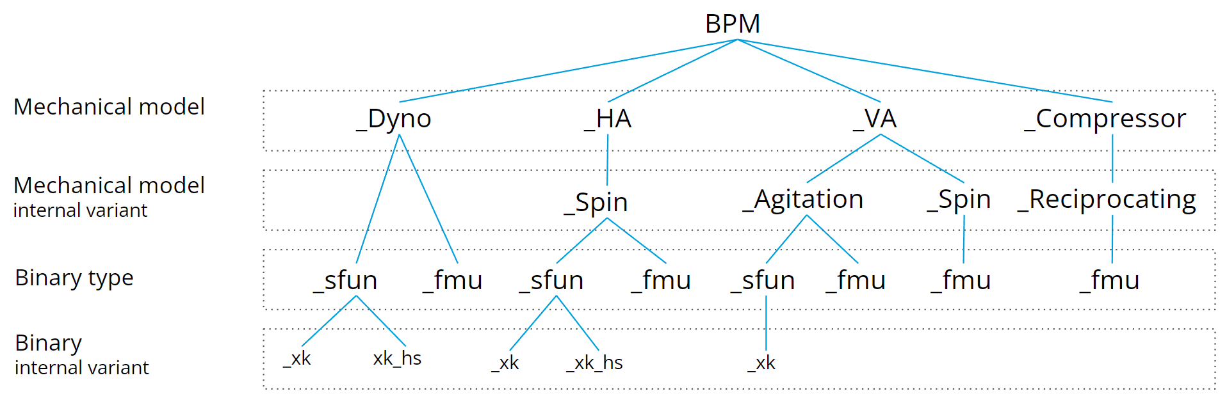

CONTRIBUTORS
(Individuals who contributed to the content of this document)
NAME | USERID | NAME | USERID
Chinmay A. Kirtane | KIRTACA
Szymon A. Bednarz | BEDNASA

REVISION HISTORY
REV | DESCRIPTION OF CHANGE | SECTION | BY | CN | DATE
A | Draft | All | KIRTACA | - | 01-Dec-2017
B | Major update. Document reorganization. Alignment with the latest BPM transient model (v2.5.0). | All | BEDNASA | - | 06-Feb-2023

