Table of Contents

PURPOSE

SCOPE

REFERENCES

TERMS, DEFINITIONS, ABBREVATIONS AND ACRONYMS

DISCLAIMER

INTENT OF GUIDELINES

GUIDELINES ARE NOT

MOTOR CONTROL TRANSIENT SIMULATION ARCHITECTURE

PURPOSE
This document describes the organization and structure of the Motor Control Transient Simulation Architecture for HA and VA Washers and how to configure for motor control algorithm simulation and tests. It is a live document and will be updated as more subsystems and variants or enhancement are added to the architecture.

SCOPE
The Motor Control Transient Simulation Architecture includes S- Function for Motor Control source code, Plant Models for BPM and CIM Motors, Rectifier Board Model, Inverter Model and interfaced together. In addition, architecture also includes parameter files and graphical user interface to set the architecture in particular configuration. The application can be in Vertical or Horizontal Axis washers.

REFERENCES
-

TERMS, DEFINITIONS, ABBREVIATIONS, AND ACRONYMS

TERM | DEFINITION
CIM | Controlled Induction Motor
BPM | Brushless Permanent Magnet
MCI | Motor Control Interface
MCU | Motor Control Unit
VA | Vertical axis washer
HA | Horizontal axis washer
HVDC | High voltage direct current bus
HVPS | High voltage power supply
PFC | Power factor correction
FMU | Functional Mockup Unit
FOC | Field Oriented Control
DTC | Direct Torque Control
MIL | Model In Loop
SIL | Software In Loop
PIL | Processor In Loop
GUI | Graphical User Interface

DISCLAIMER
The information in this document contains recommendations based on best practices available and have been proven to some extent in different products. Challenging these recommendations is possible, but some risk may be there and should be evaluated carefully.

Intent of Guidelines
Guidelines are intended to be living documents that improve over time based on a compilation of experiences. The document is concise and explains best practices, practices that should be avoided, and other points worth noting. Guidelines are an enabler of global cross-product knowledge sharing which can be useful for new, as well as highly experienced, employees

Guidelines Are Not
Guidelines are not a replacement for engineering rigor nor do they override consumer/regional requirements. Guidelines are not requirements and are therefore not specifications.

Motor Control Transient Simulation Architecture

Motor Control Transient Simulation architecture (Architecture onwards) is a toolset and frame-work for transient simulation of motor control loop modeled in Simulink in order to simulate the motor control algorithms in Model in Loop (MIL), Software in Loop (SIL).

System Requirements:
- Matlab R2016b 64-bit
- Compiler- Microsoft Visual C++ 2015 Professional (C)
- FMIKit (This toolbox will be invoked implicitly when the model is loaded)

Loading Architecture from RTC
- Go to Motor Control (Change Management) Area and right click on the stream Model_Based_Design_Transient_Simulation_Architecture_Rel
- Select New Repository Workspace

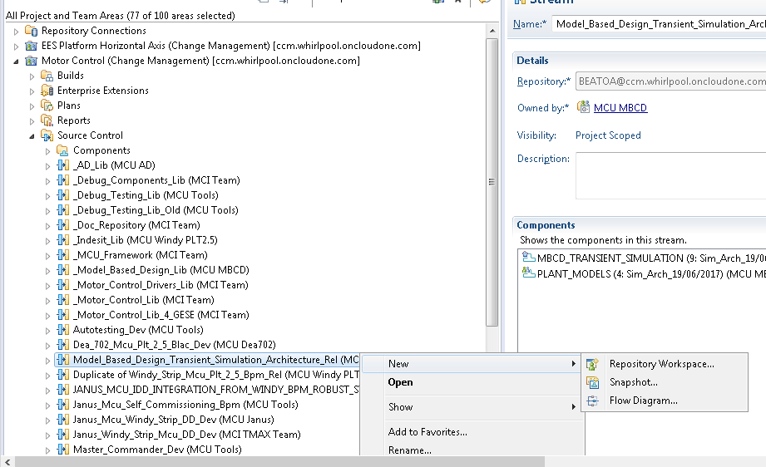

3.Choose a name for the workspace and click on Finish
4. Select load from a load rule file and click Next
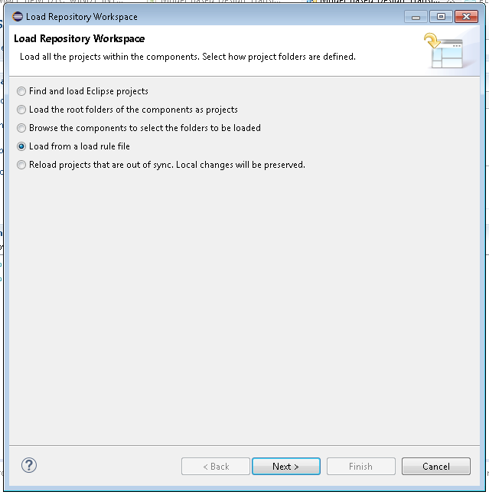

5. Select Load from a remote load rule file. The load rule is located here. Click Ok.
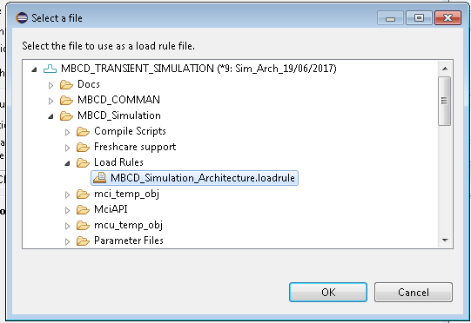
6. The Simulation Architecture will be loaded into your sandbox.

Organization of the Architecture
Architecture is structured into three layers.
- Layer-1: System Layer
This is the topmost layer where all the subsystems of the motor control system are interfaced as shown below:
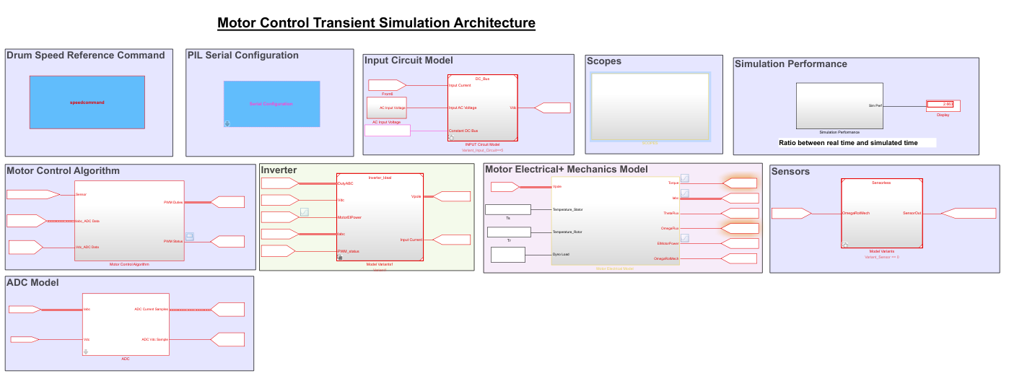

- Layer-2: Sub-System Layer

Sub-System layer consists of Model Variants for each sub-system of the motor control system. Simulink Model Variant is used to model variants of each sub-system in a single system model.
Following table describes the variants for each- subsystem

Subsystem | Variants
Input Circuit | Constant DC Bus
 | HVPS 120V
 | HVPS 120PFC
 | HVPS 230
 | HVPS 230 PFC
Motor+Mechanics Coupled | CIM Basic
 | CIM MBCD
 | BPM Basic-HA
 | BPM Basic-VA
 | BPM MBCD- VA Agitation
 | BPM MBCD- VA Spin
Sensor | Tachometer
 | Sensorless
Inverter | Ideal Inverter
ADC Model | -
Control Model | SIL
 | PIL
Signal Inspector | -
Simulation Performance | -

Variant Control Parameters for each sub-system and variant selection conditions are as listed below:
Variant Control Parameter | Variant Control Condition | Sub-System Variant Invoked in the System Model
Variant_Input_Circuit | 1 | HVPS 120 V
 | 2 | HVPS 120 PFC
 | 3 | HVPS 230
 | 4 | HVPS 230PFC
 | 5 | Constant DC Bus
Variant_Motor_Control | 1 | SIL
 | 2 | PIL
Variant_Motor | 1 | HA-CIM-Basic Model
 | 2 | HA-CIM-MBCD (Advanced Model)
 | 3 | HA-BPM-Basic Model
 | 4 | HA-BPM-MBCD(Advanced Model)
 | 5 | VA- BPM-Agitation Model
 | 6 | VA-BPM-Spin Model
 | 7 | VA-BPM-Basic Model
Variant_Sensor | 0 | Sensorless
 | 1 | Tachometer Model

- Layer-3: Component Layer

Component layer consists of the models of the components either developed in Simulink or developed in Dymola and imported in Simulink as FMUs. Sub-System Plant Models are separate Simulink models referenced into the system model using Model Variant blocks.

Component | Model Source | Import Method In Simulink
Input Circuit Model | Dymola Model | FMU Co-Simulation using Cvode Solver. Imported using FMI toolkit.
CIM Basic Model | Simulink Model | -
CIM Advanced Model | Dymola Model | FMU Co-Simulation using Cvode Solver.  Imported using FMI toolkit.
BPM Basic Model | Simulink Model | -
BPM Advanced Models | Dymola Model | FMU Co-Simulation using Cvode Solver  Imported using FMI toolkit.
Sensor | Simulink Model | -
Control Model | Embedded Source Code | S- Function to interface production code into Simulink.

Short Description about the sub-systems and components of the Motor Control transient simulation architecture is described below:
  - Input Circuit Model:

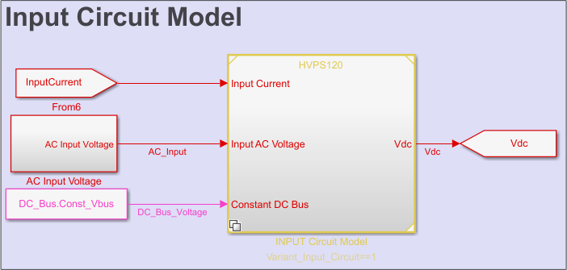

This Model converts AC Input Voltage to the Constant DC Bus Value which in turn acts as the input to the Control Model and 3-Phase Inverter model. Rectifier Variants for the input circuit are modeled as FMUs for each particular board families as follows:
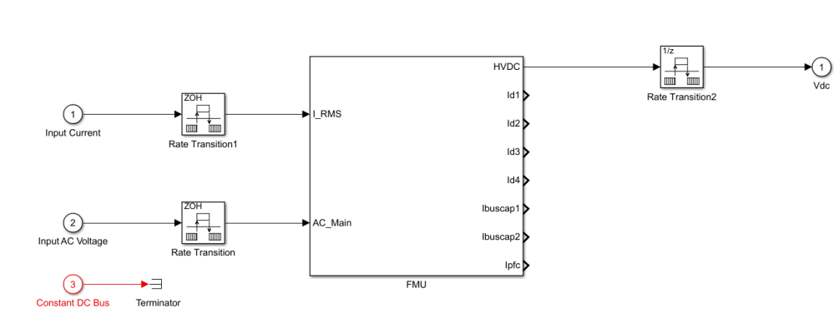

Inputs:
- Inverter Input Current (A)
- AC Input Voltage (V)
- Constant DC Bus Voltage( For the Simulation of Constant DC Bus Simulation) (V)

Outputs:
- DC Bus Voltage (V)

Detailed documentation for the Rectifier Models is available in the Plant Model folder as shown below:
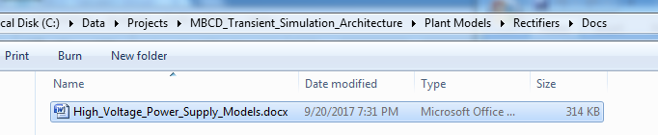

  - Motor Control Algorithm

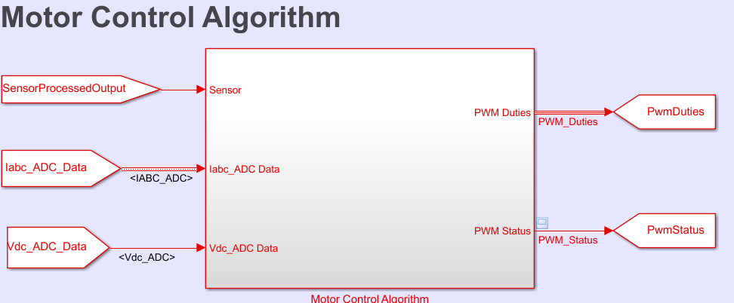

This Model implements the Motor Control Algorithm. In SIL Simulation, Motor Control Source Code is compiled to the S-Function. In PIL Simulation, this model acts as interface in between evaluation/production board and Simulink environment.
Inputs:
- Sensor Output (Output of the Speed Sensor)
- ADC Data for Motor 3-Phase Currents
- ADC Data for the DC Bus Voltage.
Outputs:
- PWM Duty Cycles for 3-Phase Inverter. (%)
- PWM Status(1/0)

  - Inverter

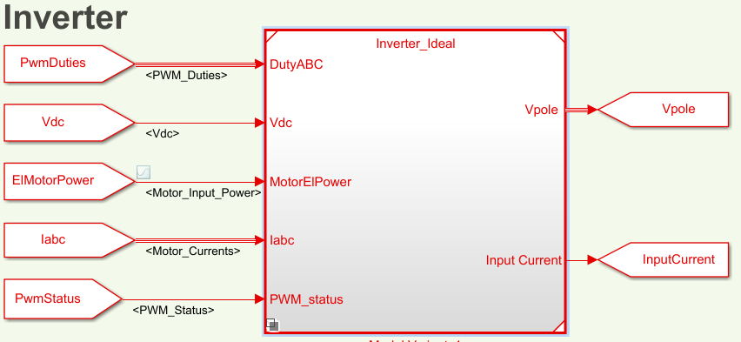

Inverter Model implements the ideal 3-Phase inverter model. Inverter model generates the 3 pole voltages corresponding to each leg of the 3-phase inverter. These voltages are applied to the motor models.

Inputs:
- PWM Duty Cycles for 3-Phase Inverter. (%)
- DC- Bus Voltage. (V)
- Motor Input Power(W)
- Motor 3-Phase Input Currents(A)
- PWM Status(0/1)

Outputs:
- Pole Voltages for 3 Inverter Legs.
- Input Current from the DC- Bus

  - Motor Electromechanical Model

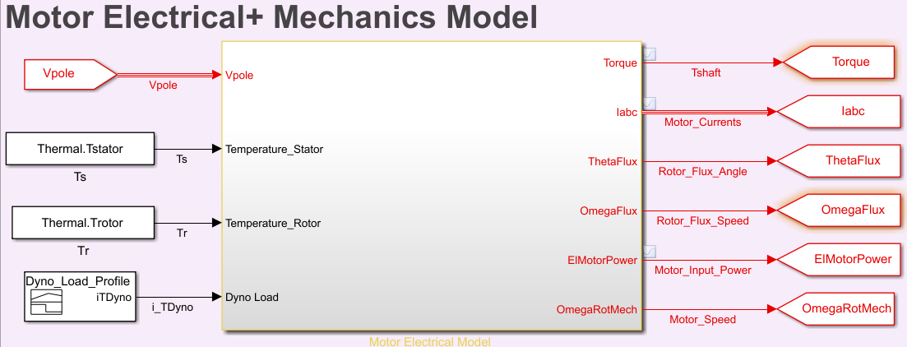

Motor Electro Mechanical Model implements the Models for the Electric Motor and the mechanical components which are part of the washer drive system. By keeping the interfaces same, various motor and drive system/load models are invoked as per the architecture configuration.

Inputs:
- Pole Voltages (V). (Model Internally converts into the Motor Phase Voltage)
- Temperature of the Stator Windings (Deg. C)
- Temperature of the Rotor Windings/Magnets (Deg. C)
- Dyno Load Torque. (N.m)

Outputs:
- Motor Shaft Torque (N.m)
- 3-Phase Motor Currents (A)
- Rotor Flux Position (rad)
- Rotor Flux angular speed. (rad/sec)
- Motor Input Power(W)
- Motor angular speed. (rad/sec)

Advanced model variants are modeled as FMUs from Dymola as follows:

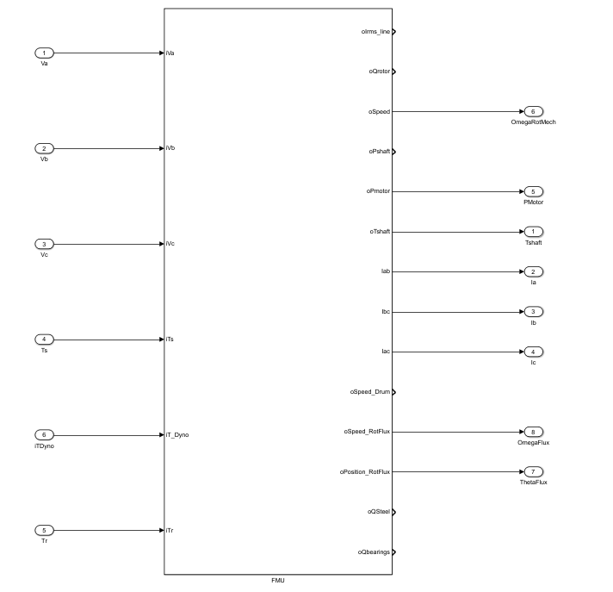

Documentation for the CIM and BPM Electromechanical Models can be accessed from the respective plant Model folders as shown below for CIM:
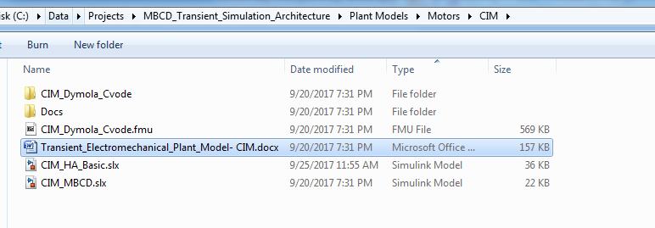

  - Sensors

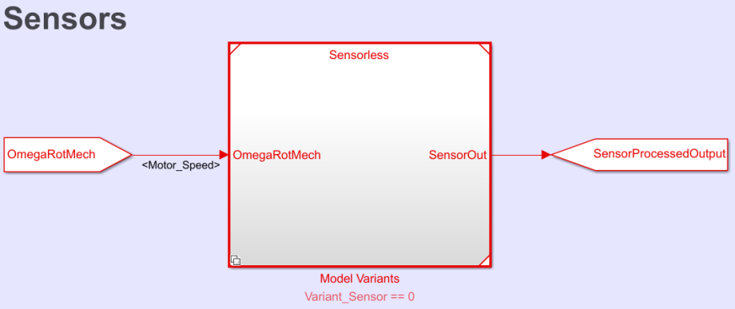

Sensor model consists of the model of the tachometer in case of CIM projects and where as this Sensorless model is invoked in case of all BPM Project In case of Sensor Model invoked; Sensor Output will consist of signal as per the following Tachometer model:
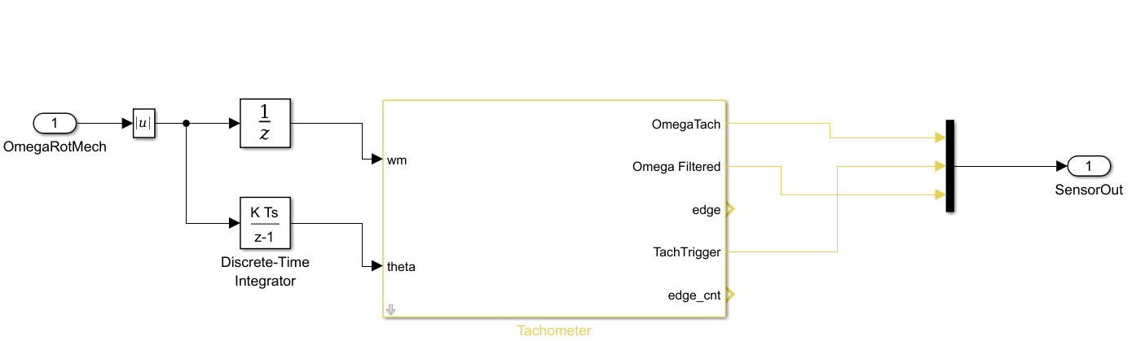

  - ADC Model:

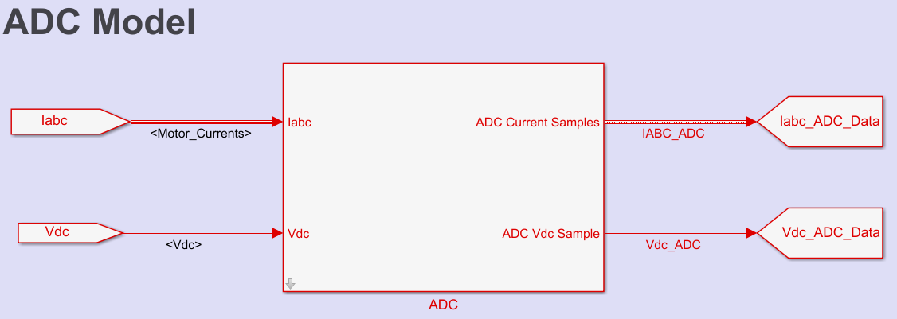

ADC Model converts Physical Feedback signals into corresponding ADC Levels. This ADC Signals are in turn input to the control model. Appropriate parameters will be invoked when Input Board is selected.

Inputs:
- 3-Phase Motor Currents. (A)
- DC Bus Voltage (V)

Outputs:
- ADC Data corresponding to the3-Phase Motor Currents.

- Speed Command UI:

Different speed commands for the Drum can be generated including wash and spin cycles with the help of Speed Command UI as shown in figure below:

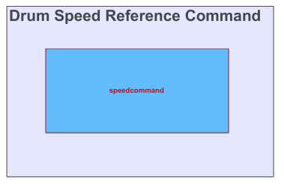
Speed Command UI can be accessed by double clicking on the speed command S-Function block:

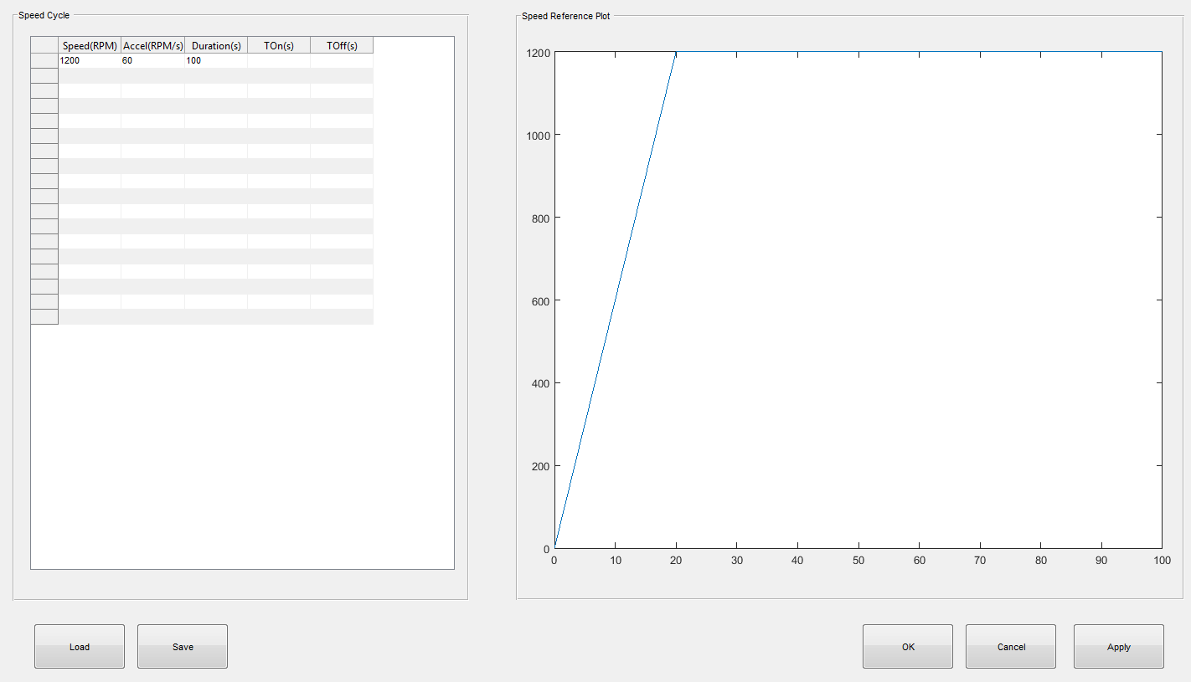

Speed Commands can be saved as Saved as .MAT file using the Save Pushbutton on the speed command UI.
Previously saved speed command can be loaded by using the Load pushbutton on the speed command UI.

- Model Configuration UI:

Architecture can be configured for different combinations of the sub-systems with the help of Sim_Arch_Config_UI as shown below:

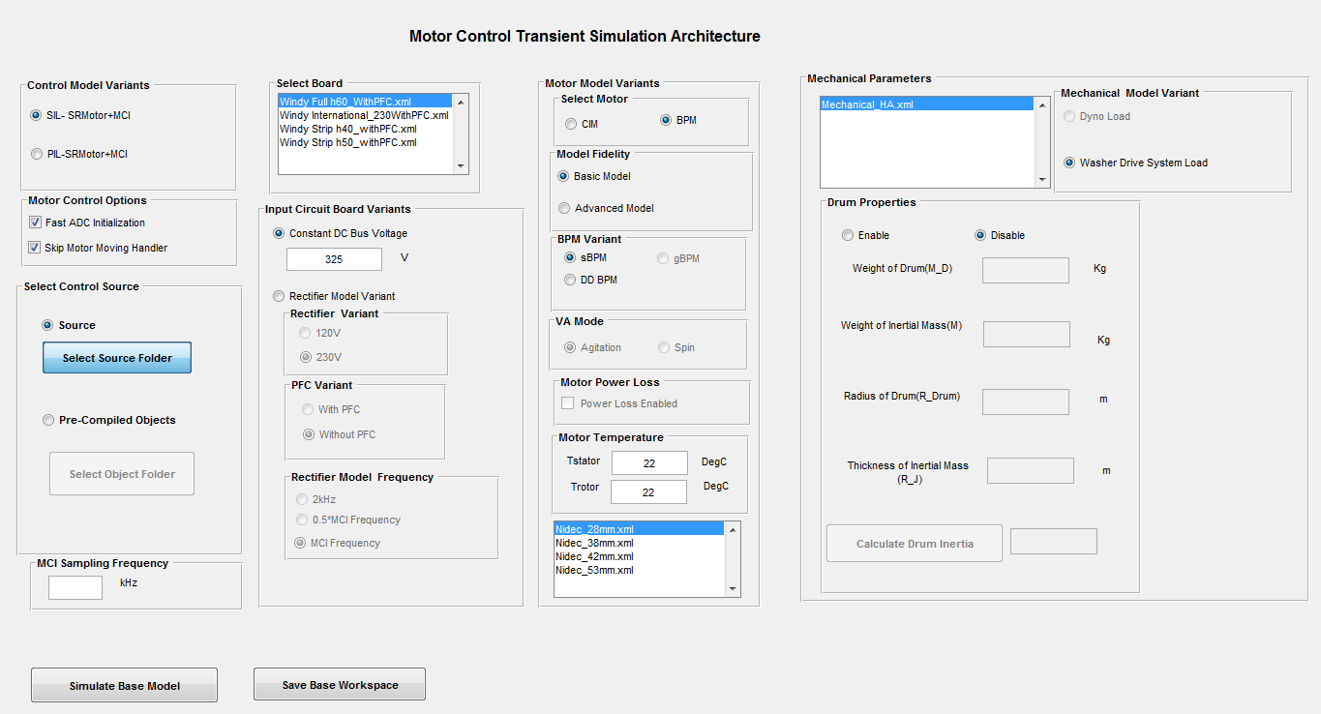

Different Model configuration options using this UI have been explained in the section 6.4

- Parameter Files

Each Sub-System in the architecture is parameterized. Parameters for the plants are maintained in the XML documents in the Parameter Files Folder:

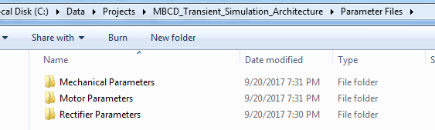

Parameter XML File example:

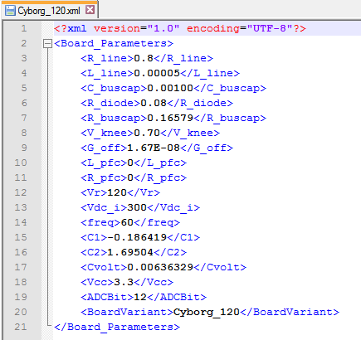

Parameters are loaded as Structures (except variant control) corresponding to each sub-system in the base workspace as shown below:
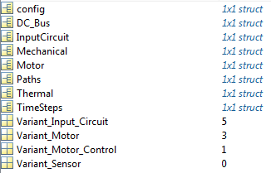

‘config’ structure is populated with the configuration and variant details for all the sub-systems as shown:

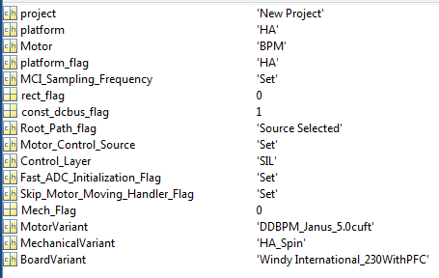

‘Motor’ structure in the base workspace populates the parameters related to the Motor Plant Model:
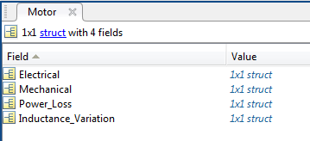

‘InputCircuit’ structure in the base workspace populates the parameters related to the Input Circuit Model and the ADC Model:
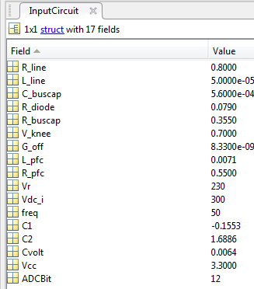

‘Mechanical’ structure in the base workspace populates the parameters related to the Motor Plant Model:

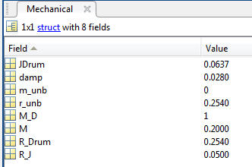

Configuration of the Architecture for the Simulation

Following steps will describe the procedure to work with the architecture for different use cases while simulating the motor control.

    - Simulation of New Project

- Make MBCD_Transient_Simulation_Architecture as current directory in the Matlab
- Click on the Simulink model MCU_Simulation_Architecture.slx
- Click on the New Project after pop-up window comes as shown below:

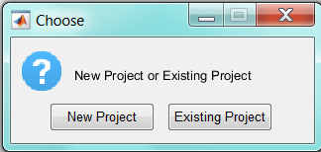

- After New Project option is selected, another pop-up will come to select appropriate platform HA/VA as shown below:

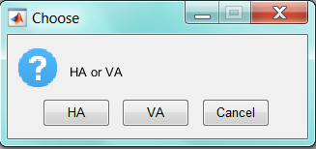

- After these initial selections, Simulink model will be opened along with model configuration UI. Model will be initialized depending upon the options selected in previous two steps.

- Select the Variant for the Control Simulation either SIL ( Motor Control Source code is compiled as S-Function in the simulation) or PIL (Motor Control Source code is deployed on evaluation board)

Note: Model is initialized to the SIL as the Control Variant.

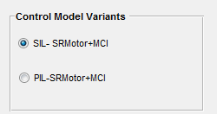

- In case, PIL variant is selected, following subsystem can be used to select COMPORT and to set Baud rate for the Processor:
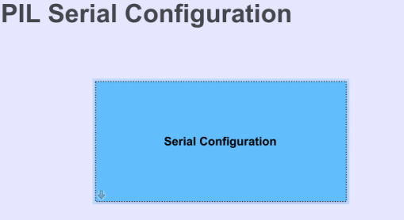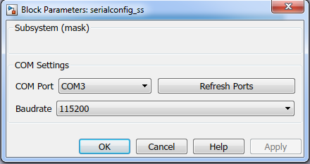
- Since, Motor Control Source code is simulated with SR+MCI, following options are provided to skip the initial delay in the simulation of the speed profile:

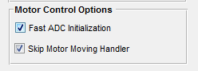

Note: Model is initialized with the above options as checked.

- Select the Control algorithm source code by selecting appropriate source folder from particular project as shown below:
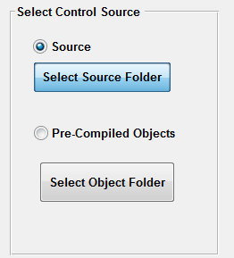

- Alternately, pre-compiled objects can be selected by selecting the appropriate object folder as shown
Below:
NOTE
By Default Object Files are stored at the folder mcu_temp_obj.
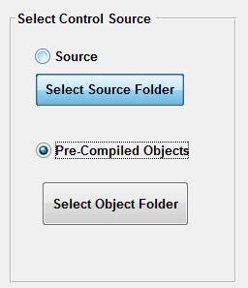

- Select the frequency (Step-Size)of the simulation as shown below:

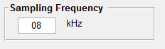

- For the Plants, by selecting the corresponding plant parameter file, parameters will be loaded in the Matlab base workspace as shown. In the below selection, BPM Plant Model will be parameterized for DDBPM Janus 5.0cuft.

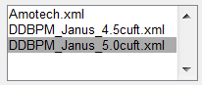

- CIM or BPM Motor can be selected from following controls:

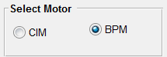

- Model fidelity for the Motor Plant is selected as shown below. Basic Model will invoke the basic formulation of BPM or CIM. Advanced Model will invoke the MBCD plant model FMUs in the architecture.

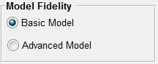

- For BPM Motors, type of the BPM variant can be selected as shown below. Depending upon the selection, appropriate BPM parameter files will be available for selections. Note that by default gBPM will be invoked if VA platform is selected.

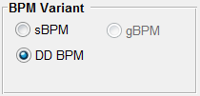

- If VA platform is selected, gBPM motor model can have Agitation and spin mode variants that can be invoked from the controls shown below:

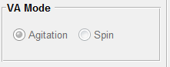

- Stator and Rotor Temperature for both CIM and BPM motors can be set from the following controls. Architecture is initialized to the 22 DegC for both stator and rotor temperatures.

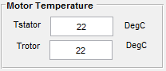

- Input Circuit variant is selected from the controls shown in the figure below. Model is initialized to constant DC bus voltage of 325V.

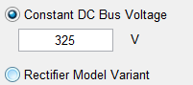

- Note: Board selection can be done independent of Input circuit variant so as to parameterize and simulate the ADC model for which parameters are board specific.

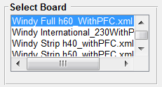

- Rectifier model variant is selected with the help of control as shown in the figure below.

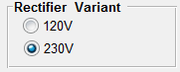

- Note: With PFC variant is invoked only with 230V boards.

- Rectifier variants can be simulated at different frequencies than the control simulation frequency with the help of controls shown in the following figure:

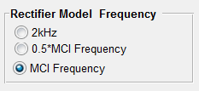

- List of Mechanical parameter file selected will be as shown in the following figure:

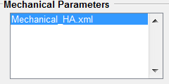

- Mechanical Model Variant Can be changed with the help of following control:

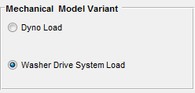

Dyno Load option simulates Mechanical Model as simple load torque acting on the motor shaft.

NOTE (If Dyno Load option is invoked in the Simulation):
- Dyno Load Torque Option for the HA Basic Model variant is disabled as this functionality is modeled in the Advanced Motor model Variants.
- Dyno Load Torque Option for the VA Advanced Model variant is disabled.
- Dyno Load Torque Setting is initialized to zero.
- Dyno Load Torque Profile can be set with the help of following Signal generator block:
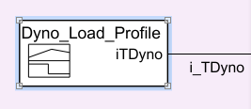

- Drum Inertia can be changed by enabling the drum properties as shown in the following figure:
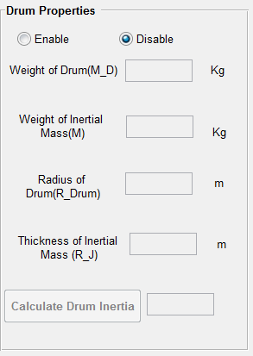

NOTE:
- Above option will be enabled only if Washer Drive System is selected as mechanical model variant.
- Basic Models for CIM and BPM have all of the parameters as plant parameters associated with the calculation of J_Drum. However, MBCD plant models of the BPM and CIM have only J_Drum as plant parameter hence, with the help of model configuration UI, J_Drum can be controlled with same granularity as with the Basic Models of BPM and CIM.

- Once architecture is configured, motor control simulation can be started with the help of following control:

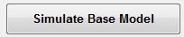

- If the Motor Control Source Code folder is not selected, following message will appear if above control is clicked.

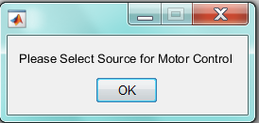

- If the simulation step-size (or MCI Simulation Frequency) is not set, following message will appear:
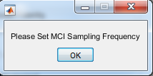

- Matlab base workspace can be saved as .MAT file for the future usage with the help of control as shown below:

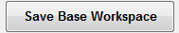

- Once the above control is clicked, following pop up will come to save base workspace:

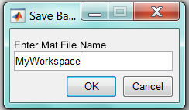

- Note: Matlab Base workspace will be stored as .MAT file in the folder- Saved Workspace

    - Simulation of Existing Project

- Simulation architecture can also be simulated by loading previously stored workspace data.
- In order simulate in this mode, click on Existing Project as shown in the following table while opening the model-

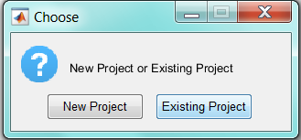

- Once Existing Project is clicked, choose appropriate .MAT file from the Saved Workspace location as shown in the following figure:
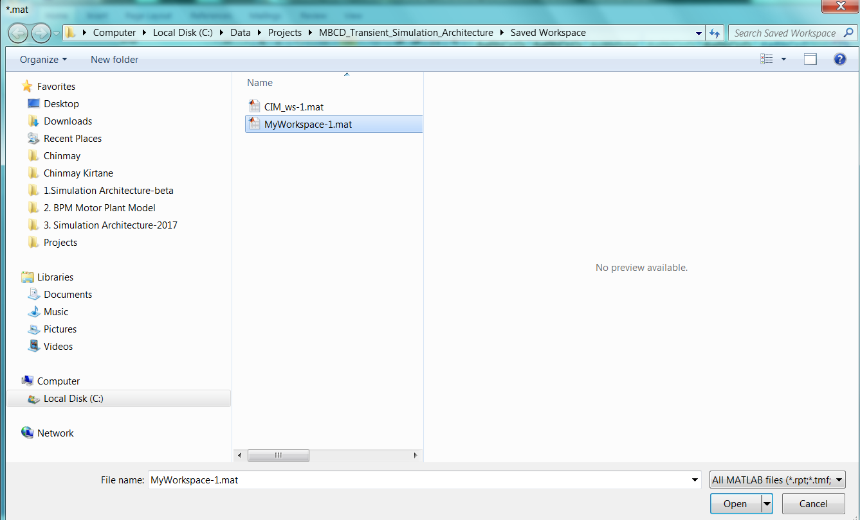

MciAPI
MciAPI Folder contains following modules as shown below:

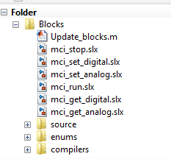

- This Folder contains Models having S-Functions for the following methods:
- MCI Run
- MCI Stop
- MCI Set Digital
- MCI Set Analog
- MCI Get Digital
- MCI Get Analog.

- Above mentioned S-Functions can be used in the Architecture to send or retrieve the data from motor control source code.
- For e.g. mci_get_analog :
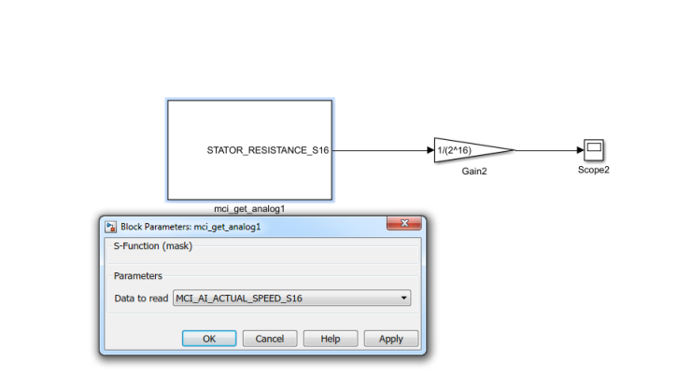

- Required Parameter can be set from the drop down menu available from the mask.

Signal Inspector

- Signal Inspector sub-system can be used to stream the signal to the Simulink Data Inspector:
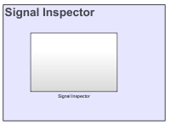

- Signal Inspector GUI will be opened by clicking on Signal Inspector Sub-system:

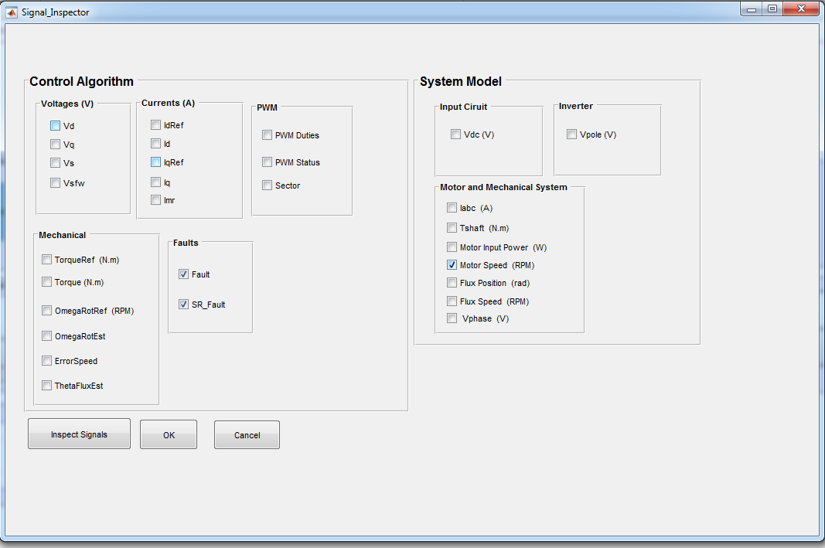

- Signals required to be streamed to the Simulink Data Inspector can be checked as shown in the figure above.
- After the simulation, Simulink data inspector can be opened by clicking on Inspect Signals pushbutton:
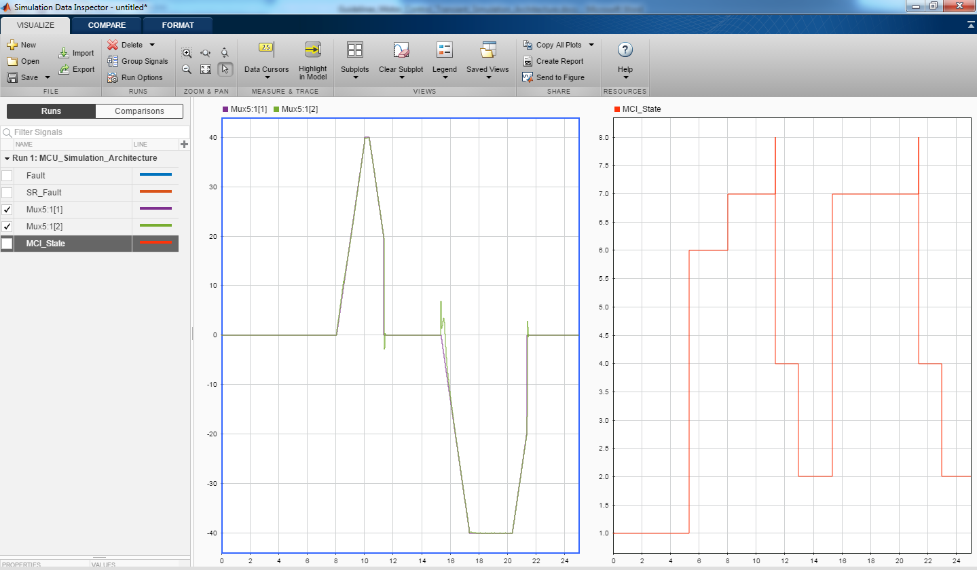

6.7 Exporting as Separate Model
Latest releases of the Simulation Architecture have an extra button to export the current configuration as an independent model.
One of the main reasons for this feature is to expose the architecture to external harness, making it easier to use the results provided by a particular configuration without having to make changes to the actual MCU_Simulation_Architecture.slx model.
After configuring the Simulation Architecture according to item 6.4 you can export such configuration as an atomic model by following these steps:
- Double click on the green button called ‘Export current configuration’.
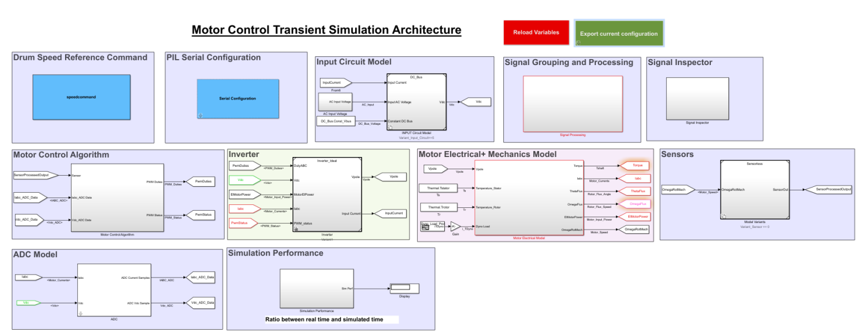
- Type in a name to the new model in the ‘Model’s export name (no extension)’ box. Just a name, without model’s file extension.
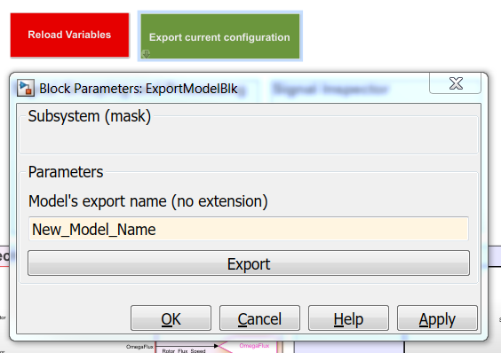
- Click ‘Export’ button.
The new model will be created under the folder ‘Exported Models’ located at your Simulation Architecture root folder.
6.7.1 Using Exported Model as Reference
To use an exported model from a Simulation Architecture configuration, add a Model block into your new model.
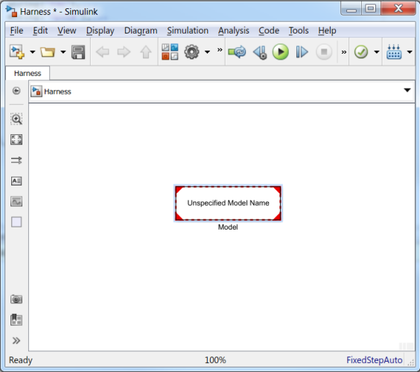
Double click the Model block, click on the ‘Browse’ button and select the exported model inside ‘Exported Models’ folder.
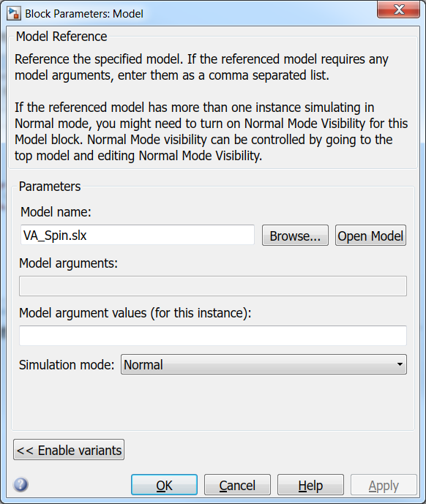

Once you click the ‘OK’ button, the exported model will be shown as a reference in your new model, as bellow:
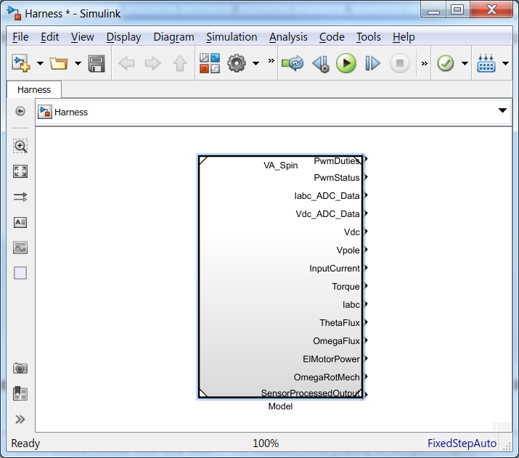

Simulation values can be retrieved from the named output ports, for model’s variables, and using MCI API blocks, for MCI variables, as shown in item 6.5.
6.7.2 Reloading MCU_Simulation_Architecture variables
Each exported model has its own configuration stored in its own Model Worskspace.
Every time one of these models is run, it loads its own configuration into the Base Workspace, which is shared with MCU_Simulation_Architecture model.
If you try to run the MCU_Simulation_Architecture, that is already opened, after one of the exported models, there is a chance of loading values from the exported model that has just run.
To avoid that, when this situation happens, an error message is thrown and the simulation of the MCU_Simulation_Architecture model is halted.
To continue simulating the simulation architecture normally you must double click the red button called ‘Reload Variables’.

