Statement of Work

Although we all generally had a role in each aspect of creating this project, the following shows what the majority of each member focused on:

Bonnie
- assigned roles and made sure they were completed
- planned out meeting times
- worked on documentation
- worked on slides
Arturo
- back end code
- front end code
- tested and debugged
Aviva
- filmed and edited video
- created all external files for app (sounds)
Alex
- worked on documentation
- worked on slides
- created backgrounds/various images for app
Brian
- created visuals
- back end code
- front end code
- tested and debugged

By electronically signing our names below, the Class-C Coders 2.0 team agrees that everything stated above is what each member contributed.
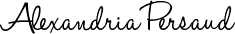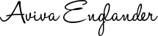
___________________________________________ ____________________________________________
Name Name
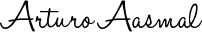
___________________________________________ ____________________________________________
Name Name
___________________________________________ ____________________________________________
Name Name

