TSP 2-OPT Algorithm

**INTRODUCTION**

2-Opt is an approximation algorithm for the Travelling Salesman Problem (TSP). The TSP simply asks the following: for a given list of cities and their coordinates, find the optimal Hamiltonian cycle. Despite its simplicity the TSP is a NP-Hard algorithm. Furthermore, there exist many subtle variants of the TSP. For this report, we will assume the following conditions:

1. The distance between two points is Euclidian

2. The triangle inequality holds.

The 2-Opt algorithm was first suggested by Flood in 1956, but more formally proposed by Cores in 1958. The 2-Opt algorithm belongs to a family of metaheuristics known as stochastic local search. In layman's terms, this metaheuristic does the following:

1. Construct an arbitrary valid solution set

2. Improve the solution set by incrementally exchaning one element within the set with another element from a potential set.

a. If the exchange improves the solution, keep it and continue.

Step number two is called "hill-climbing". It is a greedy heuristic in which the algorithm makes the optimal local choice each time. The image below demonstrates this visual metaphor.

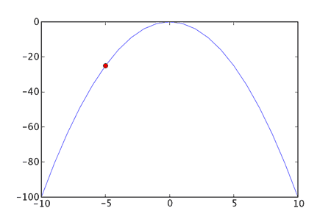

As seen above, the algorithm will continue to go uphill, until it reaches the local maximum at 0, 0.

**HOW IS HILL-CLIMBING IMPLEMENTED IN THE 2-OPT ALGORITHM?**

The 2-Opt algorithm belongs to the class of k-Opt algorithms. The k-Opt algorithms perform k amount of hill-climbing exchanges with each turn. With each step the heuristic chooses the optimal options among adjacent values. Thus, each value has O(nk) neighbors. Within the context of the TSP problem, the 2-Opt algorithm randomly selects two edges and their four endpoints. The two edges then cross, so that the the Hamiltonian cycle is maintained. If this leads to an improvement, this exchange is maintained. If not, then the algorithm maintains the original solution. Since the stochastic local search metaheuristic begins with a valid solution and incrementally makes improvements, we can stop the algorithm and it will return a valid solution. Algorithms with this propery are known as "anytime" algorithms.

**LIMITATIONS OF HILL-CLIMBING**

Hill-climbing is a simple and intuitive way to find the local maximum. However, consider the following graph.

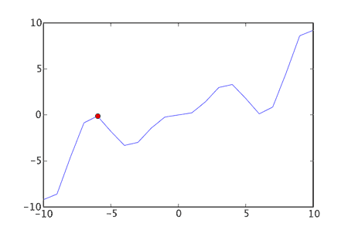

As seen above, since the hill-climbing heuristic only goes "uphill", it will stall once it finds the first local maximum. This may be far from the globally optimal solution. In order to make the 2-Opt algorithm more flexible, we will then need to introduce another heuristic, known as simulated annealing.

**SIMULATED ANNEALING**

Simulated Annealing is a term borrowed from metallurgy. Annealing is a technique where metallurgists apply heat to a material in order to become more flexible and malleable. Analogously, we can use simulated annealing to bend the hill-climbing heuristic to better suit our needs. To do so, we introduce a parameter (sometimes known as temperature) to the algorithm. When the temperature is high, the algorithm allows for greater flexibility. When it's low, it will only make uphill changes. It works as follows:

1. Initialize the temperature variable

2. Perform the edge exchange

a. If the exchange is an improvement, keep it

b. If not, make a probabilistic choice based on the temperature and how much worse the exchange is

3. Decrease the temperature

4. Go to 2.

Initially, the 2-Opt algorithm is flexible with simulated annealing. It is more likely to go downhill for a longer time. However, with time, the algorithm becomes more inflexible and, eventually, it will approximate the behavior of a simple hill-climbing heuristic.

**HOW CLOSE IS THE APPROXIMATION?**

The 2-Opt algorithm can achieve relatively close approximations. Assuming the triangle inequality holds, we can achieve O(sqrt(n)) approximations. Assuming Euclidian distances, we can achieve O(log(n)) approximations. To see a full proof of O(sqrt(n))-approximation, see Engels and Manthey.

**REFERENCES**

1. Englert, Matthias, Heiko, Roglin, and Vocking Berthold. "Worst Case and Probabilistic Analysis of the 2-Opt Algorithm for the TSP". 17 January 2008. TWTH Aachen, Germany, Department of Computer Science.

2. Johnson, David and McGeoch, Lyle. "The Traveling Salesman Problem: A Case Study in Local Optimization". 20 Novemeber 1995. AT&T Bell Laboratories

3. Kim, Byung-In, Shim, Jae-lk, and Zhang, Min. "Comparison of TSP Algorithms". December 1998. https://www.slideshare.net/kaalnath/comparison-of-tsp-algorithms

4. Engels, Christian and Manthey, Bodo. "Average-Case Approximation Ratio of the 2-Opt Algorithm for TSP". Saarland University, Department of Computer Science. http://citeseerx.ist.psu.edu/viewdoc/download?doi=10.1.1.175.635&rep=rep1&type=pdf