Read me  
  
1. Run program.  
  
2. Choose from 1 of 6 options.  
 Output - Print out contents of array  
 Search - Search by a specific value and the index that value is at will return.

Modify - Change the value at a specific index with a new value.

Add - Add a value of your choice to the end of the array.

Remove- Remove the value at the specified index.

Exit - Exits program

Output

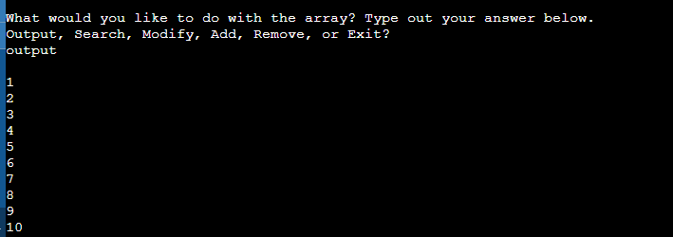

Search

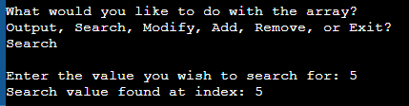

Modify

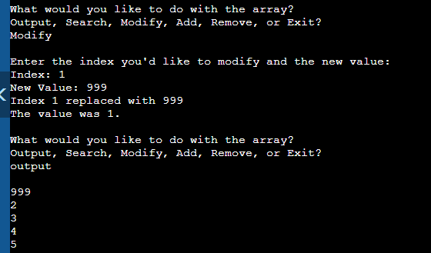

Add

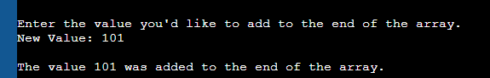

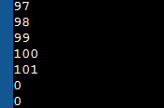

Remove

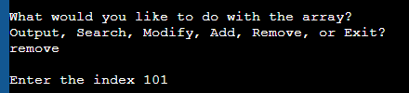

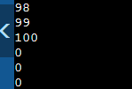

Exit

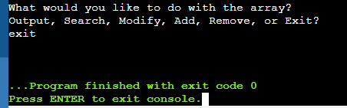

Example of error being thrown

