Emil Hellgren Learning Diary 1 (6)
A2103167 R504TL114-3001

8.2.2024

This learning diary goes through the following subject areas (based on Lapland UAS Cloud Computing):

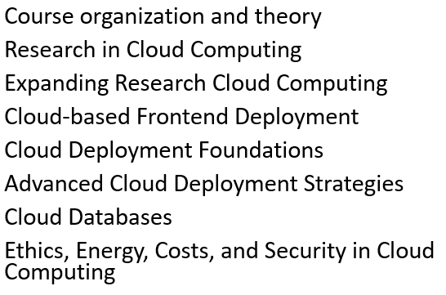

8/9/10 February 2024, Module 1, Course theory

Terminology.

HTTP / HTTPS
- Hypertext Transfer Protocol (/ Secure)
- HTTPS encrypted, HTTP plain text

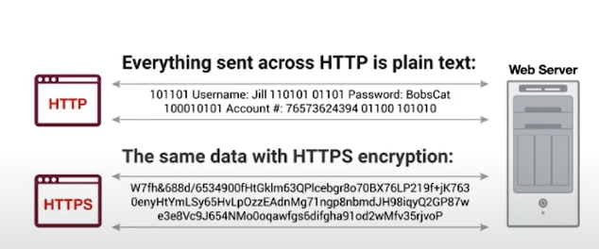

Git
- Version control
- Standard for version control in software development

Pipeline
- Automated process that allows devs and DevOps professionals to efficiently compile, build and deploy.

Virtualization
- Process of creating a virtual version of something
- Virtual computer hardware platforms, storage devices, computer network resources

Containerization
- Lightweight alternative to full machine virtualization that involves encapsulating an application in a container with its own operating environment.
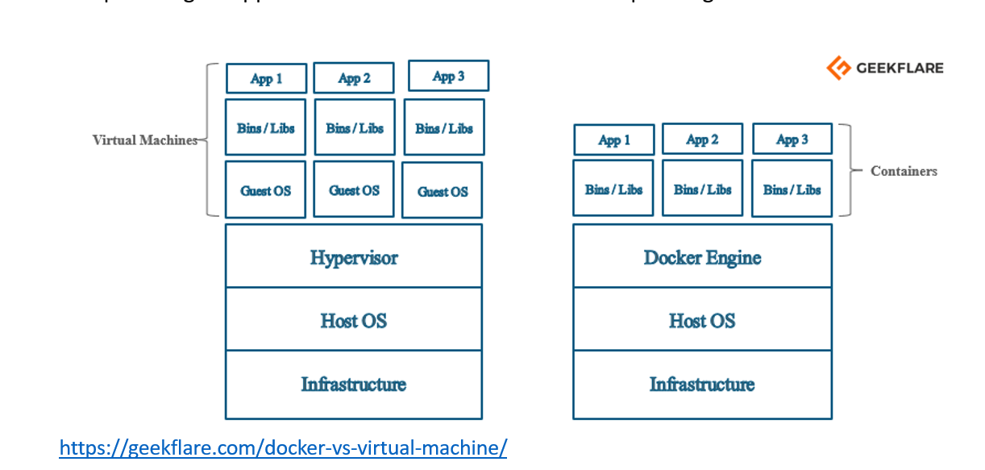

Docker
- Containerization platform
- Allows devs to package apps into containers.
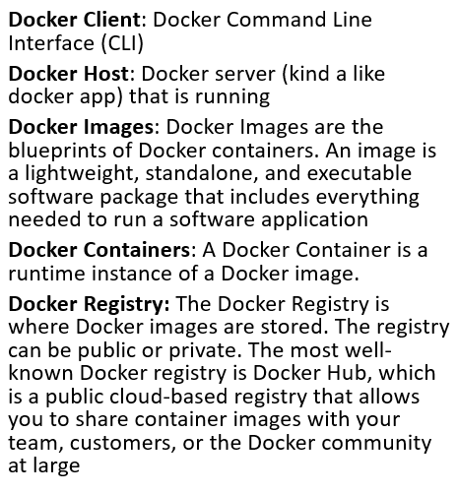
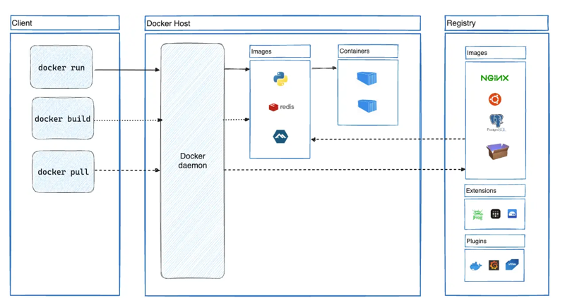

Kubernetes
- Container orchestration platform
- Place to run and manage containers
- Can handle deployment of containers in multiple servers
- Can automatically load balance, deploy the app in the least used server
- Automated Rollouts + Rollbacks, no build breaks so the app is always running.
- Can also scale performance by increasing or decreasing number of backend containers running
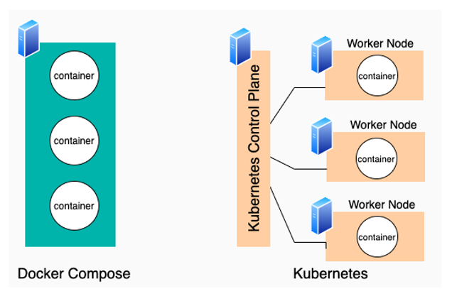

Cloud Service Offerings
- Public, Private and Hybrid Cloud
  - Public cloud sells services to anyone on the internet
  - Private cloud is a proprietary network or a data center that supplies hosted services to limited number of people
  - Hybrid cloud is a combination of the previous two
- PaaS (Platform as a Service)
  - Cloud computing services that provide a platform allowing customers to develop, run and manage apps without building and maintaining the infrastructure.
- IaaS (Infrastructure as a Service)
  - Online services that provide high-level APIs used to dereference various low-level details of underlying network infra like physical computing resources, location, data partitioning, scaling, security, backup
- SaaS (Software as a Service)
  - Method of delivering apps over the Internet as a service.
  - Frees users from software and hardware management

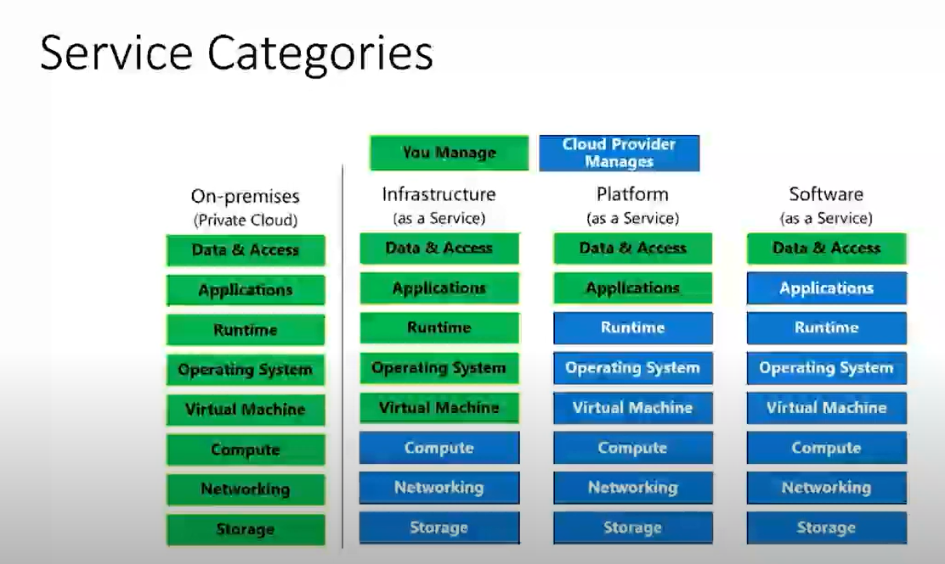

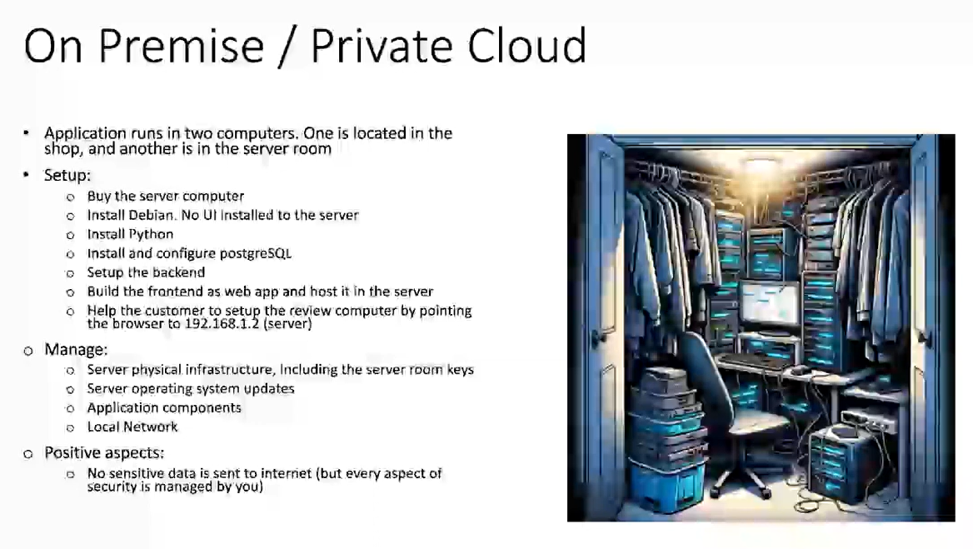

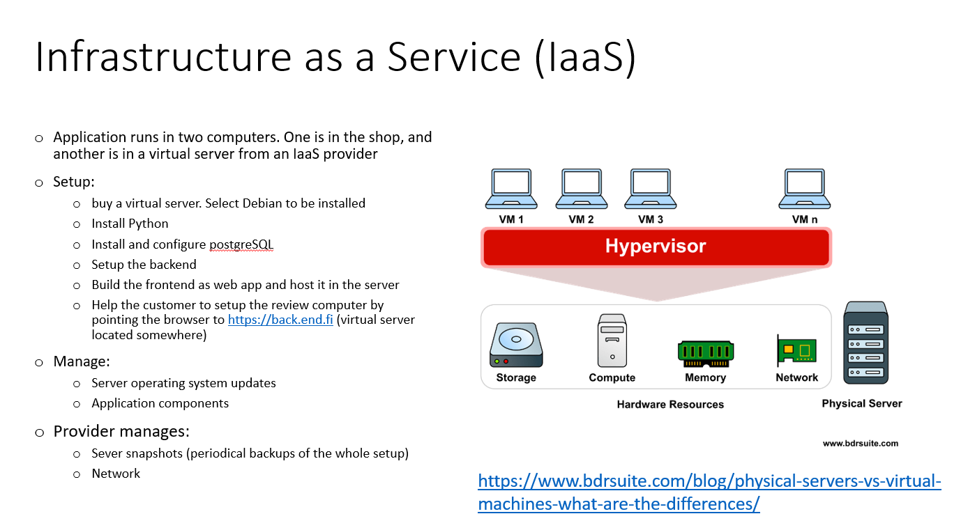

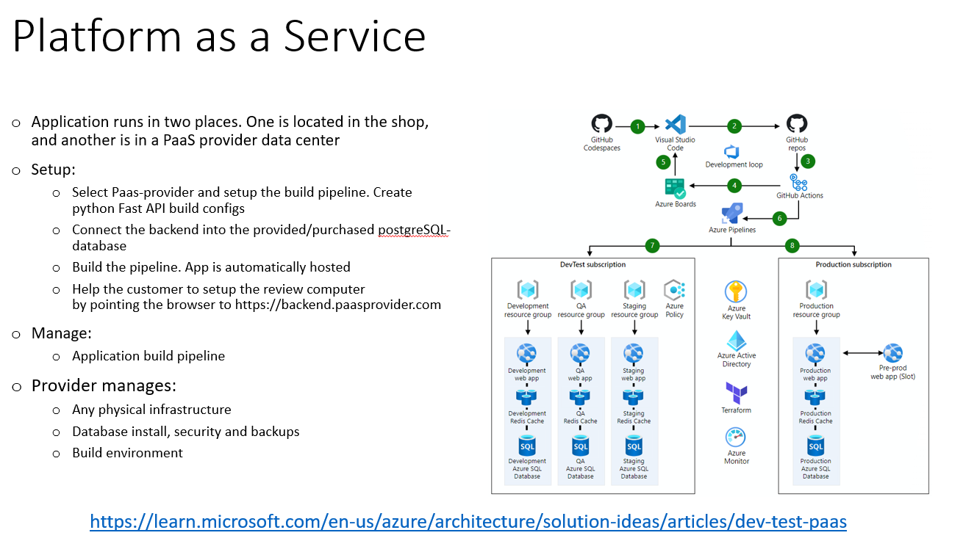

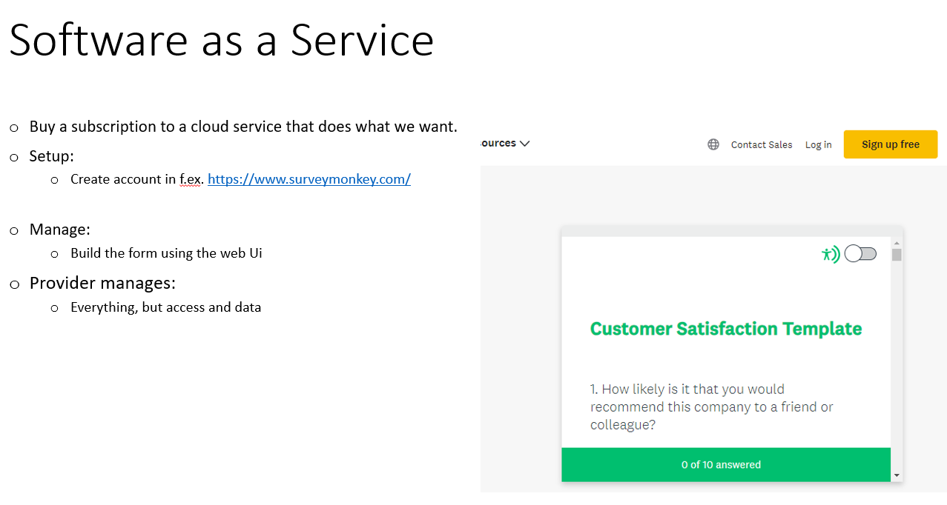

Recap:
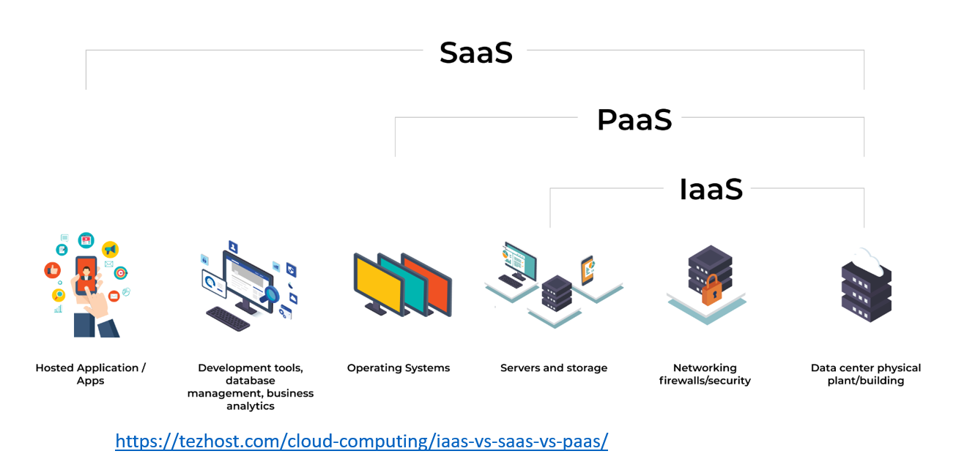

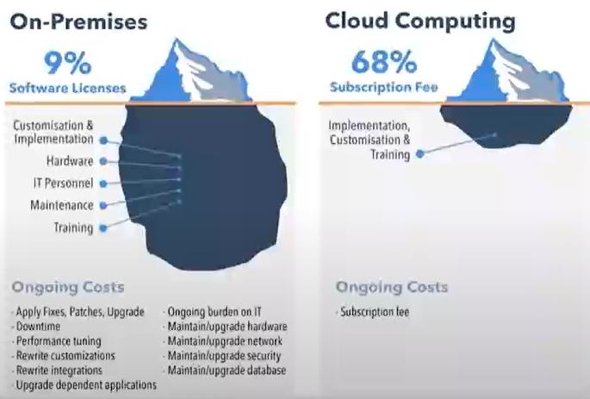

Cost estimator tool:
https://cloud.google.com/products/calculator?hl=en

Online learning platforms:
- Free:
  - AWS, Google Cloud, Azure
- P2P:
  - coursera, Udemy, LearnDash

Exercise 1 (Module 1):

- computer vision: image classification, object detection, semantic segmentation, image analysis, face detection analysis, optical character recognition
- knowledge mining: term used to describe solutions that involve extracting information from large volumes of often unstructured data to create a searchable knowledge store
- risks with ai application dev:
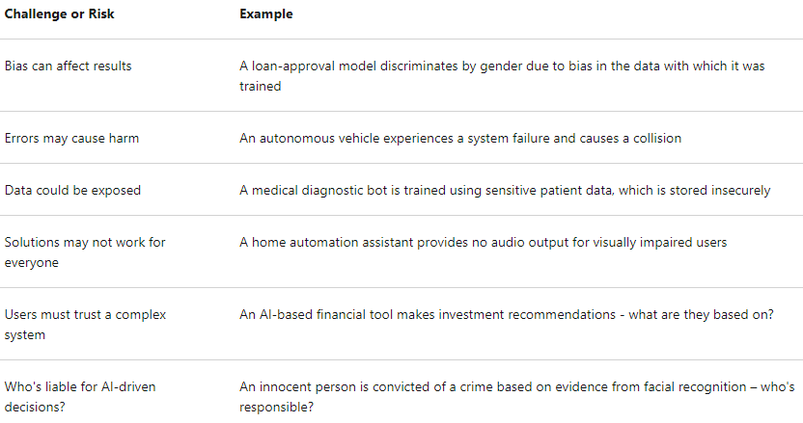

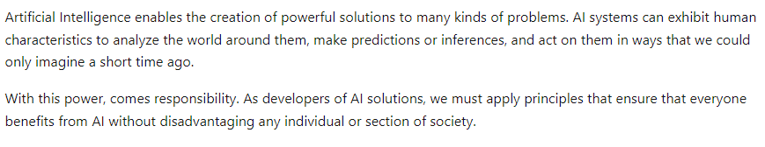

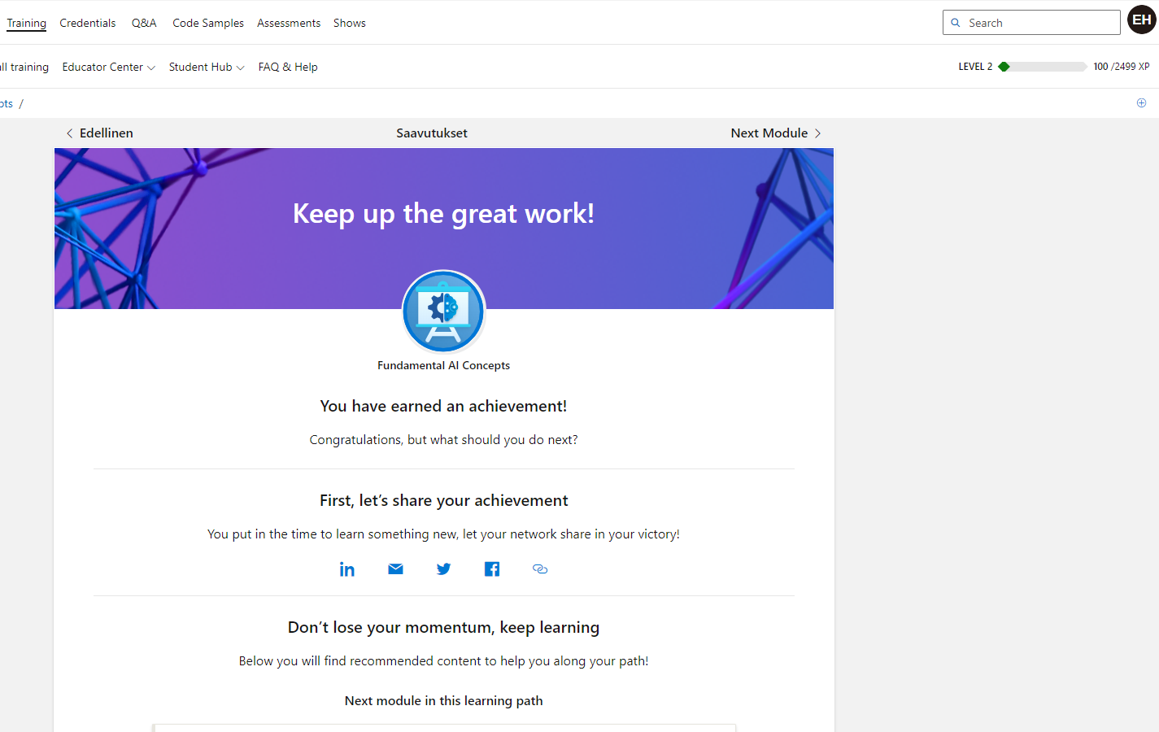

Exercise 2 (Module 1):

Cloud deployment plan for an app with relational database, backend and frontend. Specifying tech stack, cloud provider and IaaS/PaaS.

Tech Stack:
- ReactJS as frontend
- Flask as backend
- MS SQL Server as db

Azure as Cloud provider. Service model would be PaaS to make the load on the Cloud end as light as possible for dev (me).

I would use App Service for hosting the front-/backend for the simplified deployment.

Azure VM for hosting my MS SQL server, I want the hands-on control for my database.

Blob Storage for the object / unstructured data storage and backups.

DevOps for the pipeline and version control.

Summasummarum, I use Azure in my everyday development work and I find it logical and somewhat simple to use.

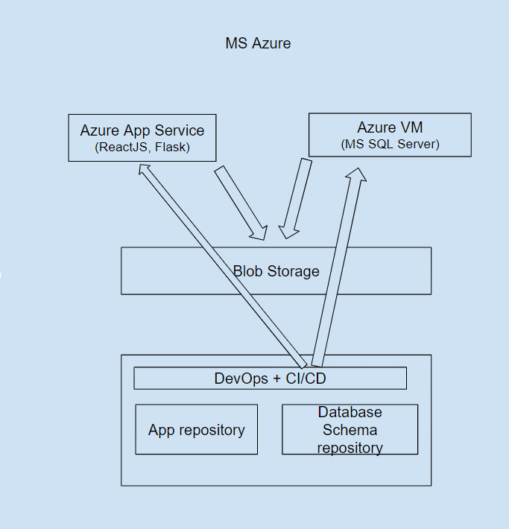

4 March 2024, Module 2

Task:
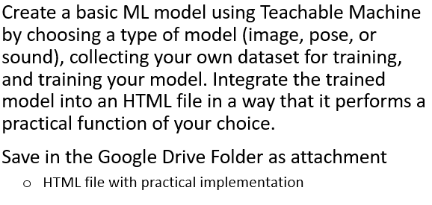

For the task I chose to do an img model, one-pager for helping people to know if they have a cat or not!

I trained the Teachable Machine with 300 cat pictures and 150 human pictures to recognize the difference.

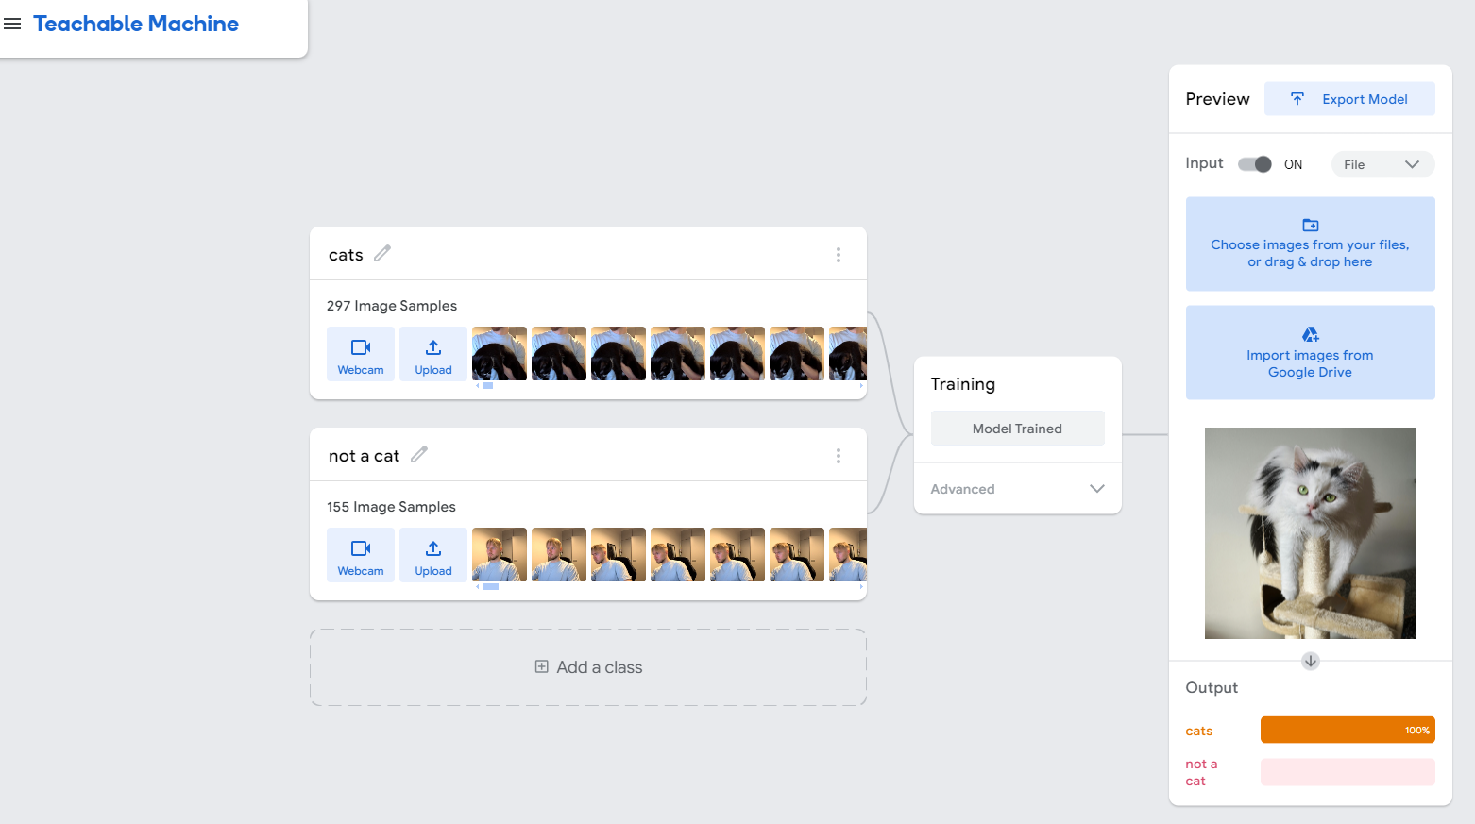

Then I exported the base:

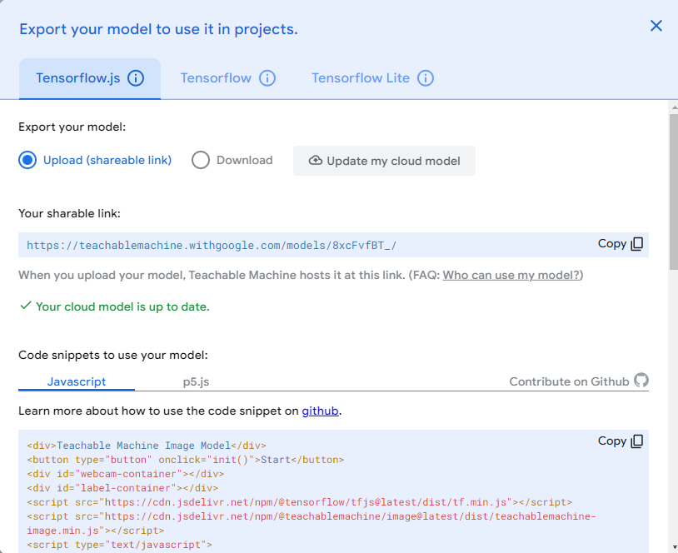

Added btn upload and the project was ready. End result:

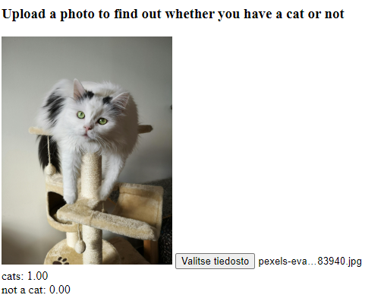

Source-code can be found in my Github:

https://github.com/ehellgre/cloud-computing-2024/tree/master/ml-image-model

13 May 2024, Module 4

Main Task:

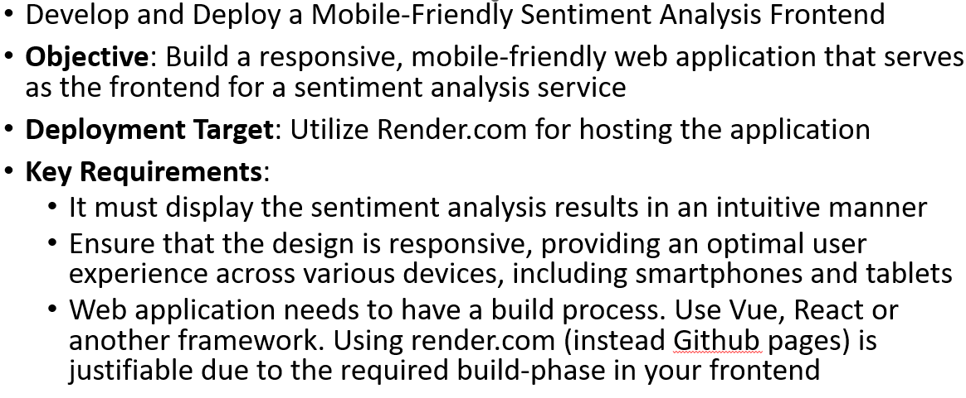

I quickly developed the needed frontend using React. I also used a public api for the sentiment analysis (https://rapidapi.com/symanto-symanto-default/api/sentiment-analysis9/).

Result frontend:

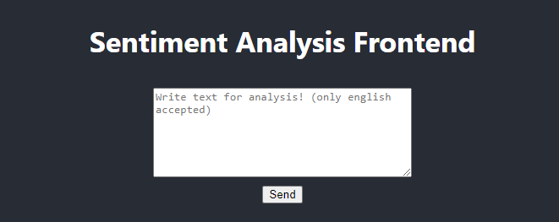
=>
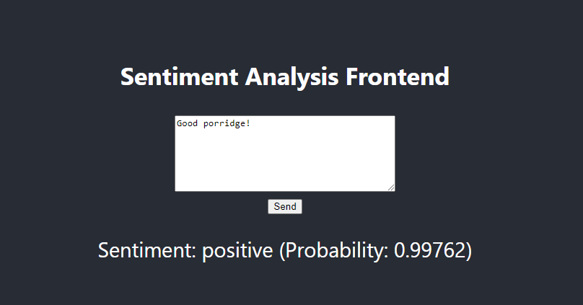

Source code again visible in my Github repo: https://github.com/ehellgre/cloud-computing-2024/tree/master/sentiment-analysis-frontend

Setting up the deployment:

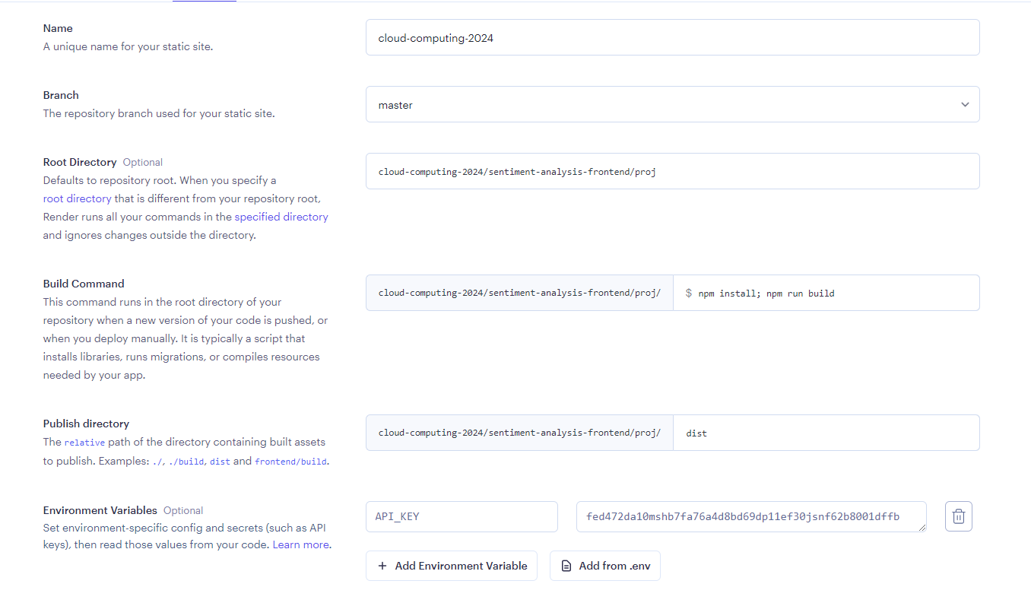

First build failed, correct publish dir should be build instead of dist.

After that change, build succeeded!

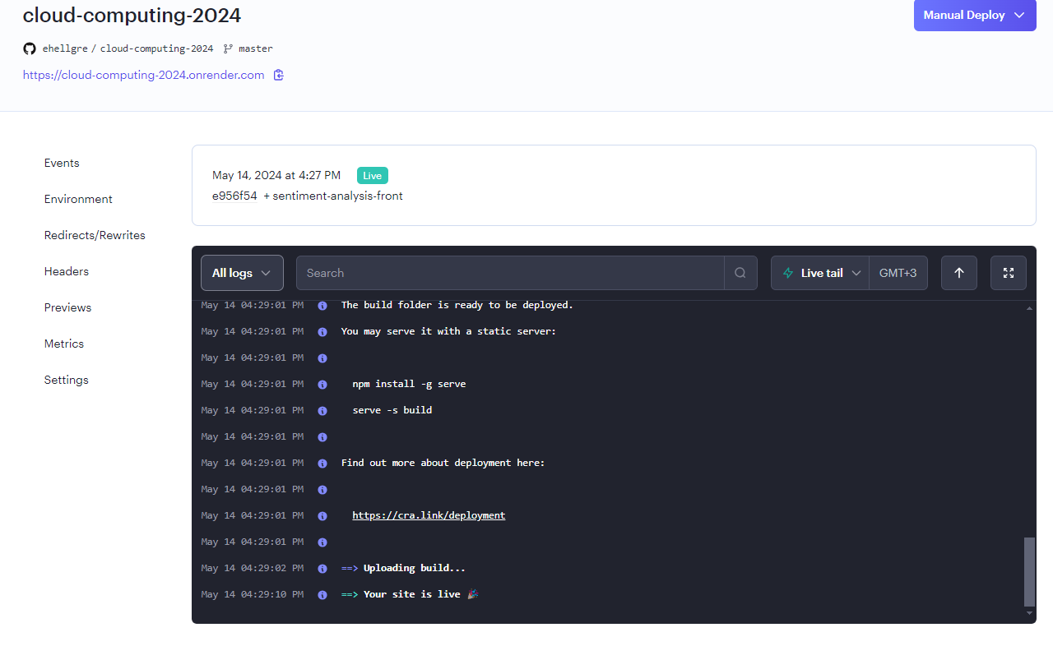

Bugfix: API_KEY changed to REACT_APP_API_KEY

Emil Hellgren
Emil Hellgren

