Eric Henderson
3/8/26
CMT-227

Hands on Project 4

Part 1: Sensitive Data Exposure:

Example:
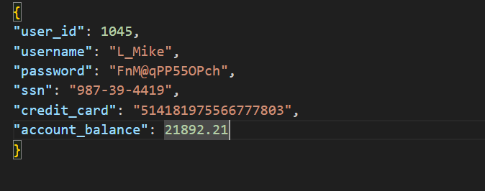

Questions and responses:
- Identify at least three security issues with this JSON response:
  - Three of the six key-value pairs in this JSON would pose a security risk if returned:
    - “password” - this is a plain text password - an exact and unprotected account credential. Passwords need to be hashed when they are stored in a database. A plain text password should never be returned in a JSON response.
    - “ssn” - Social security numbers are regulated data, protected by federal and state privacy laws. An SSN should NEVER be exposed in a JSON response.
    - “credit_card” - Exposing a credit card number in a JSON response is a violation of the Payment Card Industry Data Security Standard. Violations of this standard could incur fines or investigations. Tokenization should be used in place of an exposed card number.
- Explain why exposing this data is dangerous:
  - The data listed in this JSON is very private and vulnerable to attackers. Not only could transmissions of this unprotected data result in theft, but could also violate laws and statutes.
- Rewrite this JSON in a secure version:
  - 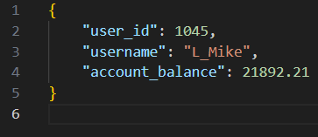
  - This second version of the above file applies the rule of least privilege - providing the client with only the data that is absolutely necessary. The previous response returned far more data than the client actually needs.
  - I kept the account_balance pair - this is legitimate data for a user viewing their own account.
  - Sometimes, the best way to protect user data is to provide them with the least data possible.

Part 2: Overexposed API Response:

Example:
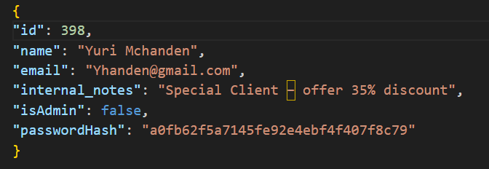

Questions and responses:
- Which fields should NOT be sent to the client?
  - “internal_notes” - Internal business rules and strategy should never be returned in a public-facing API response. This exposes business logic to users.
  - “isAdmin” - This value is almost certainly used as an authorization flag. Returning this flag is very dangerous because it can be so easily bypassed by intercepting and modifying the response.
  - “passwordHash” - This is a hashed password. Even a hashed password should never be returned from an API response.
- Why is exposing password hash still risky?
  - Exposing a password hash, especially the above hash, is extremely risky.
  - The above value is an MD5 hash - these are cryptographically broken and trivially crackable when passed through a rainbow table.
- Provide a secure response example:
  - 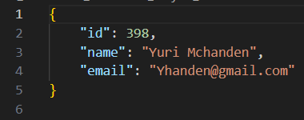
  - Like in the first part of the assignment, I have again applied the principle of least privilege in this second version. The three fields omitted posed the highest security risk.
  - The exposed password hash belongs in the authentication layer ONLY.
  - Authorization flags should never even be considered in client-side responses; server-side only.
  - Business strategy, like what was being exposed in “internal_notes” should NEVER even find their way into a client side response.

