|  |  |
| --- | --- |
| Contract Number | {{ContractNumber}} |
| Contract Term | {{term}} months |
| Contract Start Date | {{ContractStartDate}} |
| Contract End Date | {{ContractEndDate}} |

**Contract Summary**

{{#lineitems}}

**{{ProductName}}**

|  |  |
| --- | --- |
| **NUMBER OF SERVICES: {{Quantity}}** | **CONTRACT TERM : {{term}} months** |
| **UNIT Price: {{UnitPrice}}** | **TOTAL Price: {{TotalPrice}}** |
| **SERVICE ADDRESS:**  **{{ContractAccountName}}**  **{{street}}, {{city}},**  **{{state}} {{country}}** | |

{{/lineitems}}

GENERAL TERMS AND CONDITIONS

Cancellation

If you cancel any of the Services on an Individual Service:

(a) before the Service Start Date, then you must pay Vlocity all infrastructure and installation costs incurred by Vlocity in connection with preparation for the provision of the Service or Individual Service; or

(b) during the Contract Term, then you may have to pay Vlocity a Cancellation Fee, as set out in the Standard Form of Agreement Pricing Table for the relevant Service.

Privacy Information

We collect personal information in forms like these and also during our on-going relationship with you. We use it to supply products, give you the best possible service and for the other purposes described in our privacy policy. Without it, we may not be able to supply products or provide the level of service you expect.

We share personal information within the Vlocity Group and with a number of other service providers and partners for these purposes; some of whom may be overseas.

Unsolicited Sales

If you have purchased a good or service from us as a result of an unsolicited telemarketing call or visit, you have a right to cancel your service within 80 business days from and including the day after you signed or received this agreement. Please contact your Vlocity sales representative for details about your additional rights to cancel this agreement and the cancellation form.

Produce-specific terms and conditions

The section below detailed information relevant to your products and services in plain language that is easy to understand. For further information and the full terms and conditions about other product and services which do not have a Critical Information Summary, please refer to the Standard Form of Agreement found at [www.vlocity.com](http://www.vlocity.com)

PRODUCT SPECIFIC TERMS AND CONDITONS



Market Energy Index Product

Product Information

Since the customer is basically absorbing all the risk that the price will fluctuate, there is no variable load cost associated with this option. This hourly fluctuation can make it difficult for some businesses to accurately manage their cost as it relates to the quantity that needs to be consumed for that particular hour. However, businesses can take advantage of price volatility to competitively plan and manage the quantity of electricity they consume based on anticipated hourly prices. Manufacturers, for example, can opt to use more electricity at off-peak hours (overnight).

Addittional Information

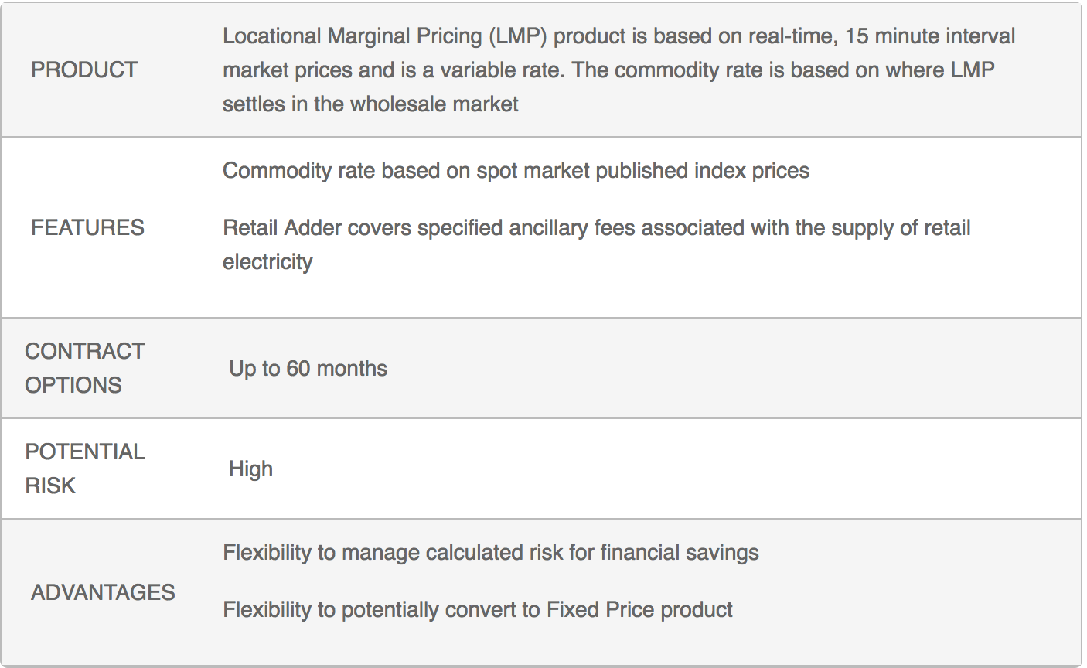

There are no product specific terms and conditions. Only the general terms and conditions will apply

**UAN/Meters Quoted**

|  |  |  |  |
| --- | --- | --- | --- |
| Meter ID | Peak Demand | Meter Type | Exclude |
| {{#Meters}} {{MeterId}} | {{Demand}} kW | {{MeterType}} | **{{/Meters}}** |

|  |  |
| --- | --- |
| {{Company_Name}} | Keton Energy Inc. |
| Signature:  \vlcSignHere1\ | Date:  \vlcSignDate1\ |