Orange Juice Sales Analysis

Eric Hestekin

1/14/2019

I was provided with orange juice sales data for 1070 orange juice purchases. The data contained pricing and sales data for two different brands of orange juice, Minute Made and Citrus Hill. This analysis was performed to determine the affect of price on sales of orange juice.

The analysis found that 61% of the orange juice sales were for Citrus Hill. Citrus Hill had a median price $0.23 (11%) lower than Minute Maid. The plot below shows the price distribution of the Citrus Hill sales prices:

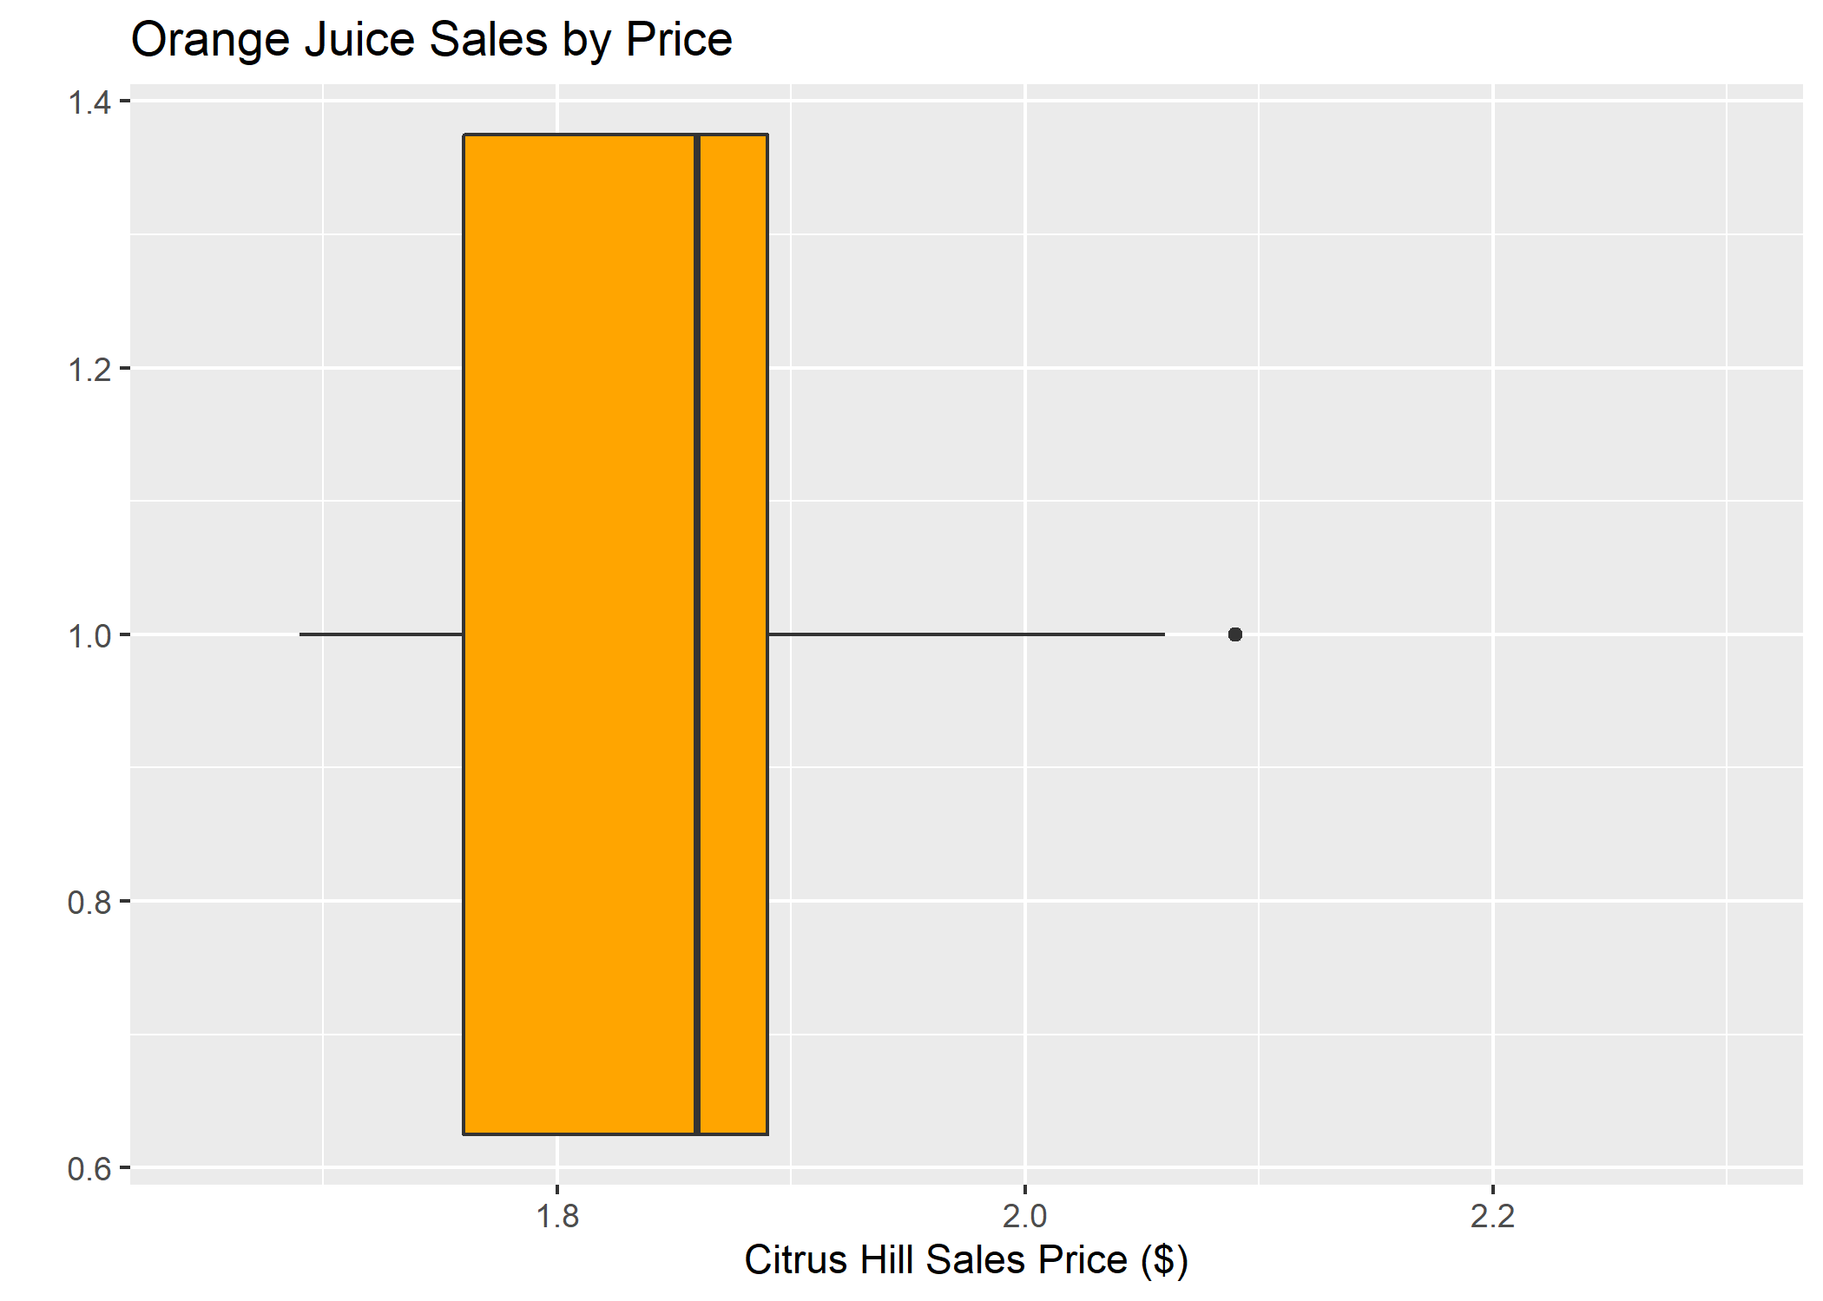

Note the larger variation in price in the 2nd quartile compared to the 3rd quartile.

The analysis implies that price is a significant factor in determining orange juice sales. Further analysis is required to determine other factors.

Best, Eric Hestekin