CS-322 SOFTWARE CONSTRUCTION
SOFTWARE REQUIREMENTS
SPECIFICATION
Scholarship Management System
Presented by
Muhammad Khizar (04072413008)
Ahsan Ali (04072413001)
Supervised by
Dr. Onaiza Maqbool
Department of Computer Science
Quaid-i-Azam University, Islamabad
Version 1.0 | 15 October 2026

SRS Approval Signatures
Role | Name | Signature | Date
Project Manager | ________________________ | ________________________ | ____________
Team Member 1 | Muhammad Khizar | ________________________ | ____________
Team Member 2 | Ahsan Ali | ________________________ | ____________
Stakeholder / Supervisor | Dr. Onaiza Maqbool | ________________________ | ____________

Change History
Version | Date | Modified by | Description
1.1 | 07/10/2026 | Ahsan Ali | Initial SRS

Table of Contents
1. Introduction
1.1 Purpose
1.2 Scope
1.3 Definitions, Acronyms, and Abbreviations
1.4 References
1.5 Overview
2. Overall Description
2.1 Product Perspective
2.2 Product Functions
2.3 User Characteristics
2.4 Constraints
2.5 Assumptions and Dependencies
3. Specific Requirements
3.1 External Interface Requirements
3.2 Functional Requirements
3.3 Performance Requirements
3.4 Logical Database Requirements
3.5 Software Quality Attributes
3.6 Requirements Verification
Appendix A: Use-Case Summaries
Appendix B: Items Requiring Stakeholder Confirmation
Change History

1. Introduction

1.1 Purpose
This Software Requirements Specification (SRS) defines the functional and non-functional requirements for the Scholarship Management System developed for Quaid-i-Azam University. It provides a common reference for stakeholders, developers, and testers and supports implementation, verification, and validation.

1.2 Scope
The Scholarship Management System is a web-based application for publishing scholarship opportunities and managing student applications. Authorized scholarship administrators can create and publish need-based and merit-based advertisements, review applications, record feedback and decisions, and manage scholarship information. Students can browse published scholarships, review eligibility criteria and deadlines, submit applications and supporting documents, and track application status.
- User authentication and role-based access for students and scholarship administrators.
- Creation and publication of scholarship advertisements with categories, eligibility criteria, required documents, opening dates, and deadlines.
- Student application forms, document upload, validation, submission confirmation, and unique tracking IDs.
- Administrative review of applications and documents, recording feedback and assessment results, and recording selection or rejection decisions.
- Student access to application status and released feedback, with notifications when a notification service is configured.

1.3 Definitions, Acronyms, and Abbreviations
Term | Definition
Administrator | Authorized user who creates scholarship advertisements and reviews applications.
Student | Applicant who views scholarship advertisements and submits scholarship applications.
SRS | Software Requirements Specification.
FR | Functional Requirement.
PR | Performance Requirement.
Tracking ID | Unique identifier issued for a successfully submitted application.
Need-based scholarship | Scholarship assessed using financial-need information and criteria provided by the university.
Merit-based scholarship | Scholarship assessed using academic/merit information and criteria provided by the university.

1.4 References
IEEE Std 830-1998, IEEE Recommended Practice for Software Requirements Specifications.
Prressman Software Engineering Book

1.5 Overview
Section 2 describes the system context, users, constraints, and assumptions. Section 3 specifies interfaces, functional requirements, performance expectations, data requirements, quality attributes, and verification. Appendix A summarizes key use cases; Appendix B lists details that require stakeholder confirmation.

2. Overall Description

2.1 Product Perspective
The system is a browser-accessible university application that centralizes scholarship advertisements, application submission, administrative review, and status tracking. It stores user, scholarship, application, document-reference, review, decision, and tracking information. Integration with university authentication, student-record, or notification services is not assumed unless a documented interface is made available.

2.2 Product Functions
- Authenticate users and enforce student/administrator permissions.
- Create, validate, edit, publish, and display scholarship advertisements.
- Allow students to browse advertisements and view eligibility requirements.
- Collect application information and supporting documents, validate submissions, and issue tracking IDs.
- Allow administrators to inspect submissions, record feedback and assessments, and make decisions.
- Allow students to view their own application statuses and released feedback.
- Provide submission confirmations and relevant notifications when configured services are available.

2.3 User Characteristics
Students are expected to have basic digital literacy and be able to use a supported browser, complete forms, and upload documents. Scholarship administrators are expected to understand scholarship categories, eligibility criteria, deadlines, and review procedures. Any system-maintenance personnel are responsible for operational maintenance and data protection.

2.4 Constraints
- The system is intended to be accessed through a supported web browser and requires network connectivity.
- Students must not access administrative functions or other students’ private application records.
- The project draft identifies HTML, CSS, JavaScript, Java, MySQL, and Apache Tomcat as intended technologies; the team should confirm these implementation choices.
- Draft-supported upload formats are PDF, DOCX, JPG, and PNG. Maximum file size and other validation limits must be confirmed.
- The system must comply with applicable university privacy and data-security policies.

2.5 Assumptions and Dependencies
- Users have internet access and a supported browser.
- Administrators enter accurate scholarship descriptions, criteria, required documents, and deadlines.
- Scholarship eligibility and assessment rules are provided by the university or authorized administrator.
- Email or other notification delivery depends on the availability and configuration of the relevant service.
- Any integration with university authentication or student-record systems depends on documented interfaces and authorization.

3. Specific Requirements
The requirements below are individually identifiable and testable. “Shall” indicates a mandatory requirement.

3.1 External Interface Requirements

3.1.1 User Interface
The system shall provide role-appropriate interfaces for students and scholarship administrators. Forms shall use clear labels and provide validation, error, and confirmation messages. Scholarship pages shall display relevant categories, eligibility criteria, required documents, opening dates, and deadlines.

3.1.2 Software Interfaces
The system shall use its configured database to store and retrieve user, scholarship, application, document-reference, review, decision, and notification records. Any external authentication, student-record, or notification interface shall be specified once the provider and interface are confirmed.

3.1.3 Communications Interfaces
Users shall access the system over a network using a supported web browser. If email notifications are enabled, the system shall use the configured email service and record relevant delivery failures for operational follow-up.

3.2 Functional Requirements

3.2.1 Authentication and Access Control
1: The system shall allow an authorized user to sign in using the configured credentials or authentication service.
2: The system shall distinguish student and scholarship-administrator roles and restrict functions and records according to the authenticated role.
3: The system shall deny access to protected functions when a user is not authenticated.

3.2.2 Scholarship Advertisement Management
4: The system shall allow an administrator to create an advertisement containing a title, category, description, eligibility criteria, required documents, opening date, and application deadline.
5: The system shall allow the administrator to classify an advertisement as need-based or merit-based.
6: The system shall validate required advertisement fields and identify missing or invalid information.
7: The system shall save and publish a valid advertisement and confirm successful publication to the administrator.
8: The system shall display published advertisements to students with their category, description, eligibility criteria, required documents, opening date, and deadline.
9: The system shall not present an advertisement as open for applications before its opening date or after its deadline.

3.2.3 Scholarship Application Submission
10: The system shall allow an authenticated student to open a published advertisement and view its eligibility criteria before applying.
11: The system shall provide an application form for a selected scholarship.
12: The system shall allow the student to enter the personal, biographical, and academic information required for the application.
13: The system shall allow the student to upload supporting documents in configured supported formats.
14: The system shall validate required fields and uploaded files before accepting an application.
15: The system shall identify missing or invalid information and allow the student to correct it before submission.
16: The system shall allow the student to review the completed application before final submission.
17: The system shall save a valid submitted application and update the relevant application record.
18: The system shall issue a unique tracking ID and display a submission confirmation after a successful submission.
19: The system shall preserve application progress where supported by the active session and provide a recovery path after an interruption; the exact recovery behavior shall be verified during testing.

3.2.4 Application Review and Decision
20: The system shall allow an authorized administrator to view submitted application details and associated uploaded documents.
21: The system shall allow an authorized administrator to record review comments or feedback for an application.
22: The system shall allow an authorized administrator to record a decision, including selected/approved or rejected.
23: The system shall support assessment of merit-based applications using academic information and criteria supplied for the scholarship.
24: The system shall support assessment of need-based applications using financial-need information and criteria supplied for the scholarship.
25: The system shall retain review comments, assessment results, and decisions against the relevant application.

3.2.5 Application Status Tracking and Notifications
26: The system shall allow a student to view the status of their own submitted applications.
27: The system shall allow a student to retrieve application tracking information using the tracking ID, subject to appropriate access checks.
28: The system shall display administrator feedback and recorded decisions to the student when that information is released.
29: The system shall confirm successful application submission and notify the student of relevant status changes when notification services are configured.
30: The system shall allow administrators to manage scholarship advertisements and submitted applications within their authorized permissions.

3.3 Performance Requirements
PR-01: Under normal operating conditions, common user actions should respond within two seconds. The team shall define the test environment, workload, and response-time percentile used to verify this target.
PR-02: The system shall display a confirmation or an error message after an application submission attempt completes.
PR-03: The system shall validate required fields and uploaded files before finalizing an application.

3.4 Logical Database Requirements
The system shall maintain records for users and roles, scholarship advertisements, application submissions, uploaded-document references, review comments, assessment results, decisions, and tracking identifiers. Each application shall be associated with the student who submitted it and the scholarship for which it was submitted. Access to records and documents shall be restricted according to role and ownership. Data-retention periods and backup frequency shall follow university policy and must be confirmed by stakeholders.

3.5 Software Quality Attributes
Security: The system shall enforce authentication and role-based authorization and protect personal information and application documents from unauthorized access.
Reliability: The system shall not present an application as submitted unless it has been saved successfully and shall provide clear outcomes for successful and unsuccessful operations.
Usability: The system shall use consistent terminology and understandable validation, error, and confirmation messages.
Maintainability: Requirements, validation rules, and application-status values shall be documented so they can be reviewed and updated without ambiguity.
Portability: The web interface should work with agreed supported modern browsers on commonly used desktop and mobile devices.

3.6 Requirements Verification
Each requirement shall be verified by inspection, analysis, or a test case. Testing shall cover valid and invalid input, role-based access, advertisement publication, application submission, file validation, administrative review, decision recording, and status tracking. Requirements dependent on external services shall be verified when those services are available.

Appendix A: Use-Case Summaries

UC-01 Advertise Scholarship
Primary actor: Scholarship Administrator. Preconditions: the administrator is authenticated. Main flow: enter scholarship title and description; select need-based or merit-based category; provide eligibility criteria, required documents, opening date, and deadline; submit the advertisement. The system validates, saves, publishes, and confirms it. Alternate flow: if information is missing or invalid, the system displays validation messages and allows correction.

UC-02 Apply for Scholarship
Primary actor: Student. Preconditions: the student is authenticated, a scholarship advertisement is published and open, and the student meets the applicable eligibility conditions. Main flow: open the advertisement; review criteria; complete the application form; upload required documents; review and submit. The system validates and saves the application, issues a tracking ID, and confirms submission. Alternate flow: if required information or files are invalid, the system identifies the issue and allows correction.

UC-03 Review Application
Primary actor: Scholarship Administrator. Preconditions: one or more applications have been submitted. Main flow: open an application; inspect submitted information and documents; record assessment and feedback; record a decision. The system saves the review and makes the appropriate status available to the student.

UC-04 Track Application
Primary actor: Student. Preconditions: the student has submitted an application. Main flow: open the application-status view or provide the tracking ID through the supported tracking function. The system checks access and displays the corresponding status and released feedback.

Appendix B: Items Requiring Stakeholder Confirmation
The supplied project material does not fully define the following items. They should be confirmed by the project stakeholders rather than assumed:
- Maximum upload size and exact file-validation rules.
- Authentication method and whether university single sign-on is available.
- Notification channels and the exact events that trigger notifications.
- Detailed merit and need assessment formulas and whether calculations are automatic or administrator-assisted.
- Permitted application-status values and the decision/reconsideration workflow.
- Application-data retention period, backup frequency, and recovery expectations.
- Whether a student may submit multiple applications and whether only one scholarship may be awarded.
- Supported browser/device matrix and measurable performance-test conditions.

Change History
Version | Date | Description
1.2 | 15/10/26 | Cleaned structure and formatting

System Sequence Diagram:
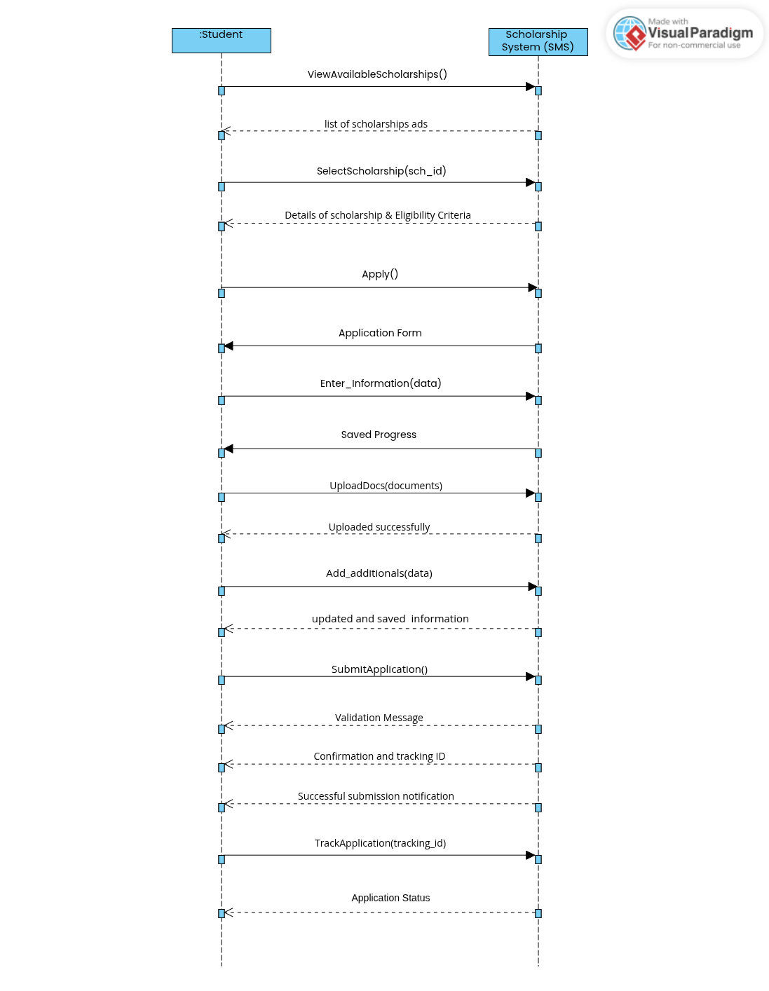

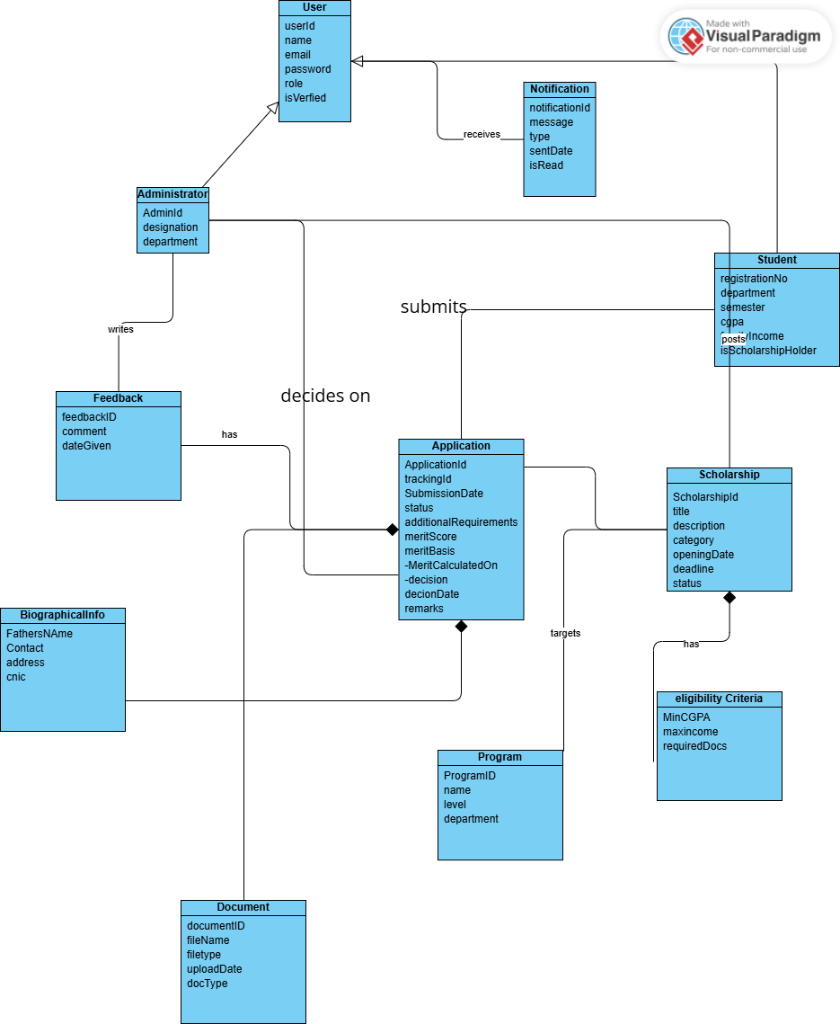
Domain Model:

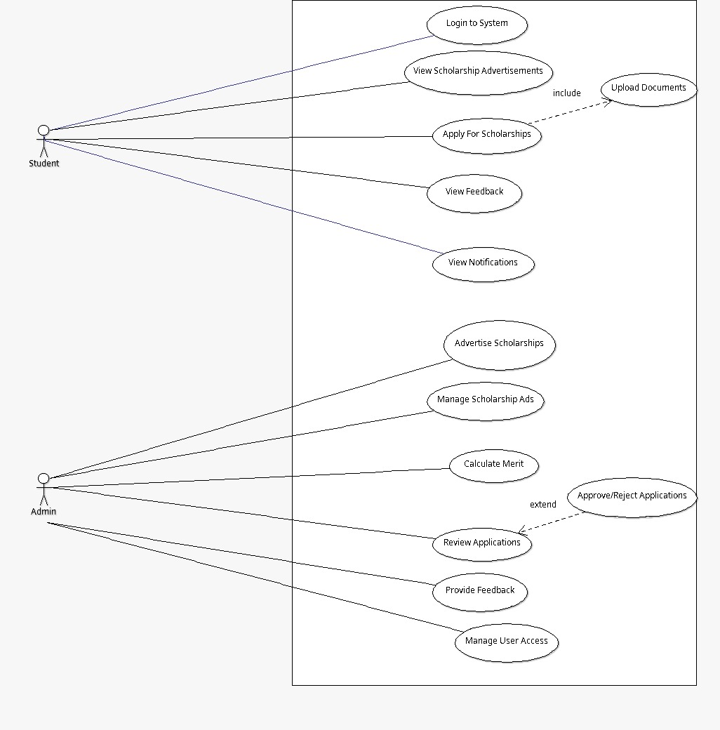
Use Case Diagram:

