SOCIAL MEDIA PORTFOLIO

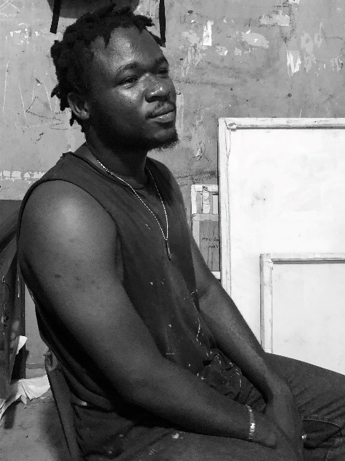

Charles Ephraim Ola is a digital marketing creative based between Benin city and Lagos. He has had experience working for brands in art and magazine and also social media. While doing so, he manages the social media accounts for businesses while continuing to educate himself by utilizing online courses and media to better her skill set. Charles is passionate about all of the work he does and holds the skills of being detail-oriented, organized, responsible, a team player, communicative, and manages his time evenly, all while holding a consistent positive attitude.

**EMAIL:** [Charles.ola@outlook.com](mailto:Charles.ola@outlook.com)

DIGITAL **RESUME**

**THE HUTS MAGAZINE**

Social Media Manager | January 2022 – Present

**THE PONTY COLLECTIVE**

Freelance content creator | January – February 2023

MARKETING & DESIGN **SKILLS**

**EDITING PROGRAM**

Adobe Creative Suite

Corel Draw

**MARKETING**

Google Analytics

Google Ads

Facebook Ads Management

Hootesuite

Hubspot

**SOCIAL MEDIA SKILLS**

SOCIAL MEDIA PLATFORMS

: Instagram

Twitter

YouTube

Facebook

Pinterest

Spotify

Apple Music

SoundCloud

Social Media Planning –

Social Media Strategy –

Social Media Insights –

Social Media Design –

- Full Production

You can find additional information here