AnoChat Workspace
Client Presentation Document
A modern standalone SaaS workspace for project management, team chatter, user roles, monitoring, and operational visibility.
Frontend  Vercel static workspace | Backend  FastAPI service | Database  PostgreSQL

1. Executive Overview
What AnoChat gives the client
- A polished login experience and protected workspace access.
- Role-based access: admin users manage the complete system, while other roles see assigned work and chatter.
- Project records automatically connect to team conversation spaces.
- Chatter supports attachments, mentions, deleted-message handling, and contact-detail masking.
- Monitoring gives a clean audit trail for activity across the workspace.
2. Login Experience
Secure entry point for all workspace users
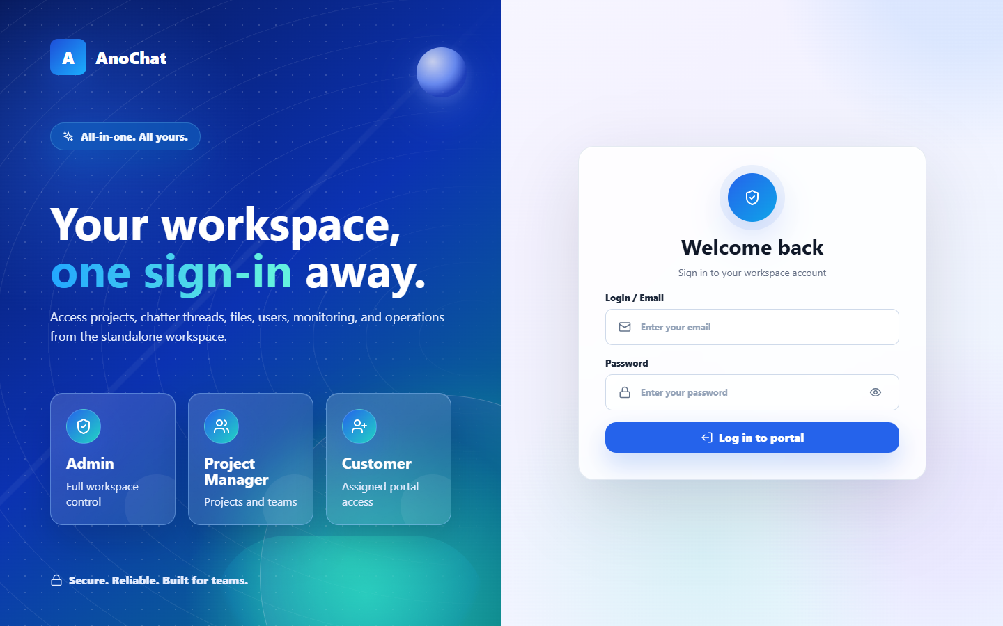
Figure 1: Premium SaaS login page with AnoChat branding and role positioning.
- The login page uses a split-screen SaaS layout with clear brand positioning.
- Credentials are no longer prefilled, which is safer for production use.
- The frontend is configured to communicate with the deployed backend gateway.

3. Dashboard
A concise workspace command center
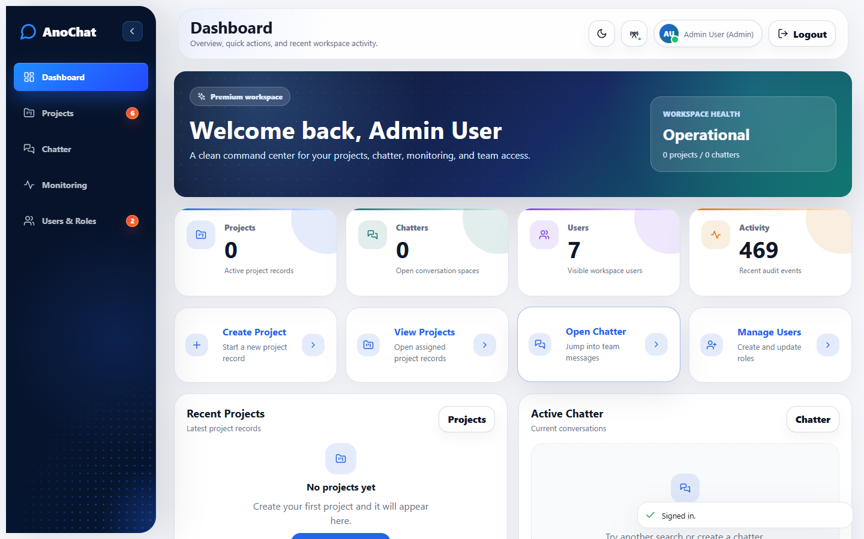
Figure 2: Dashboard showing workspace health, quick actions, recent projects, and active chatter.
- The dashboard summarizes projects, chatters, users, and activity depending on role access.
- Quick action cards guide the user directly to core workflows.
- The layout is responsive and optimized for scanning rather than heavy admin clutter.
4. Projects
Project management with linked chatter spaces
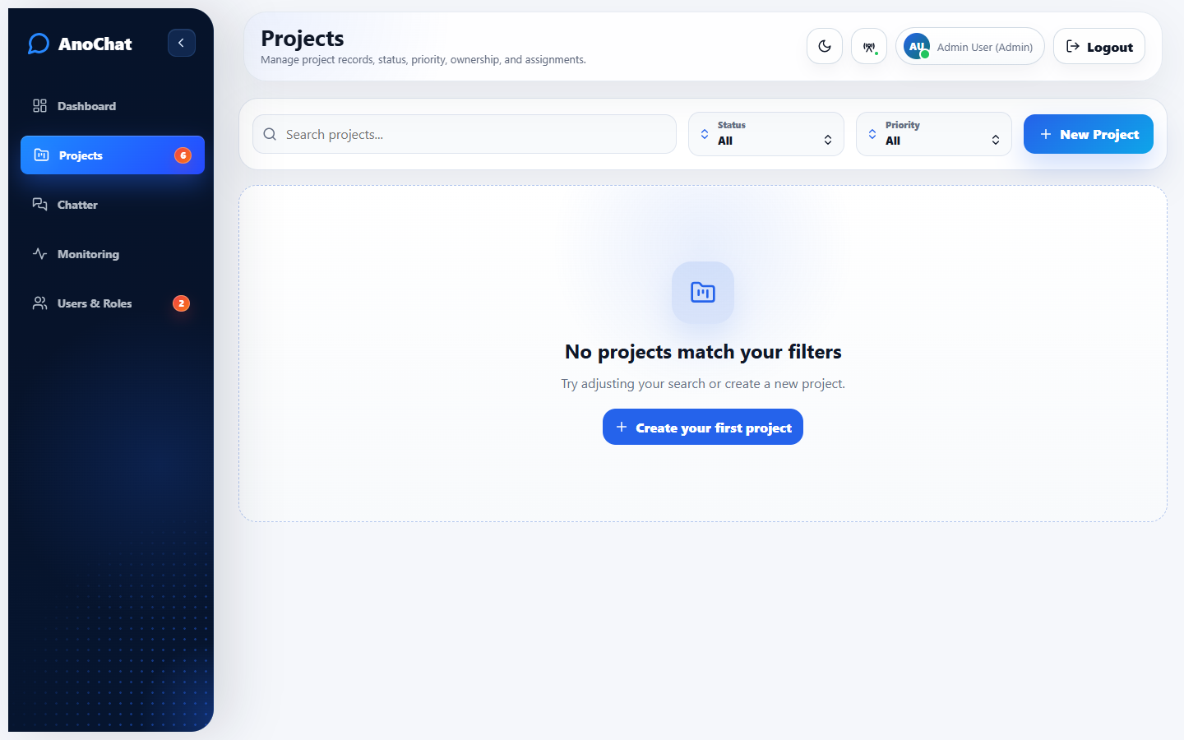
Figure 3: Projects section with search, filtering, status, priority, ownership, and actions.
- Projects support creation, editing, deletion, status, priority, customer, and member assignment.
- Creating a project also creates the related chatter so teams can immediately collaborate.
- Archived/deleted project flows are tied to corresponding chatter cleanup behavior.

5. Create Project Modal
Modern form flow for new workspaces
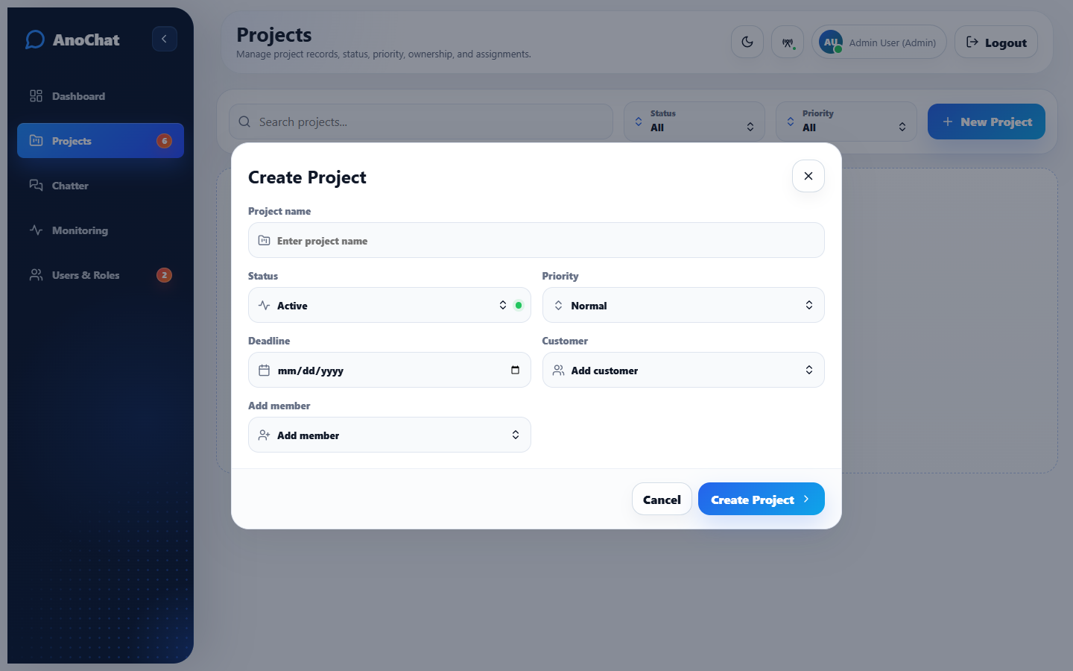
Figure 4: Create Project modal with project fields, customer selection, and member assignment.
- The form keeps project creation simple while preserving important metadata.
- Members can be assigned through a modern dropdown experience.
- The modal is responsive and uses clean validation-focused input styling.
6. Chatter
Team conversation workspace
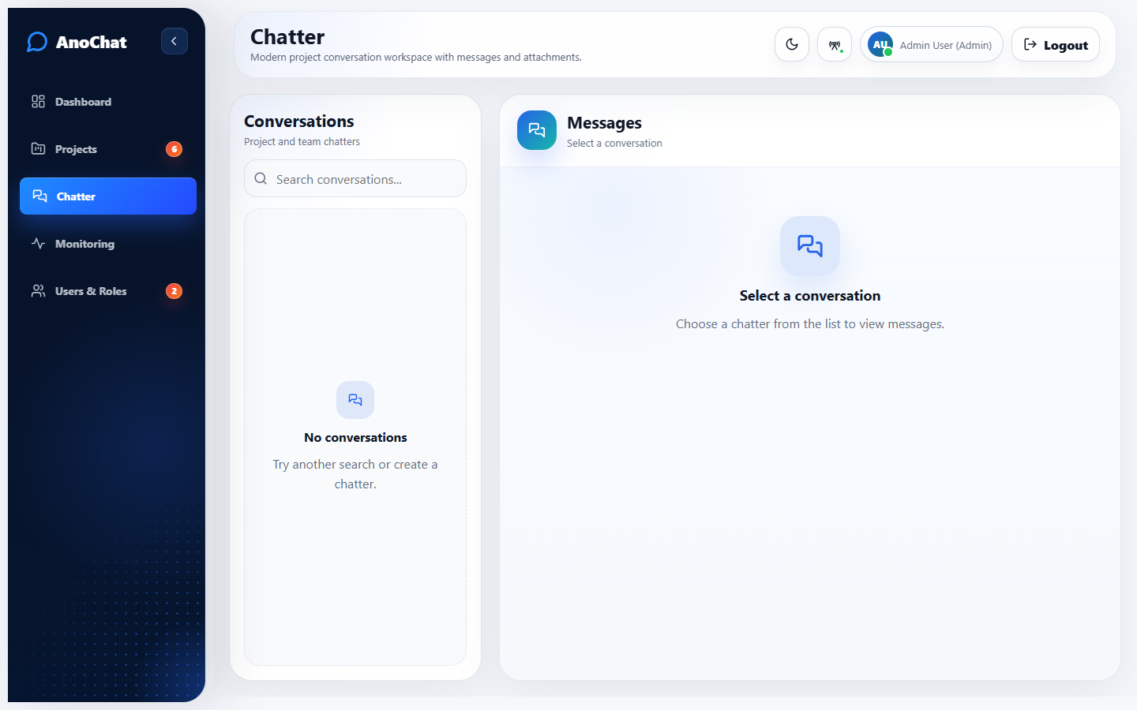
Figure 5: Chatter section with conversation list, message composer, attachments, and group context.
- Chatter supports messages, file attachments, image previews, and group/member context.
- Regex-based contact protection masks sensitive contact data for non-admin messages.
- Admin visibility rules preserve governance while protecting normal users from exposed contact data.
- The screen uses fixed chat layout behavior so the conversation area remains usable.

7. Monitoring
Audit events and workspace activity
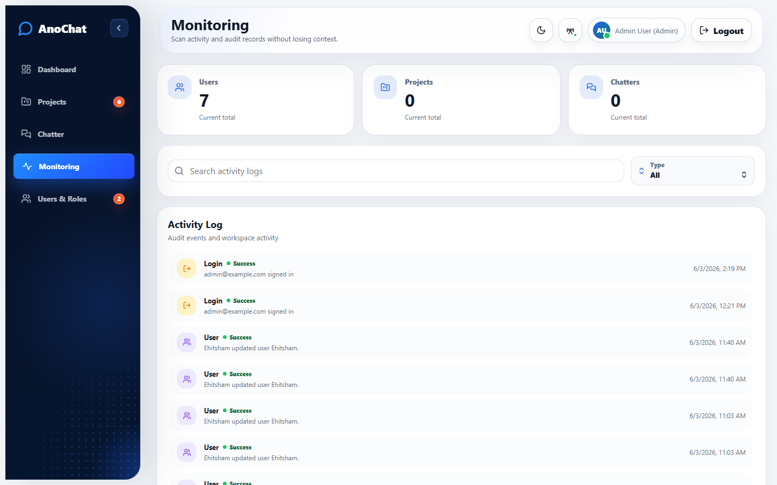
Figure 6: Monitoring screen with metrics, activity search, filters, and audit timeline.
- Monitoring provides visibility into login, project, chatter, message, user, and attachment activity.
- Search and type filters allow the admin to quickly inspect relevant audit events.
- The activity log was redesigned into a cleaner, minimal layout for client readability.
8. Users & Roles
Access management for the workspace
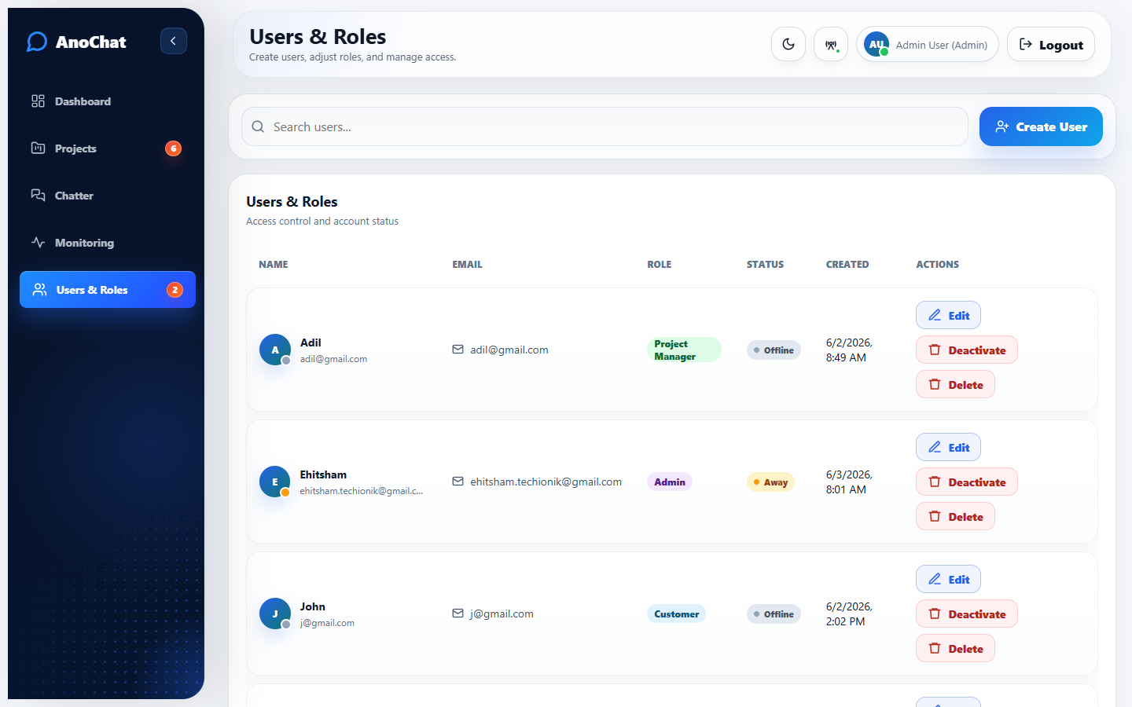
Figure 7: Users & Roles screen with role badges, status indicators, and user actions.
- Admins can create, edit, deactivate, delete, and update user roles.
- Users can update their own password and presence status.
- Role-based navigation ensures non-admin users only see relevant assigned work and chatter.

9. Deployment Summary
Current production-oriented setup
Layer | Implementation
Frontend | Vercel static deployment from the /frontend directory.
Backend | FastAPI service exposed through the Cloudflare gateway route.
Database | PostgreSQL database for users, projects, chatters, messages, activity logs, and role data.
Attachments | Stored through backend upload handling; persistent storage should be kept on the backend host.
Security | JWT auth, role-based access, message masking, deleted-message visibility rules, and audit logging.
10. Client Talking Points
Suggested points for the presentation
- AnoChat is now independent from Odoo and runs as a standalone workspace.
- The UI has been redesigned into a modern SaaS experience suitable for production demos.
- Project creation, chatter, user management, monitoring, attachments, and role access are functional.
- The platform is ready for client review, with deployment split between Vercel frontend and backend API service.

