# **Project Report – *Brain Bucket Game***

## **Objective**

The goal of this project is to make a fun memory game called **"Brain Bucket"**. In this game, a **human player** plays against an **AI (computer player)**. The game helps people improve their memory and also shows how a computer can play smart using memory.

## **Introduction:**

In games, AI helps the computer play like a smart person. AI is used in many games to:

* Make the computer act like a player.
* Make decisions by itself.
* Give a fun challenge to human players.

In this project, we use AI to remember cards and find matching pairs.

## **Project Description**

Our game shows **16 cards** face down (4 rows and 4 columns). Each card has a picture. There are **8 pairs**. Players flip 2 cards on their turn. If the cards match, the player gets 1 point.

The **AI (computer)** remembers the cards it has seen. If it knows a matching pair, it chooses them. If not, it chooses two random cards.

### **Who is the Player?**

* **Player 1:** A real person (you).
* **Player 2:** AI (the computer).

### **Player Moves and Winning**

* On each turn, a player flips 2 cards.
* If the 2 cards match, the player gets 1 point and gets another turn.
* If they don't match, the turn goes to the other player.
* The player with **more points** at the end **wins**.

### **Game Flow Chart**

Here is a simple flow of the game:

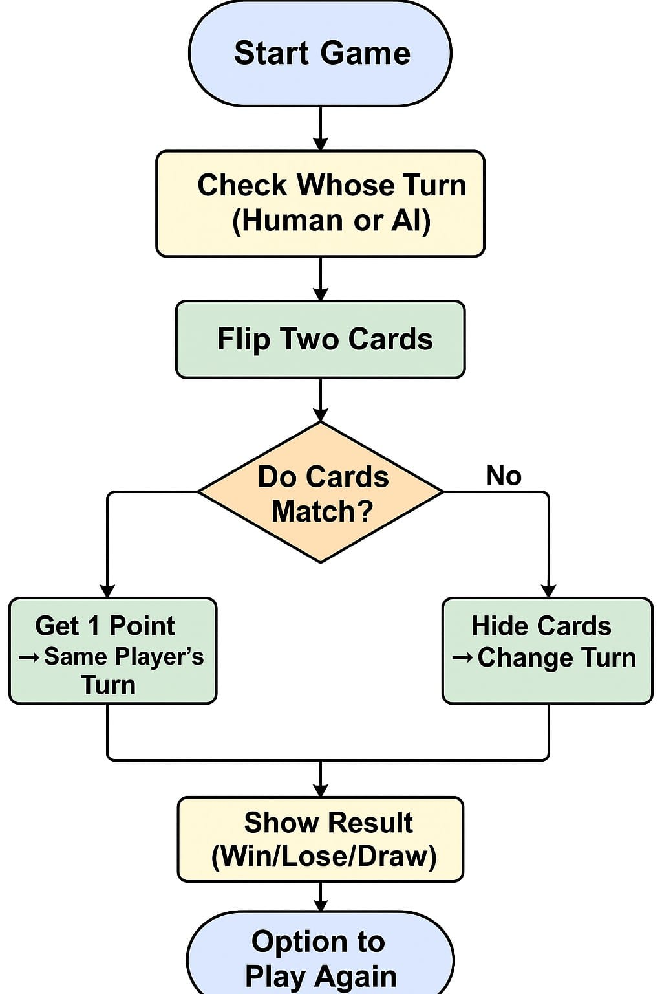

## **Result**

### **How the AI Plays**

#### **Step 1:**

AI flips a card with image 3 and remembers it.  
 *(You can add a screenshot here)*

#### **Step 2:**

Later, AI sees another card with image 3. It remembers both.

#### **Step 3:**

AI's turn: It knows the location of both cards with image 3. It picks both, matches them, and scores a point.

This shows how AI uses memory to play smart.

## **Discussion**

### **Problems Faced**

* Making the card flip animation smooth.
* Making sure the AI waits before playing.
* Showing win or lose result correctly.

### **Future Improvements**

* Add difficulty levels (easy, medium, hard).
* Save scores using file or database.
* Add background music and sound.

## **Contributions**

Each member of our group worked on different parts. No one did the same work.

## **Conclusion**

This project helped us understand how to:

* Make a real game using Python and Pygame.
* Use AI in a simple way.
* Work together as a team.

We learned how AI can make games more fun and smart.