Base Requirements
Title: 3D Ball Pit
Description: A realistic ball pit, complete with three-dimensional spheres and user-controlled directional gravity.
IDE: Processing
Timeline: 04/09 – proposal done and approved
04/16 – original program modified to have a 3D space
04/23 – sphere modeling, gravity modified to be 3D
04/30 – finish program, presentation to class
Team Members: Zack Michener
Emily Myers

Paper Prototype

(Visually, detail your project using a low-level prototype, or rough screen sketches. What will your software do? Show the user interaction.)

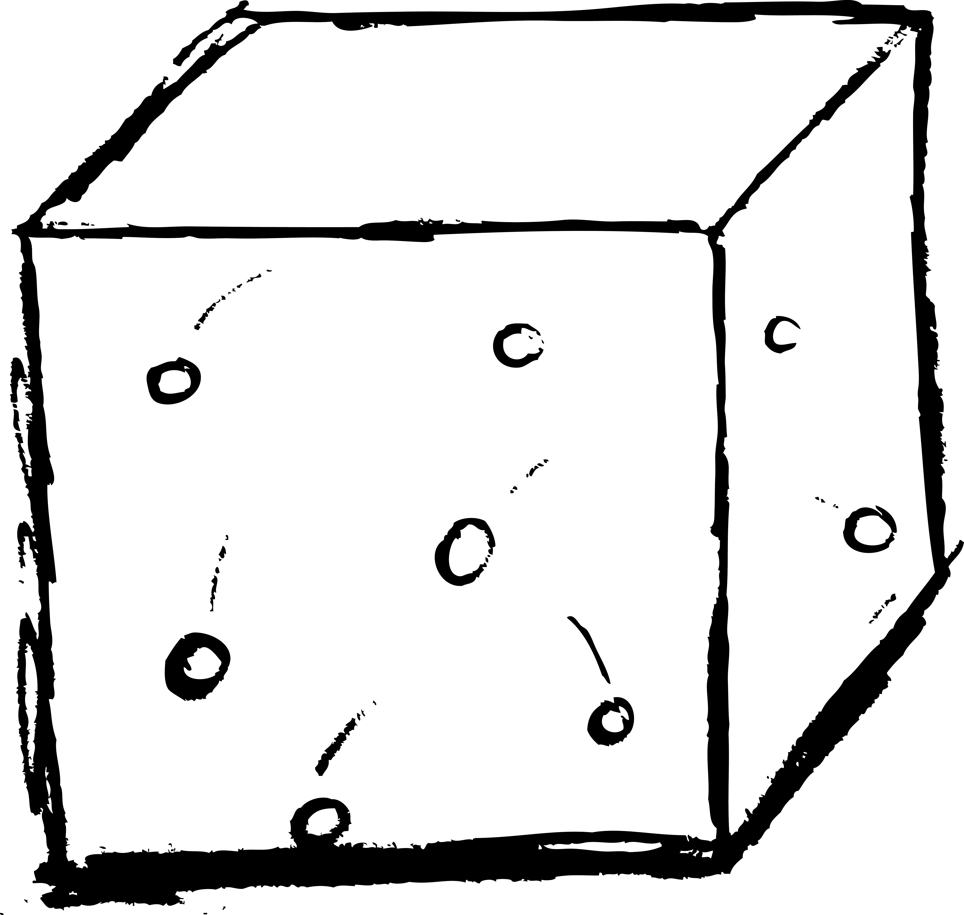
This project will simulate a 3D ball pit, with the user controlling the direction of gravity by using the number keys 1-6. Each of those number keys will be attached to a different face of the cube, and the balls will ‘drop’ towards it based on the user’s selection. It will default to the bottom face, as it is in this drawing.

Project Management

What do you expect to accomplish each of the next 4 weeks?
Covered above in the timeline

If you are working as a team, how will you divide your work?
Zack will be covering the bouncing and gravity as applied to 3D space
Emily will be handling the modeling of the spheres and possibly shadows

Grading

Exceptional: Program works as planned, all features implemented.

Good: Program has interaction, looks 3D, but gravity does not work as planned.

Acceptable: Program has interaction, but does not look 3D, and gravity does not work as planned.

