Technical Tips for Learning at Walden

- Naming files and documents properly.
To ensure timely feedback, please name your documents according to the naming convention specified in the weekly areas.
- Proper Microsoft Word formatting.
You should follow proper APA formatting when composing papers. This includes:
  - Cover page with your name listed
  - Double-spaced
  - Set correct margins
  - Use the tab key, not the space bar, for paragraph indents
  - Use Times New Roman or other approved font
  - Hanging indents on the reference list
Please consult your APA Manual for guidelines on any of these formatting requirements.
- Understanding where to find feedback.

Comments not directly in My Grades can usually be found on the paper itself. If you have a version of Microsoft Word earlier than 2003, please ensure you have the “track changes” and “view comments” feature turned on in Word to view feedback. In the Word menu bar, select Tools: Track Changes check “Highlight changes” and Tools: Options: View Tab: Check “Screen Tips” and “Hidden Text.”

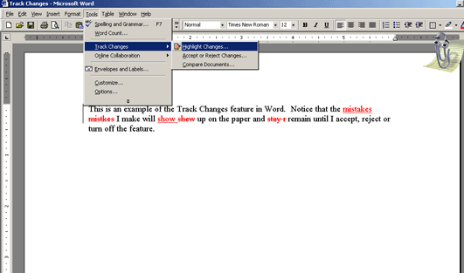

- Knowing how to find key Walden information in your myWalden portal and the Walden University website.
Almost everything you need—from online registration, to residency information, to program forms—can be found either in your myWalden portal under the Academics or Student Services tabs or on the Walden University website “Inside Walden” http://inside.waldenu.edu/

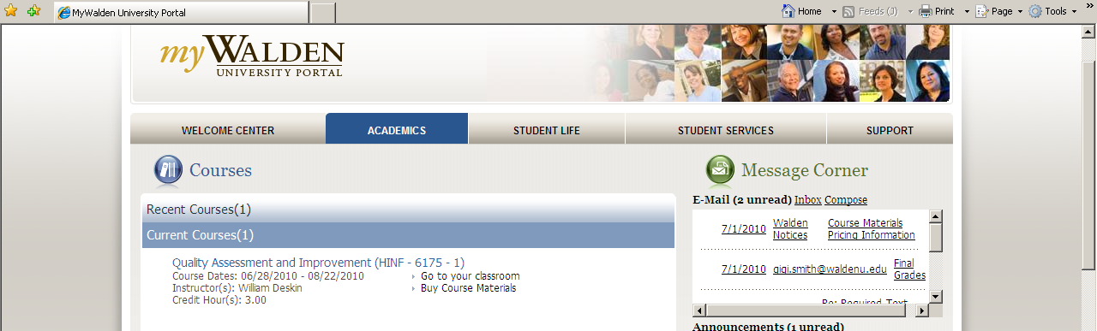
- If you cannot access a link, try right-clicking on the link and selecting “Save Target As…” and saving the file to your desktop first before opening it.
Large documents don’t always open by simply clicking on the link. They must be downloaded to your computer first. If you still cannot open the link, you may have a pop-up blocker on that needs to be temporarily turned off.
- If BlackBoard kicks you out of the classroom and asks you for a BlackBoard login, a security setting on your system will need to be adjusted.
As long as you haven’t been idle for a long time, if you are asked for a BlackBoard login ID and password, it may be that you have a) too high a browser security, b) a firewall, or c) a pop-up blocker. Please review your Student Technical Readiness Orientation for directions on how to check and adjust these settings.
- If you do not log in to your course for 3 consecutive days, you will receive a reminder e-mail.
These e-mails are a safety-net measure to make sure everything is okay technically. They are automated and in no way a reflection of your participation or your performance in the course. If you do not need assistance from the online concierge team, please feel free to disregard the messages.
- If you need technical assistance on a weekend or holiday, BlackBoard is available 24/7 to help you troubleshoot by calling: 1-888-788-5264.

