Erik Holmgren
STAT 315
HW 10
2017-12-07

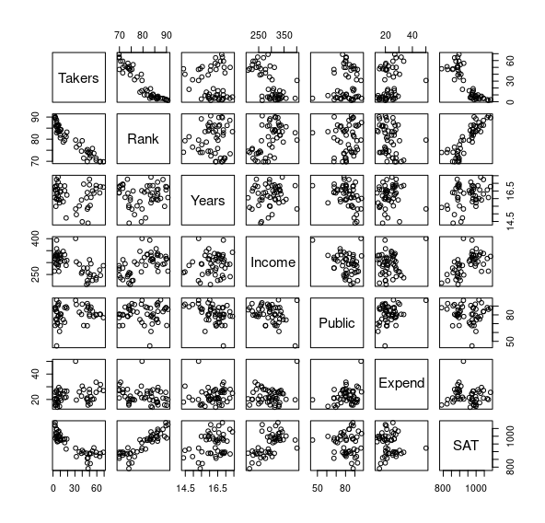

Finding connections between SAT scores and environmental factors across states

Q1: When comparing SLRs on SAT score vs number of Takers and SAT score vs the log of the number of Takers, which model does a better job of predicting SAT score?
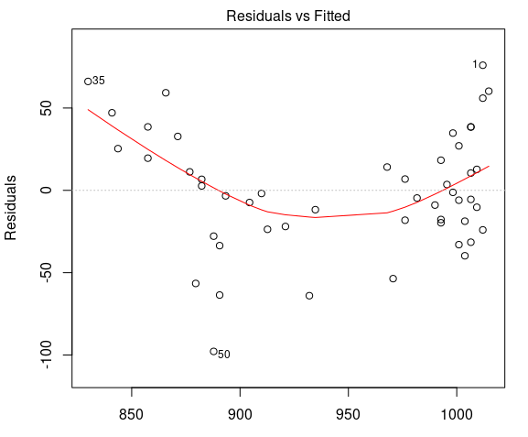

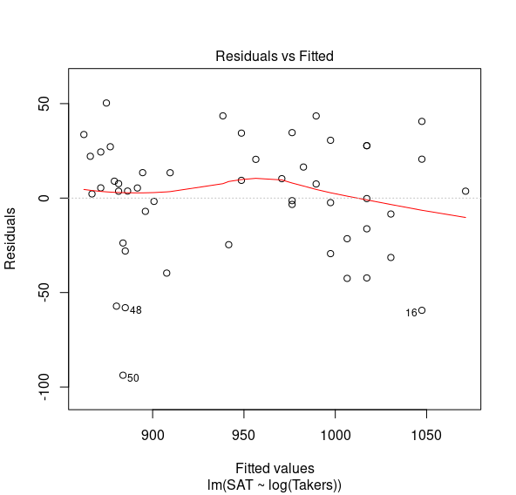
As seen in the top-left plot, there is a curve in the fit of SAT vs Takers. It would follow that this model is not a good fit. Multiple R² for this model is 0.736, while multiple R² for the fit of SAT vs log Takers is 0.811. These values are reasonably close, and both indicate a significant correlation between the two variables. However, the shape of the SAT vs log Takers plot (bottom-left) shows a much better fit, and a more consistent variance (homoscedasticity). Based on the above, I would say that log Takers is a better predictor of SAT score.

Q2: Does Income or Expend have a stronger linear relationship with SAT?
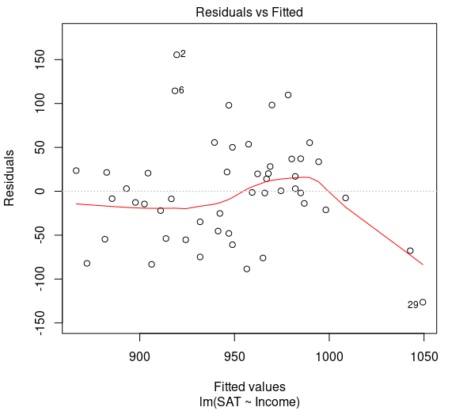
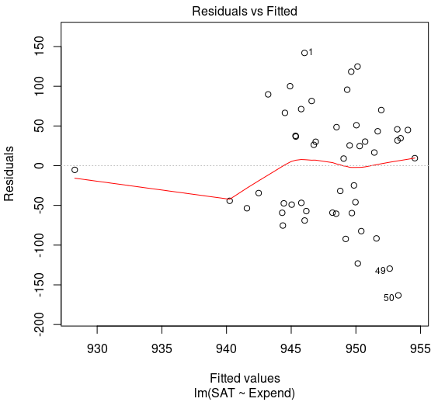
Both Income and Expend have outliers and non-constant variance. The multiple R² value of SAT vs Income, 0.342, is higher than the multiple R² value of SAT vs Expend, 0.00395. While neither model seems to give a particularly good fit, Income has a stronger linear relationship.

