Moving Sale — Furniture, Electronics & an E-Bike
I’m moving overseas and selling my stuff. All prices are OBO (or best offer) — local pickup on Button St, first come, first served. DM me if you’re interested in anything.
- Furniture: pickup only. I can disassemble it beforehand or help you disassemble.
- Smaller items: pickup, meet in a public place, or I can deliver to your office at UCSC.

Aventon Soltera 2.5 E-Bike (Matte Black, Size L) — $700
Lightweight Class 2 e-bike with hydraulic disc brakes, 350W motor, 9.6Ah battery, torque sensor, and integrated lights with turn signals. ~1,533 miles; scuffs/scratches from parking and an attempted theft (the lock held). Includes a Kryptonite U-lock. MSRP $1,199.
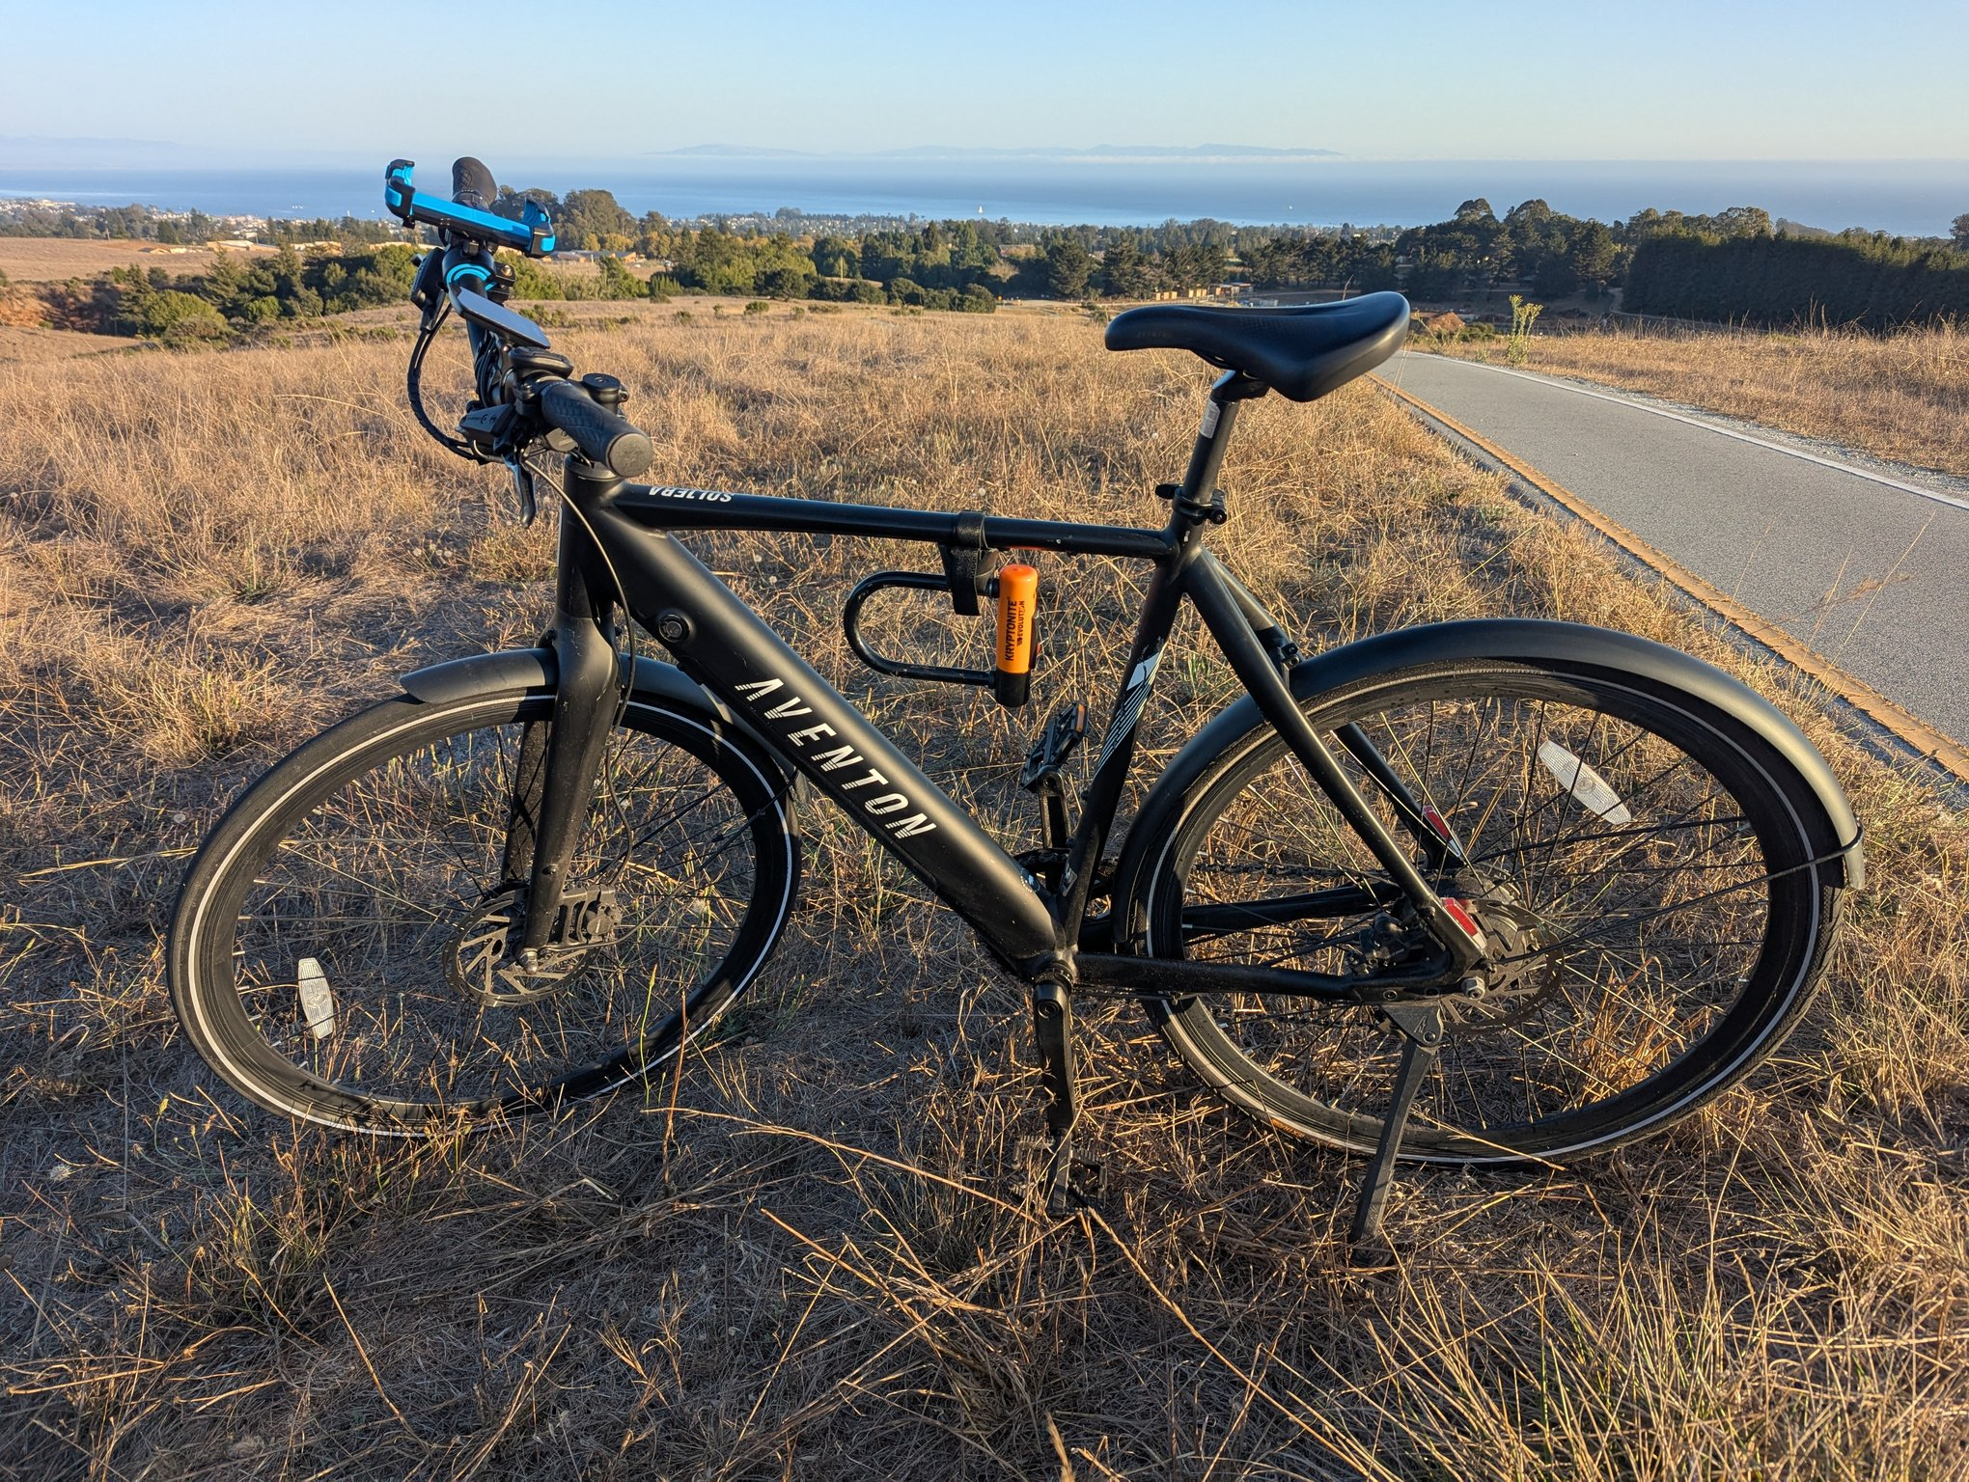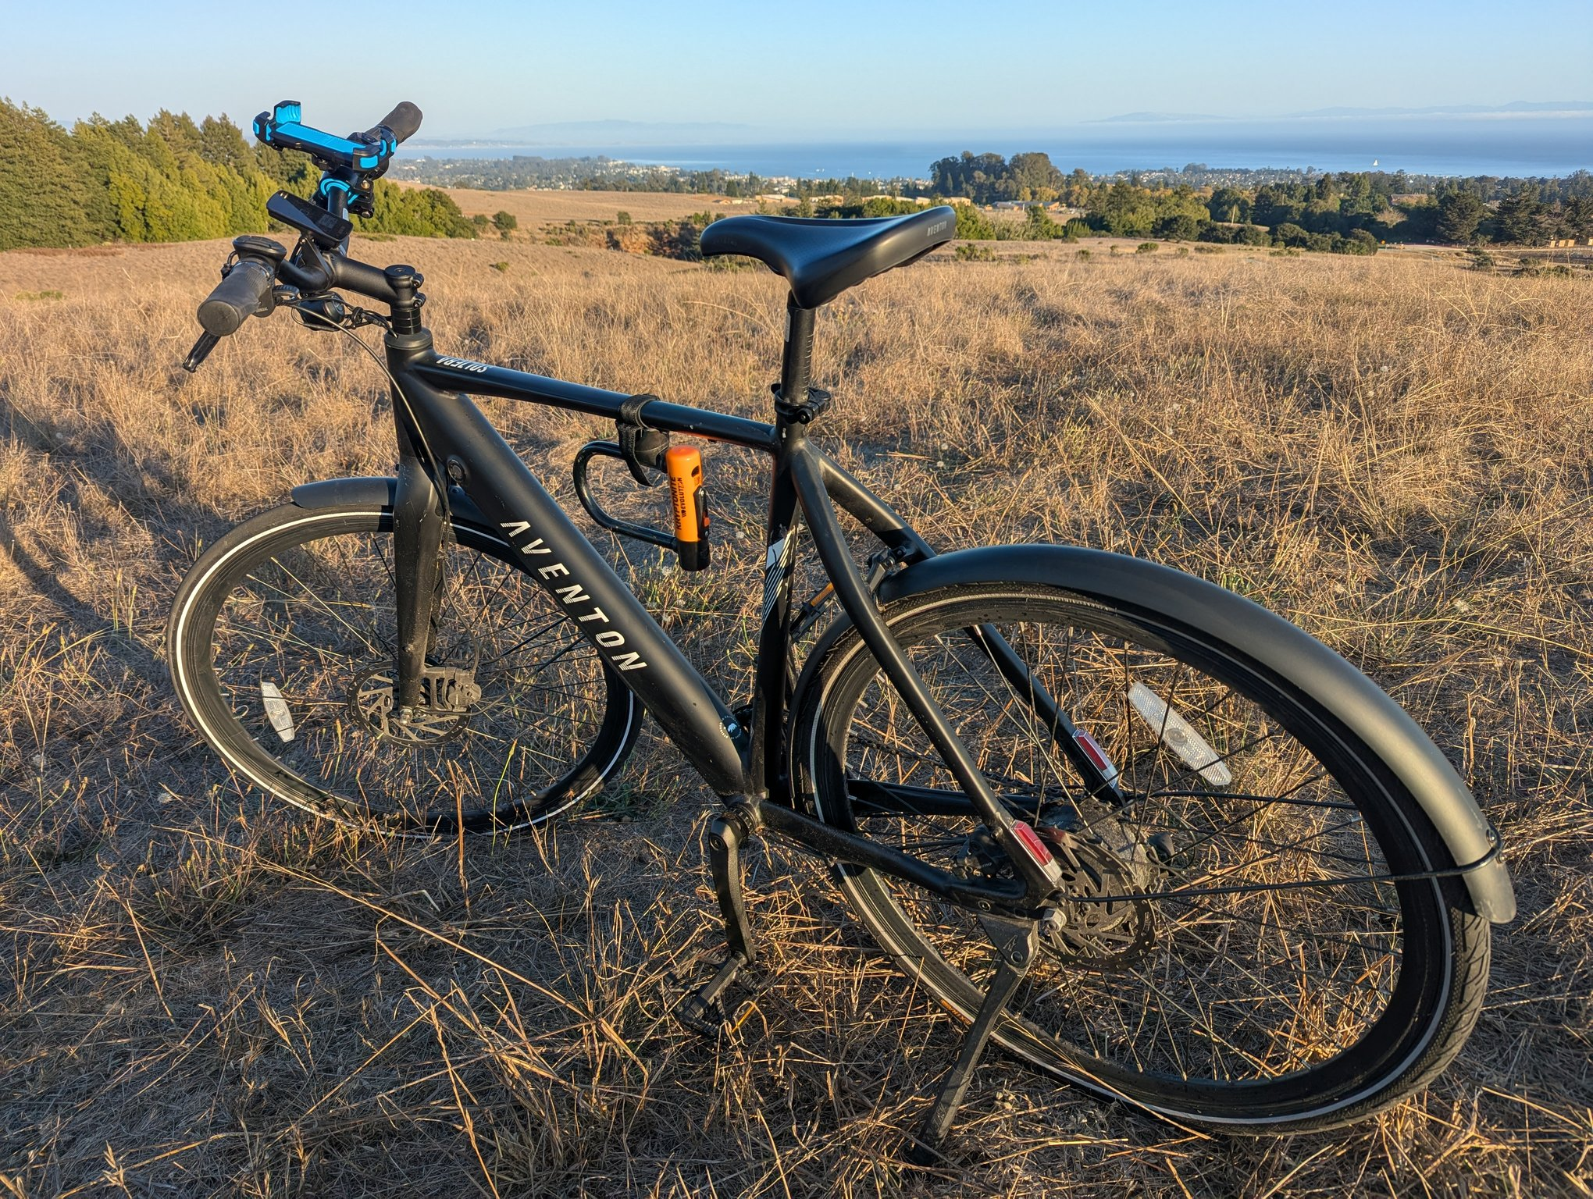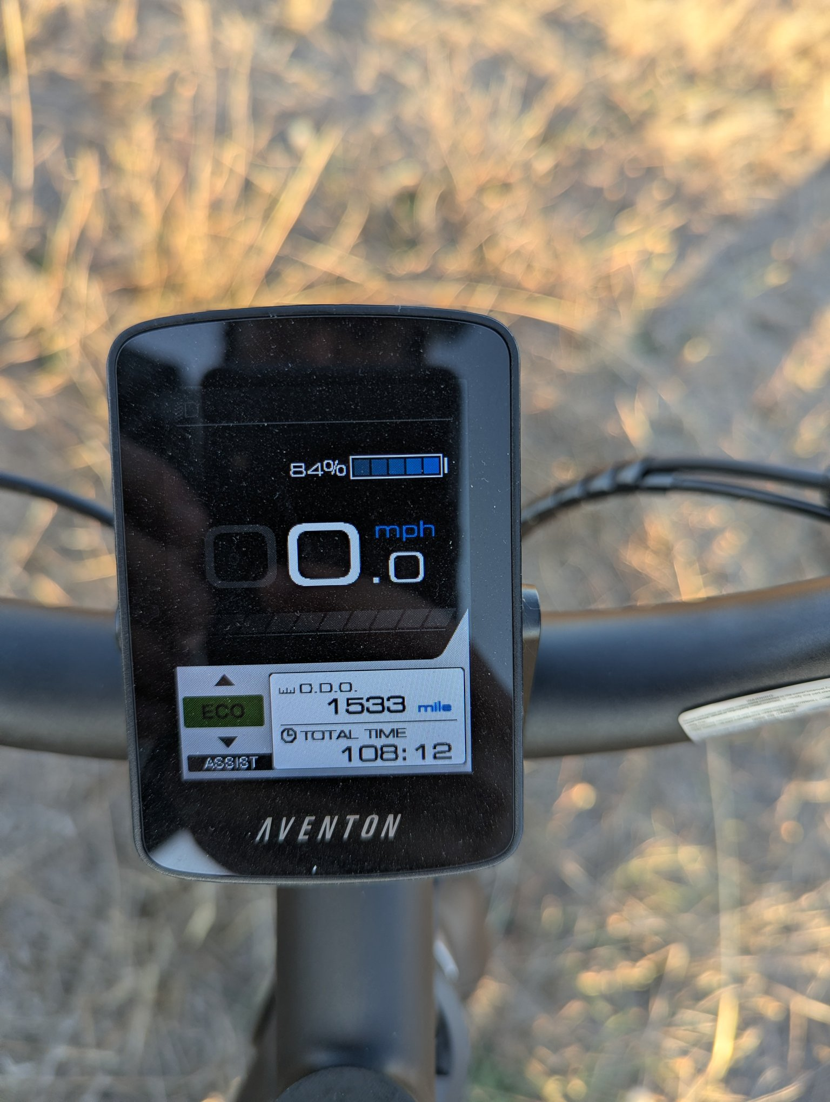

Eurotech Vera Ergonomic Office Chair (Piano Black) — $250
Genuine Eurotech Vera mesh-back task chair with 6-way adjustable arms, seat-depth/height adjustment, and synchro-tilt. Piano Black mesh, soft 2-tone casters, no headrest; a new 5-pack of hard replacement casters is included.
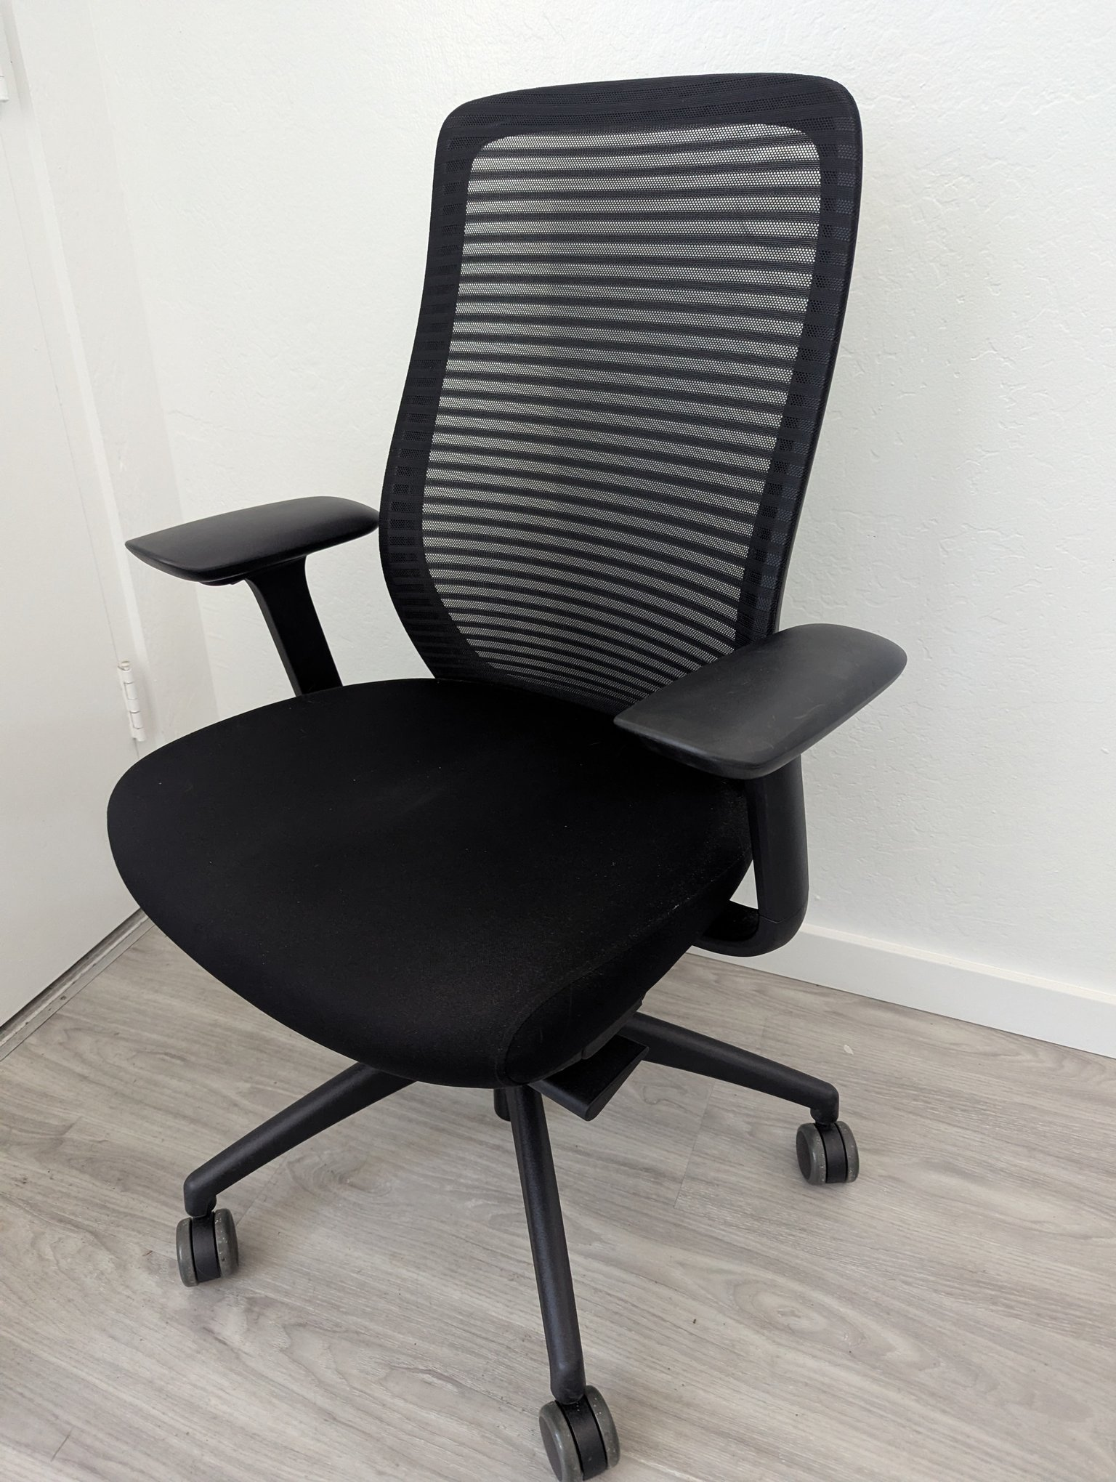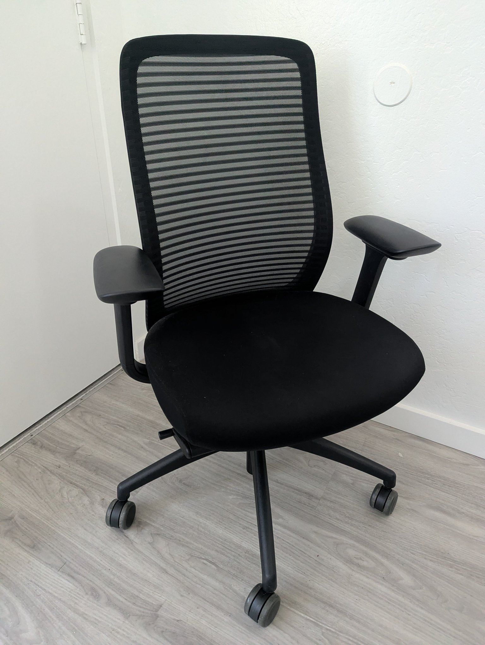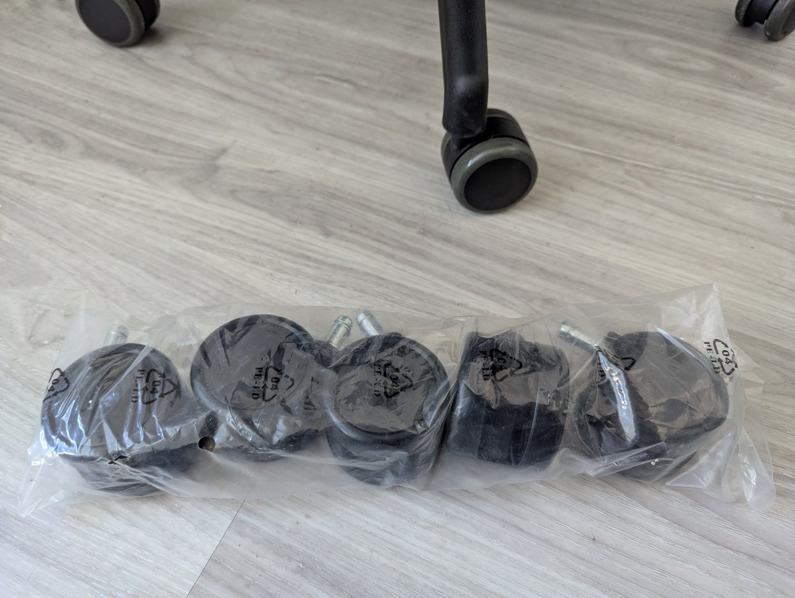

IKEA KIVIK 2-Seat Sofa (Grey) — $150
Low, deep IKEA KIVIK loveseat in a grey woven cover with the line’s signature wide, low armrests. Approx. 190 × 95 × 83 cm. Good condition, minor fabric slack.
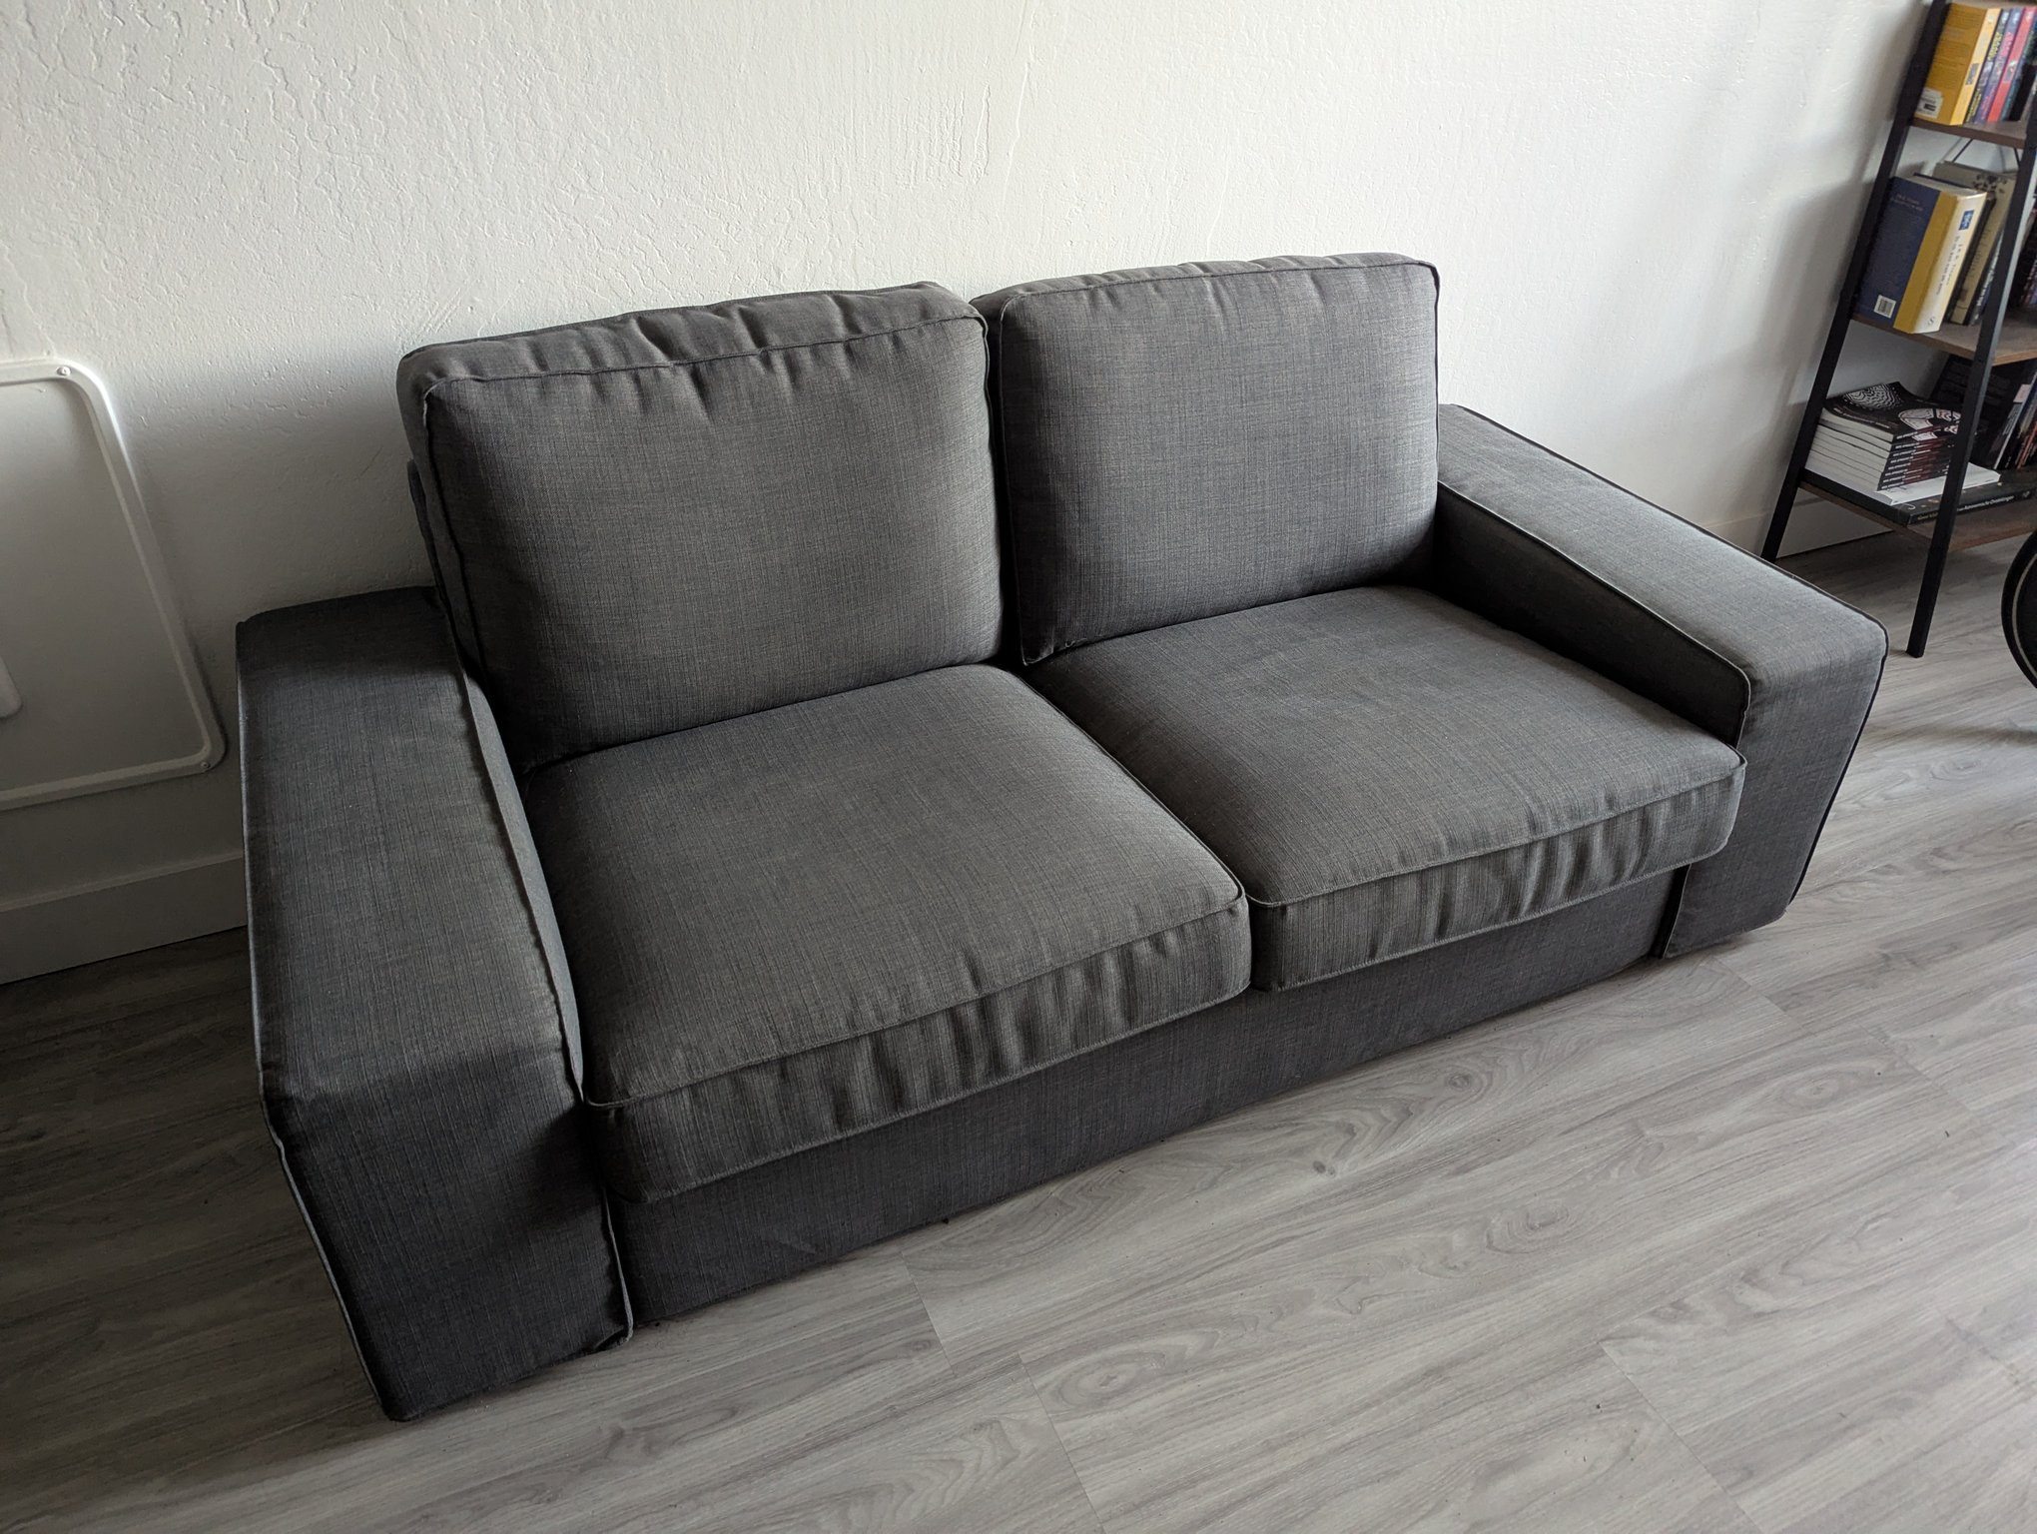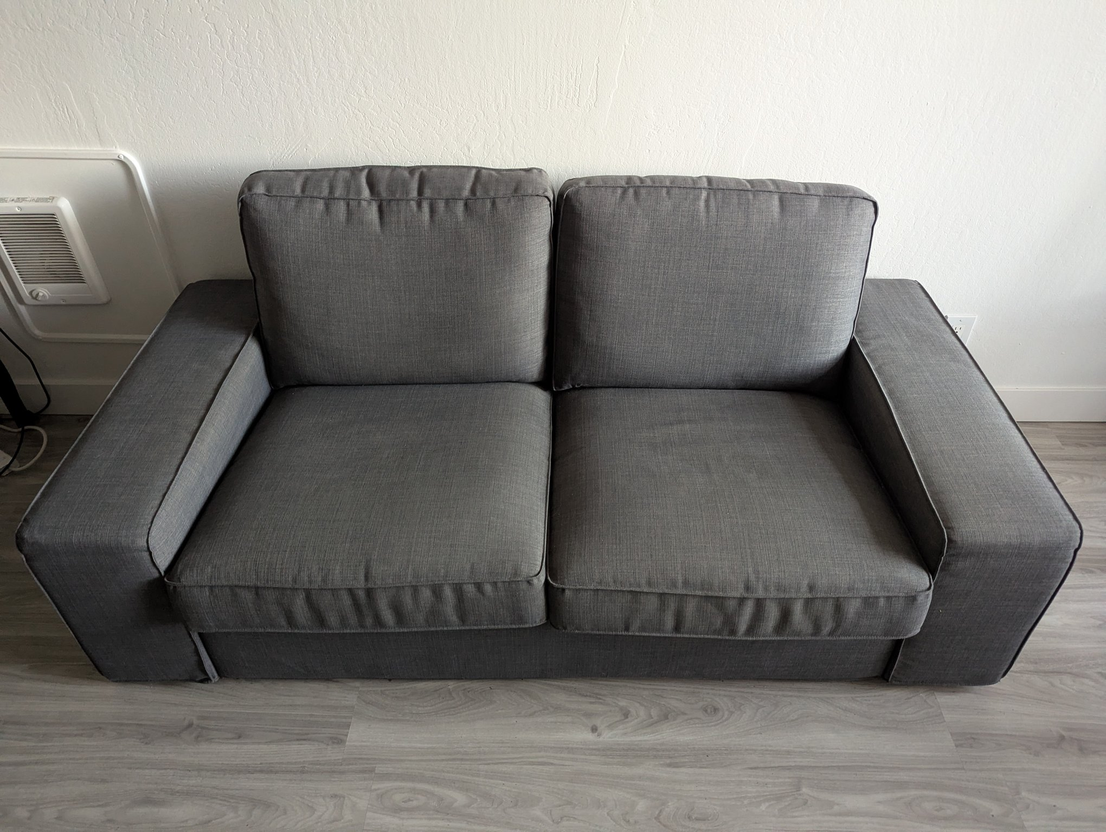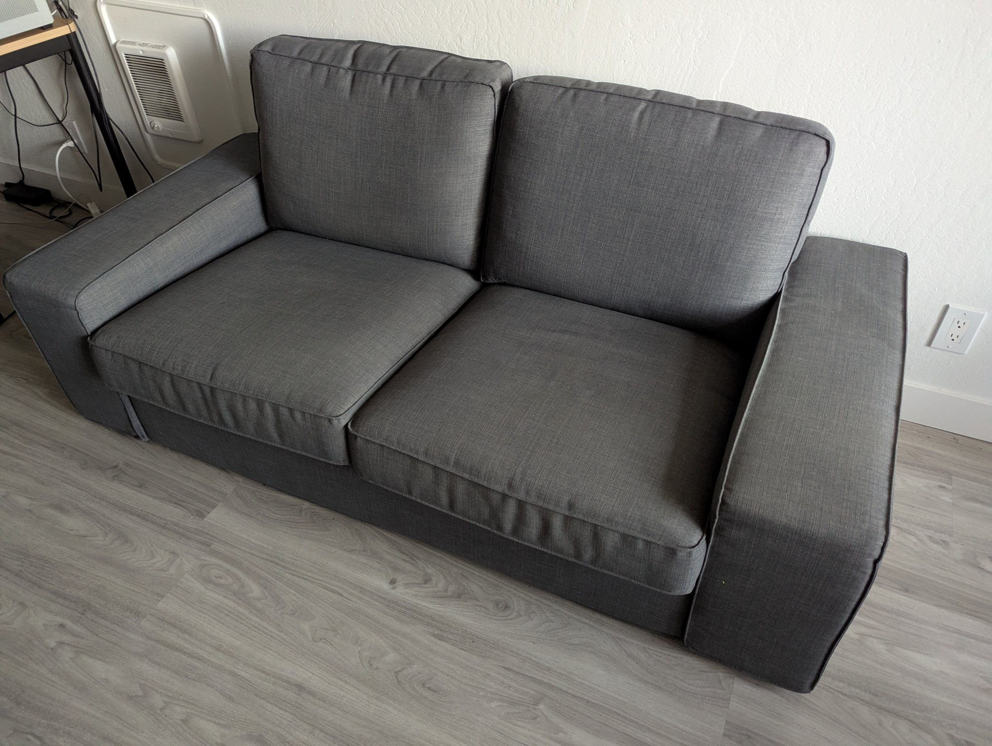

Elgato Stream Deck + (Unused, Open Box) — $150
Unused Elgato Stream Deck + with 8 LCD keys, 4 dials, and a touch strip. Includes original box, cable, and quick-start guide. Retails $199.99.
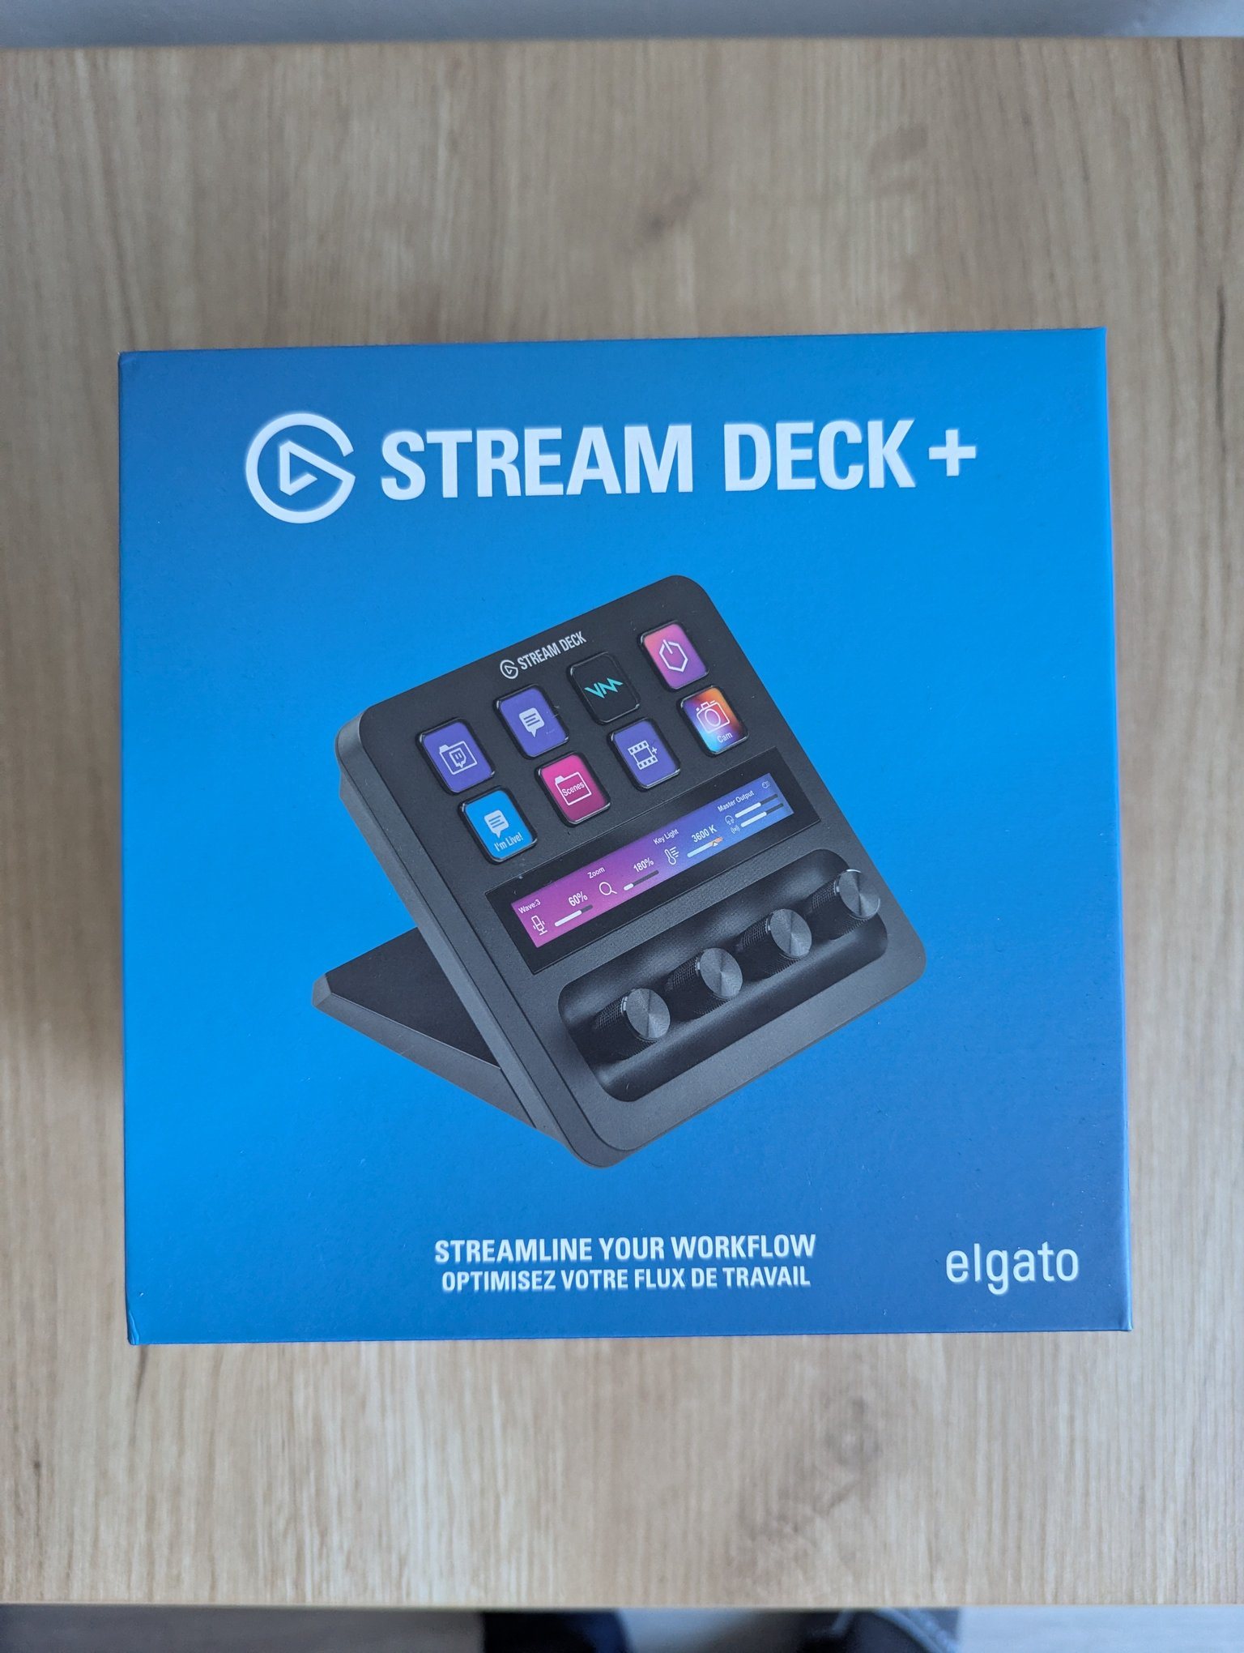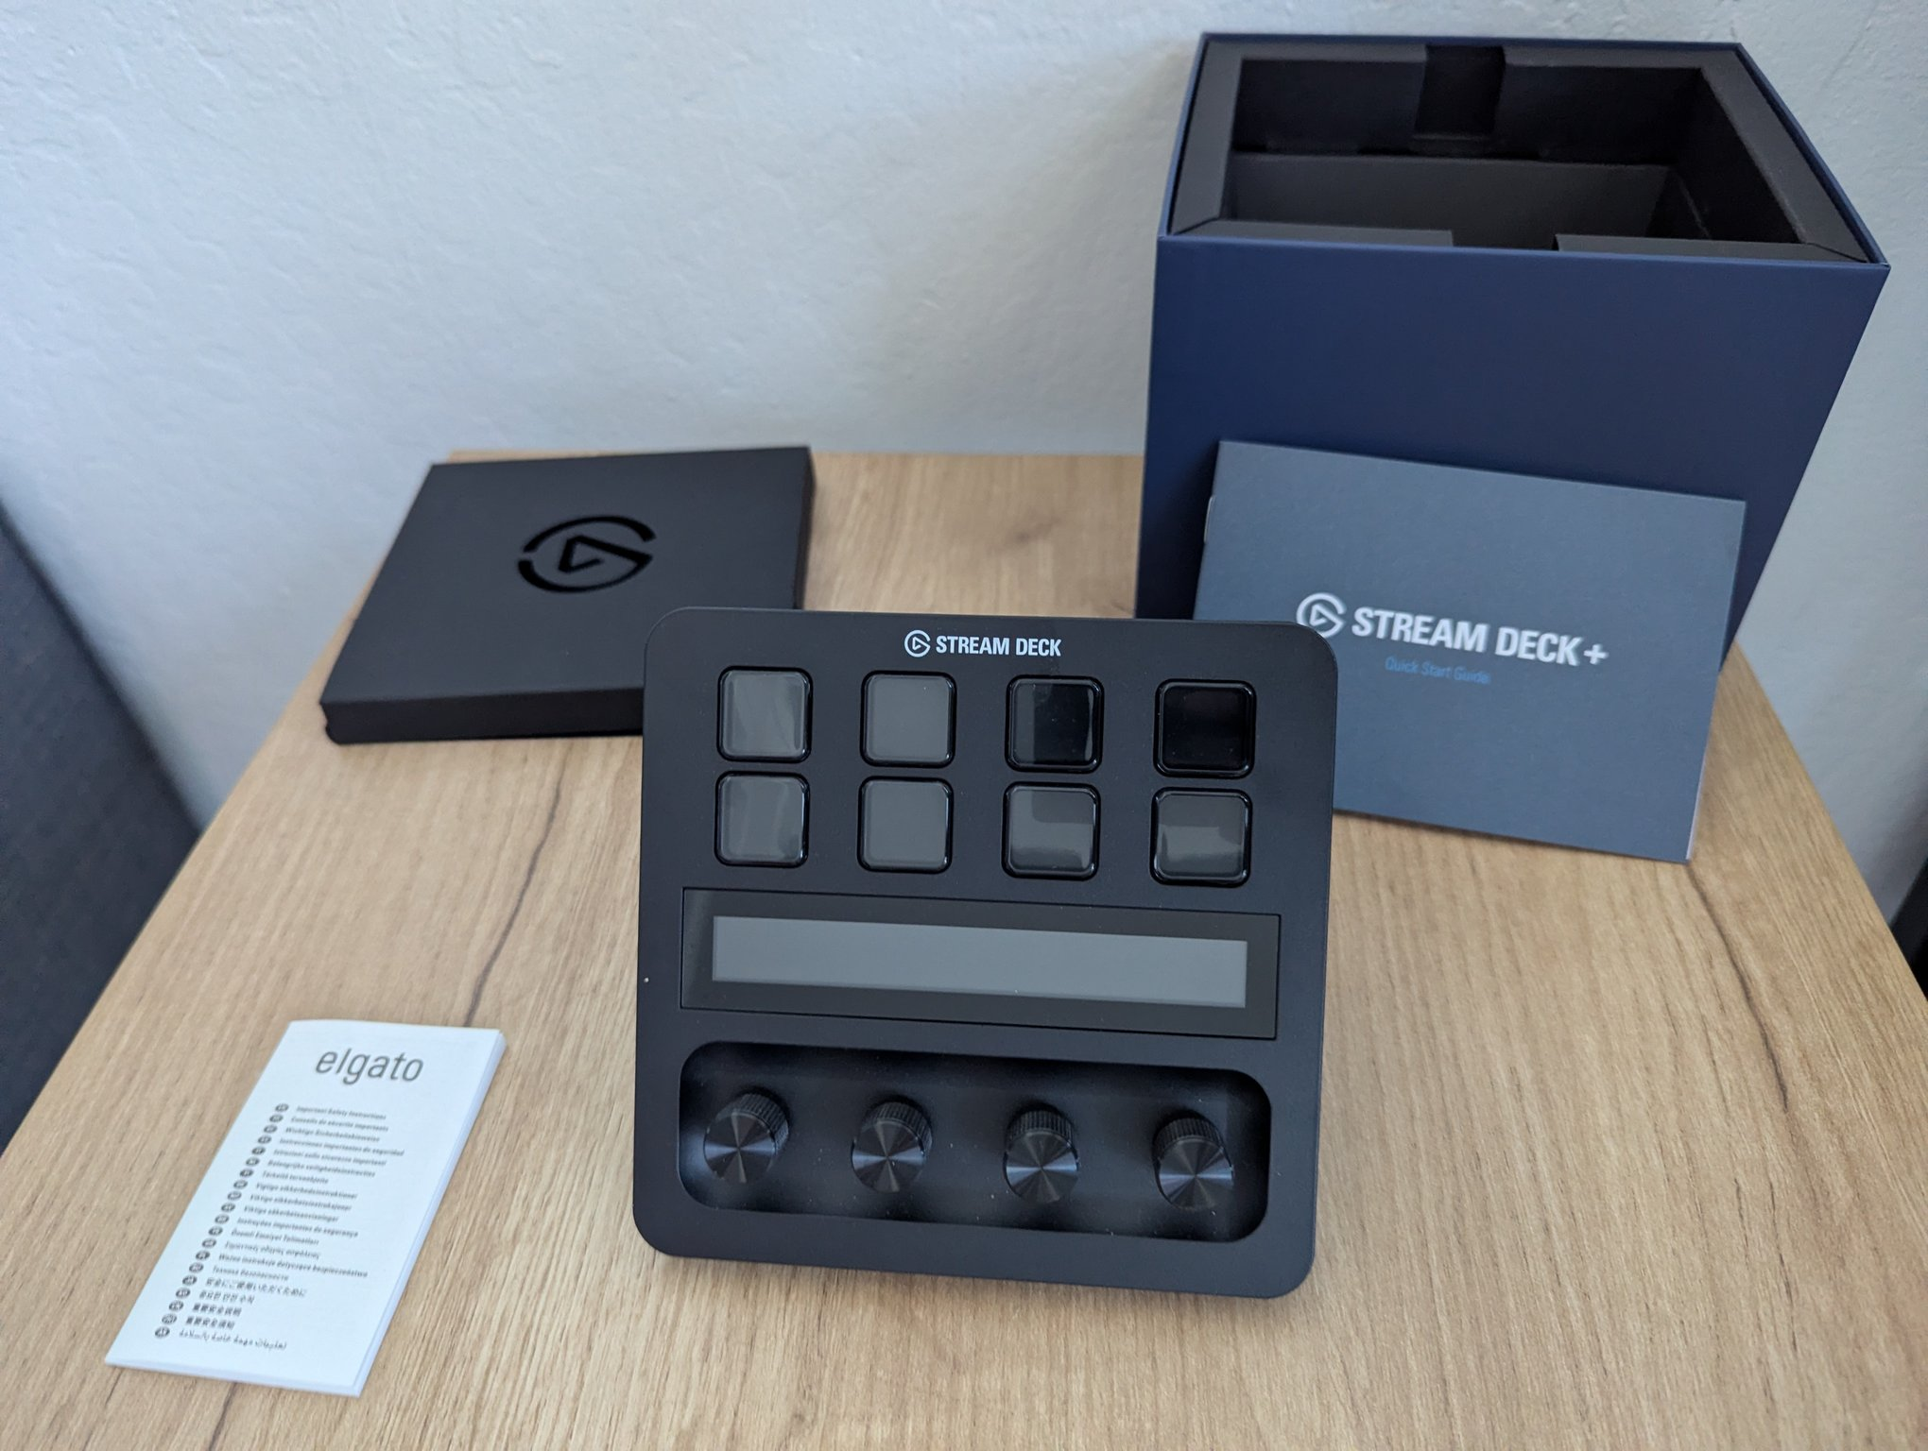

IKEA FJÄLLBO Sideboard (Black) — $120
IKEA FJÄLLBO sideboard: black metal frame, solid pine top, open display shelf, and two mesh doors with internal drawers. 111 × 47 × 95 cm. Matches the FJÄLLBO coffee table. Retails $299.
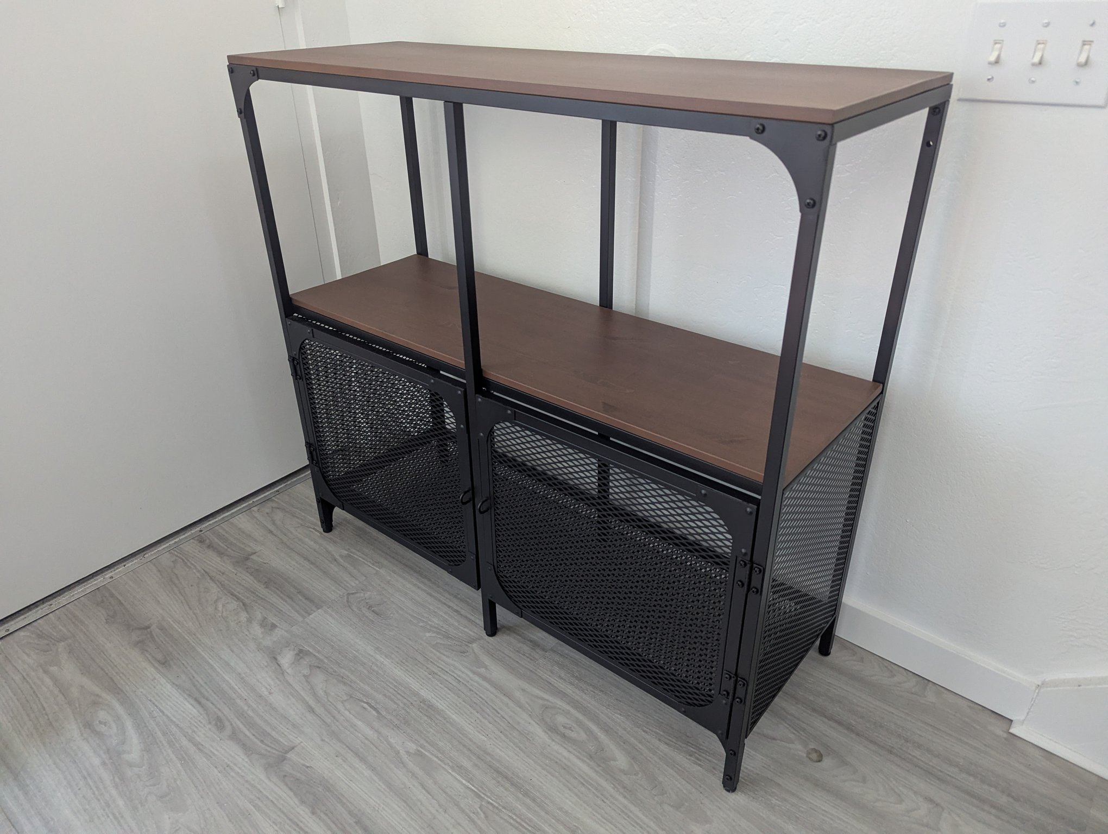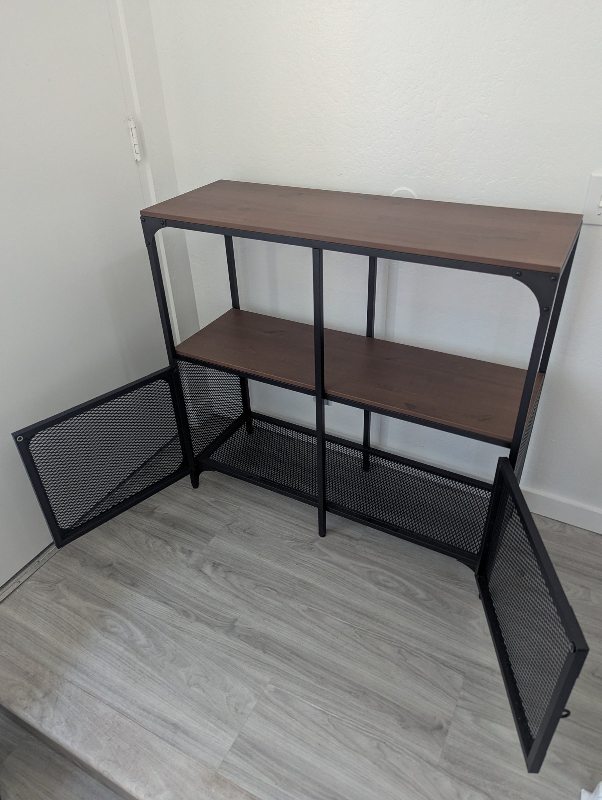

IKEA TRYSIL Bed Frame, Dark Brown — $90
IKEA TRYSIL bed frame with angled slatted headboard and metal center rail; wooden slats included (no box spring needed). 220 × 157 cm, 98 cm headboard. Good condition — the veneer is damaged at one corner (shown in photo 3), reflected in the price.
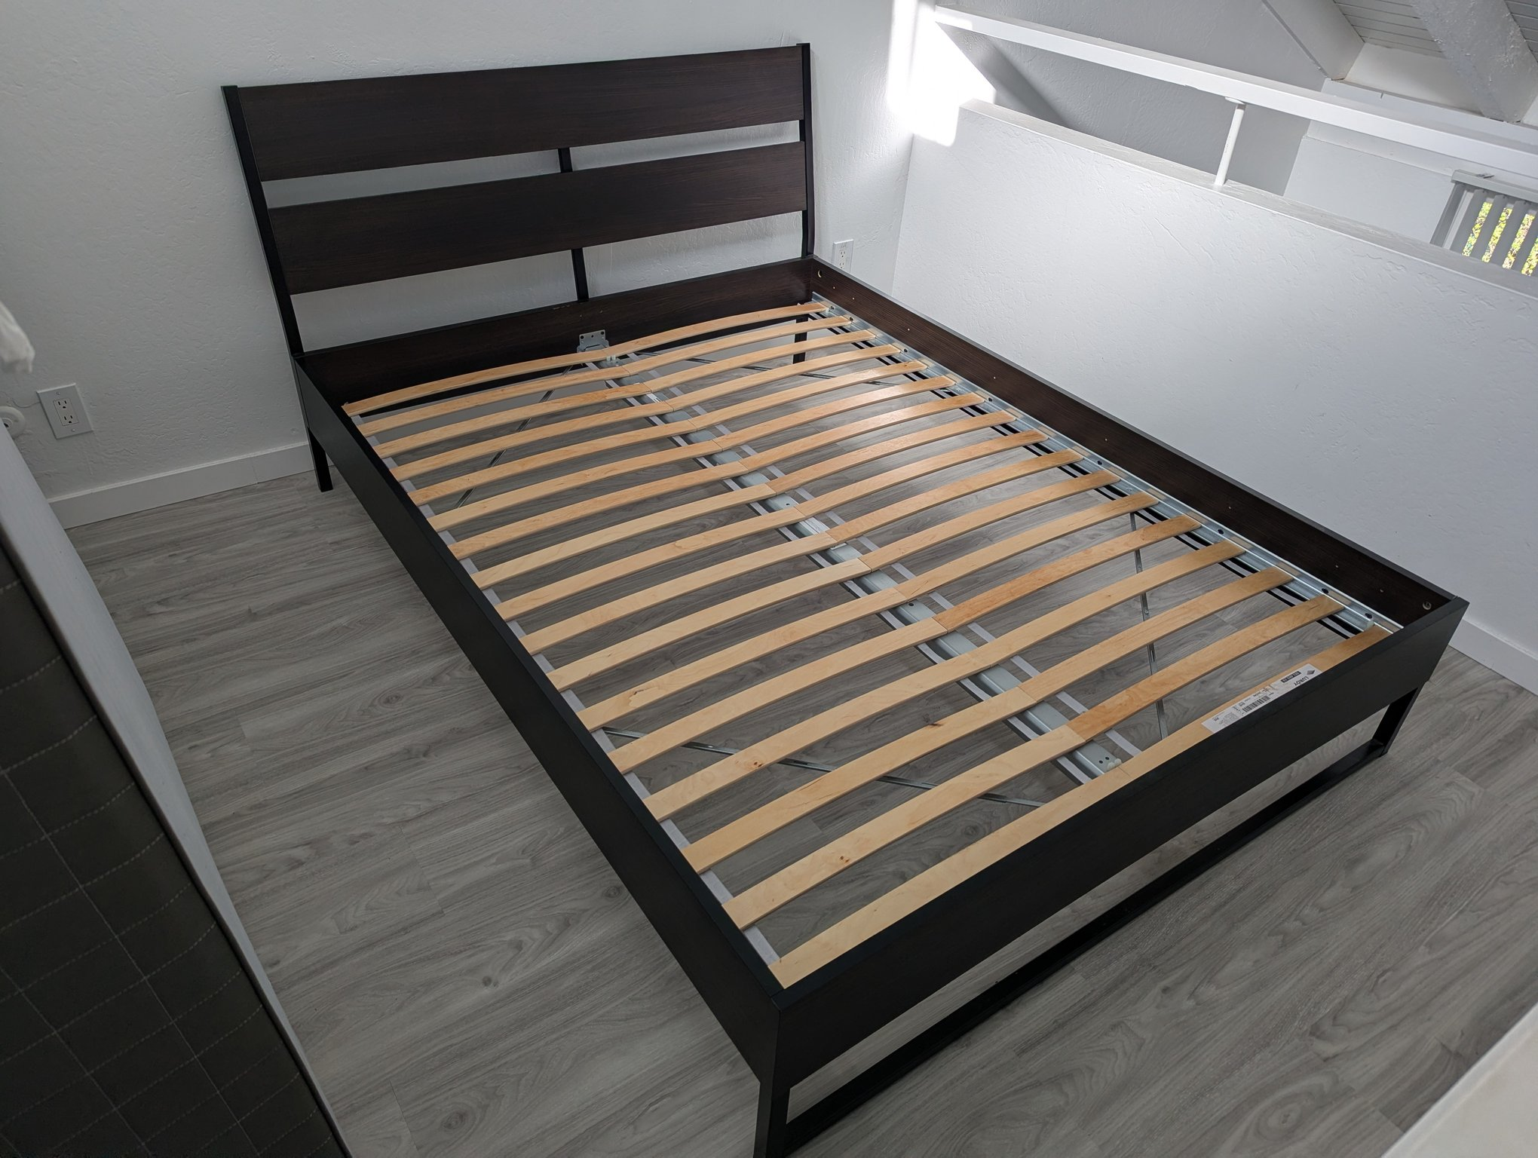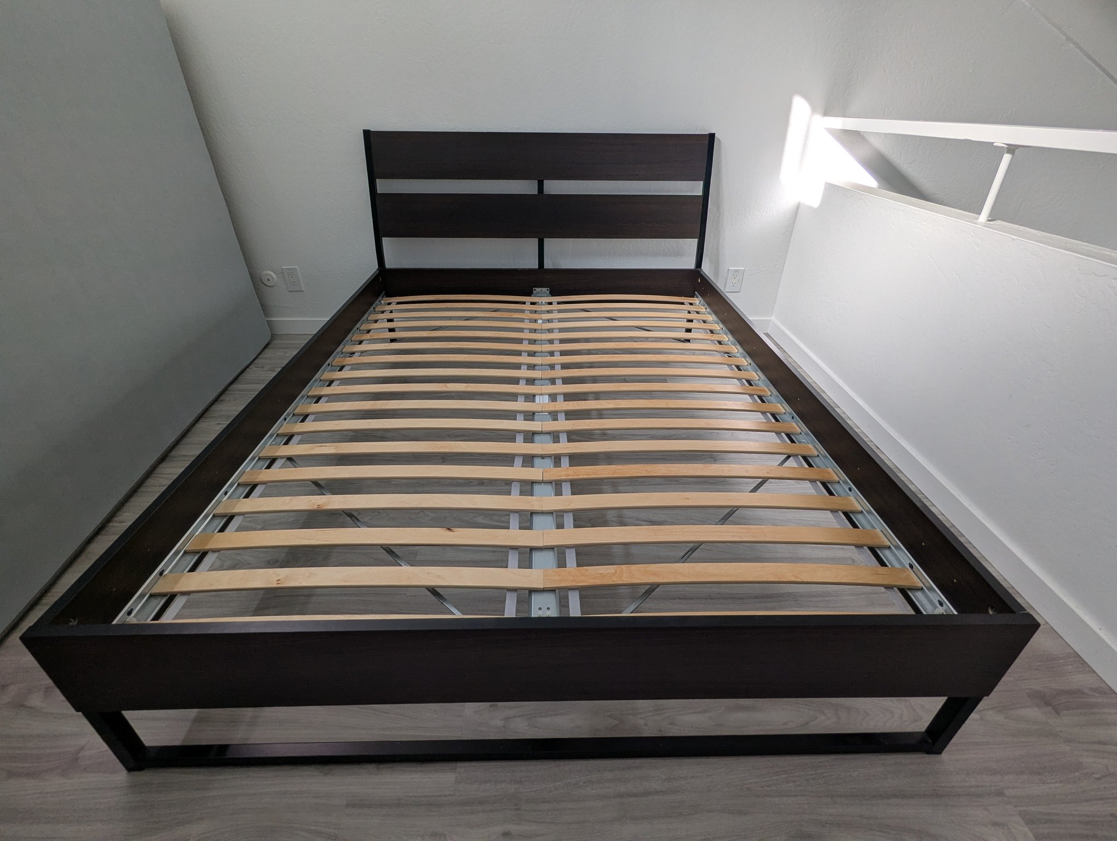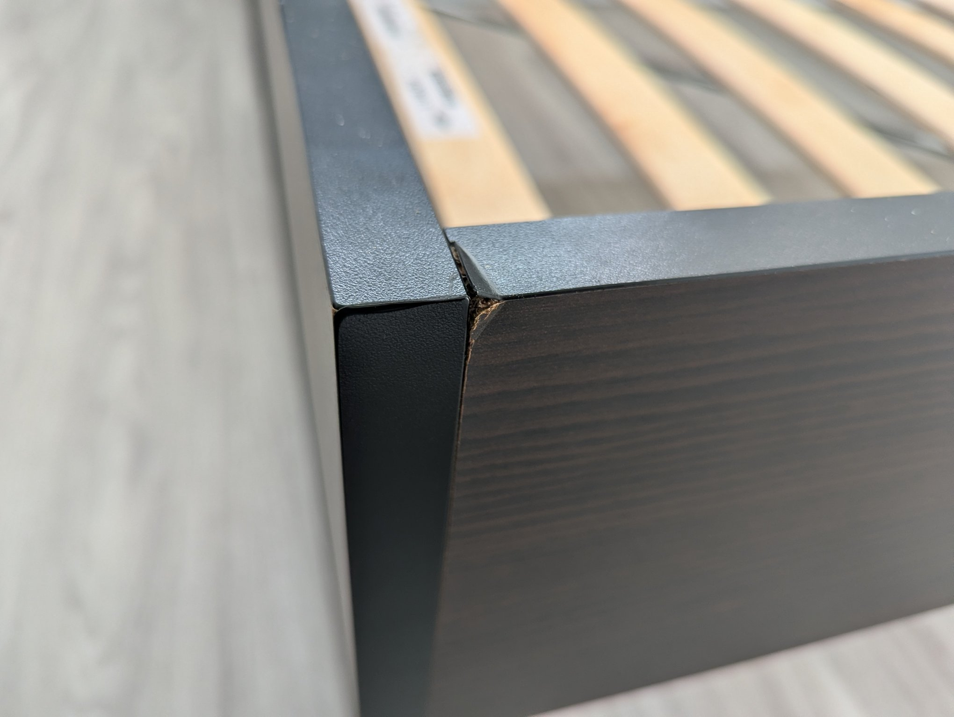

Elgato Key Light (Professional LED Panel) — $90
Genuine Elgato Key Light (SKU 10GAK9901): 2800 lumens, adjustable 2900–7000K, Wi-Fi/app control. Includes the Master Mount L desk clamp/boom arm and power supply. Retails $179.99.
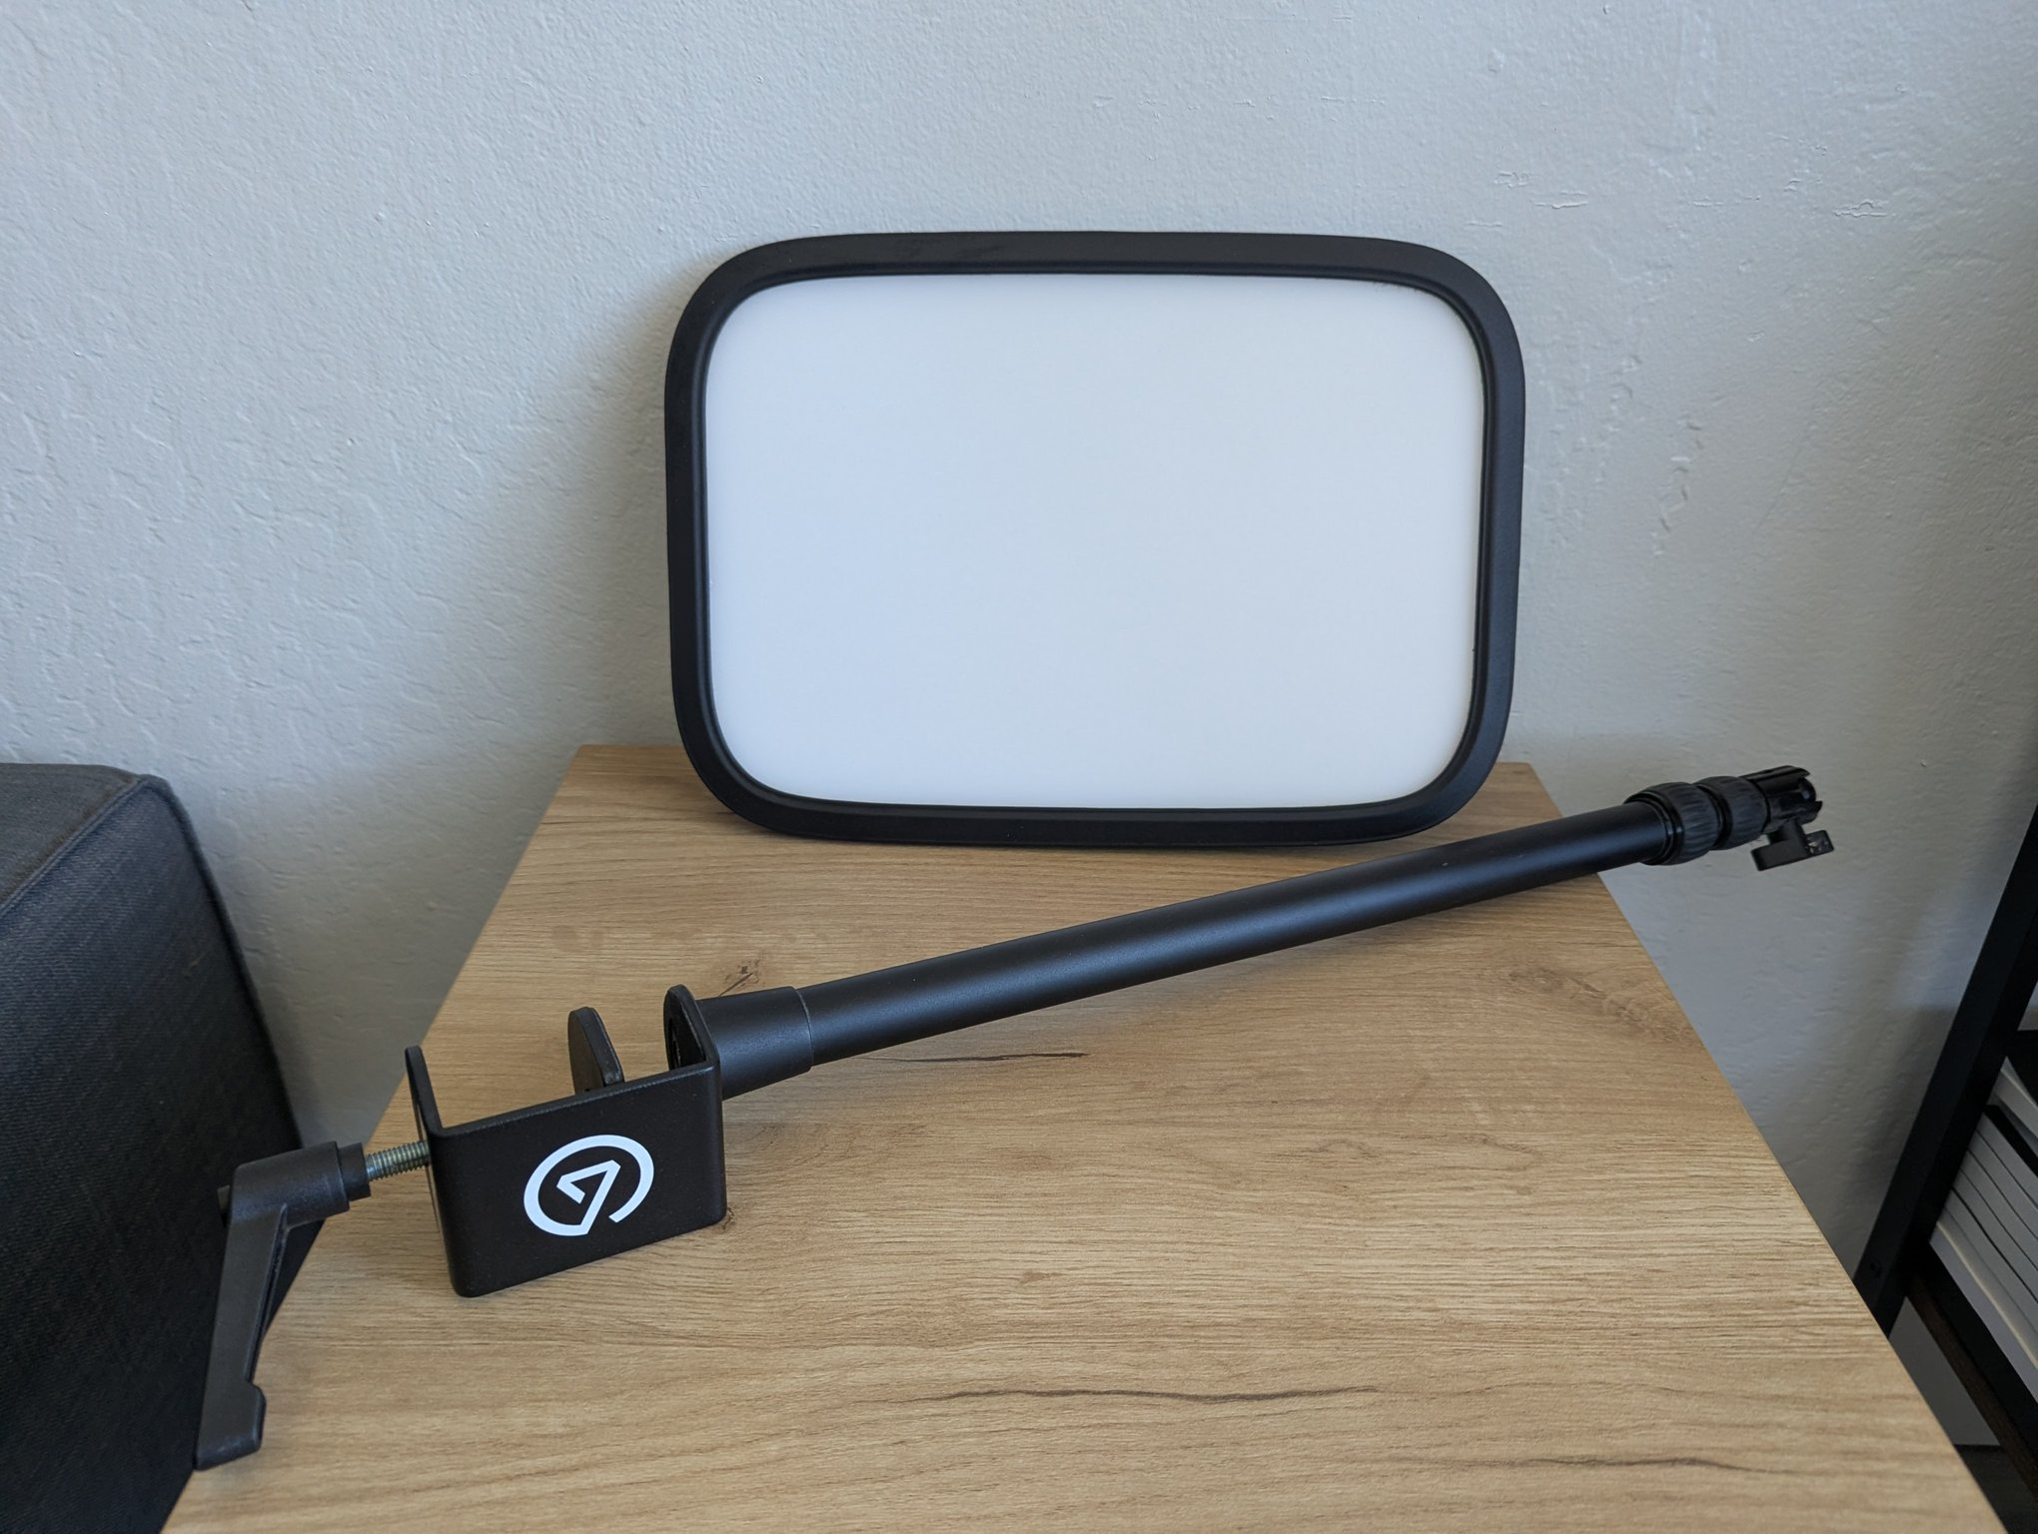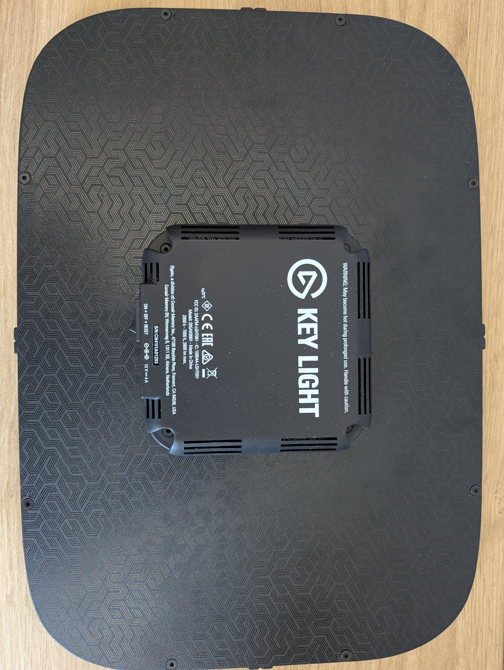

Lutron Caseta Wireless Smart Lighting Bundle — $80
Brand new, sealed box (DVRF-BDG-1DP-A). Includes Smart Bridge, in-wall dimmer, Pico remote, wallplate, power supply, cables, and guide.
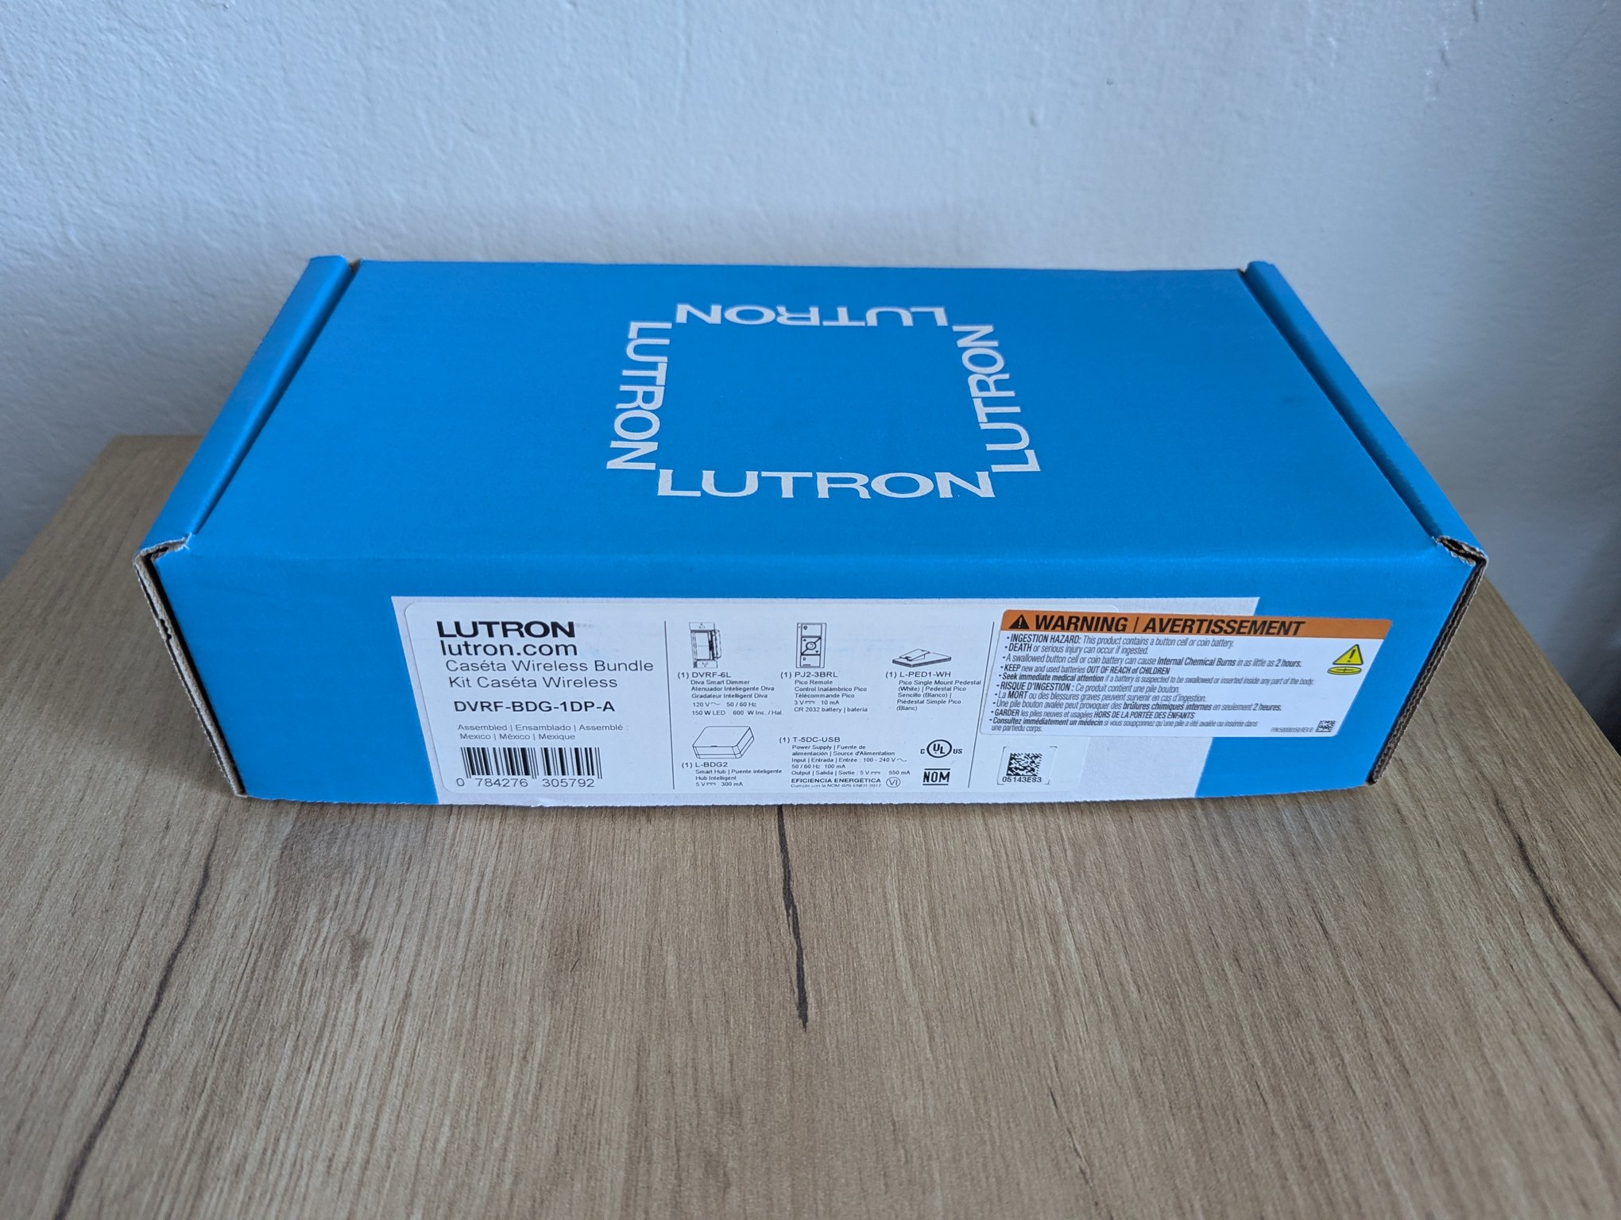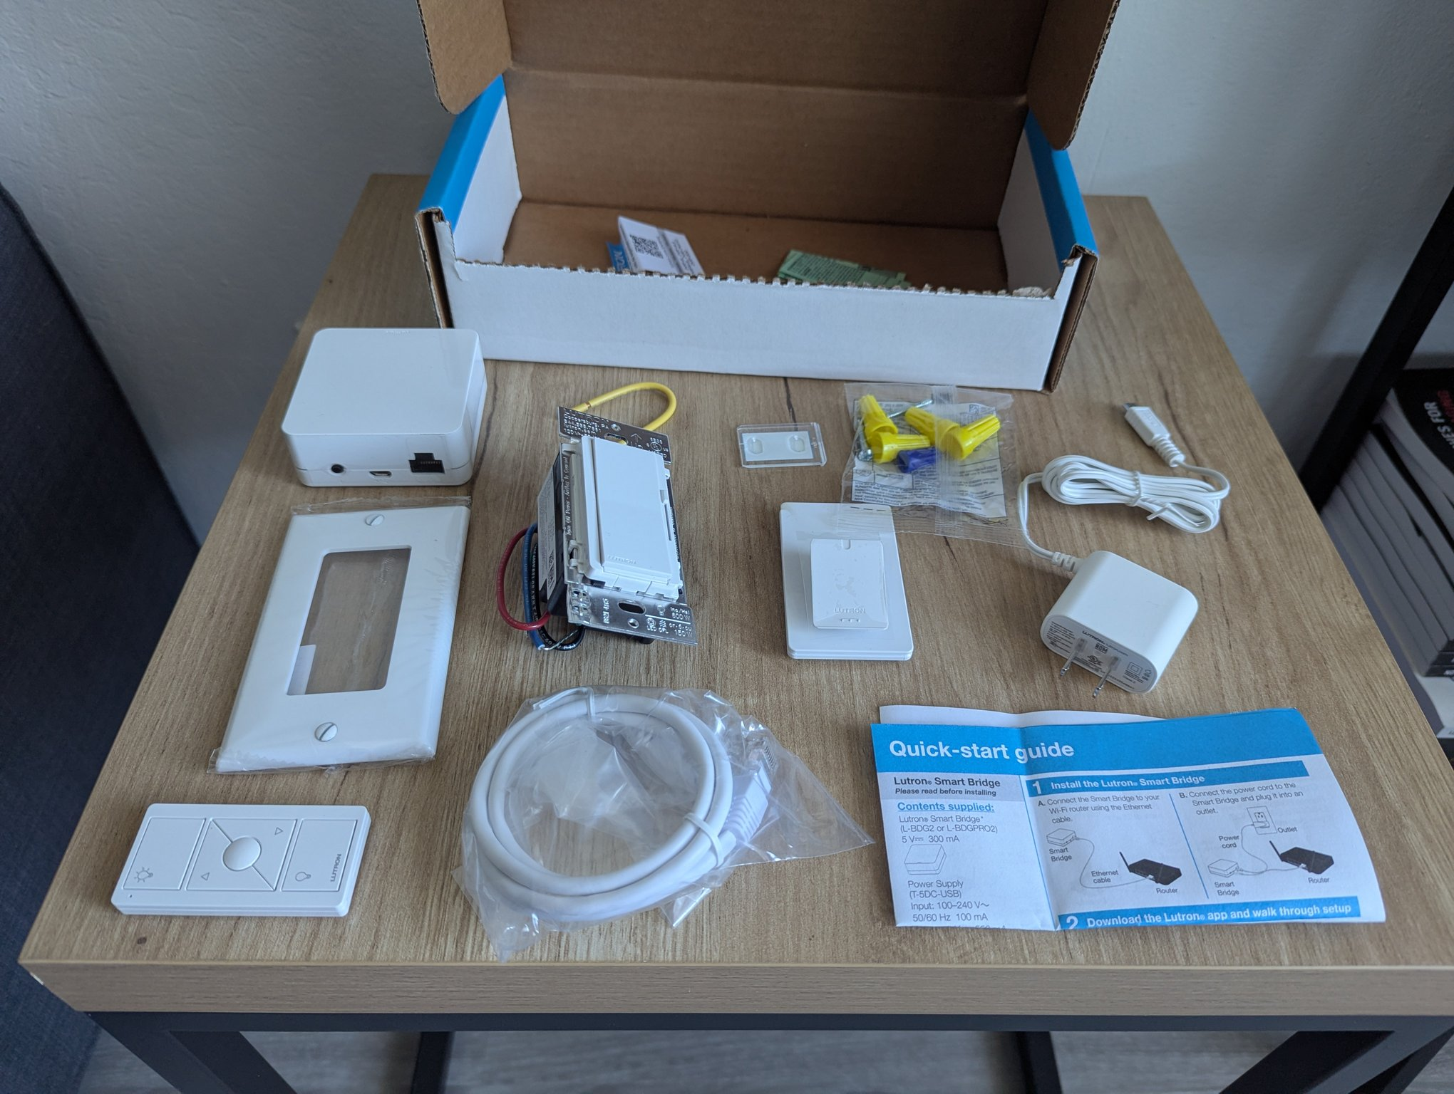

Reolink Video Doorbell WiFi (2K 5MP) — $75
Used for about 2 years, fully working (D340W). 2K/5MP WiFi doorbell with chime, power adapter, mounting screws, and Ethernet cable.
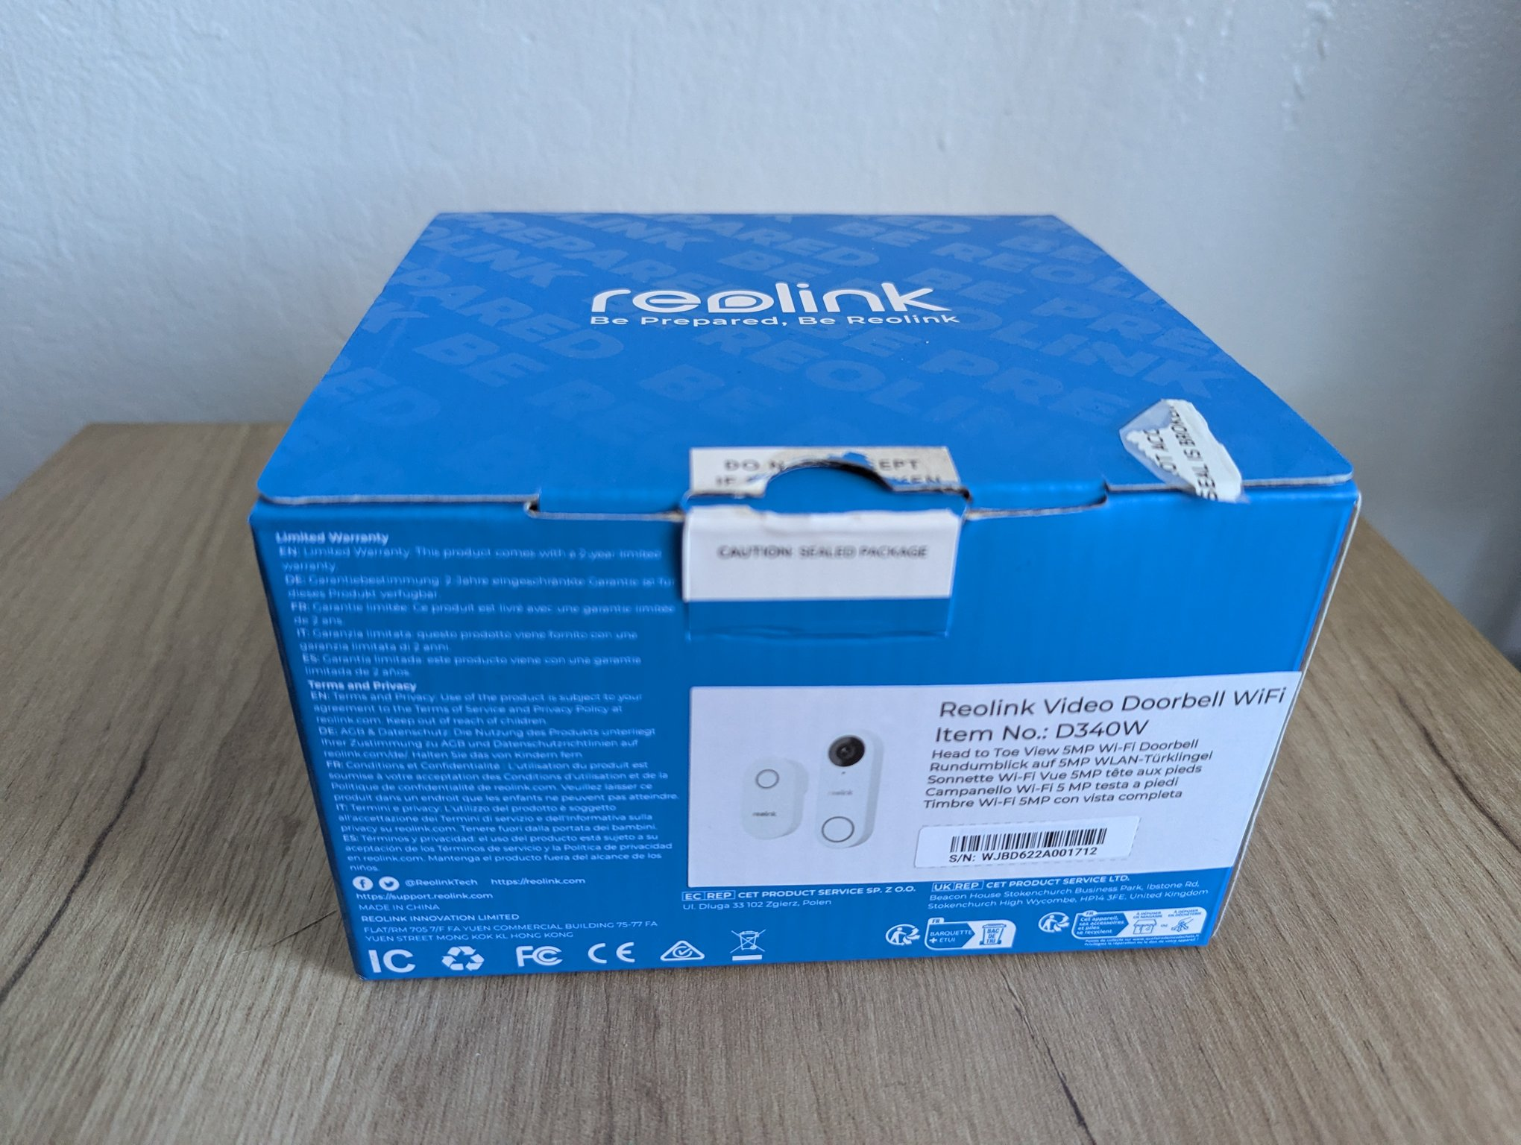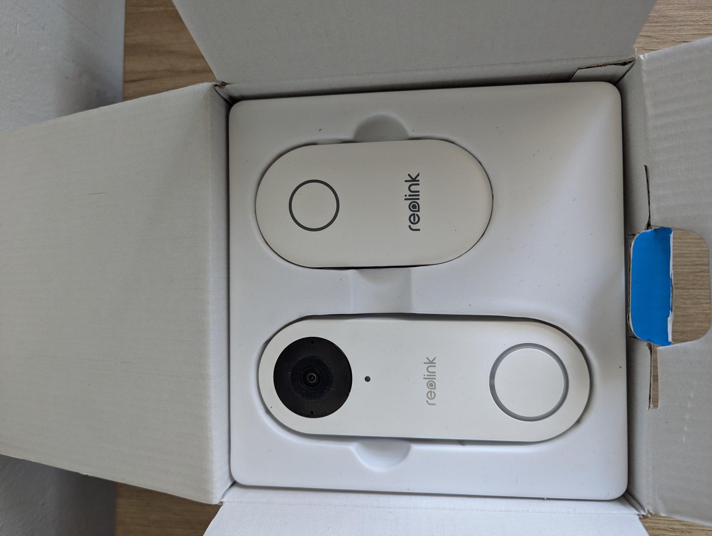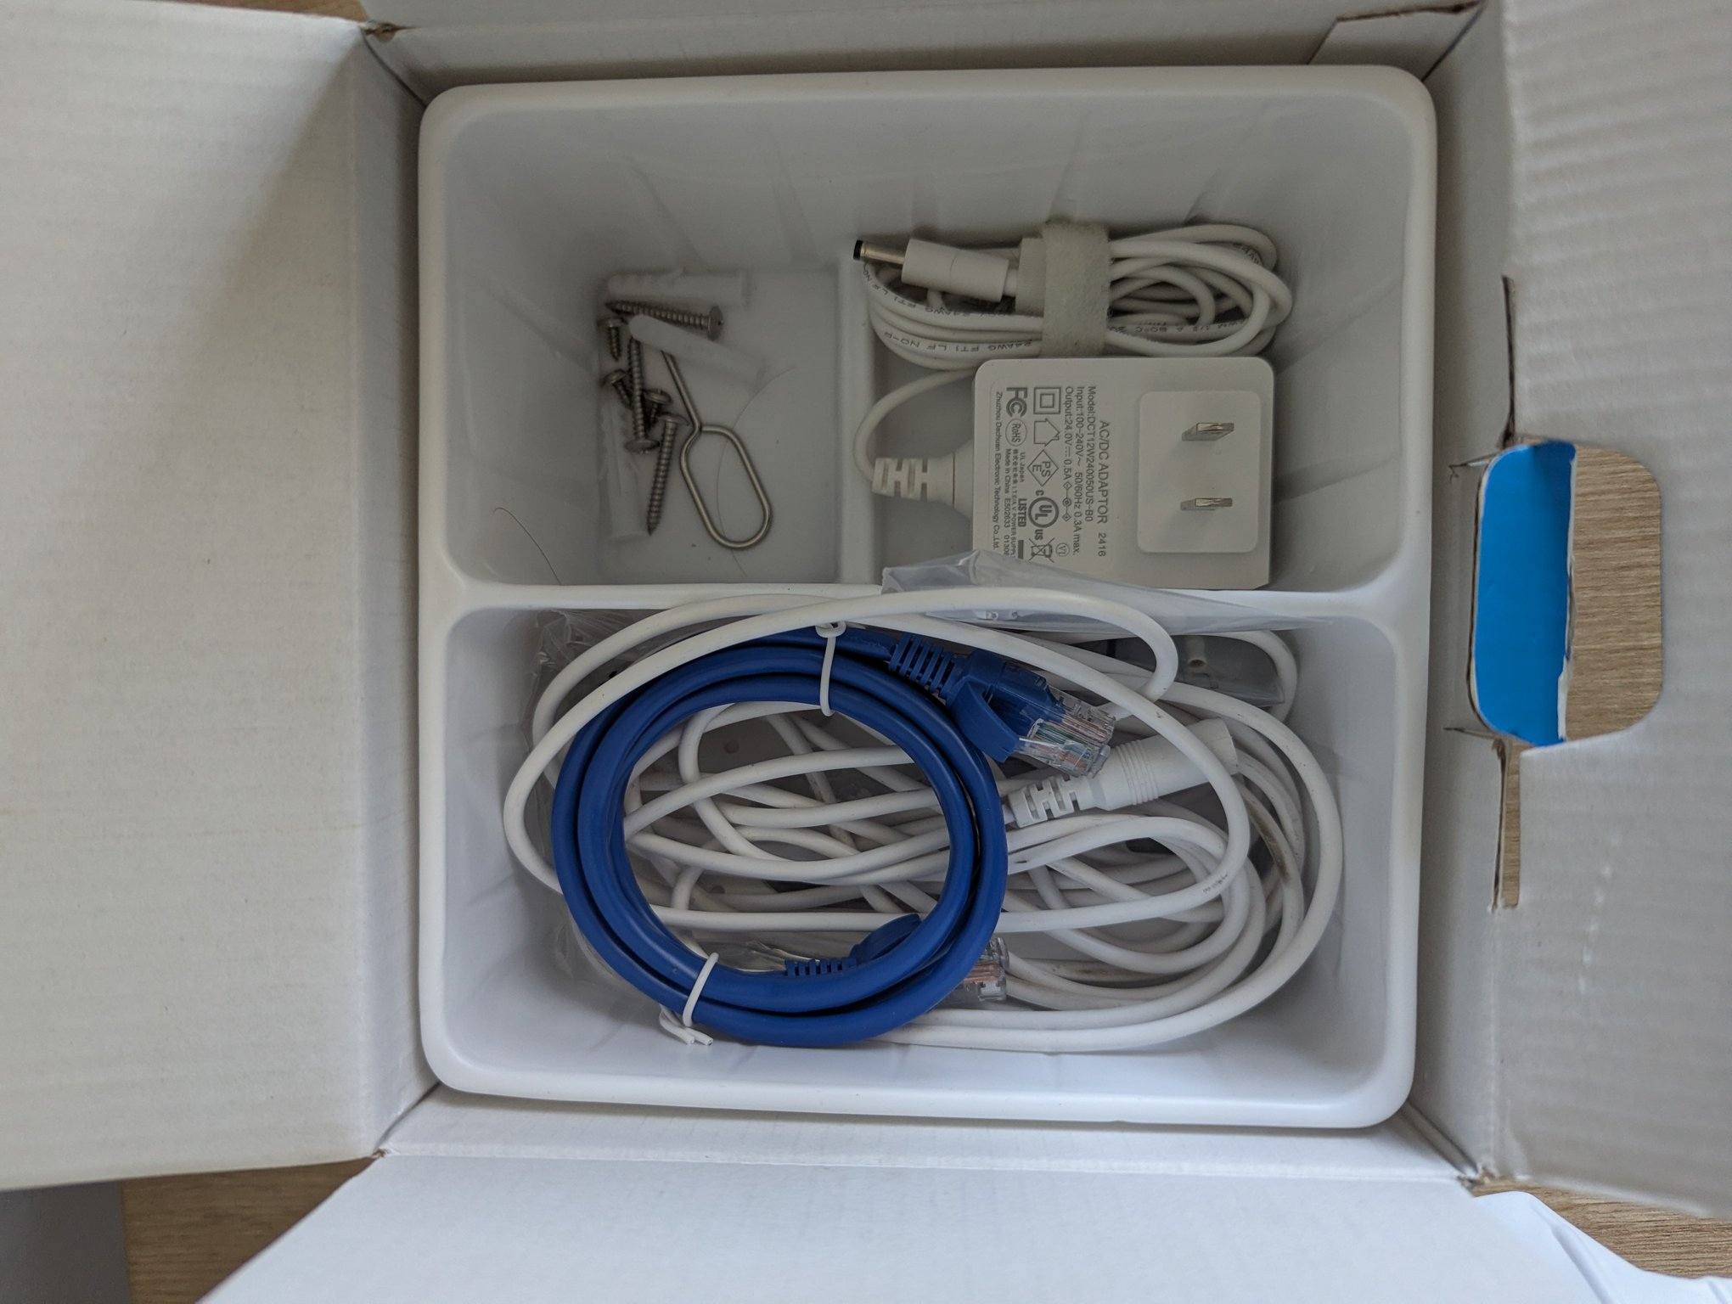

IKEA Desk (Oak Effect / Black), 130 × 70 cm — $70
Simple IKEA desk with a light oak-effect top and a black metal frame — round legs, a front support rail, and built-in hooks on both sides underneath for headphones or a bag. Approx. 130 × 70 cm, 75 cm high. Good condition; computer gear in the photos is not included.
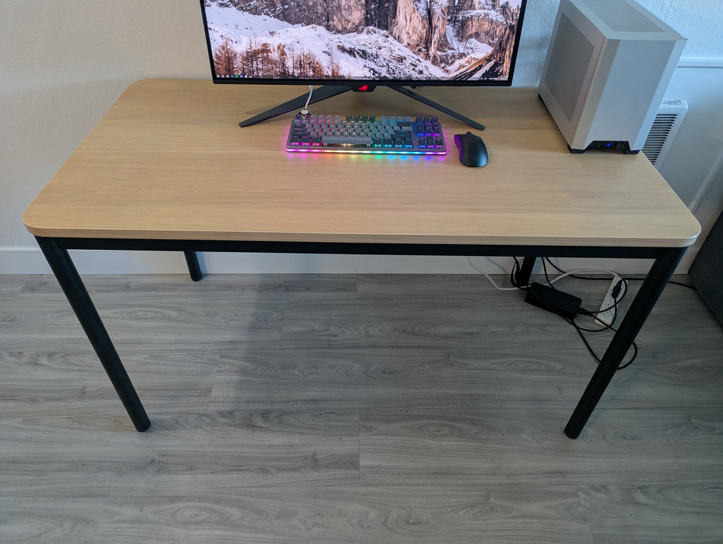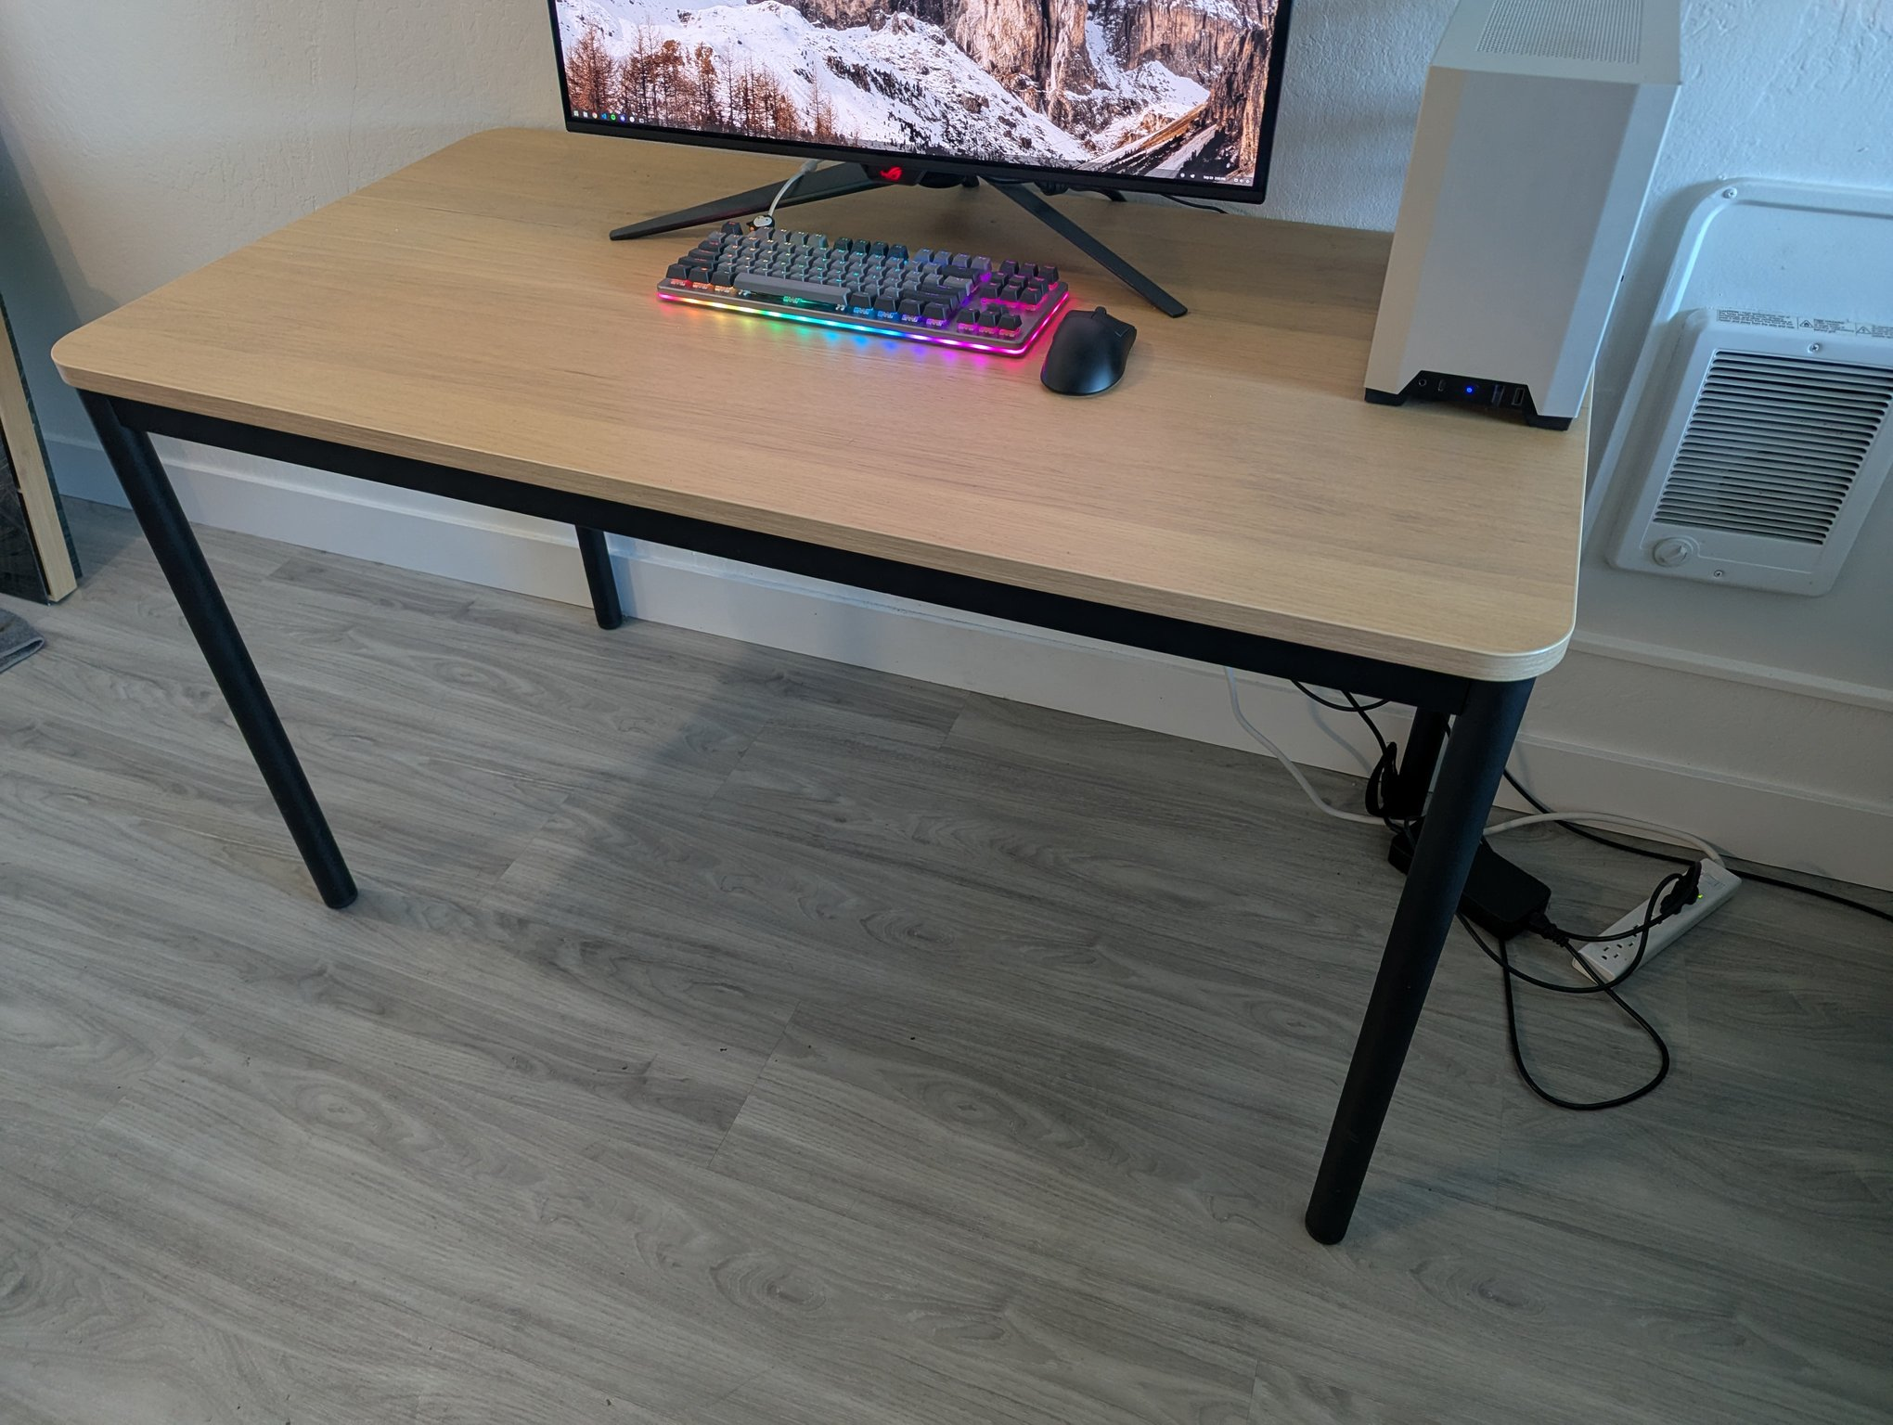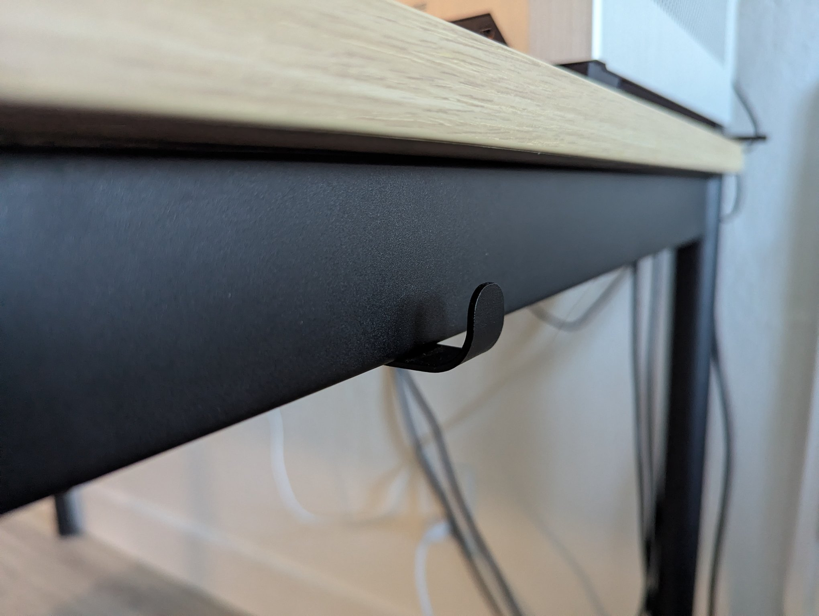

iTouchless SoftStep 13.2-Gallon Step Trash Can — $50
Semi-round brushed stainless-steel step can with soft-close pedal, removable inner bucket, and AbsorbX odor filter. Clean, works smoothly; includes one extra odor filter. Retails ~$140.
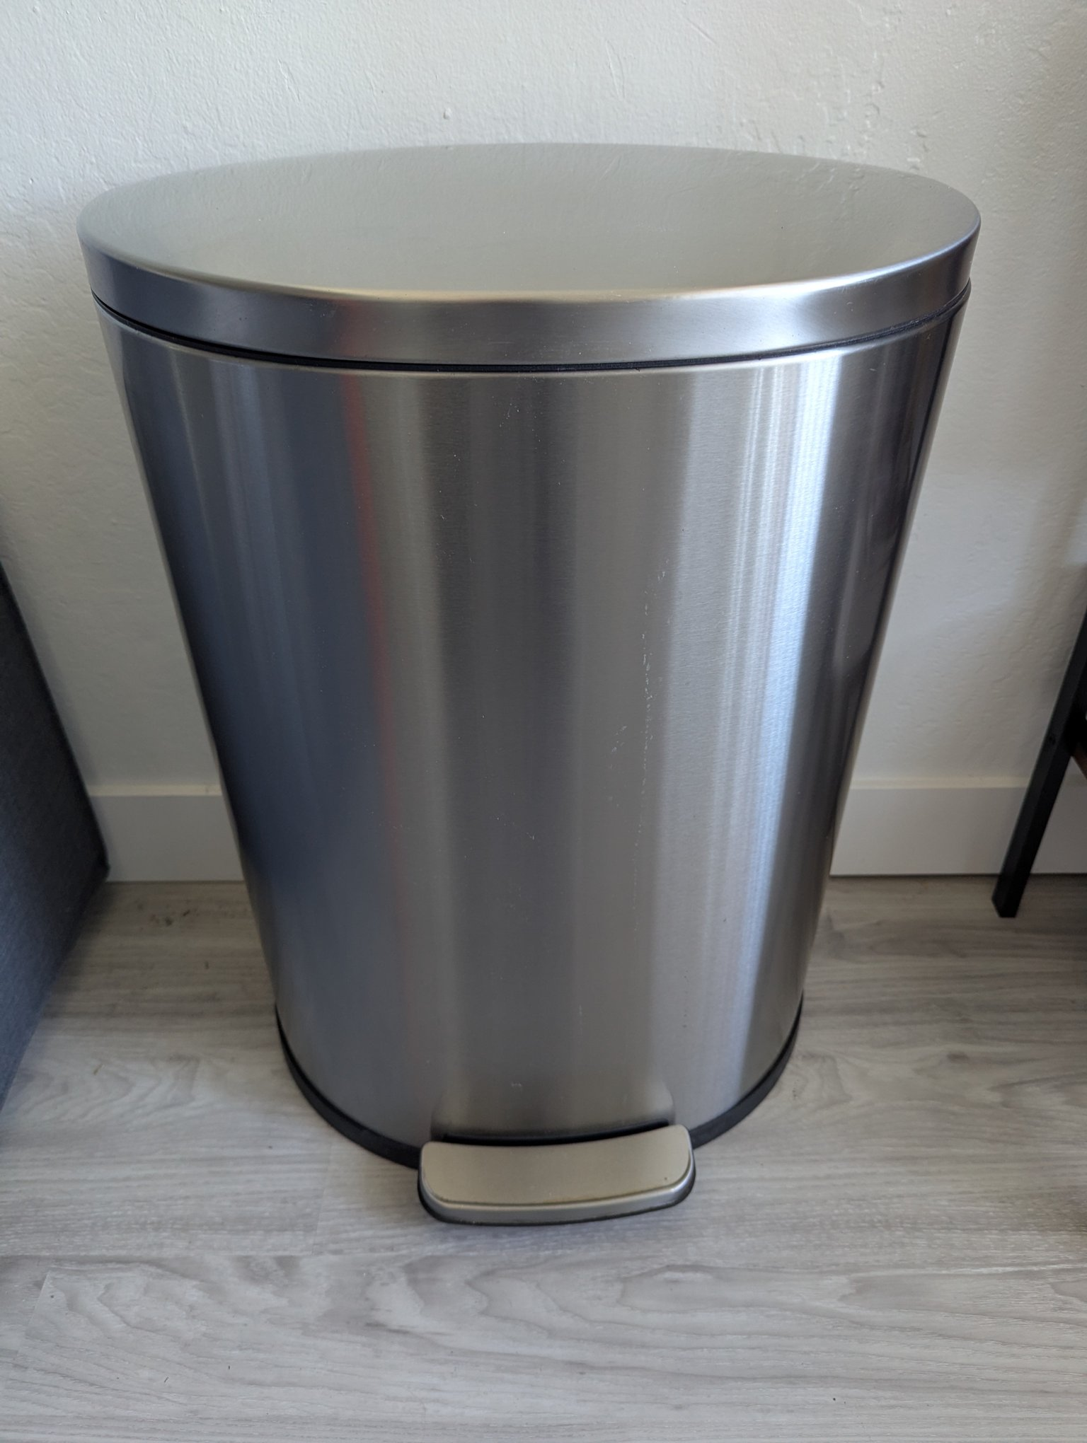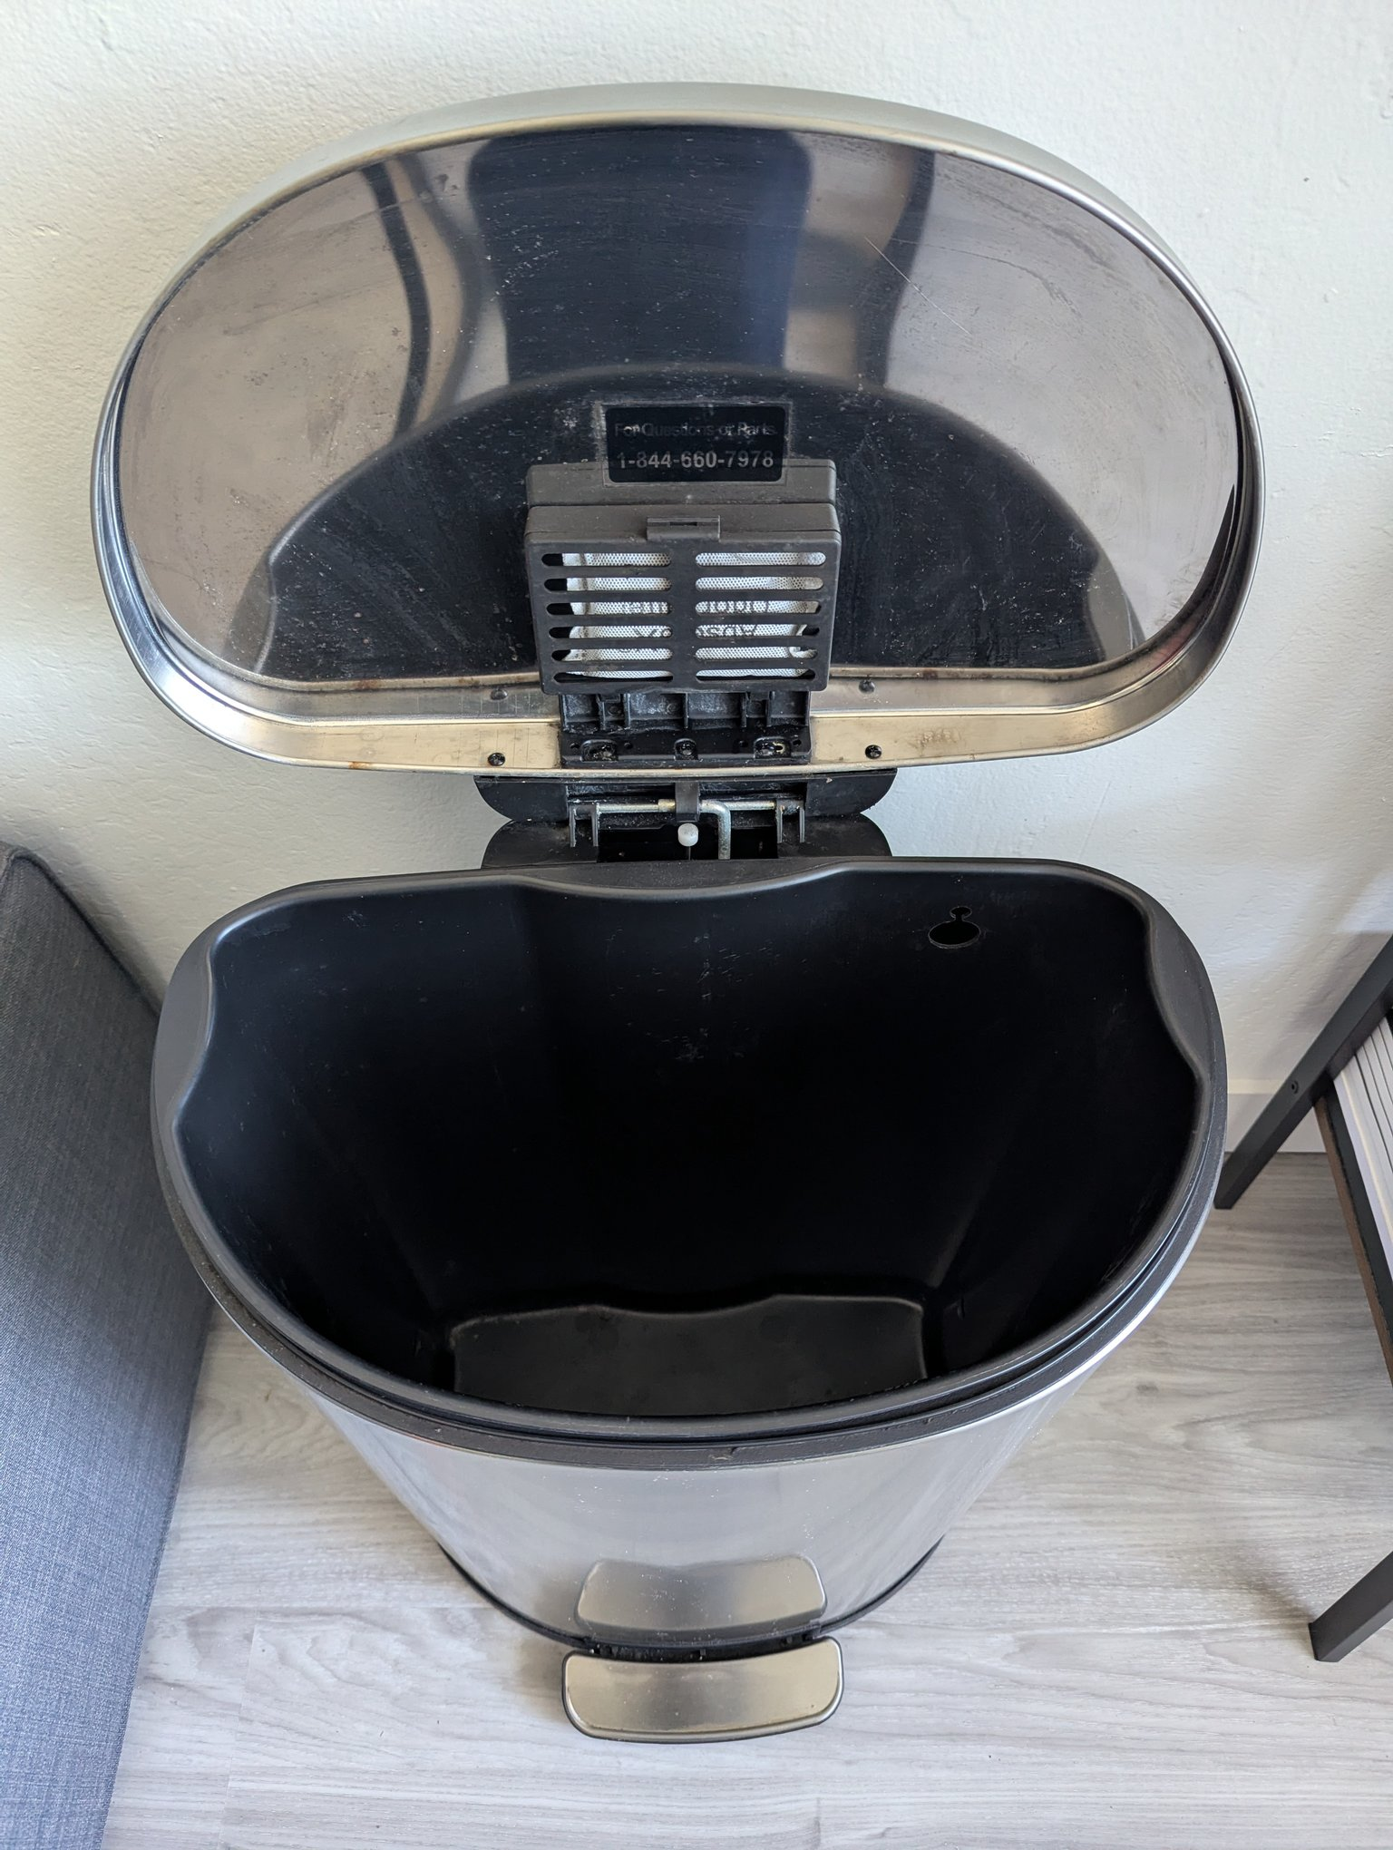

IKEA FJÄLLBO Coffee Table (Black) — $45
IKEA FJÄLLBO coffee table: black metal frame, solid pine top, and a lower mesh shelf. 90 × 46 × 46 cm. Solid and stable with minor wear.
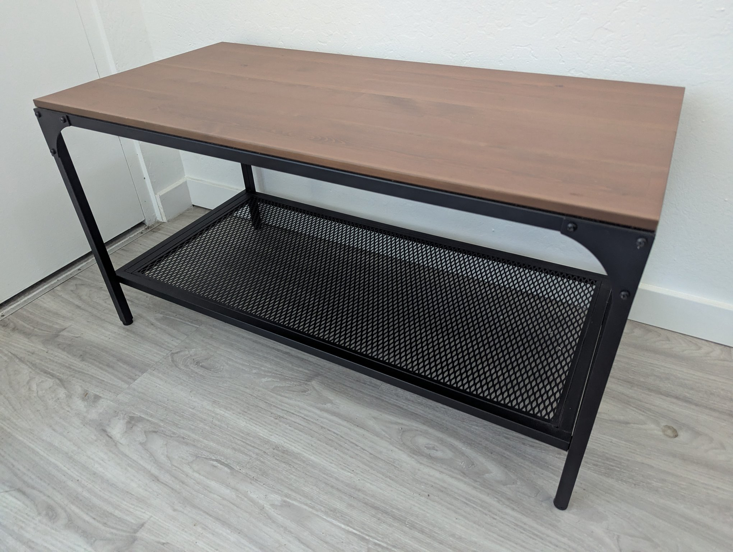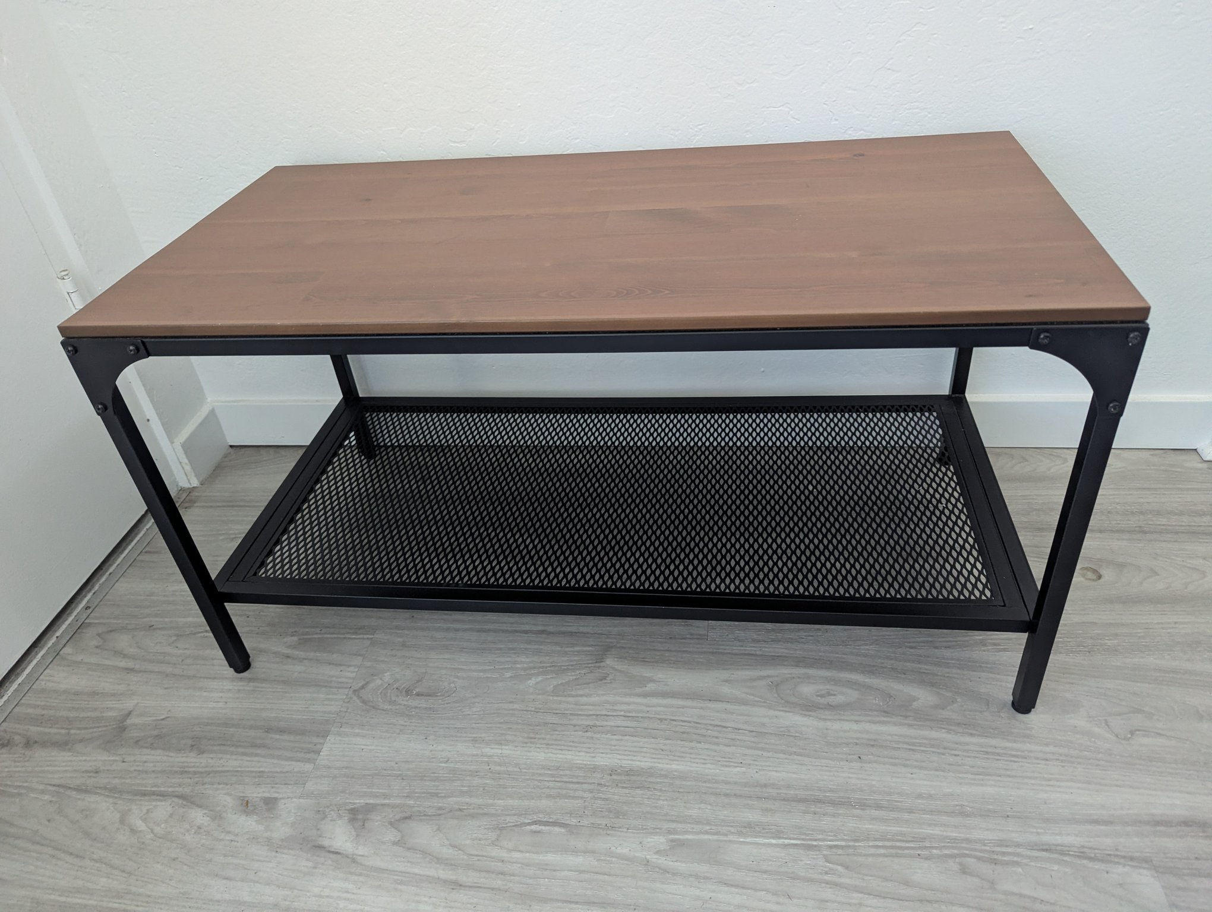

Black Metal 5-Tier Ladder Bookshelf — $45
Industrial leaning ladder shelf with black metal A-frame and five dark wood-grain shelves. 5.5 ft tall, sturdy, good condition. Books and decor not included.
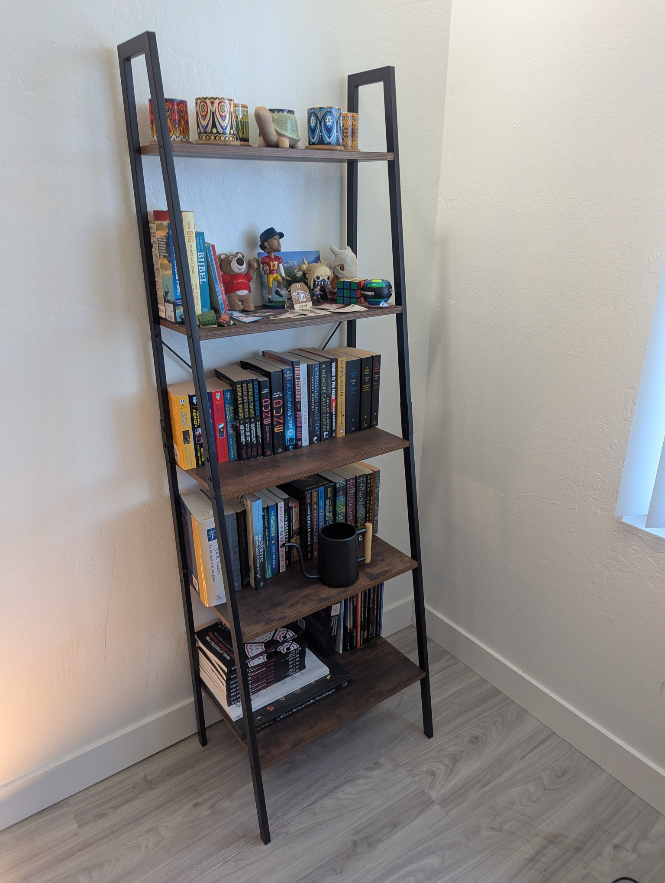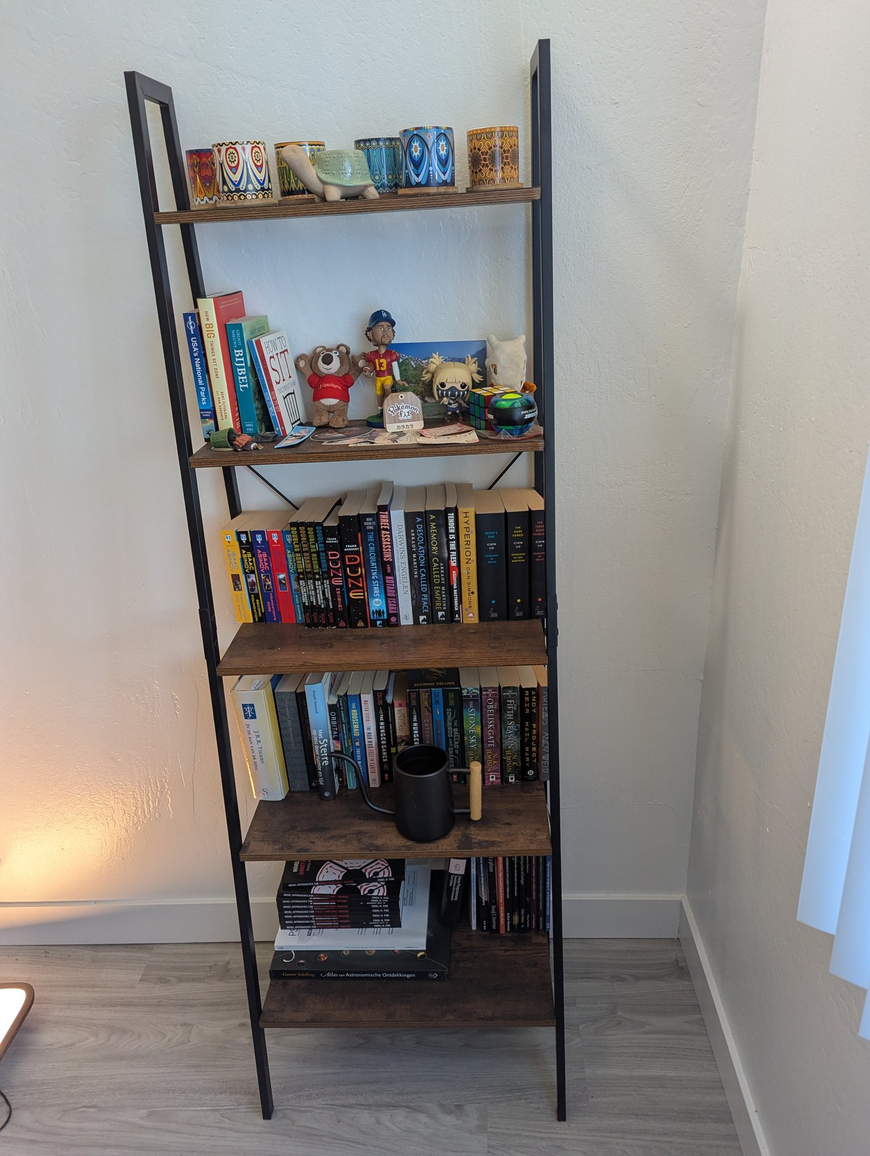

Blue Yeti USB Microphone (Silver) — $40
Fully functional Blue Yeti condenser mic with desk stand — great for streaming, podcasts, or calls. Minor cosmetic wear on the base.
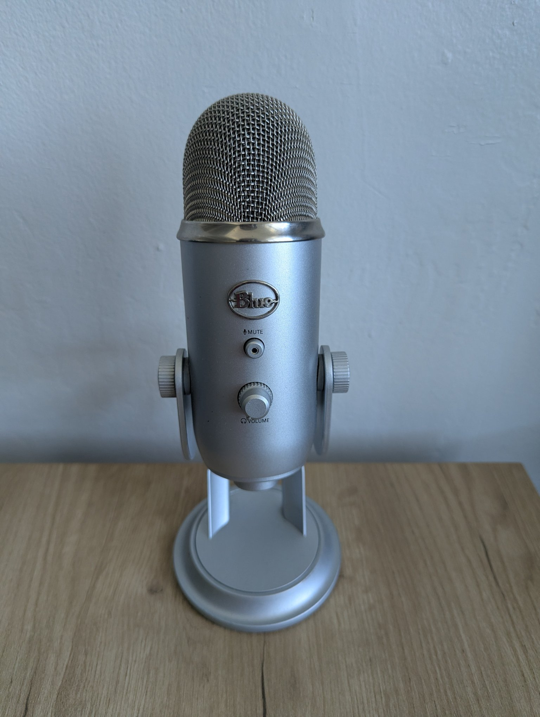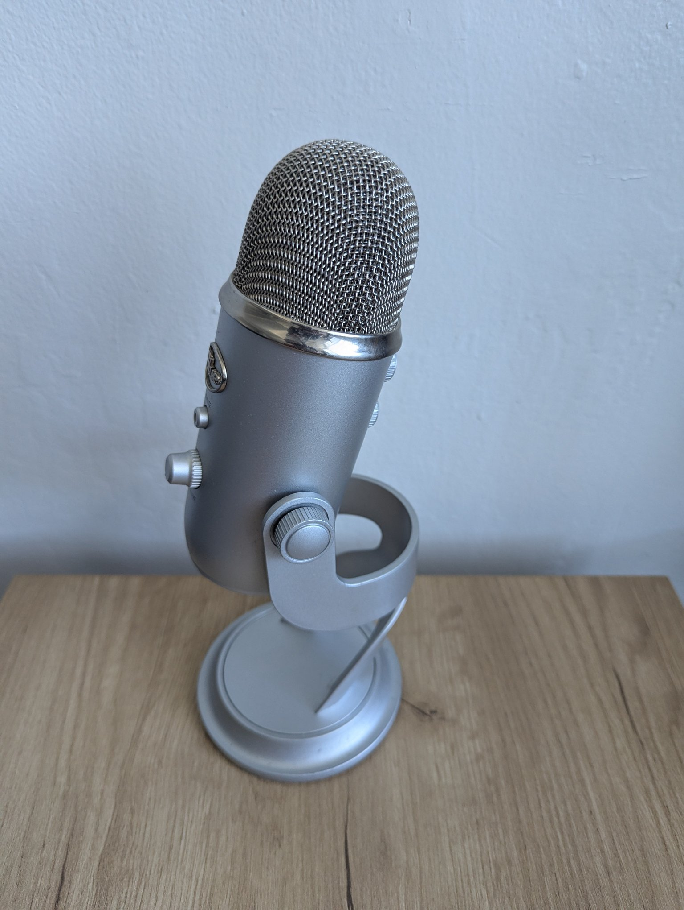

Pair of Wooden Table Lamps with USB Ports — $40
Two matching lamps with light wood bases, chrome stems, and white linen drum shades. Each plugs into the wall and has two built-in USB charging ports. Both lamps include bulbs.
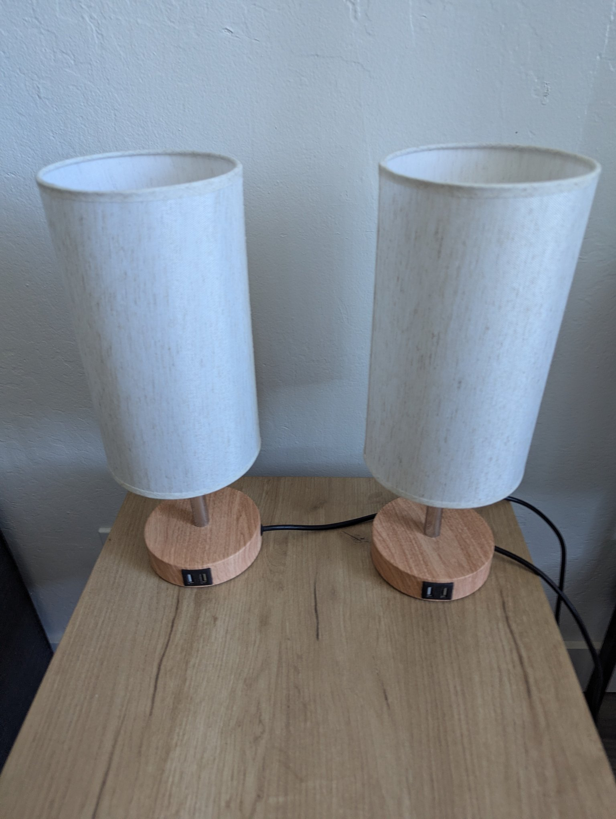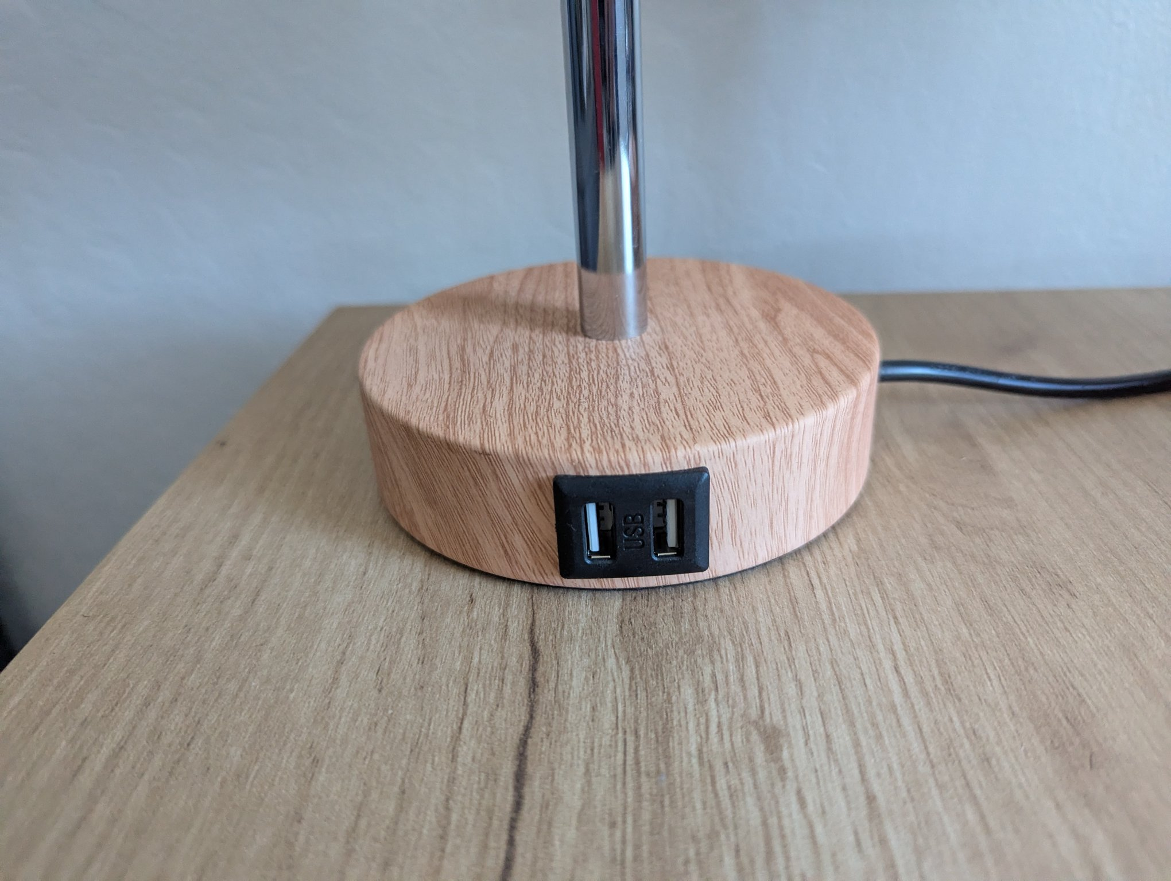

Light Oak Square Side / End Table — $35
Modern side table with a light oak-tone top and black square metal frame. Approx. 18 × 18 in. Great beside a sofa or bed.
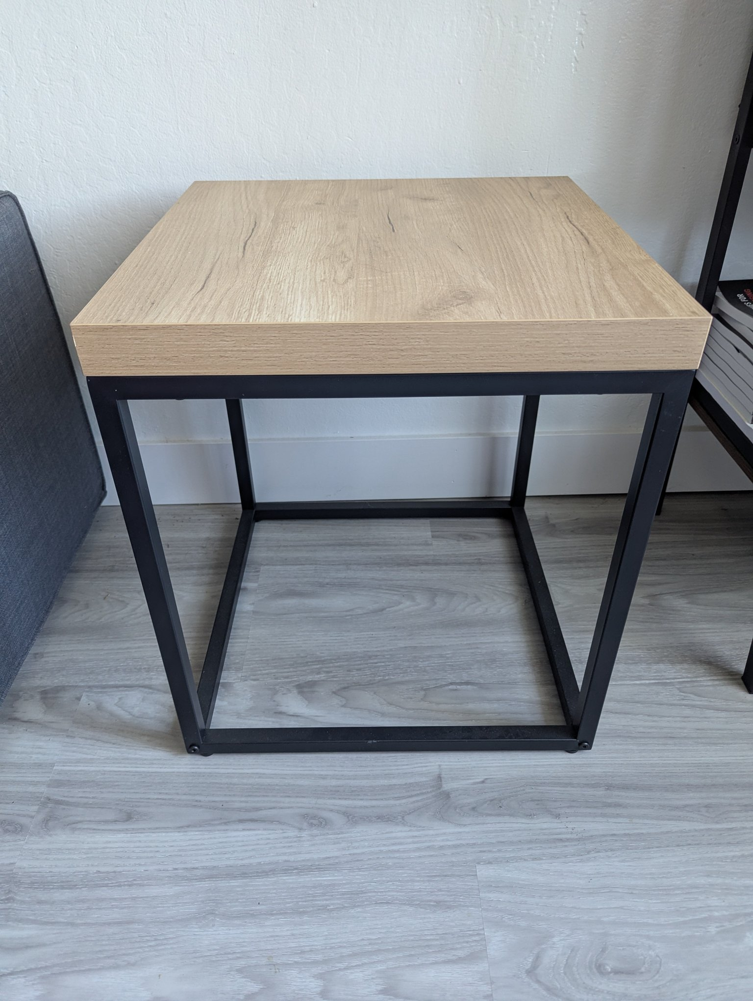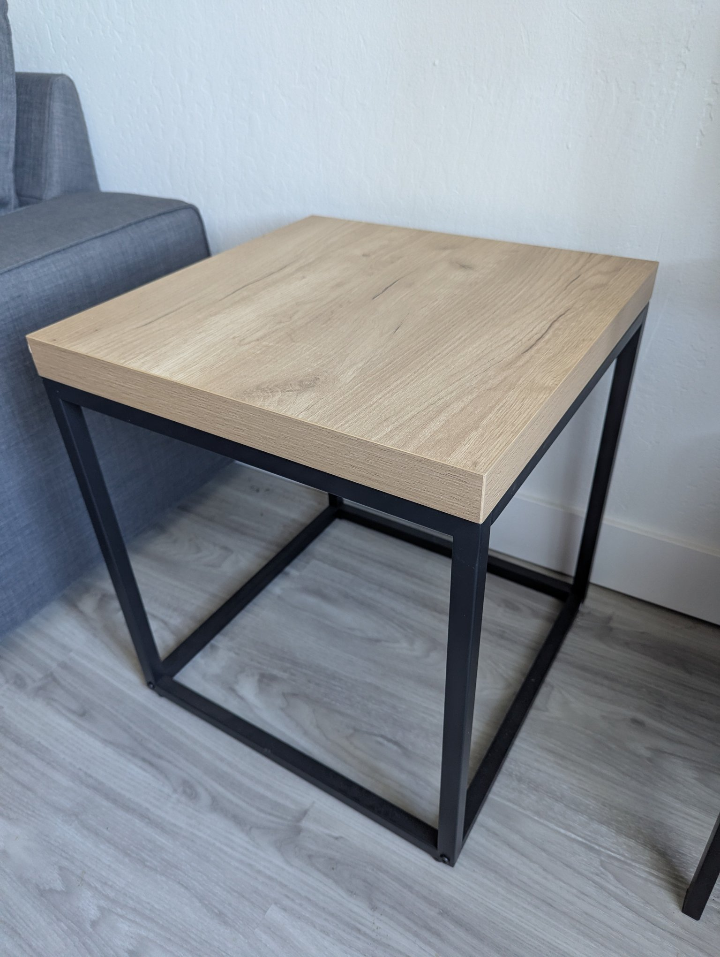

Walnut 2-Tier Open Nightstand — $25
Walnut-effect nightstand/bedside shelf with two open compartments, round tapered wood legs, and a tray-style top. Approx. 24 in tall.
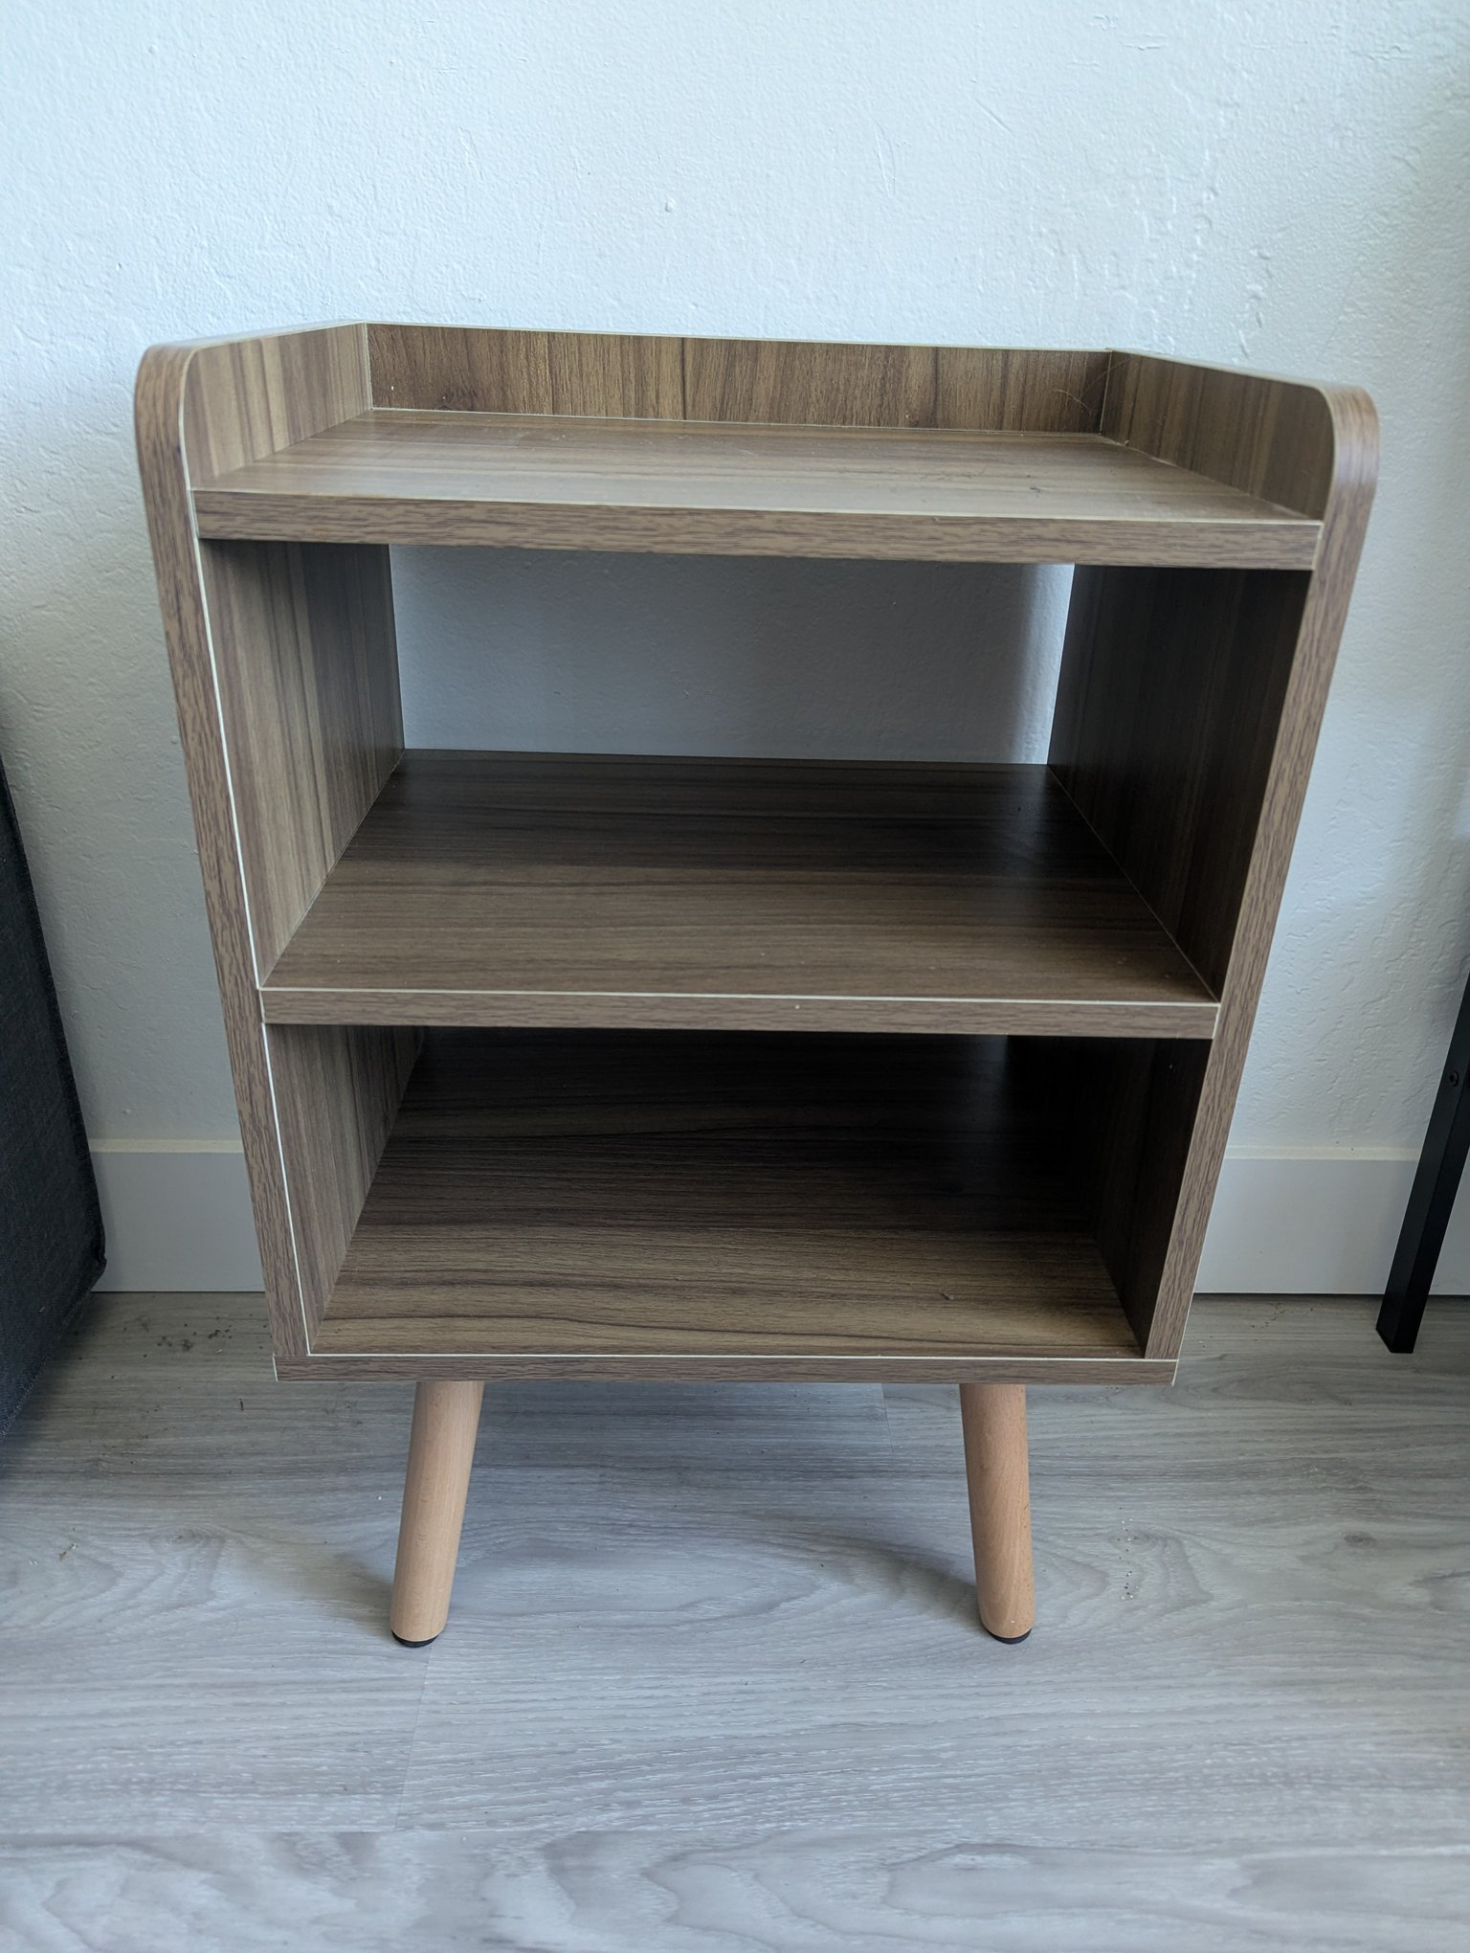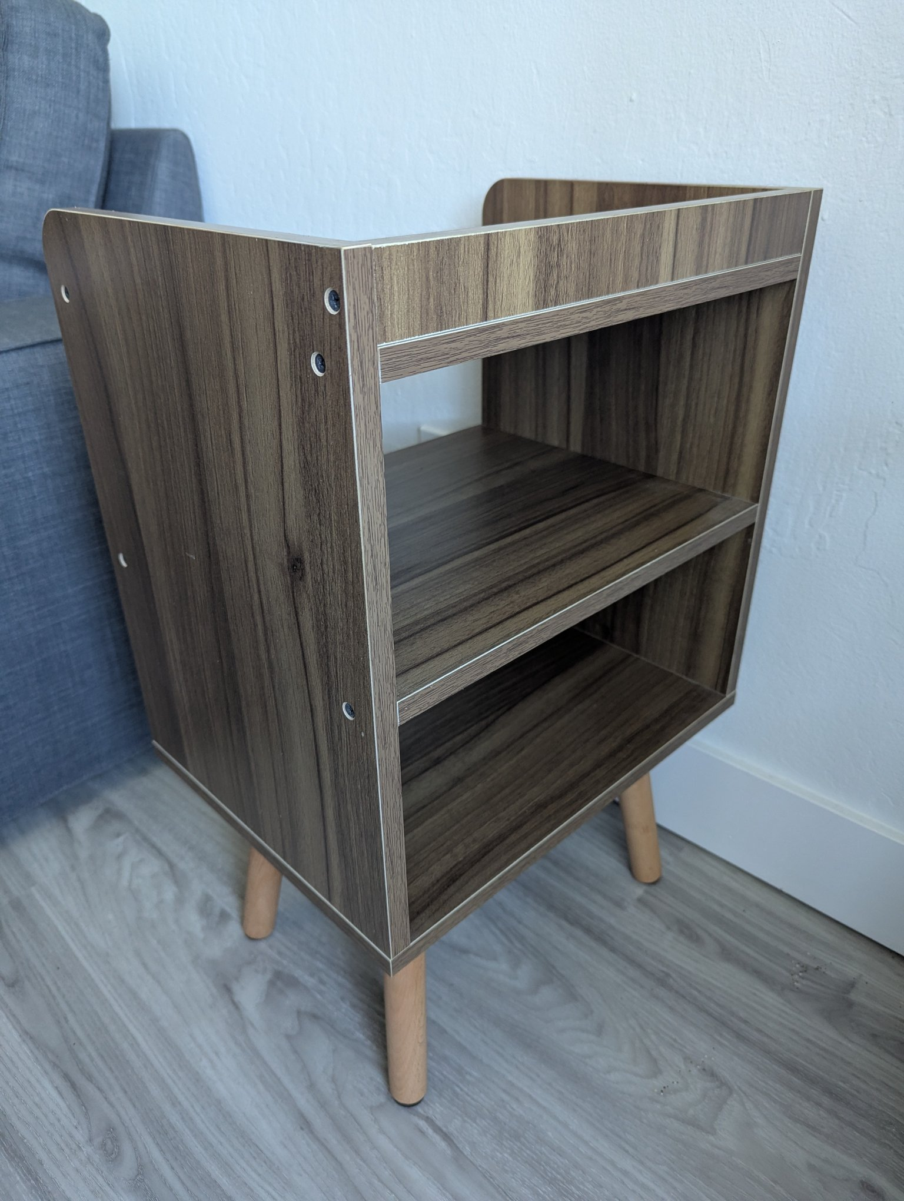

Govee Dual Smart Plug 2-Pack (Model H5082) — $20
Both units work. Each plug controls two outlets independently via the Govee Home app with voice control and scheduling. 120V, 15A.
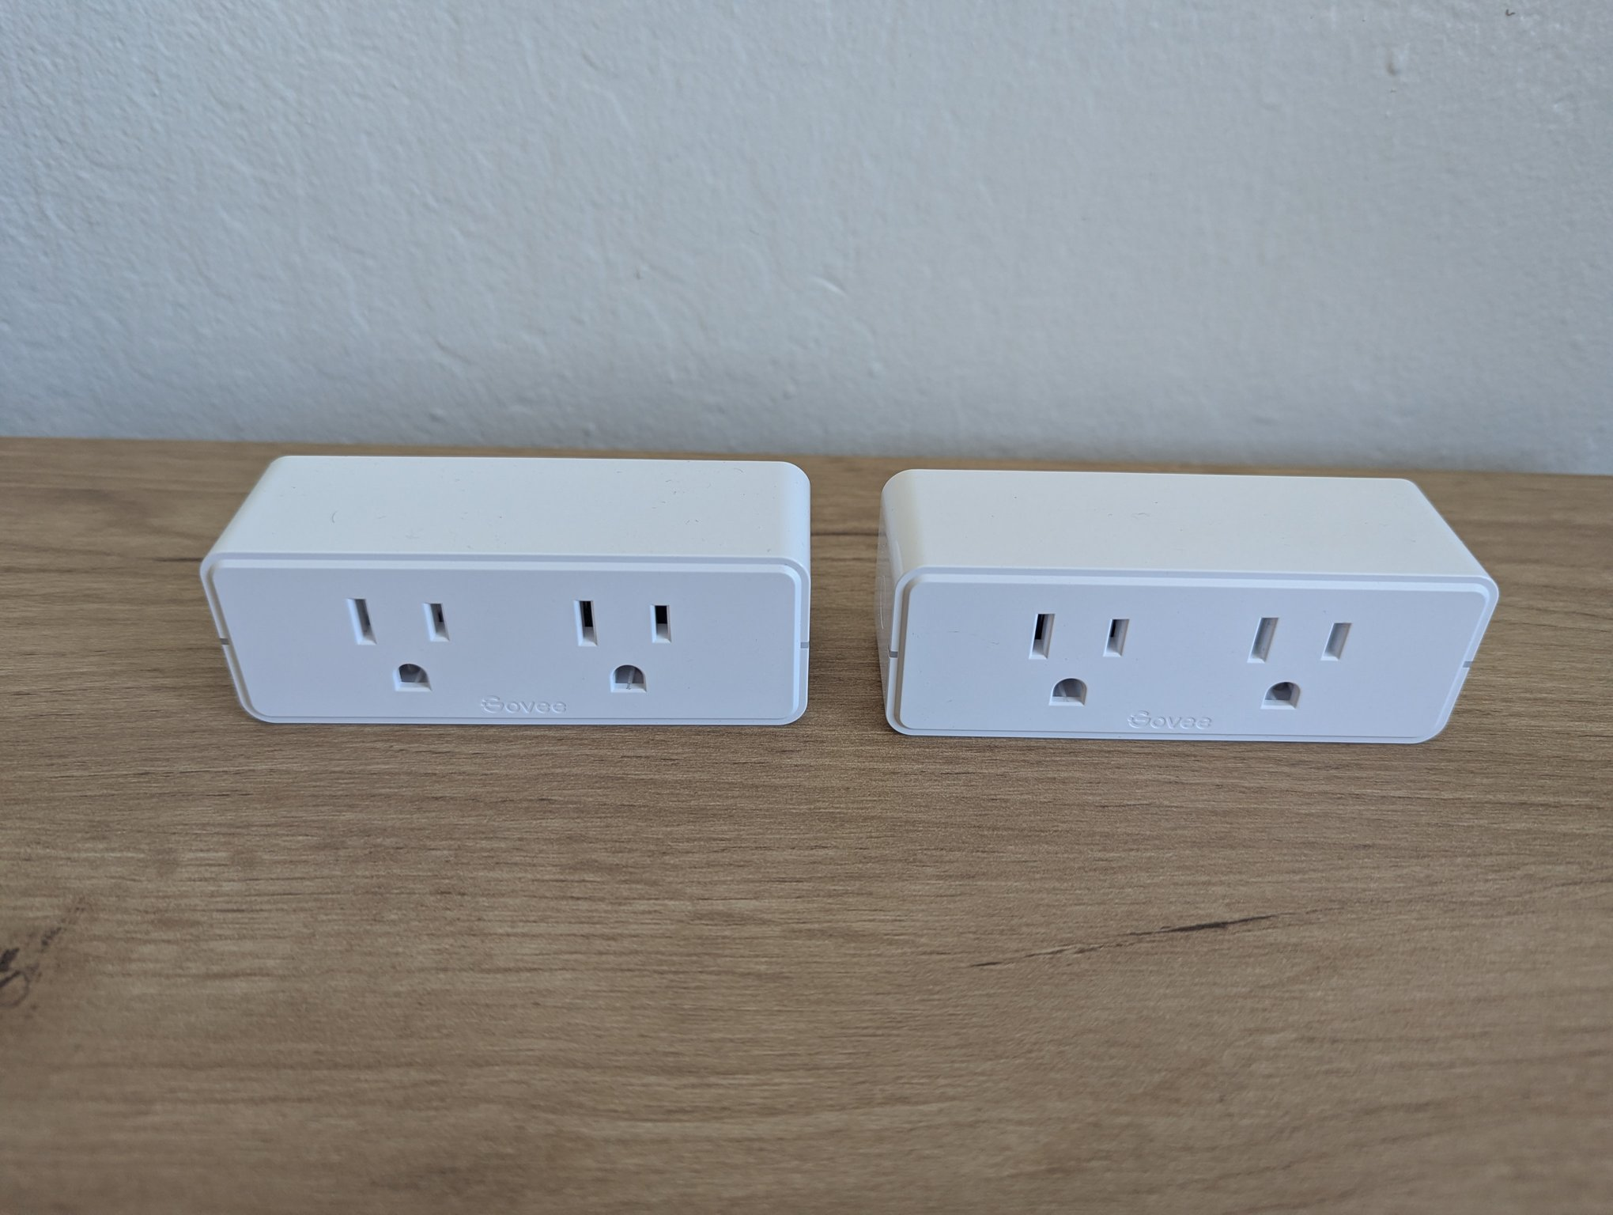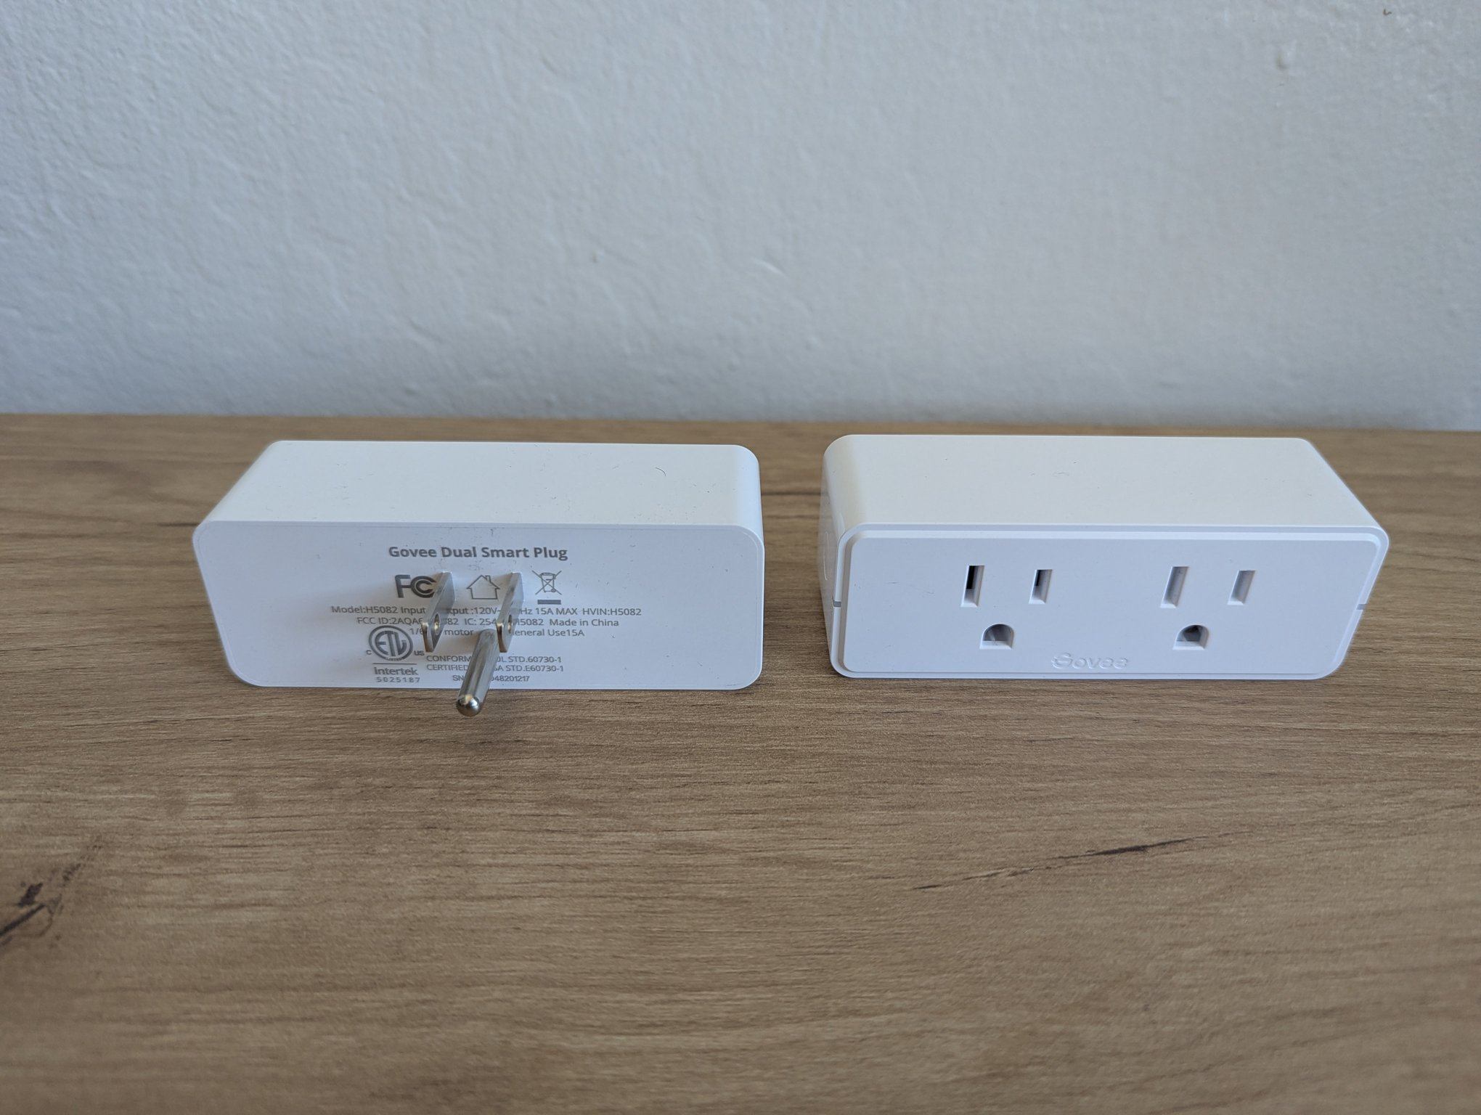

Miniware MHP50 Mini Hot Plate Preheater — $20
Compact constant-temperature hot plate for SMD rework/PCB preheating with digital display. Includes original box, power cable, and silicone mat. Lightly used.
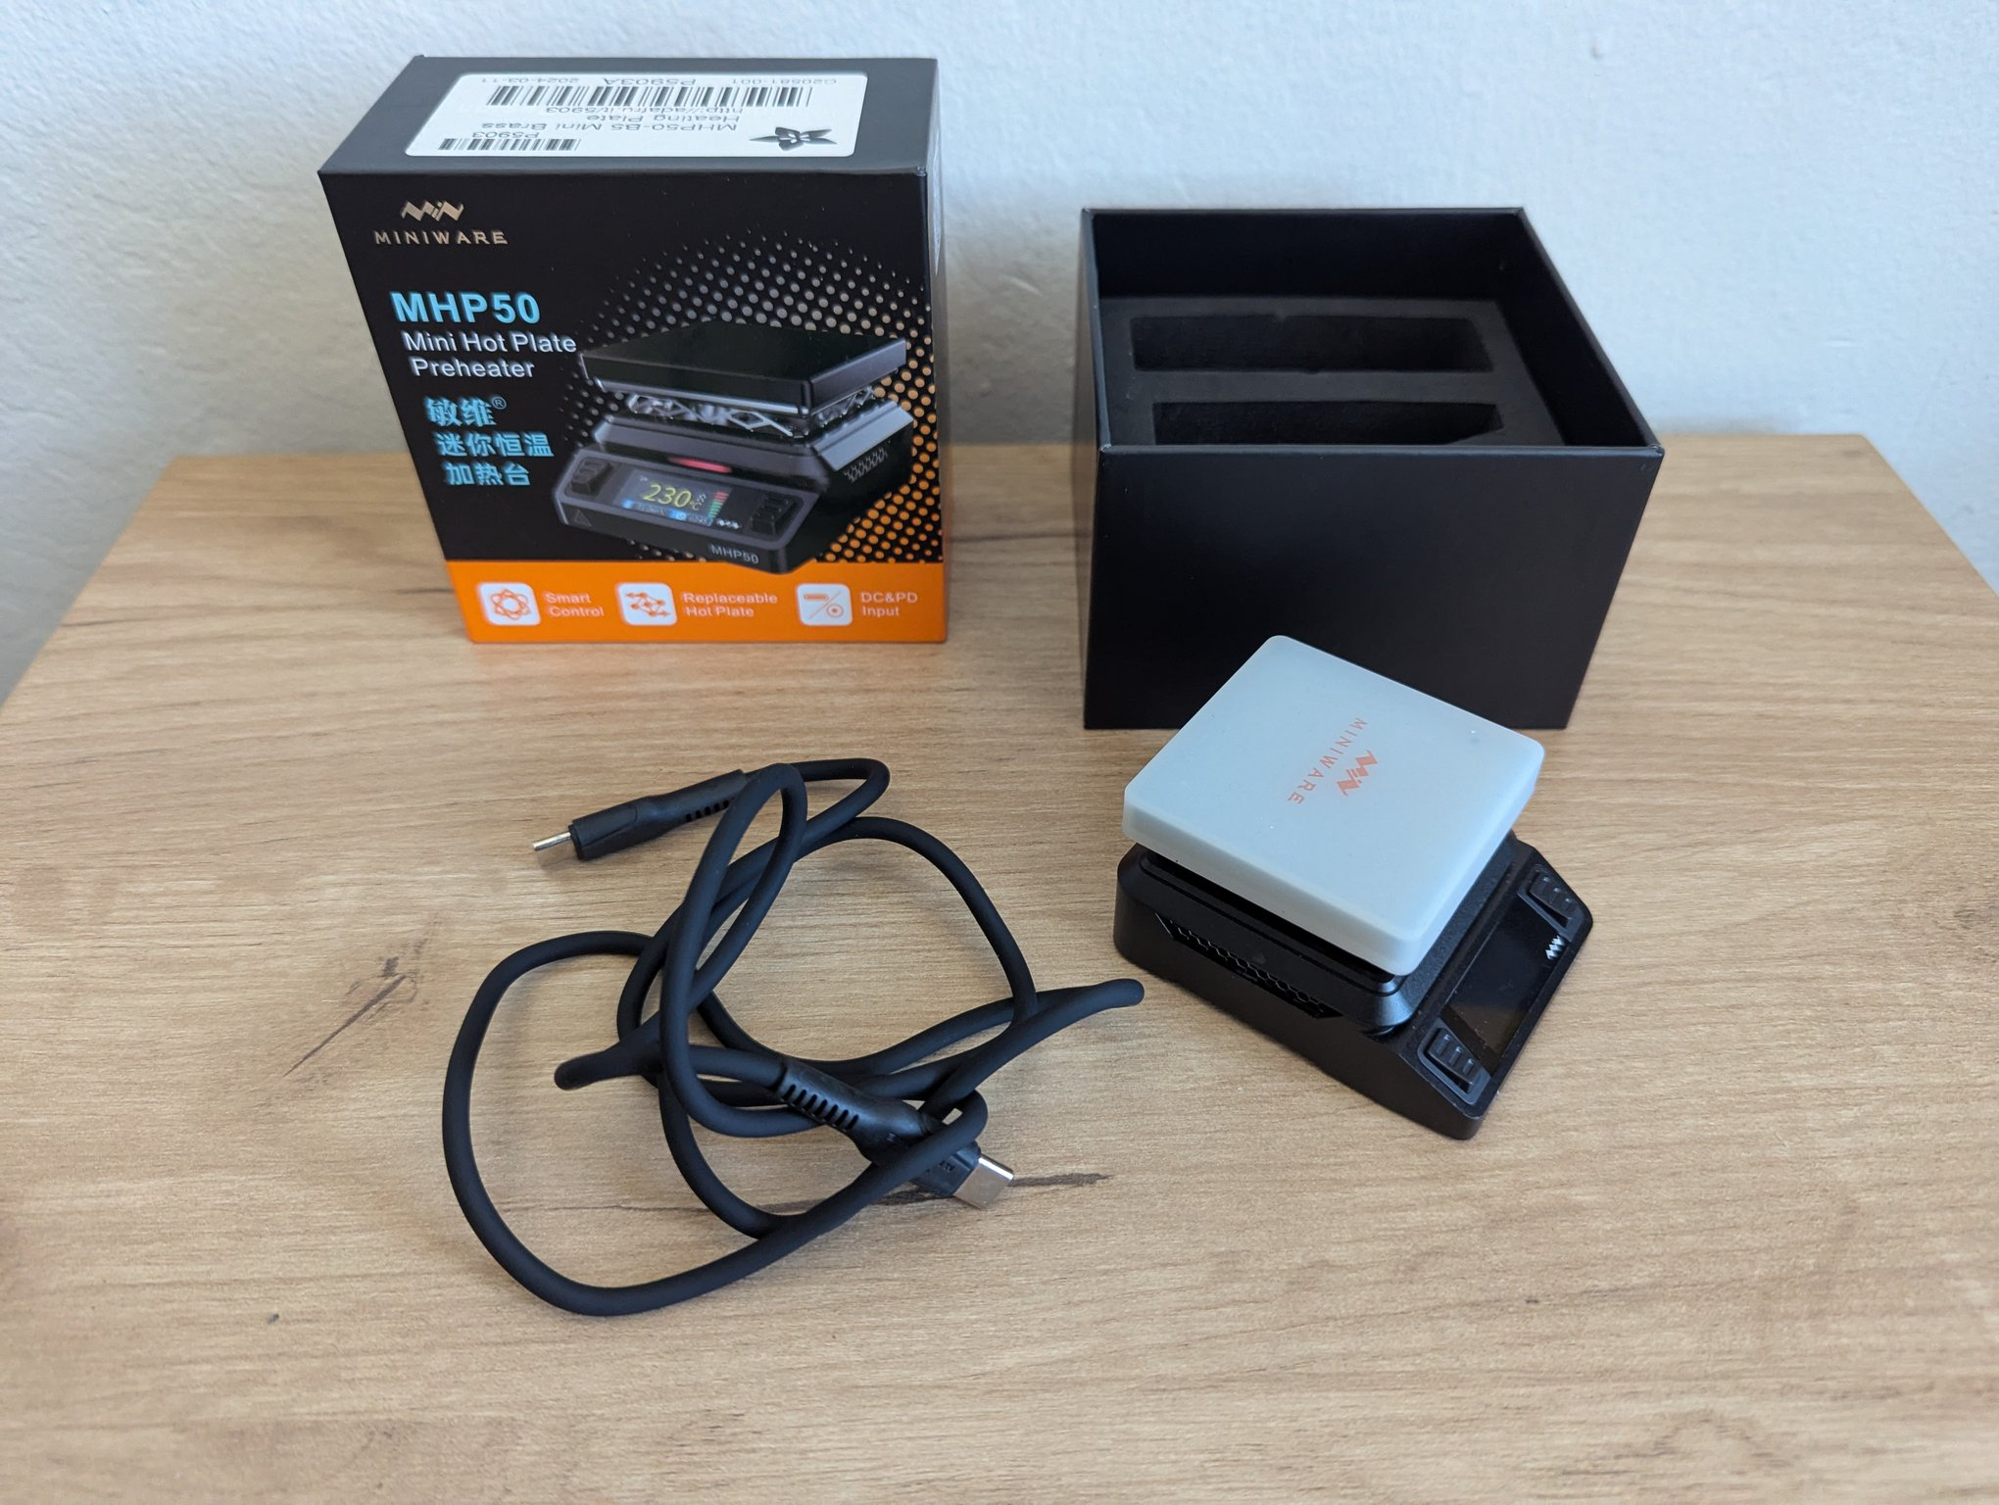
Miniware hot plate

Cosori 1.7 L Electric Kettle (Black) — $15
Cosori 1.7 L glass kettle with stainless-steel interior (no plastic contact with water), 1500W fast boil, auto shut-off, and blue LED. Clean, no cracks or chips.
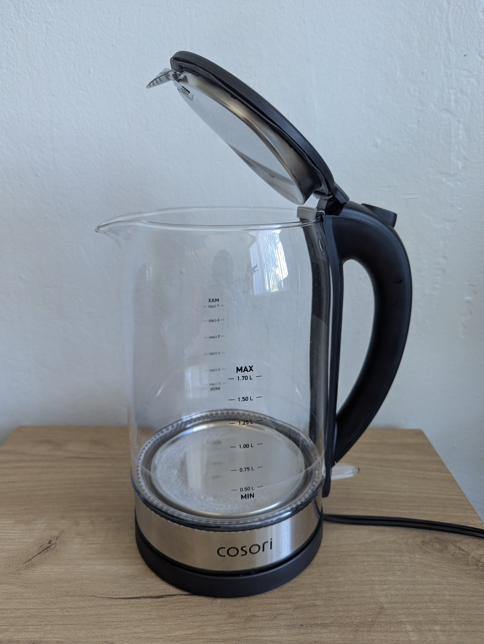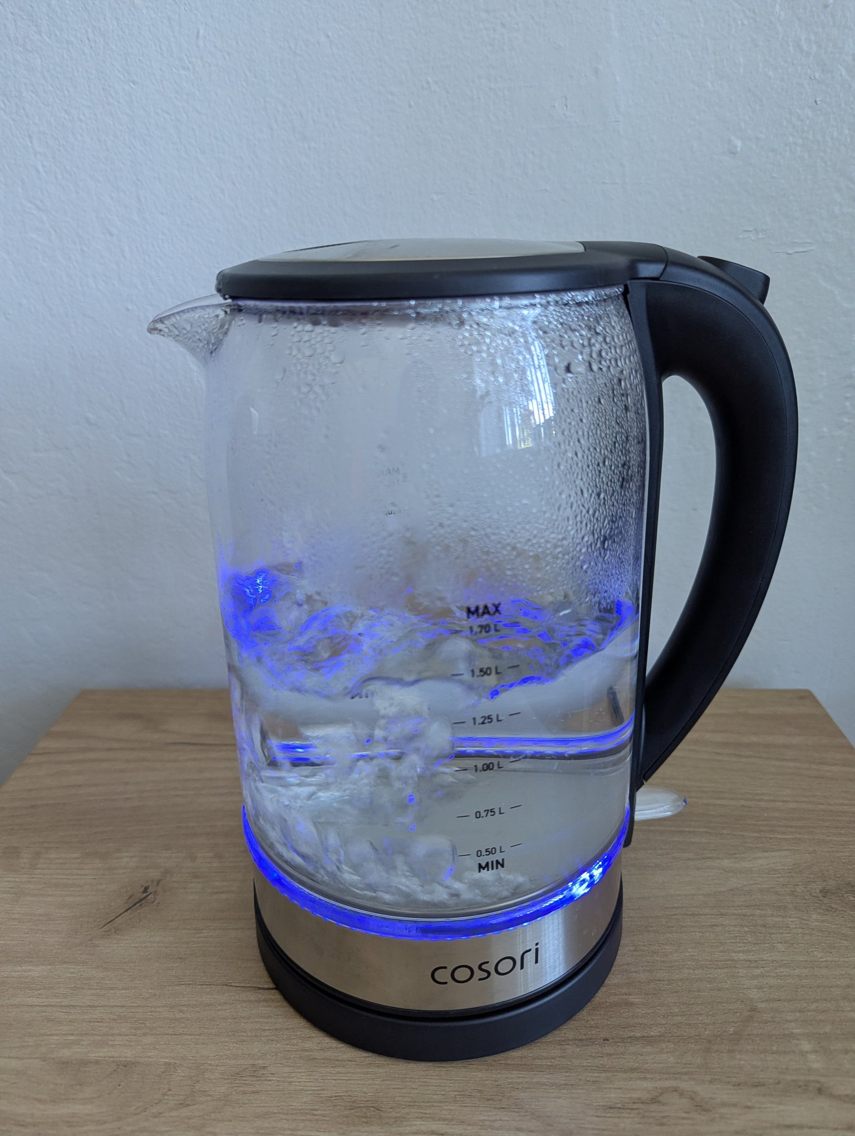

Set of 6 Colorful Ceramic Planters (+ Turtle Planter) — $5
Six colorful ceramic planters on wooden bases, plus a small turtle planter. Some interior soil residue, otherwise good.
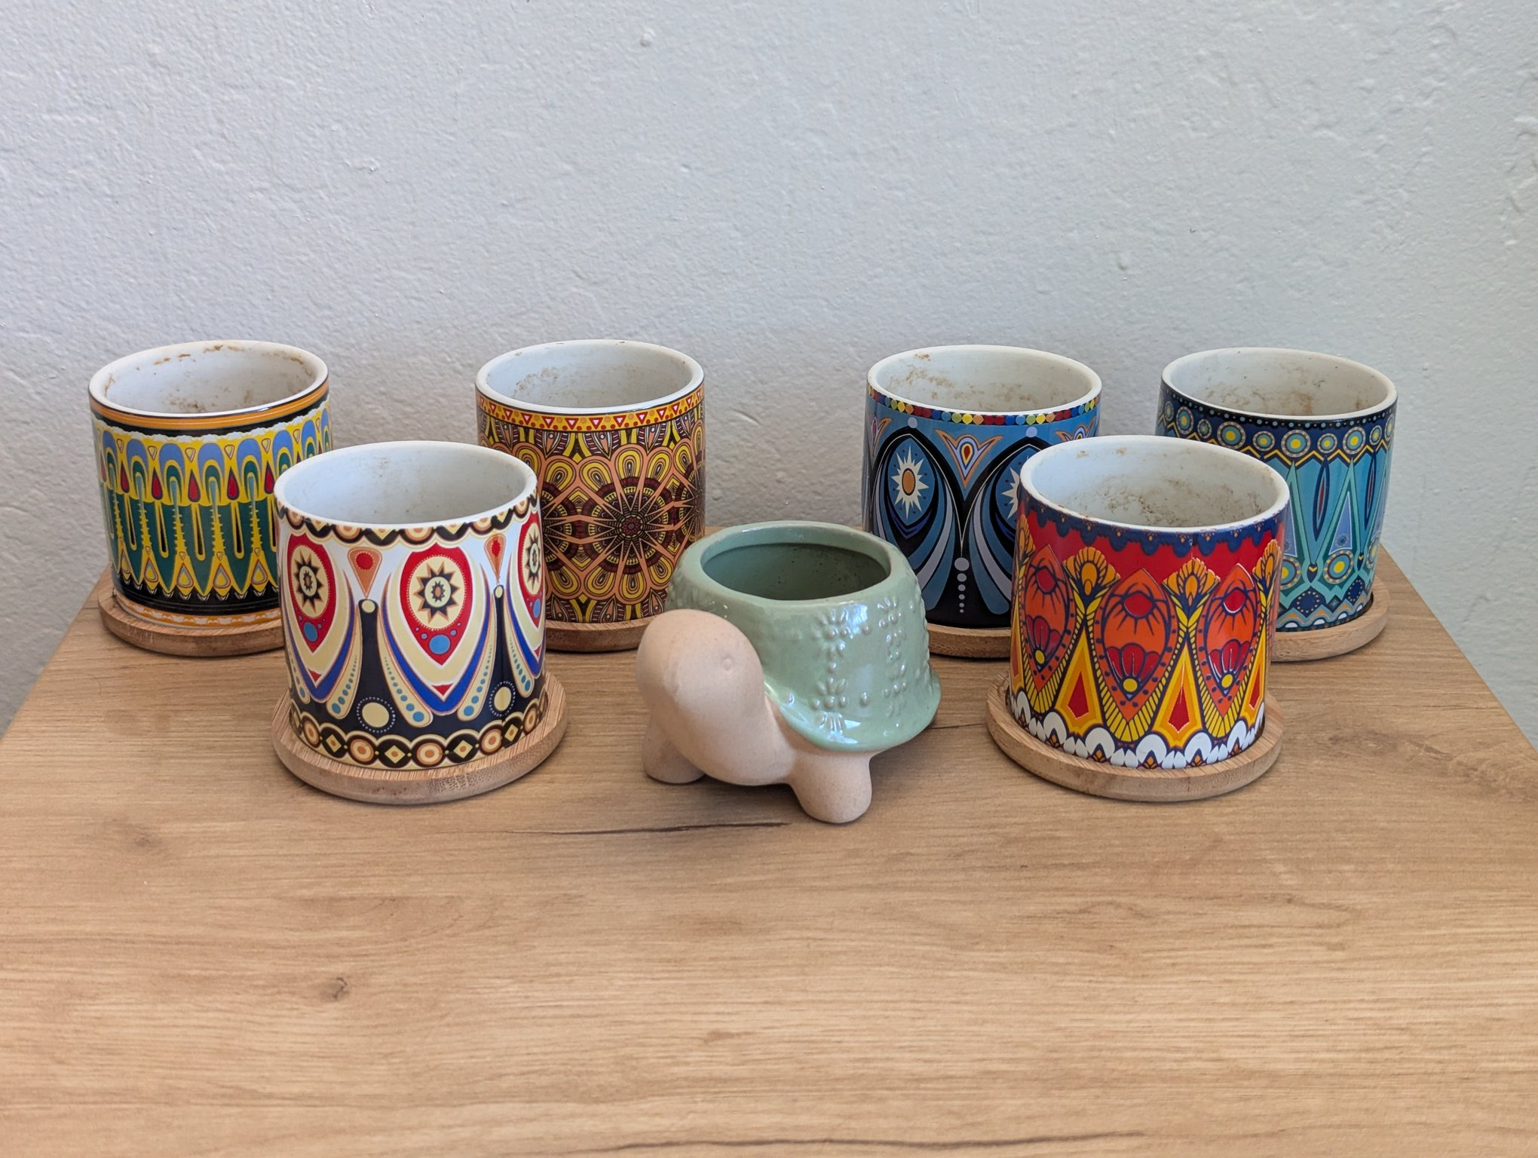
Ceramic planters

Black Metal Watering Can with Wooden Handle — $5
Black metal gooseneck watering can with a wooden handle. Good condition.
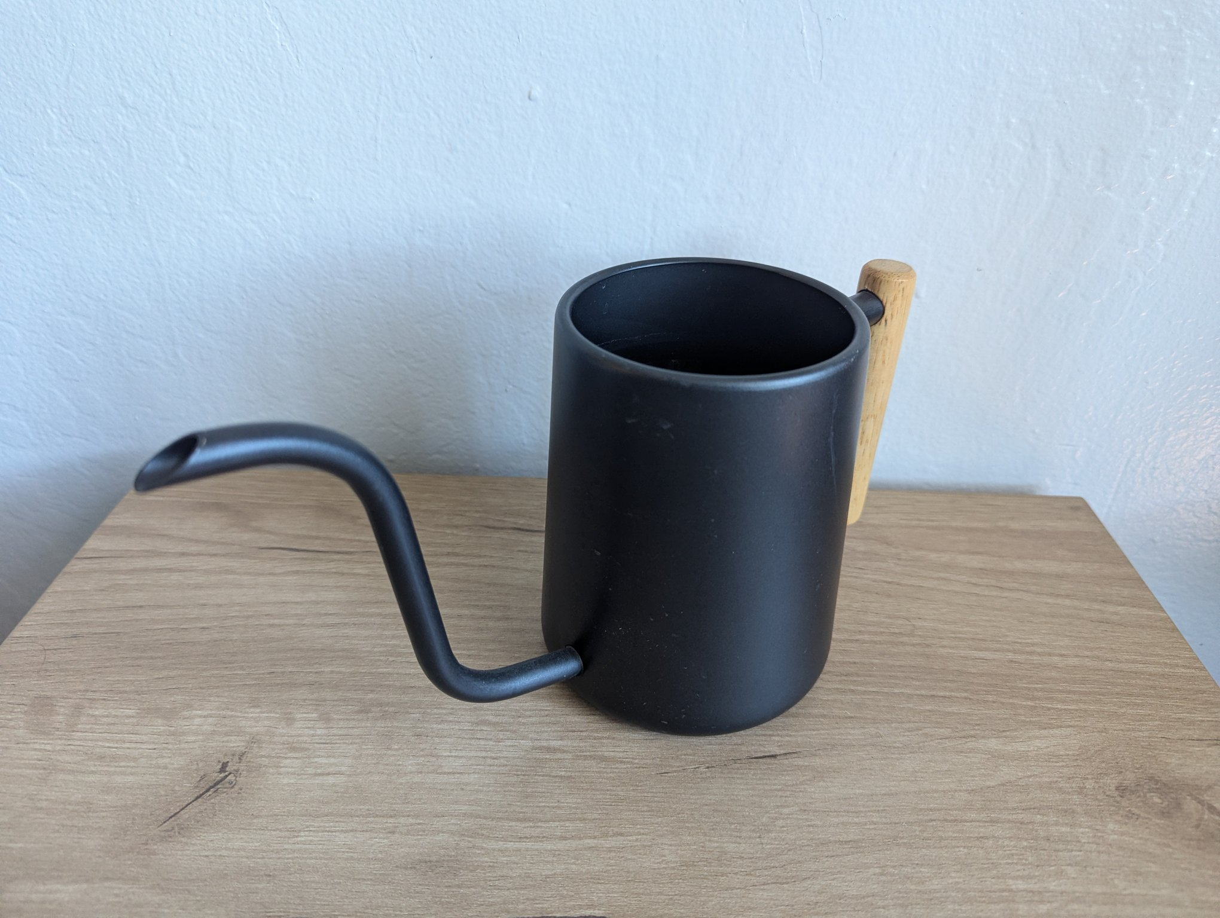
Watering can

