

User’s Manual





Era Vivien A. Perral

Christine Mae D. Estocado

CONTENTS

About this guide .....................................................................................................................3
WHAT’S WITH E-DIARY?..................................................................................................3

Starting My DAILY Diary for the First time......................................................................4
Welcome to My DAILY Diary....................................................................................4
Figure 1.1 LOGIN.......................................................................................................4

Dear Diary...............................................................................................................................5
Writing your first entry....................................................................................................5
Figure 2.1 add entry.................................................................................................5
Figure 2.2 new entry.................................................................................................5
Figure 2.3 save entry.................................................................................................6

Editing you story..............................................................................................................7
Figure 3.1 Editing......................................................................................................7
Figure 3.2 Homepage...............................................................................................7

ABOUT THIS GUIDE

WHAT’S WITH MY DAILY DIARY?

Manual Diary involve writing by hand the various information for storing and retrieving at a later date. It is very tiring and takes longer time as the writing might fade. Everyone can read it and your privacy might be invaded, No alerts for possible updating-cancellation, deleting on paper may be costly and thus, we have come up on the idea of making an electronic diary that can minimize cost and have security for your own privacy.

MY DAILY DIARY involves feeding and storing information using mobile, iphone, P.C, laptops, and etc. Where easy access, disposal and modification are at hand. In contrast to paper diaries, electronic diaries are quicker and more flexible to use.

MY DAILY DIARY is easy to use but there is a need to learn how to use it.
This guide describes how to use MY DIARY of the mobile technology
Platform.

Starting
My DAILY Diary
for the First time

When you first turn on the app, you have the opportunity to activate your mobile app, to sign into your MY DIARY Account, and to decide how you want to use
your first encounter with it.

WELCOME TO MY DAILY DIARY

After you have successfully sign up
You can now then login to your diary.
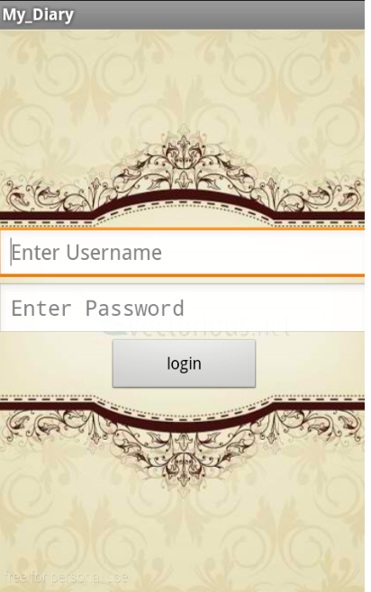

Enter your username

Enter your password

Press login to enter account
Figure 1.1 LOGIN

DEAR DIARY

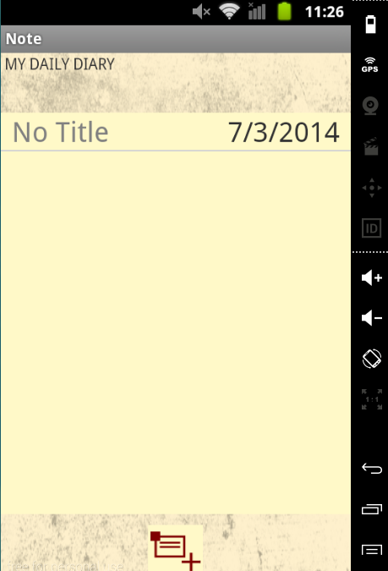
Figure 2.1 Add Entry
WRITING YOUR FIRST ENTRY

MY DAILY DIARY
HOME PAGE

Your Entry Title

Present Date
Figure 2.2 New Entry Page
Set by your Default phone date

Make
New entry

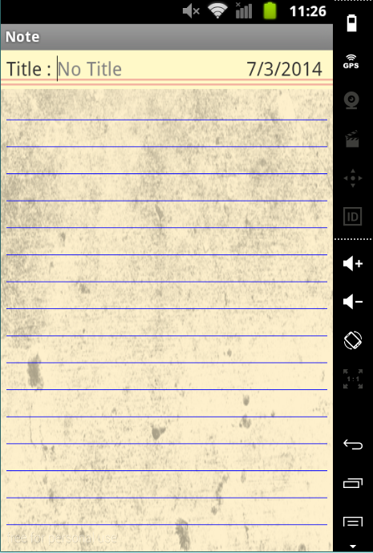

Your Diary Title for the Day

Write your story

Figure 2.3 save entry
In saving your work you need to
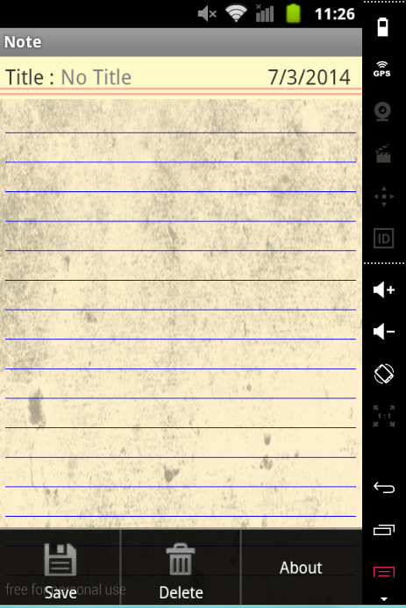
Press menu and SAVE,DELETE,
ABOUT will pop in your screen

MENU BUTTON

Figure 3.4 about
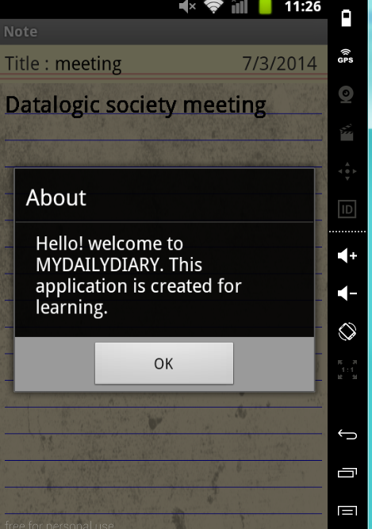
Touch Save
And will save
Automatically
In your
HOMEPAGE

When you touch
About
This will pop up
In your screen

EDITING YOUR STORY
Figure 3.1 Editing
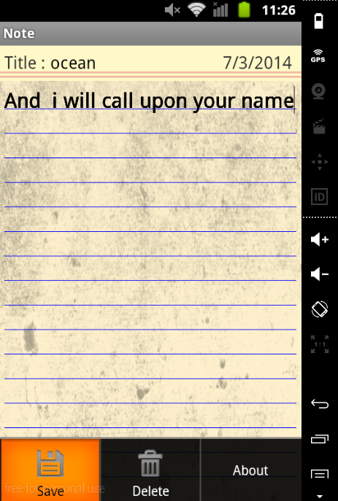

When you have written
Your story and want to make
Changes

Touch the entry
You wish to change
And you will see
Like this

Once you’re done editing,
touch save to
automatically save in
changes made.
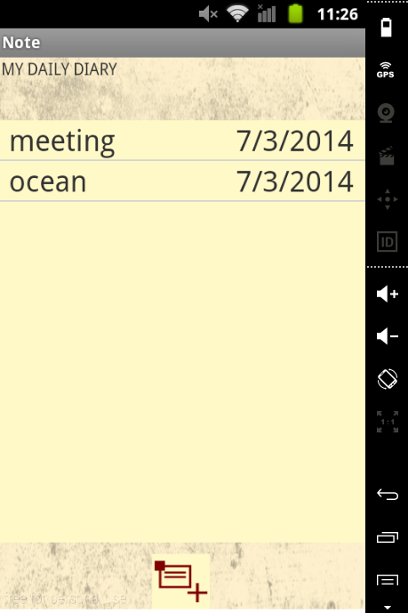

Touch Delete
If you want to delete you entry

BACK TO YOUR HOMEPAGE
Figure 3.2 homepage

