Lab 3 - Week 4

Rae Ehret, 040907812

# Create resource group and storage account

Create a resource group called “CST8912-demo”.

Screenshot 1:

Once that is done, we can create a storage account by clicking “+ Create” and then searching for Storage Account by Microsoft. Name your storage account “labtest8912” and make sure “geo redundant storage” is selected. Keep the options to default.

Screenshot 2:

# Go to your storage account, change configuration

Navigate to “labtest8912”, and under “Data management” go to “Redundancy”. Change the Redundancy to “Locally-redundant storage”.

Screenshot 3:

Then under “Settings” in “Configuration”, change Blob access tier from “Hot” (default) to “Cool”.

Screenshot 4:

# Make data storage container, upload blob

Navigate to “Data Storage” on the left, click “Containers” and then “Add new container”. Name this container “labtestcontainer8912”.

Screenshot 5:

Screenshot 6: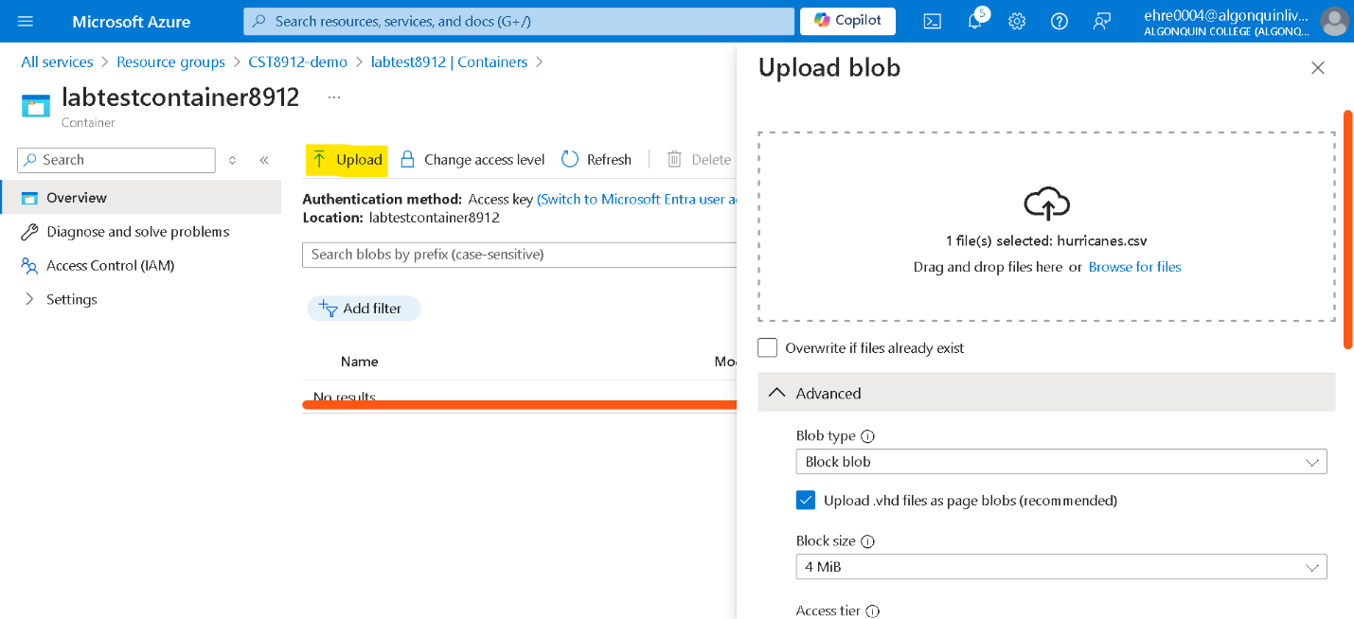

Before uploading, change access tier to “hot” and the “upload to folder” to “sampletest8912”.

Screenshot 7:

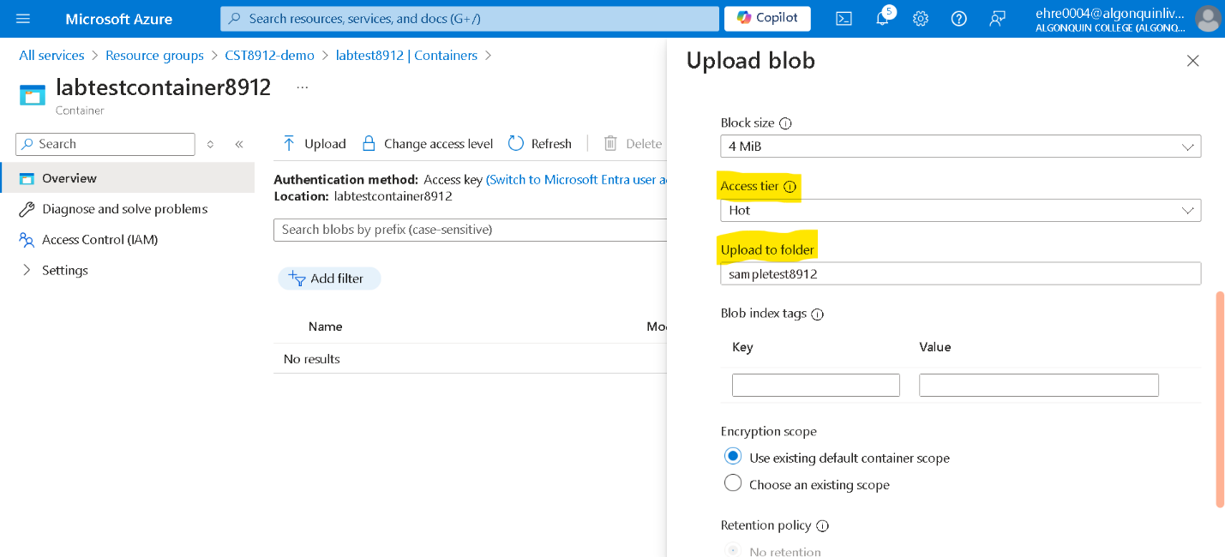

# copy blob url, paste in new private window

Click the file, see configuration options and copy the blob URL.

Screenshot 8:

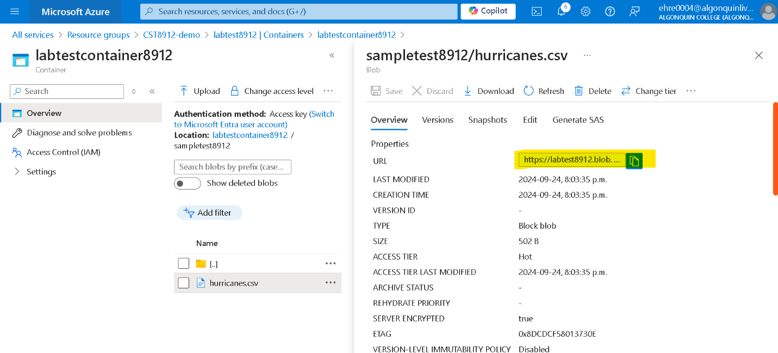

Paste this URL of the blob into a private window of your browser. You should get the below (Access denied).

Screenshot 9:

# Generate SAS and test

Click generate SAS and copy the token generated.

Screenshot 10:

Paste this token into the address bar of a new Private window of your browser. We are able to download the data as an excel sheet.

Screenshot 11:

Screenshot 12:

# Create a new rule for your data storage

Navigate back to your labtest8912 data storage and to “Data Management” > “Lifecycle Management”. Create a rule called “myrule8912” with rule scope of “Limit blobs with filters”.

Screenshot 13:

Click next to go to “Base blobs” and set the if-then to the below.

Screenshot 14:

Screenshot 15:

# After demo, delete all resources created during lab

