CST8912-Midterm Project

Scenario 2:

In azure, students must utilize a set of source data (e.g., customer data, transaction data) curated themselves or use data off websites like Github or Kaggle, and load it into Azure Blob Storage. Create a data warehouse in Azure Synapse Analytics and use PolyBase to load data from Azure Blob Storage. Utilize T-SQL scripts to transform the data in the data warehouse (e.g., aggregating, pivoting, and joining data). Finally create a Power BI report that queries the data warehouse and presents it in a meaningful way for stakeholders. The students will be evaluated on their ability to configure, secure, and optimize the Azure blob storage, Azure Synapse Analytics, and PolyBase. Following correct security protocols and best practices.

# Discussion Results:

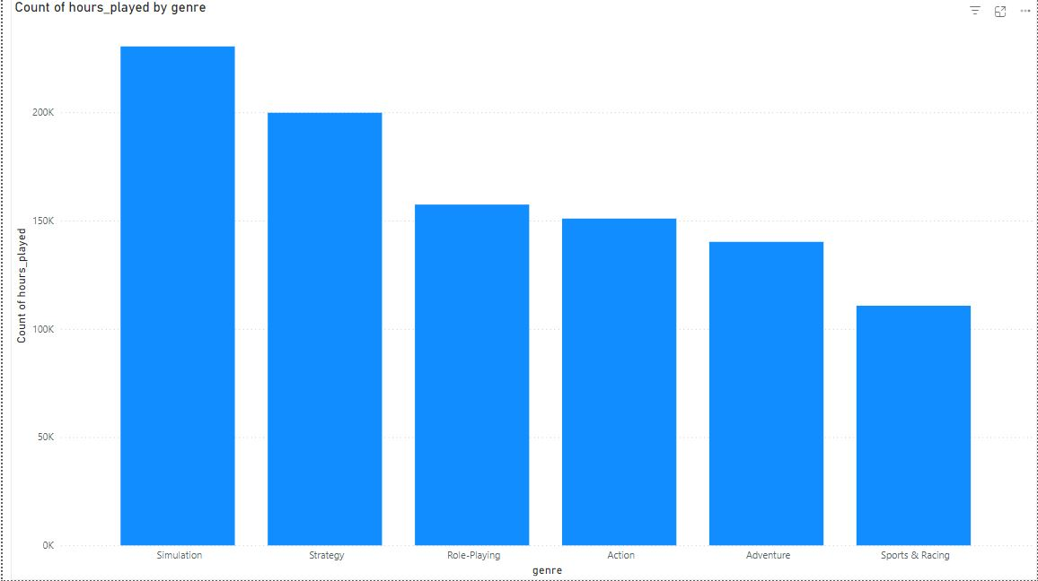

From the graph above, we analyze the data of how much hours are played for each genre. We see that Simulation is the most played and Sports and Racing is the least played.

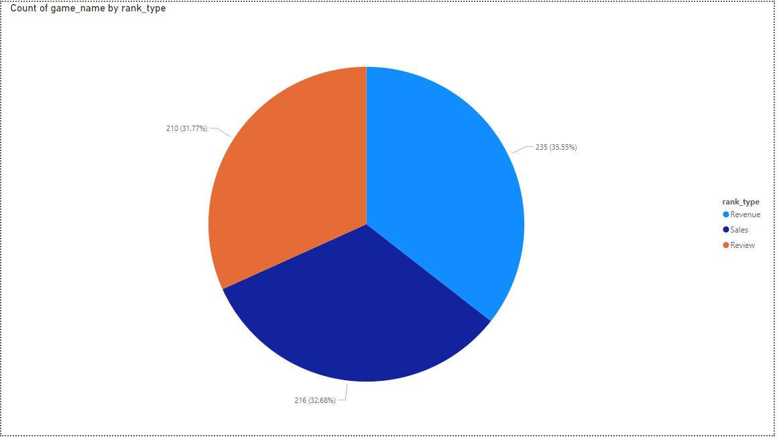

We analyzed the relation between the number of games and the type of rank. We see that each type of rank is almost evenly disturbed with the highest which is revenue and the lowest review.

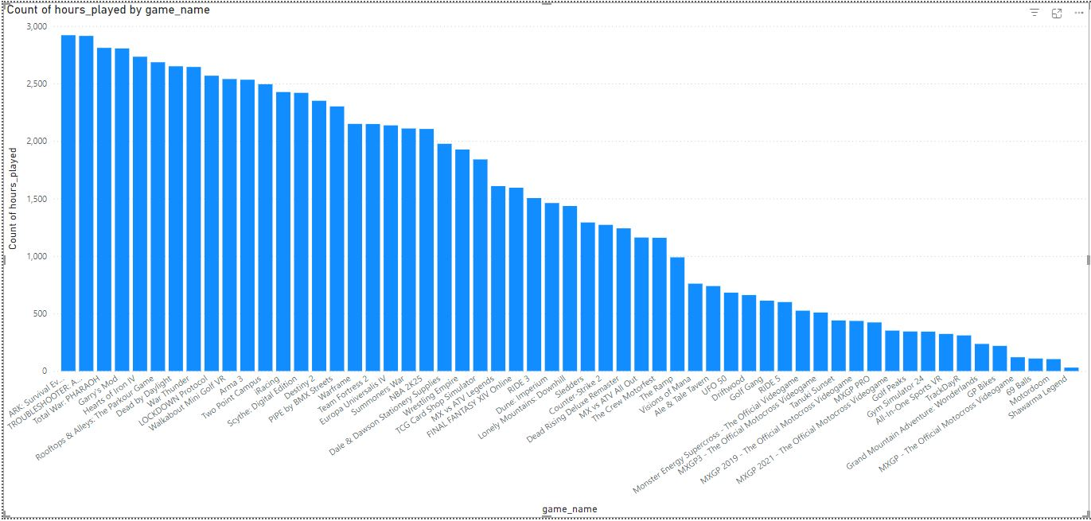

This graph shows the total amount of hours that each game is played that is less than 3,000 hours. ARK: Survival Extinction is the most played and the least played is Shawarma Legend.

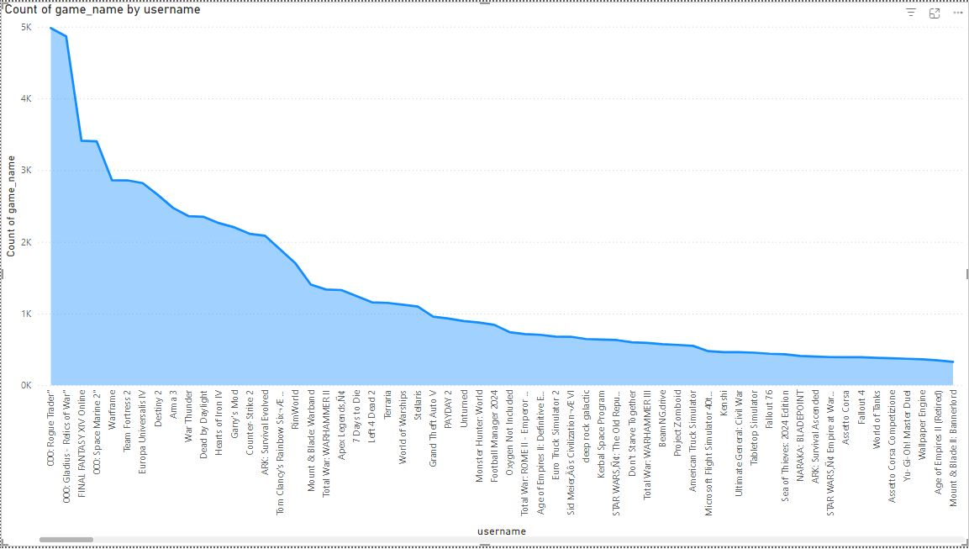

The line chart above show how many games are played by the username. We see that 000: Rogue Trader is the user has the greatest number of games played.