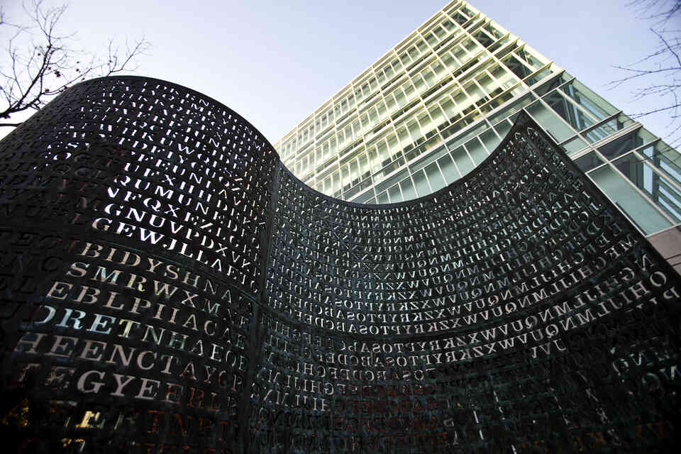

Kryptos

L’énigmatique sculpture dans les jardins de la cia

EHRET Louis

2022

* **KRYPTOS with slides**

According to the best cryptographers in the world, this is the greatest cryptographic enigma of all time. For more than 30 years the mystery has been going on. In this presentation we will discover Kryptos, the mysterious sculpture in the gardens of the world's largest intelligence agency, the CIA.

Before talking about this major work, let's discover the two men behind this sculpture. The two complement each other and form the Kryptos sculpture. One is an American artist by the name of James Sanborn, who built the sculpture and Edward Scheidt, retired from the CIA, creator of the puzzle.

Surprisingly, Jim Sanborn was far from an expert in cryptography when he designed Kryptos. He had enlisted the help of a cryptographic expert named Edward Scheidt, who had previously worked in the CIA. He applied everything that Edward Scheidt taught him when he created Kryptos, using various techniques. And on November 3, 1990, just 32 years ago to the day, Kryptos, or "hidden" in Greek, was born in the gardens of the CIA.

Now let's study the work itself. First of all, we can mention the materials. There are two pieces of granite, a piece of wood and an S-shaped copper structure surrounding a bubble pool. The wood symbolizes that there was wood here. The bubble pool refers to the information that is spread around without even knowing where it is going. And as for the panel, it contains about 1800 **(1 thousand 8 hundred)** letters of the Alphabet cut out of the copper in 4 distinct riddles, each harder than the other.

To put it simply, the 3 codes out of the 4 have been deciphered, which corresponds to 1703 characters. Mainly found by members of the CIA & the prestigious NSA & a computer scientist named James GILLOGLY. It was necessary to use several encryption methods: the Morse code, the Vigenère square as well as a modular transposition line/column to manage to reveal its contents. We can find in the deciphered codes, a quote from *Jim (The misspelling was intentional, Mr. Sanborn has said, to make it more difficult to decode),* we also have a message from internal communications to the CIA or quote from a book of Howard Carter who discovered the tomb of Toutankhamon.

97. This is the number of characters still to be deciphered. The 4th code does not use these encryption methods like Vigenère Square or morse code. It is the subject of great interest to cryptographers around the world and to all code enthusiasts who are still trying to crack it today.

But for several years, Sanborn has been releasing clues on several occasions. The 4th enigma contains NORTHEAST, BERLIN and CLOCK. He also said, "You'd better take a look at this particular clock" and "There are several really interesting clocks in Berlin. He seems to be talking about the Berlin clock or the famous time clock.

But 32 years later, nobody has managed to solve it. A real worldwide community has been created around this enigma. Everything remains to be discovered for this 4th enigma which seems out of time.

But this code will one day reveal itself. Even if Sanborn dies, there would be someone able to confirm the solution. He has decided that if the code is not broken when he dies, the secret will be put up for auction. He might even do it in his lifetime. Will we be able to decipher Kryptos before the solution is revealed?