

Share free time

Website for time sharing

Elisaveta Hristova

Università degli studi di Genova  Facoltà di Ingegneria

Contents

Specification 2

1.1. Requirements 2

1.2. Main functionality of the system 2

1.2.1. Functional analysis 2

1.2.2. Table of functions and corresponding tasks 4

1.2.3. User stories 5

1.2.4. Use-case diagram 6

1.3. Architecture 7

1.3.1. Content and user model 7

1.3.2. Navigation 8

1.3.3. Pages 8

1.3.4. Process 8

Presentation 9

2.1. Mockups 9

2.2. Design 9

2.2.1. Color scheme 9

2.2.2. Logo 9

2.2.4. Typography 9

2.2.5. Screens 10

# Specification

The ShareFreeTime project is about time sharing. Anyone who have free time and want to share it with people with same interests can make it on this website. And the individuals who have great ideas for activities can create event and find buddies. There is something for everybody.

## Requirements

1. Front-end (User) side
   * To be implemented with **HTML**
   * To be implemented with **CSS**
   * To be responsive with **Bootstrap**
   * To be implemented with **JavaScript**
   * To be implemented with **JQuery**
2. Back-end (Server) side
   * To be implemented with **PHP**
   * To be implemented with **MySQL**

## Main functionality of the system

Everybody can see the home page of the website and can read "about" and "how it works". A user can register and log in to the system. Without having a valid account, the user is not allowed to use the application. The user can search for interesting activities by date and time, location and category. Other functionality is to create and share event. The event has title, date, time, location, category, description, image, min and max number of participants. There is rating system about events and users. Users can chat and comment the events.

### Functional analysis

1. Each user can access the homepage of the site and to read the summary of the application; (Homepage, how it works ...)
2. Each user can register. (Registration form)
3. Only registered (and the logged in) users can use the service. *
4. The members of the system

* Have a rating
* They can exchange messages
* You can add
  + Interests
  + Names
  + Residence
  + Free time
  + Description
  + Picture

1. The logged user can view his own profile

* Can edit his profile
* Can delete his profile
* Can logout

6. The logged user can search activities

* Can search by date and time
* Can search by location
* Can search by type of activity
* Can filter by rating

7. The logged user can view events

* Could comment an event
* Can rate events
* Can write a message to the organizer
* May ask to participate
* Can see events in which he has participated?

8. The logged user can create events

* Can place a picture
* Must put a title *
* Have to specify the date and time *
* Have to define location *
* Must choose category *
* Can define for how many people is the activity (from - to)
* Can make a description
* Can edit
* Can update
* Can delete
* Can view all own events

9. The events can be

* Viewed
* Commented
* Rate
* Showing involved people (and if there is a limit to count how many places are remained)
* Displaying organizer (profile and rating)
* Public and private (private, for a particular group, public)
* Can be connected with events on Facebook and google calendar?

### Table of functions and corresponding tasks

|  |  |
| --- | --- |
| Functions | Tasks |
| 1. View Homepage | * 1. Open the website |
| 1. Registration | * 1. Open registration form   2. Enter email   3. Enter password   4. Press “register” button   5. Confirm registration via email |
| 1. Log in | * 1. Open login form   2. Enter email   3. Enter password   4. Pres “login” button |
| Only for register and logged in users | |
| 1. Add data in the profile | * 1. Add name   2. Add residence   3. Add interests   4. Add description   5. Add image   6. Insert free time schedule |
| 1. Search for an event | * 1. Select date and time   2. Select location   3. Select category |
| 1. Filter by rating | * 1. Choose the option |
| 1. View event | * 1. Open event |
| 1. Comment on the event | * 1. Go to the bottom of the page   2. Write comment in the text box   3. Press button “add comment” |
| 1. Applying for event | * 1. Open event   2. Chat with the organizer   3. Click button “Apply” |
| 1. Chat | * 1. Send a message |
| 1. Rate event | * 1. Open the event   2. Select the quantity of stars   3. Publish |
| 1. Create event | * 1. From the menu, select "Create event"   2. Enter the title   3. Enter date and time   4. Enter place   5. Select type of activity   12.7. Enter description (optionally)   * 1. Upload photos   2. How many people (from : to) |
| 1. Edit, update, delete event | * 1. From the menu, choose the appropriate option |
| 1. Edit, delete profile | * 1. From the menu, choose action |
| 1. Logout | * 1. From the menu choose logout |

### User stories

1. 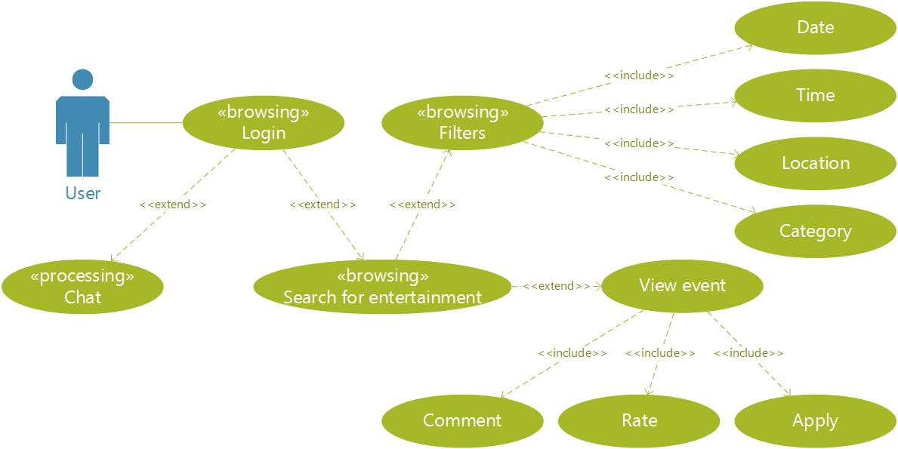The user has free time and wants to find entertainment. Opens the website and logs in. Goes to the events page then enters the date, time and selects category. The user looks at provided opportunities and activities. He writes a message to the organizer of event which he is interested. He gets the details and applies for participation.
2. The user wants to play volleyball, but does not know enough people with the same interests. Logs in to the website. Creates an event titled Volleyball and enter the date, time, place, choose sports as category, write that seeks 11 people and introduces a description of the details. Publish the event. 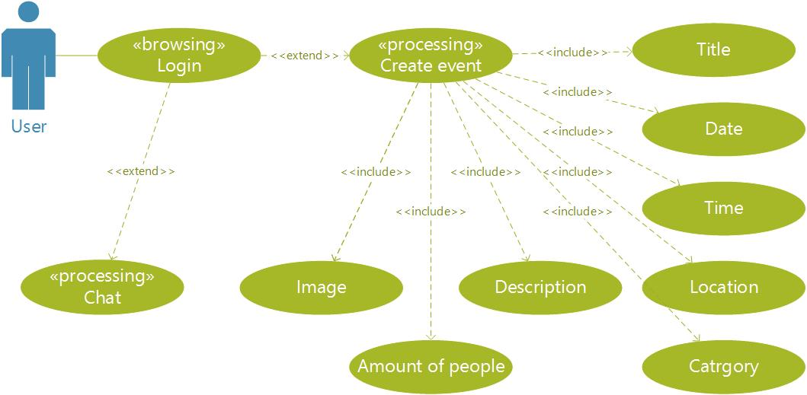Recruiting team and have fun together.

### Use-case diagram

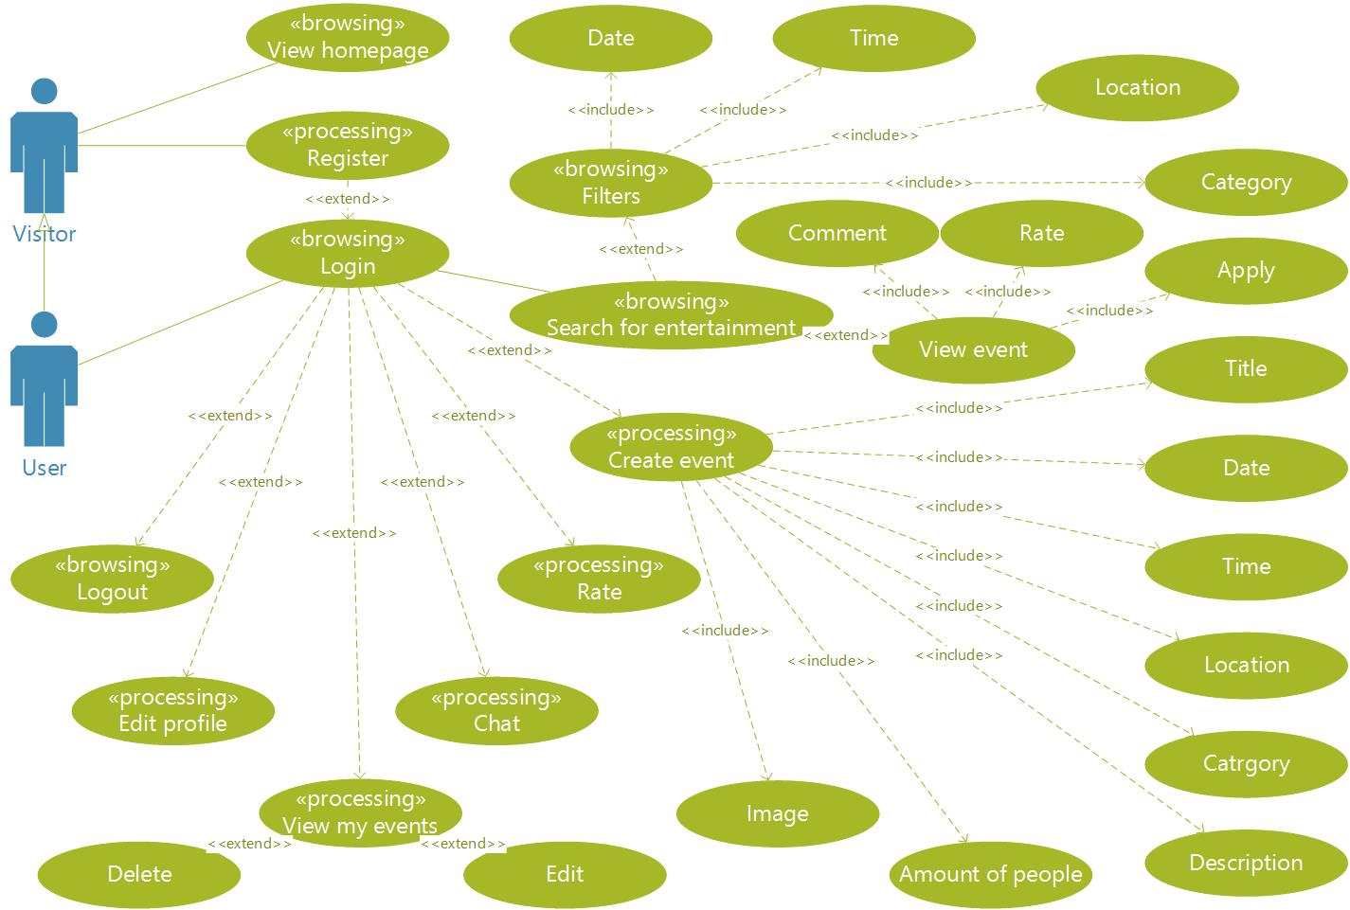

## Architecture

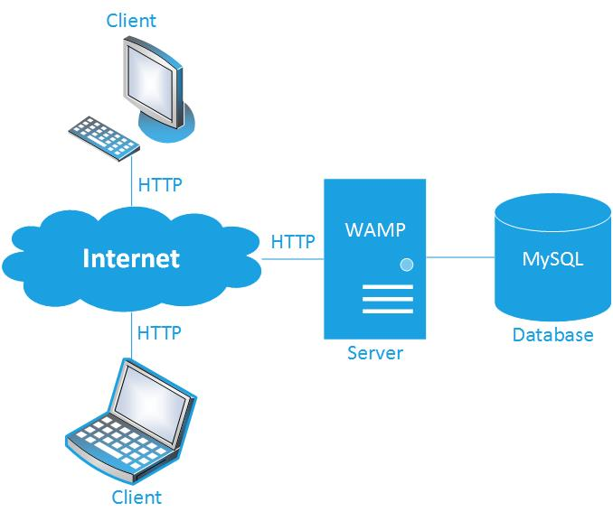

*The client–server model is a distributed application structure that partitions tasks or workloads between the providers of a resource or service, called servers, and service requesters, called clients.*

The primary function of a web server is to store, process and deliver web pages to clients. The communication between client and server takes place using the Hypertext Transfer Protocol (HTTP). Pages delivered are most frequently HTML documents, which may include images, style sheets and scripts in addition to text content.

### Content and user model

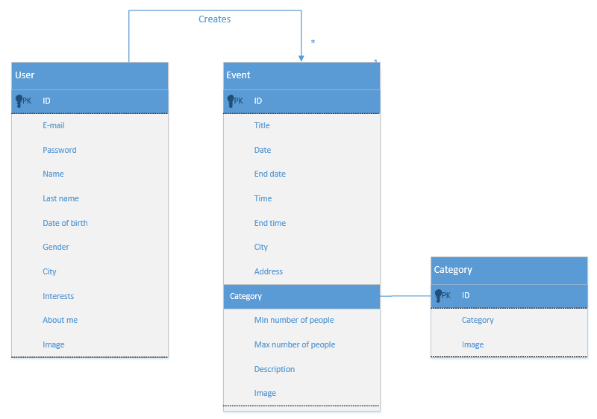

### Navigation

### Pages

* Homepage
  + Logged out
    - About
    - How it works
  + Logged in
    - My homepage (Search or create event // my events, my profile)
* Log in page
* Registration page
* Search events
  + View event
  + View profile of other user (creator of event)
* Create event
* My profile
* Chat (sent message)

#### Features

* Button to return in the beginning of the page;

### Process

# Presentation

## Mockups

## 2.2. Design

### 2.2.1. Color scheme

#F5F5F5

#B3D336

#FFFFFF

#222222

### 2.2.2. Logo

­

### 2.2.4. Typography

* Logo - Berlin Sans FB Demi Bold
* Website content - Helvetica

### 2.2.5. Screens

