Appendix E: Dynamic Instruction Count Profiling for Cortex-M0 using IAR Embedded Workbench IDE for ARM

### Dr. Ehsan Ali Assumption University of Thailand

### [ehsanali@au.edu](mailto:ehsanali@au.edu) [ehssan.aali@gmail.com](mailto:ehssan.aali@gmail.com)

### Nov. 2024

**Contents**

1. Appendix E: Dynamic Instruction Count Profiling for Cortex-M0 using IAR Embedded Workbench IDE for ARM 2
   1. System Requirement 2
   2. Target Specification 2
   3. Project Creation 2
      1. Processor Selection 3
      2. Linker Script 3
      3. ARM Simulator 7
      4. IAR Embedded Workbench - Memory Configuration 7
   4. Instruction Count Profiling 8

**Chapter 1**

**Appendix E: Dynamic Instruction Count Profiling for Cortex-M0 using IAR Embedded Workbench IDE for ARM**

# System Requirement

This is Appendix E for article "Innovative Hardware Accelerator Architecture for FPGA-Based General- Purpose RISC Microprocessors".

1. x86 or x86_64 host machine running Windows operating system.
2. Licensed IAR Embedded Workbench IDE for ARM version 8.40.1.21539.

# Target Specification

* Core: ARMv6m Cortex-M0
* ROM1: Capacity: 1.255 MB, memory address origin: 0x0
* ROM2: Capacity: 128 KB, memory address origin: 0x120000
* RAM1: Capacity: 4MB, memory address origin: 0x80000
* Initial stack pointer: 0xF400
* Initial procedure pointer: 0x0 (Not used)
* Initial heap pointer: 0xF800

# Project Creation

Either create a C/C++ program and enter your algorithm in C/C++ programming languages and then compile it using IAR compiler or enter the C/C++ code in your favorite editor and then compile it according to the guide in Appendix B using LLVM clang compiler and then import the generated ELF file into IAR by selecting "Create New Project" - "Externally built executable".

## Processor Selection

Right click on project name *→* "Options.." *→* "General Options" and set the Processor variant to Core=Cortex-M0 as shown in Fig. 1.1.

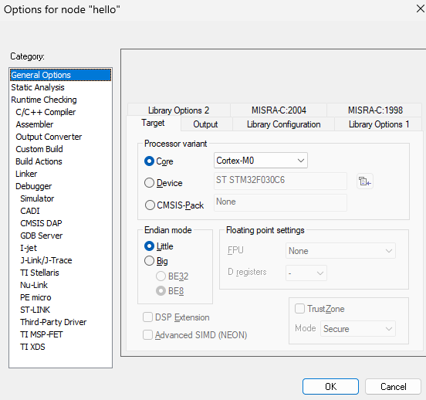

Figure 1.1: IAR Embedded Workbench - Project Linker Options - General Options.

## Linker Script

The following linker script must be passed to the LLVM clang compiler using -T parameter. Change the memory configuration according to your hardware.

Listing 1.1: "cortex-m0.ld"

1. ENTRY( main )

#### MEMORY {

|  |  |  |  |  |  |  |
| --- | --- | --- | --- | --- | --- | --- |
| 3 | ROM( rx ) | : ORIGIN = 0 x0 , | LENGTH = 0 x11FFFF | */ \** | *1 . 125 MB* | *\* /* |
| 4 | ROM2( rx ) | : ORIGIN = 0 x120000 , | LENGTH = 0 x20000 | */ \** | *128 KB * /* |  |
| 5 | RAM( rwx ) : ORIGIN = 0 x800000 , LENGTH = 0 x400000 | | | */ \** | *4 MB * /* | |
| 6 | } | | |  |  | |
| 7 |  | | |  |  | |
| 8 | SECTIONS { | | |  |  | |
| 9  10  11 | */ * The code should be l oaded a t address 0 x0 * /*  . = ORIGIN (ROM) ; | | |  |  | |

*/ * t h e dot ( . ) symbol i s l o c a t i o n counte r * /*

1. . t e x t : {
2. */ * When l i n k −time garbage c o l l e c t i o n i s i n use (’−−gc−s e c t i o n s ’ ) ,*
3. *i t i s o f t e n u s e f u l t o mark s e c t i o n s t h a t should not be e l i m i n a t e d .*
4. *This i s accomplished by s urrounding an i n p u t s e c t i o n ’ s wildcard*
5. *e n t r y with KEEP ( ) * /*
6. KEEP ( * ( . v e c t o r _ t a b l e ) ) ;

#### . = ALIGN ( 4 ) ;

1. __vec_end__ = . ;
2. */ * I n p u t s e c t i o n s : . t e x t s e c t i o n i n a l l f i l e s . * /*
3. * ( . t e x t )

#### . = ALIGN ( 4 ) ;

1. _ _ e n d _ t e x t _ _ = . ;
2. } > ROM */ * a s s i g n . t e x t s e c t i o n t o a p r e v i o u s l y d e f i n e d r eg i on o f*
3. *memory ’ROM’ * /*

26

#### . = ORIGIN (ROM2 ) ;

1. . r o d a t a : {
2. _ _ d a t a r o _ s t a r t _ _ = . ;
3. * ( . r o d a t a )

#### . = ALIGN ( 4 ) ;

1. _ _ d a t a r o _ e n d _ _ = . ;

#### } > ROM2

34

#### . = ORIGIN (RAM) ;

1. . d a t a : {
2. _ _ d a t a _ s t a r t _ _ = . ;
3. * ( . d a t a ) ;

#### . = ALIGN ( 4 ) ;

1. __heap_low = . ; */ * f o r _sbrk * /*

|  |  |  |
| --- | --- | --- |
| 41 | . = . + 0 x10000 ; | */ * 64 kB o f heap memory * /* |
| 42 | __heap_top = . ; | */ * f o r _sbrk * /* |
| 43 | __data_end__ = . ; |  |
| 44 | } > RAM |  |

Using the values stated in our linker script (Listing 1.1) the linker options for IAR Workbench IDE project must be set accordingly.

Right click on project name *→* "Options.." *→* Linker and the tick on "Override default" as shown in Fig. 1.2.

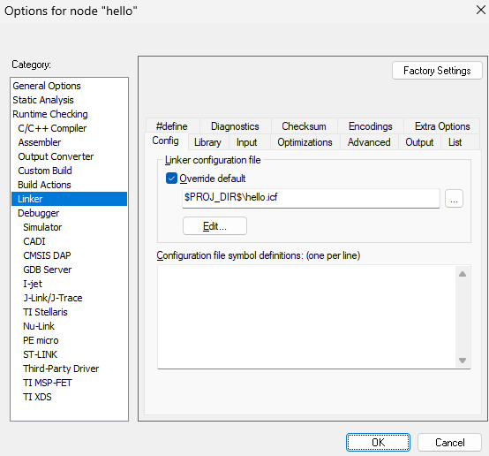

Figure 1.2: IAR Embedded Workbench - Project Linker Options.

Click the "Edit" button and define the memory regions according to the hardware value in the original linker script (Listing 1.1) as shown in Fig. 1.3.

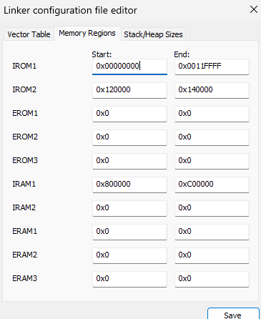

Figure 1.3: IAR Embedded Workbench - Project Linker Options - Memory Regions.

Set the size of stack and heap memory as shown in Fig. 1.4.

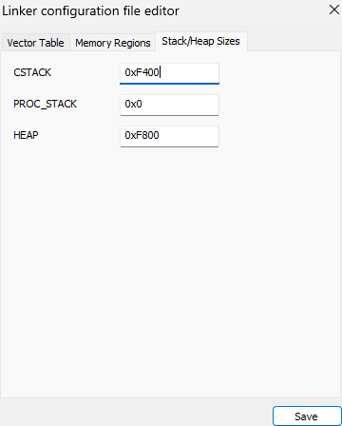

Figure 1.4: IAR Embedded Workbench - Project Linker Options - Stack/Heap Sizes.



## ARM Simulator

Right click on project name *→* "Options.." *→* "Debugger" and set the Driver to Simulator as shown in Fig. 1.5.

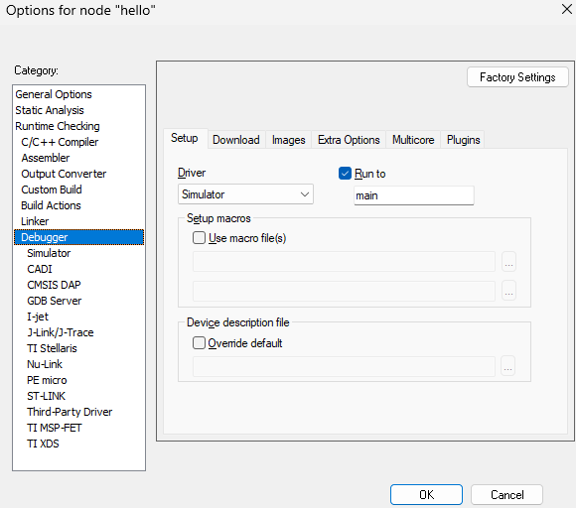

Figure 1.5: IAR Embedded Workbench Project - Debugger options.

## IAR Embedded Workbench - Memory Configuration

Set the memory configuration by stating the start, end, and type of memory according to the hardware and values in the linker script (Listing 1.1) as shown in Fig. 1.6.

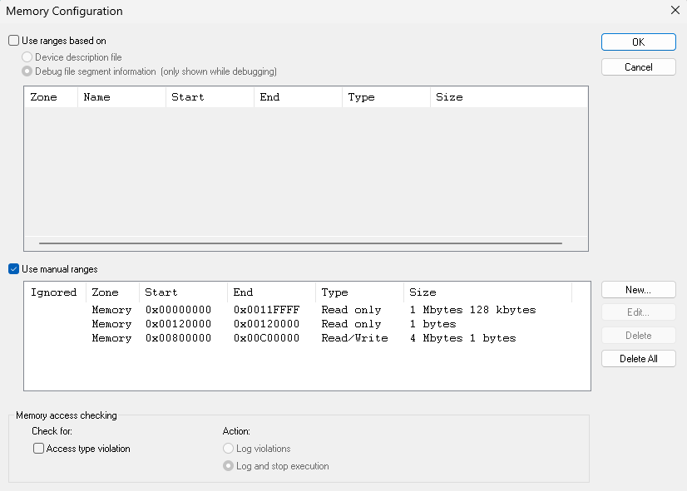

Figure 1.6: IAR Embedded Workbench Project - Memory Configuration

# Instruction Count Profiling

First build the project: "Project" *→* "Rebuild All".

Set a breakpoint on return line of the main() function and then issue the "Download and Debug" command (Ctrl+D).

Fig. 1.7 shows several profiling and trace options alongside the register bank content instruction set disassemble windows. The screenshot shows the simulation of FFT algorithm by calling the fft() function from main().

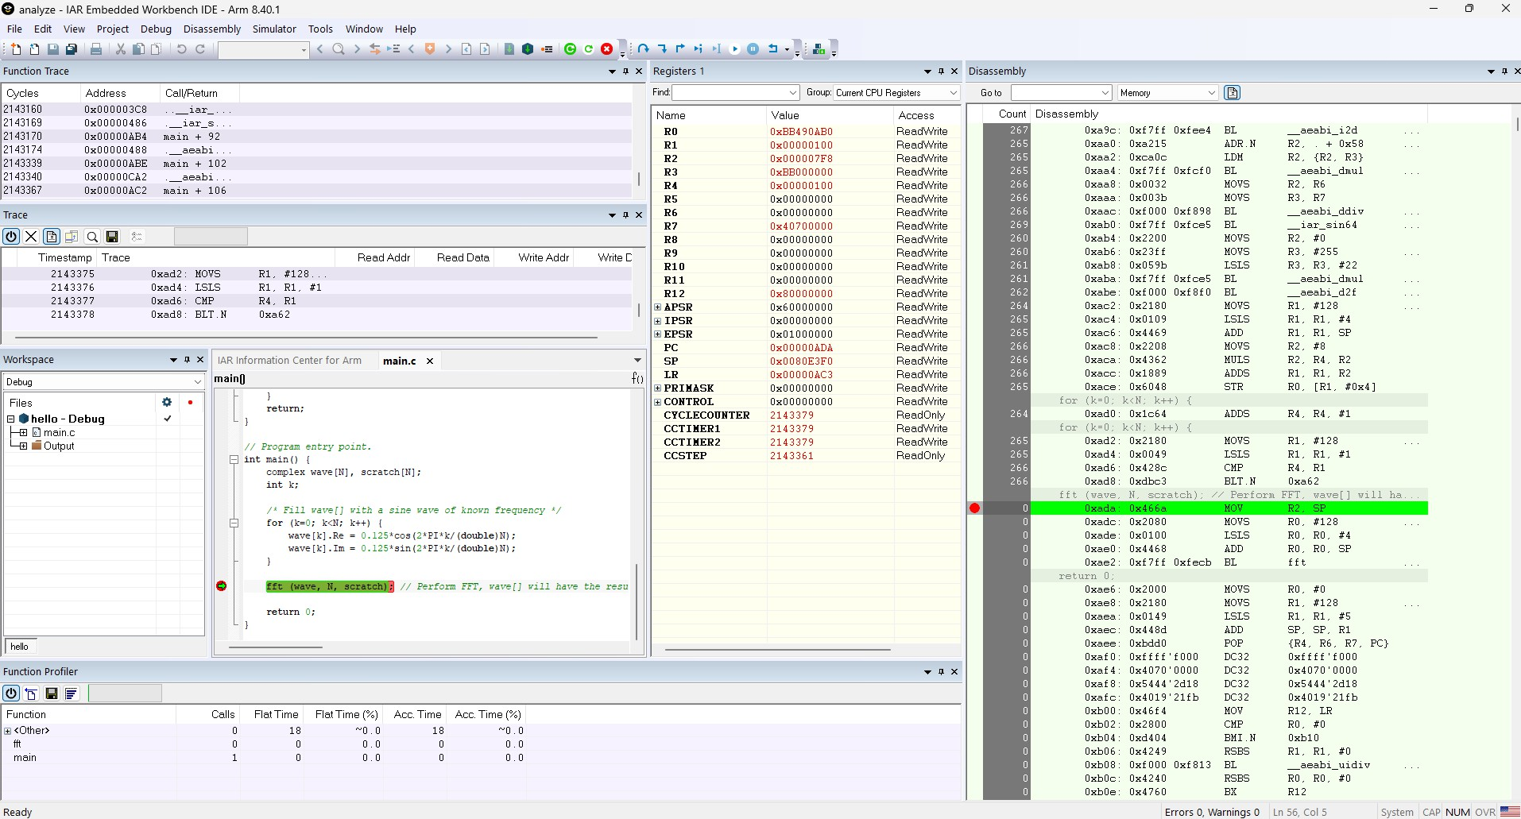

Figure 1.7: IAR Embedded Workbench - Debugging with Simulator Driver.

Fig. 1.8 shows the disassembly where the first column states the number of times the disassembled instruction is executed. It can be easily seen that code block residing at memory location 0x3c2-0x3de (marked with blue rectangle) runs twice more than the code residing at 0x370-0x3c0 while instructions at 0x3e0 onward is never executed.

Notice the frequent occurrence of [MOVS, BL] instruction pair (marked with red rectangles).

A context menu with "Copy Window Content" item is provided which can be access by right clicking on the disassembly window. You can copy the profiling result into a text file and use a scripting language to automatically extract the code blocks with highest instruction count (blue rectangle) or identify the most frequent instruction pairs (red rectangles).

This result is sent to the hardware accelerator code generator to produce VHDL modules as described in "Innovative Hardware Accelerator Architecture for FPGA-Based General-Purpose RISC Micropro- cessors" article.

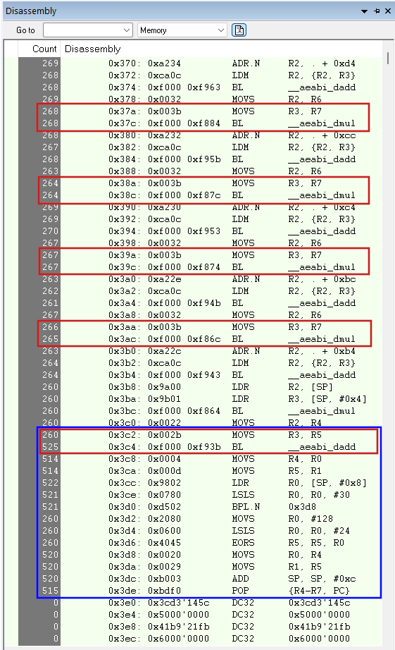

Figure 1.8: IAR Embedded Workbench - Instruction Count Profiling Result.

