Designing Machine Learning Model Framework for ServiceFirst Employee Satisfaction

(Clustering Models, Decision trees and Sentiment Analysis)

By

Ehsan Keikhavani

Content

1. Business Understanding
1.1 What are the business objectives?
- Background
- Business Objectives
- Business Success Criteria
1.2 Assess the Situation
- Inventory of Resources
- Requirements, Assumptions, and Constraints
- Risks and Contingencies
1.3 Determine Data Mining Goals
1.4 Produce the Project Plan
2. Data Understanding
2.1 Collect Initial Data
2.2 Explore Data
2.3 Verify Data Quality
3. Data Preparation
3.1 Clean Data
3.2 Construct Data
3.3 Format Data
4. Modelling and Hypothesis
4.1 Hypothesis
4.2 K-Means Clustering
4.3 Decision Tree
4.4 Sentiment Analysis
5. Evaluation
5.1 Evaluate Results
5.2 Make Prediction
6. Conclusion and recommendation
7.Refrences

1.Business Understanding

1.1 What are the business objectives?

Background
ServiceFirst, a national equipment servicing company with 250 employees, faced high staff turnover post-COVID-19, leading to increased recruitment costs and loss of experienced employees. These challenges affected productivity and workforce stability. To address this, the People & Culture (P&C) team launched an employee satisfaction survey to understand employee perceptions and the organizational climate. The primary goal is to use advanced analytics and machine learning to improve satisfaction and reduce turnover.

Business Objectives
What are the key drivers for employee satisfaction?
Employee Segmentation: Use K-Means clustering to group employees based on satisfaction levels and income, identifying key employee segments to tailor strategies accordingly.
Satisfaction Prediction: Build and evaluate a decision tree model to predict satisfaction based on factors like income, experience, and other demographics.
Sentiment Analysis: Preprocess and analyse employee feedback to determine key sentiments (positive, negative, or neutral), and create actionable insights for improving the work environment and employee satisfaction.

Business Success Criteria
Employee Segmentation & Tailored Strategies: Provide personalized strategies for different employee segments to improve satisfaction and retention.
Predictive Satisfaction & Retention: Deliver an accurate predictive model to identify employees at risk of leaving and improve retention efforts.
Sentiment Insights: Provide actionable recommendations based on sentiment analysis to improve employee engagement and satisfaction.
Actionable Insights for Retention: Offer data-driven recommendations to reduce turnover and enhance satisfaction across the organization.

1.2 Assess the Situation

Inventory of Resources
- Data: Employee survey dataset with demographic data, satisfaction scores, and sentiment analysis codes.

- Analytics Tools: Python (Jupyter Notebook), Pandas, Numpy, Scikit-Learn, Matplotlib, Seaborn, and other statistical libraries (e.g., scipy.stats) are used for analysis.
- People: HR Analysts, Data Scientists, and Business Decision-Makers.

- Methodology: CRISP-DM (Cross-Industry Standard Process for Data Mining) approach for structured and reliable analysis.

Requirements, Assumptions, and Constraints

  - Data: 142 employee responses, assuming honesty and representativeness.

  - Constraints: Potential missing or biased data; analysis limited to available survey questions.

Risks and Contingencies

- Data Quality Issues: Missing values and response bias may affect results.
- Business Buy-In: Insights need alignment with HR expectations for adoption.
- Model Accuracy Limitations: Dependent on available variables.
- Bias and Ethical Concerns: Ensure the model does not perpetuate existing biases or confirm pre-existing assumptions.

1.3 Determine Data Mining Goals

Prepare Data for Analysis
  - Clean and preprocess data to ensure accuracy and readiness for analysis.
Identify Key Patterns
  - Uncover trends and relationships within employee data to improve strategies.
Cluster Employees
  - Group employees based on satisfaction and income to identify distinct segments.
Predict Satisfaction Scores
  - Build a model to predict employee satisfaction based on key factors.
Analyse Sentiment
  - Identify positive, negative, and neutral sentiments in employee feedback.

1.4 Produce the Project Plan

Data Collection & Understanding: Gather and explore employee data, identify missing values, and analyse distributions.
Data Preparation: Clean data, handle missing values, preprocess feedback, and normalize numerical features.
Modelling: Apply K-means clustering, build decision tree model for satisfaction prediction, and perform sentiment analysis.
Evaluation: Assess model performance using metrics like accuracy, precision, recall, and sentiment accuracy.
Reporting & Recommendations: Create visualizations, summarize findings, and provide actionable strategies for improving employee satisfaction and retention.

2. Data Understanding

2.1 Collect Initial Data
Began by Importing the data and necessary libraries.
Pandas is used for data manipulation and analysis because it provides powerful, flexible, and efficient tools for handling structured data.
“The Pandas library, a crucial tool in Python for data manipulation, was used to clean, preprocess, and analyse the dataset efficiently “(McKinney, 2017).
NumPy is used for numerical computing in Python because it provides fast, efficient, and flexible operations on large datasets.

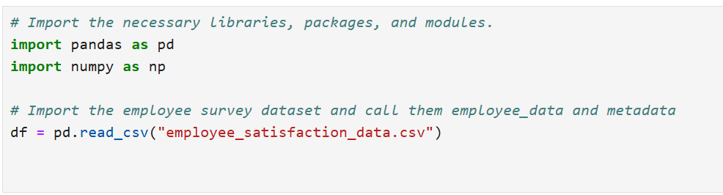

The dataset provided by ServiceFirst consists of 142 employee survey responses with 9 Columns.

2.3 Data Exploration
Conduct descriptive statistics and visualizations of key satisfaction areas.
Python libraries provided an efficient approach to handling, cleaning, and analysing the dataset. Several techniques were employed:

Exploratory Data Analysis (EDA) Methods
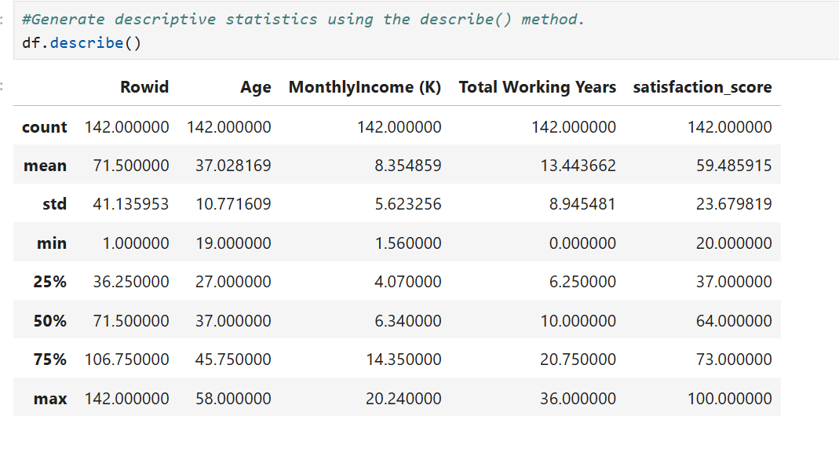
- Pandas (df.info (), df.describe()): Helped summarize the dataset, identifying key statistics and missing values.

Summary Statistics:
Age
Mean Age: ~37 years
Age Range: 19 - 58 years
Most employees (50%) are between: 27 - 45 years old
Monthly Income (in K)
Average Monthly Income: ~8.35K
Income Range: 1.56K - 20.24K
50% of employees earn between: 4.07K - 14.35K
Total Working Years
Average Experience: ~13.44 years
Range: 0 - 36 years
50% of employees have between: 6.25 - 20.75 years of experience
Satisfaction Score
Average Satisfaction Score: ~59.49 (out of 100)
Range: 20 - 100
Most employees (50%) have satisfaction between: 37 - 73
A deeper look into clustering and sentiment analysis can help understand drivers of dissatisfaction.

“The Seaborn and Matplotlib libraries played a significant role in visualizing key insights through correlation matrices, histograms, and boxplots, allowing us to understand data distributions and relationships between variables” (Géron, 2019).

Visualisation
Outliers (Boxplot Insights)
"Monthly Income" and "Total Working Years" show possible outliers.
"Satisfaction Score" and "Age" appear more evenly distributed with fewer extreme values.

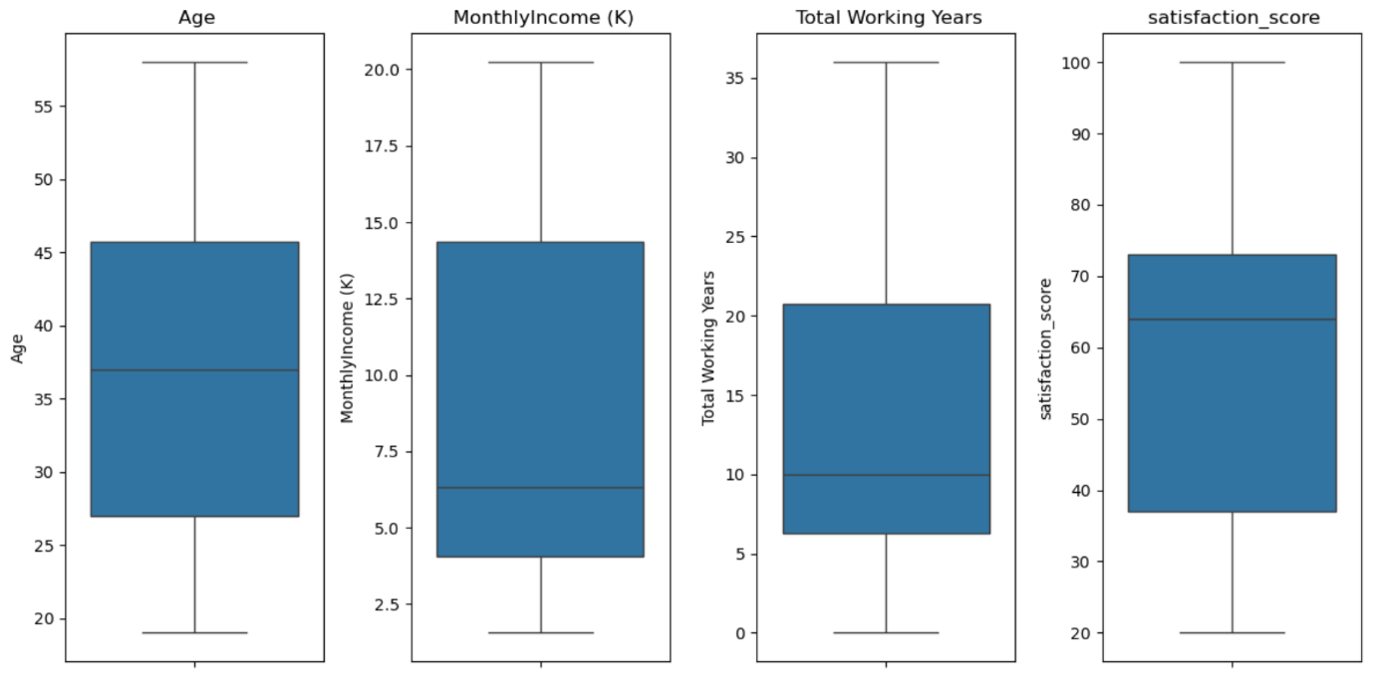
Distribution Check (Histograms)
"Satisfaction Score”: more employees have lower scores.
"Monthly Income" is right-skewed, indicating a few employees earn significantly more.

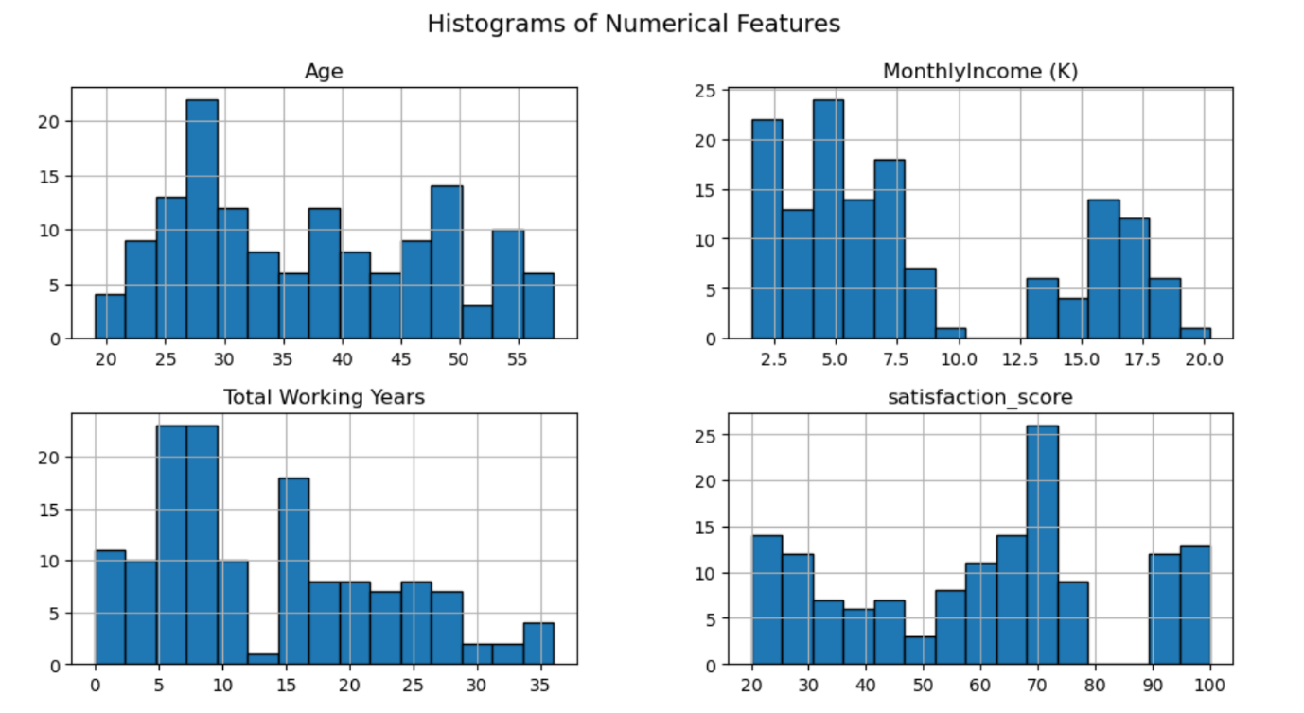

Histograms were used to visually assess the distribution of satisfaction factors and identify patterns in the data.

Skewness and Kurtosis:
Skewness and kurtosis are used to understand the shape and distribution of data, both help in detecting outliers, data normality, and model assumption.

Skewness – Measures asymmetry in data distribution. (-1, 1)

- Positive skew: Tail is on the right (high values).
- Negative skew: Tail is on the left (low values).

Kurtosis – Measures tailedness (peak/sharpness of distribution).

- High kurtosis > 3: More extreme outliers.
- Low kurtosis < 3: Fewer extreme values.

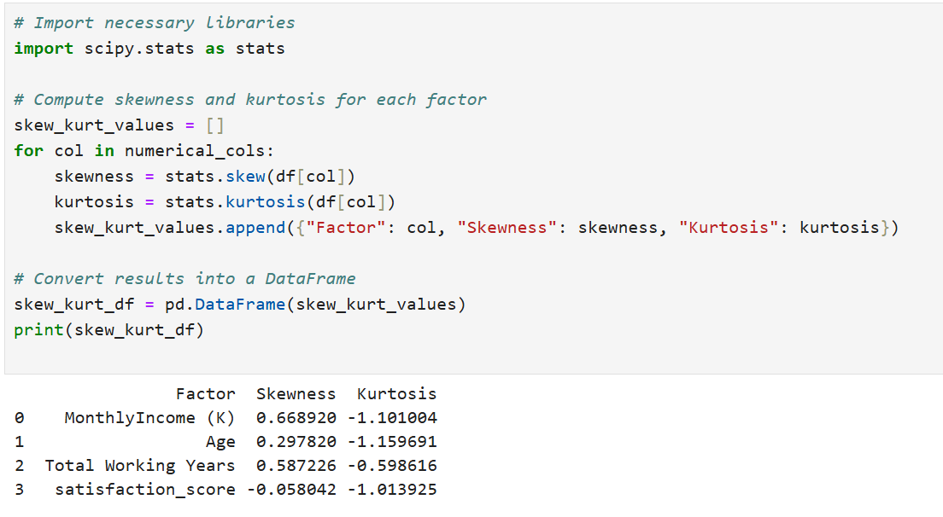
No Skewness or Kurtosis detected (No Possible outlier and data is fairly normal)

Determine if there are missing values
Why Check for Missing Values?
Detect Data Gaps – Identifies columns with missing (NaN) values.
Avoid Errors – Prevents issues in calculations, visualizations, and machine learning models.
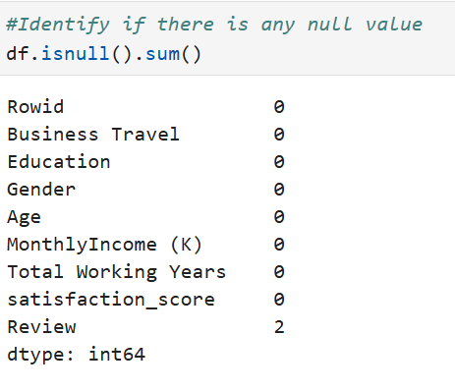
Using `isnull()`provides a quick summary of missing values in each column, ensuring data reliability.

Column Review has 2 missing value which will be removed in next steps (for sentiment analysis).

Why Identify Duplicate Rows?
Ensures Data Integrity – Avoids biased or misleading analysis.
Prevents Data Redundancy – Eliminates unnecessary duplication.
Improves Model Accuracy – Ensures unique data points for training.

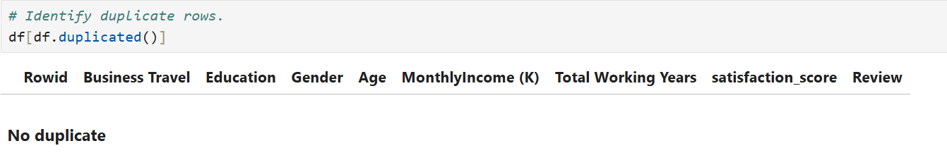
No duplicate row detected.

3. Data Preparation

3.1 Clean Data

Removed 2 missing values and 10 duplicate rows from the "Review" column.
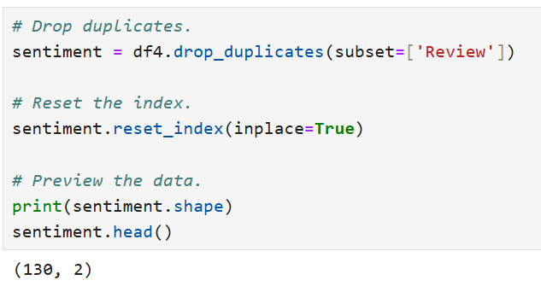

3.2 Construct Data
Rename the columns for better readability. Using the `rename () ` method.
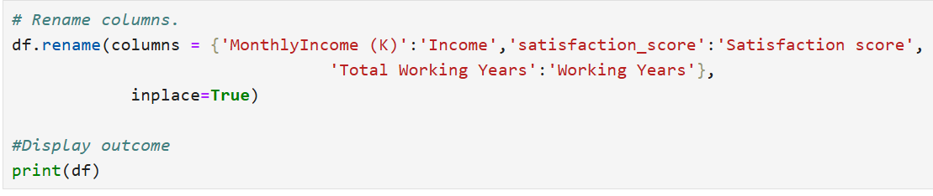

3.3 Format Data
Convert Data
Why Convert Categorical Variables?
- Prepares Data for Analysis & Modelling
- Improves Consistency – Standardizes categorical responses for easy interpretation.
- Avoids Errors

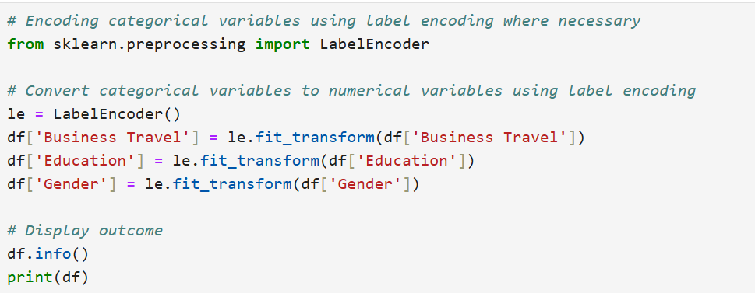

The following columns type has been changed to "int32":
Business Travel: 0 = No Travel, 1 = Rarely, 2 = Frequently
Education: 0 = lowest, 5 = highest
Gender: 0 = Female, 1 = Male

Standardization and Scale Data
Ensures all features are on the same scale (important for clustering algorithms like K-Means).
Prevents variables with larger numerical ranges (e.g., income) from dominating smaller-range variables (e.g., satisfaction score).

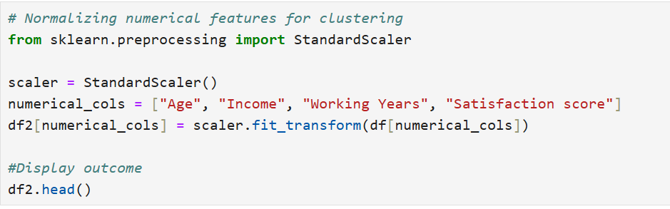

4. Modelling and Hypothesis

4.1 Hypothesis Testing:

For all Hypothesis consider:
- CI = 95%
- a (level of significance) = 0.05
- Statistical Test: Independent t-test

The Independent t-test is appropriate in this scenario because we are comparing the means of two independent groups: high-income/ experience employees and low-income /experience employees. The test evaluates whether there is a statistically significant difference between the two groups' satisfaction scores.

scipy.stats:
- Part of the SciPy library, which provides statistical functions and hypothesis testing methods.
- Used for probability distributions, statistical tests, correlation analysis, and more.
- Common methods include ttest_ind (), chi2_contingency (), etc.
T-Test
- A parametric test used to compare the means of two independent groups.
- Determines if the difference between group means is statistically significant.
- If p-value < 0.05, the difference is significant.

Two hypotheses were tested using A/B Testing (t-tests, N>30) Tests:
Hypothesis 1: Income and Satisfaction
The decision to divide employees into two groups based on income - Group A (below the median) and Group B (above the median) - is based on the hypothesis that income affects employee satisfaction. By using the median, both groups contain an equal number of employees, minimizing bias from extreme values, and making it easier to compare satisfaction scores between low-income and high-income employees.
Group A: Employees with income below the median.
Group B: Employees with income above the median.
Null Hypothesis (H₀): There is no significant difference in satisfaction between high and low-income employees.
Alternative Hypothesis (H₁): Employees with higher salaries have significantly higher satisfaction scores.

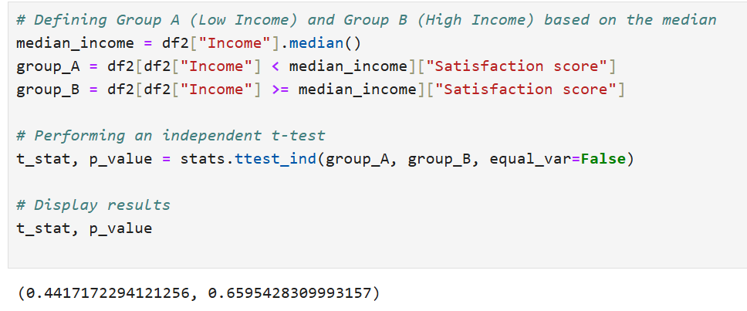

t-statistic = 0.441
p-value = 0.659

Result: p-value = 0.659, indicating no significant difference in satisfaction between high and low-income employees. Higher salary does not necessarily lead to higher satisfaction in this dataset.
Due to no significant difference is found, ServiceFirst might explore other factors that contribute to employee satisfaction, such as work environment, career development opportunities, or leadership quality.

-------------------------------------------------------------------------------------------------

Hypothesis 2: Experience and Satisfaction
The decision to divide employees into Group A (with fewer than the median total working years) and Group B (with more than or equal to the median total working years) is driven by the hypothesis that experience may have an impact on employee satisfaction. Employees with more experience might feel more secure in their roles, which could lead to higher satisfaction due to expertise, stability, or recognition.
Group A: Employees with fewer than median total working years.
Group B: Employees with more than or equal to median total working years.
Null Hypothesis (H₀): There is no difference in satisfaction between less-experienced and highly-experienced employees.
Alternative Hypothesis (H₁): Employees with more experience have significantly higher satisfaction.

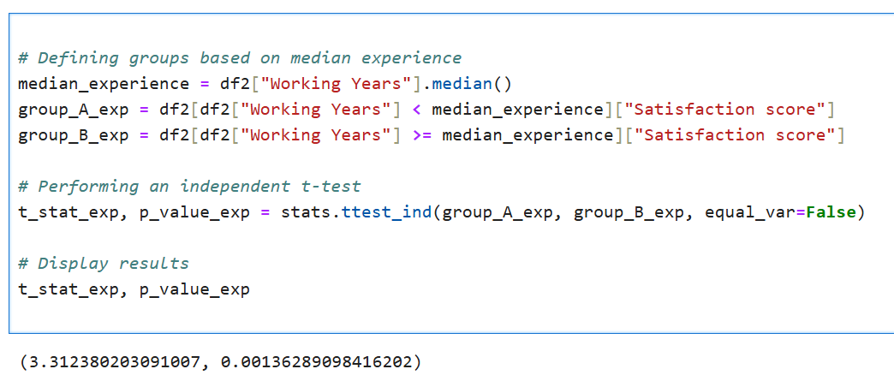

t-statistic = 3.312
p-value = 0.001

Result: p-value = 0.001, indicating a significant relationship where employees with more experience have higher satisfaction.
The test shows that employees with more experience are significantly more satisfied, the company may focus on retaining experienced employees by offering career advancement opportunities, recognition, and rewards for their loyalty and expertise.

Correlation Between variables

Correlation is used in K-Means clustering to understand the relationships between different features in the dataset. By checking the correlation, we can identify which

variables are strongly related and should be included in the clustering process, helping to ensure more meaningful and distinct clusters. It also helps in reducing multicollinearity, improving the quality of the clustering results.
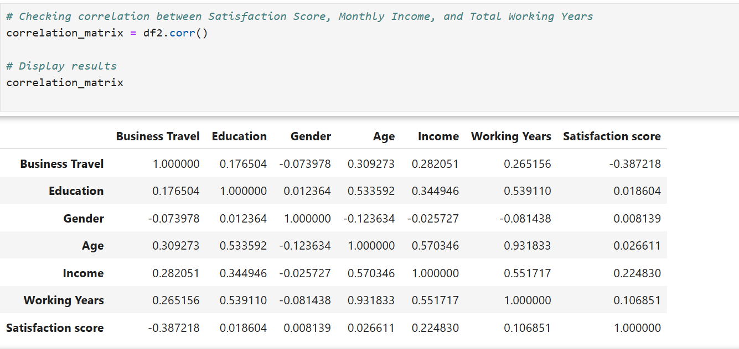

`Income` with `0.224` has a higher correlation with `satisfaction score` compare to others, therefore we use `income` and `satisfaction` score for K-mean clustering.

4.2 K-means Clustering:

K-Means is ideal for unsupervised clustering, allowing us to group employees based on unsupervised patterns in their data. It's a simple and efficient algorithm for unsupervised learning that helps identify patterns or segments in data, making it useful for tasks like customer segmentation, anomaly detection, and market analysis.
Clustering is used to group employees based on similar characteristics. For example, employees with similar satisfaction scores, years of service, and income might be grouped into the same cluster. K-Means is used here for its simplicity and efficiency.
Used pairplot() to helps visualize correlations between variables through scatter plots and correlation patterns (based on Income and Satisfaction Score).
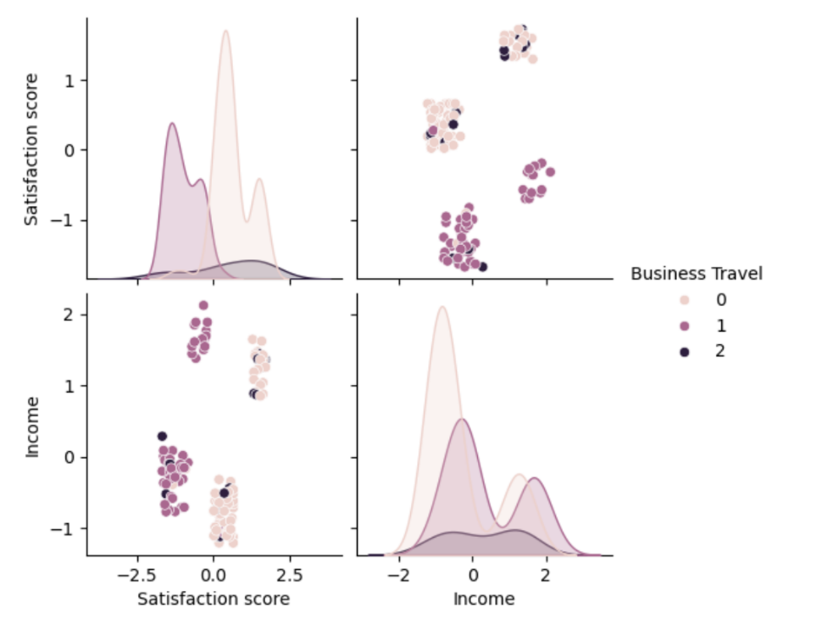
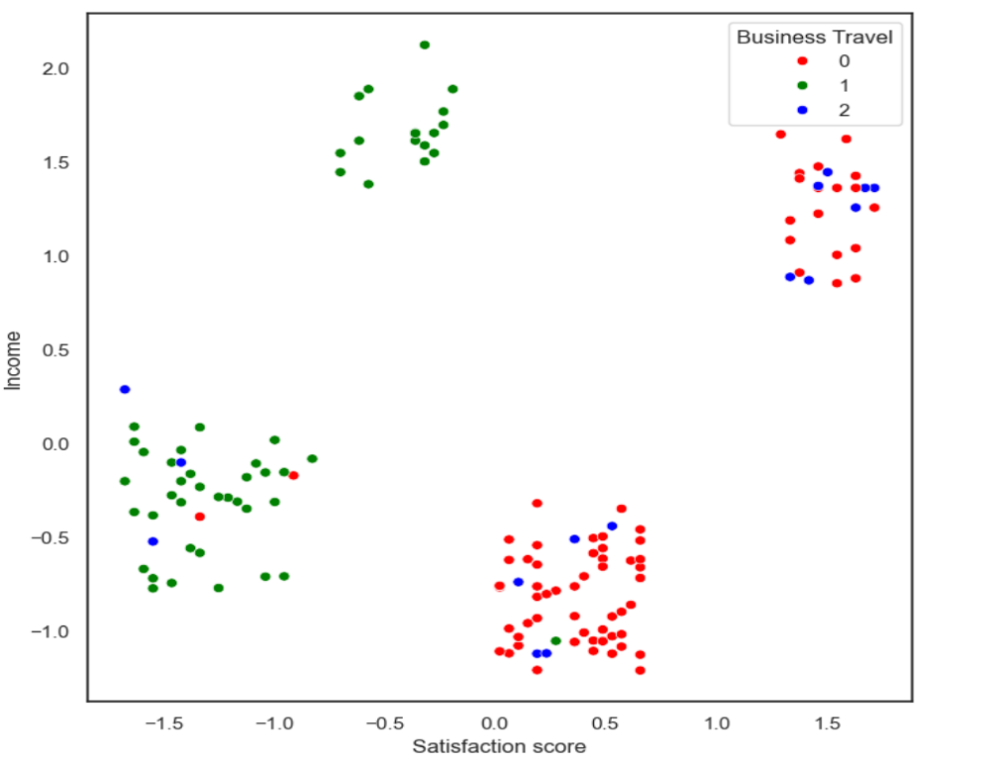
Visually, it was apparent that the data could be divided into four segments. To gain a clearer understanding of the optimal number of segments, the Elbow and Silhouette methods were applied to find the better fit.

There are 2 groups with soft margin and one mixed with others by colour, but clearly can see 4 divided segments.

Need to investigate whether the k-means clustering algorithm can derive the same grouping.

Elbow method

The Elbow method is used in K-Means clustering to determine the optimal number of clusters. It involves plotting the sum of squared distances (inertia) against the number of clusters. The "elbow" point, where the rate of decrease sharply slows down, indicates the best K value, balancing between model complexity and accuracy.
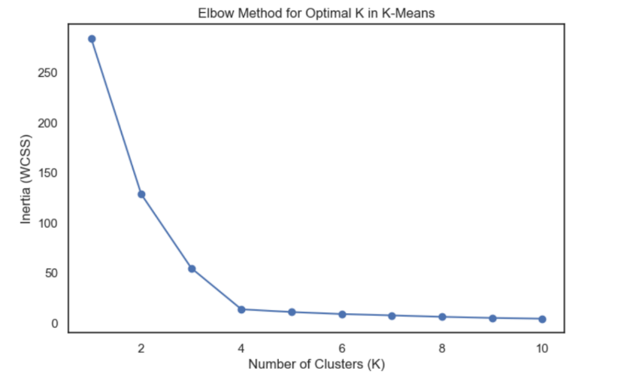

The "elbow point" (where WCSS stops decreasing significantly) suggests the optimal number of clusters. K value = 3 using elbow method

Silhouette method
The Silhouette method is used to evaluate the quality of clustering. It measures how similar each point is to its own cluster (cohesion) compared to other clusters(separation). A higher silhouette score indicates well-defined clusters, helping to determine the optimal number of clusters.
Closer to +1: Well-clustered.
Near 0: Overlapping clusters.
Closer to -1: Poorly clustered.

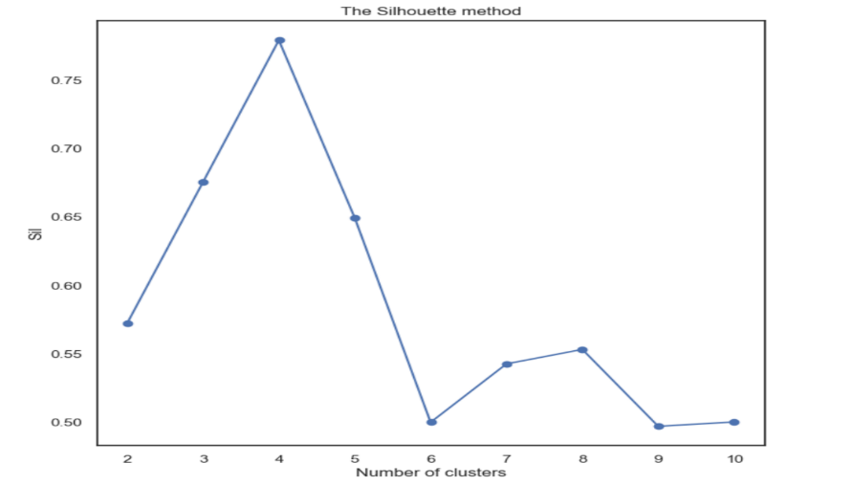
K value = 4 using Silhouette method

4.3 Decision Tree

A decision tree is used for classification and regression tasks. It models decisions and their possible consequences by splitting data into branches based on feature values. This helps make predictions or decisions by following a tree-like structure, where each node represents a decision based on an attribute.
The dataset was split into 80:20 train-test ratio.
Since the data has been normalised previously (`satisfaction_score > =50` is considered as `Satisfied` and a `satisfaction_score <=49` is considered as Dissatisfied) now `satisfaction score >= 0` considered as` Satisfied` and `satisfaction score < 0` considered as `Dissatisfied`. (Converted Satisfaction Score into a binary classification target)

Split the Data:
Features (X): `Business Travel`, `Education`, `Gender`, `Age`, `Income`, `Working Years`.
Target (y): `Overall Satisfaction` (1 = Satisfied, 0 = Dissatisfied).

For Decision tree modelling the following libraries were used:
tree and DecisionTreeClassifier: Building and training decision tree models for classification tasks.
train_test_split: Splitting the dataset into training and testing sets for model evaluation.
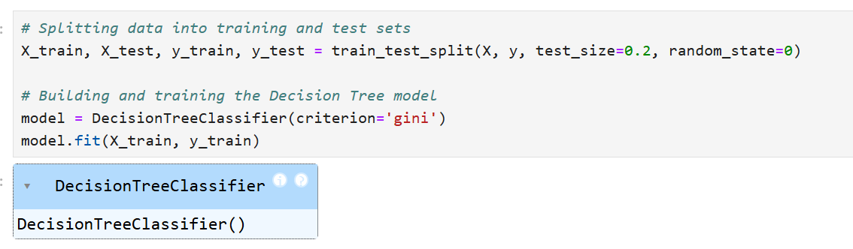
accuracy_score, classification_report, and confusion_matrix: Evaluating model performance by measuring accuracy, generating detailed metrics, and checking prediction errors.
Train and Fit the Data

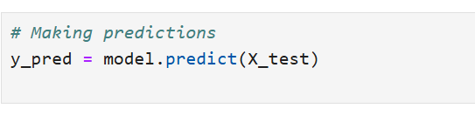
Predict the Data

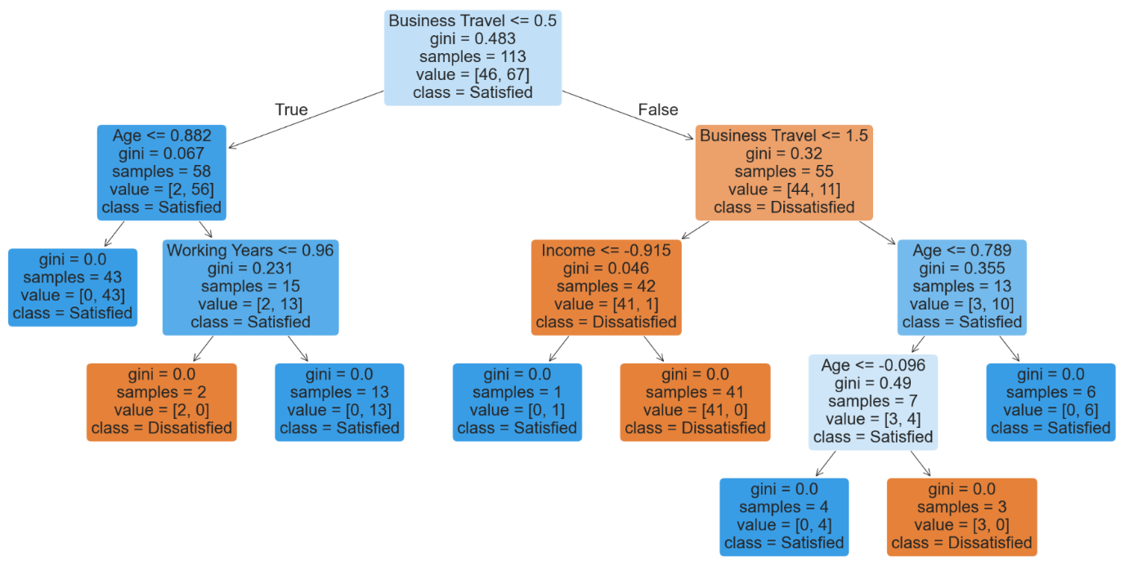
Visualise the tree model (over fitted model)

According to the decision tree, `Age` and `Work Travel` appear to have the greatest influence on the overall score, as the model uses them as key splitting criteria in the decision-making process.
Visualise the tree model (after pruning model)
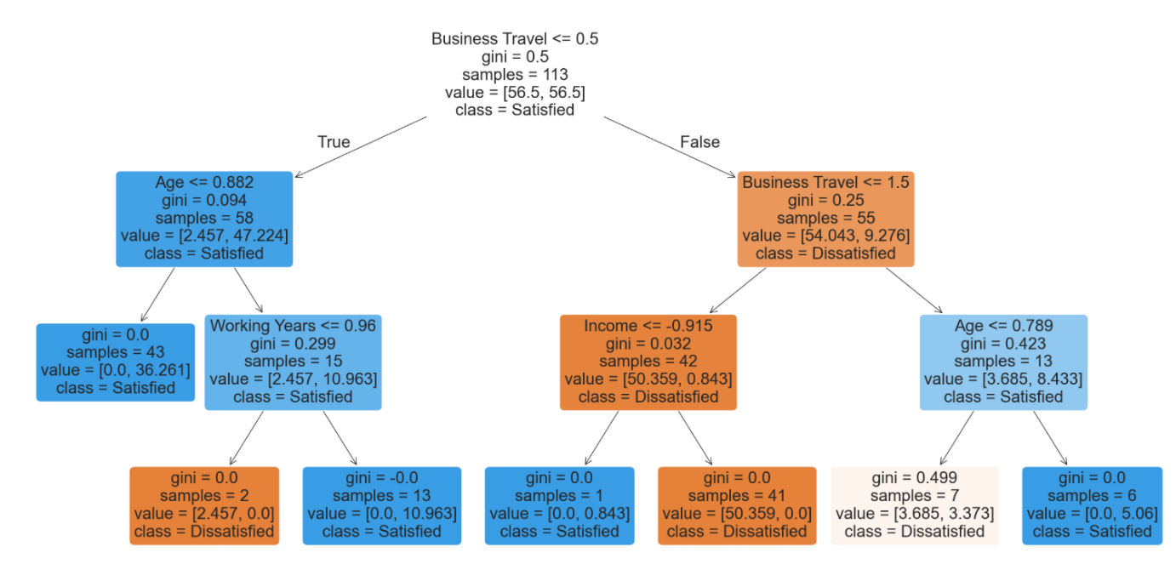

Primary Split – Business Travel:
The most influential feature for predicting satisfaction is Business Travel.
Employees who travel less frequently are generally more satisfied.
Age Matters:
Among less-traveling employees, younger employees (Age ≤ 0.882, scaled) show higher satisfaction.
Within this group, 43 employees are strongly predicted to be satisfied.
Working Years Effect:
When age is higher but Working Years ≤ 0.96, employees still tend to be satisfied.
More years of work might contribute to dissatisfaction if other factors aren’t favourable.
Income Impact:
For frequent travellers, lower income (≤ -0.915) strongly indicates dissatisfaction.
High dissatisfaction is found in this group — 41 employees predicted dissatisfied.
Edge Cases:
A small number of employees defy the patterns (e.g., older high travellers but still satisfied).
These might represent unique roles or exceptional conditions.

4.4 Sentiment Analysis

Used Sentiment Analysis as a technique to determine the emotional tone behind the feedback, classifying it into categories such as positive, negative, or neutral and derive further insights into how employees feel about the organization.
Pre-processed data such as change to lowercase, remove punctuation has been done to the data. Changing text to lowercase and removing punctuation helps standardize the data, making it easier for sentiment analysis algorithms to process.
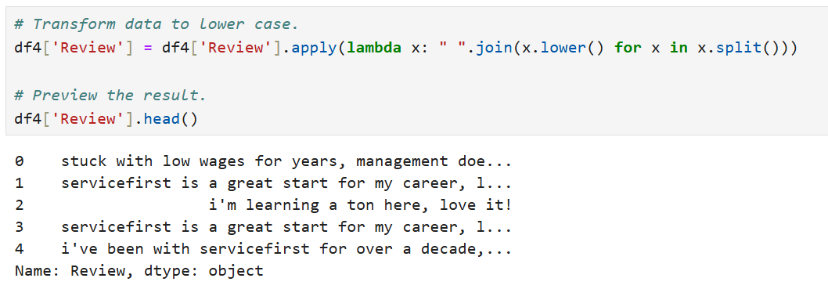
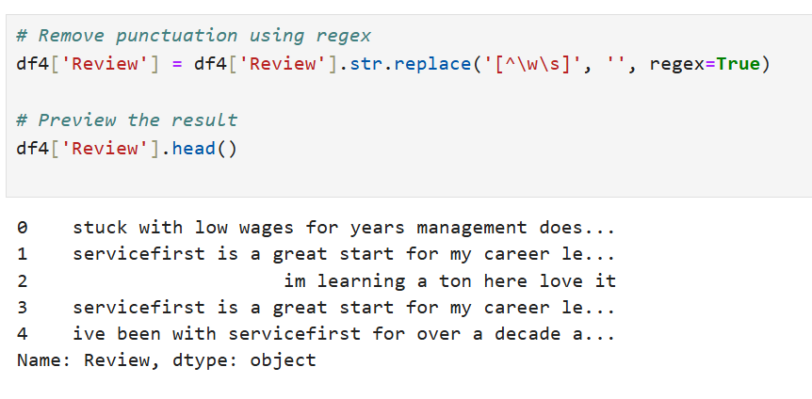

Visualise the most frequently used words
Used the WordCloud library to generate visual representations of text data, where the size of each word indicates its frequency in the given text. It's commonly used to visualize the most frequent words in a dataset, helping to quickly identify key themes or topics.

The chart above does not include Stopwords in the code to prevent their appearance. These words (such as "and," "for," and "the") are used frequently in sentences, which could skew the frequency analysis. However, they don't contribute meaningful insights to the analysis, so excluding them helps highlight more relevant terms.
The most prominent words are now `work` and `pay` and `good.

Find the most frequently used words with tokenisation
Used Tokenizing to break the text into smaller units (like words or phrases) to make it easier to analyse. The NLTK library used that provides tools for text processing, including tokenization, helping to prepare and analyse textual data for tasks like sentiment analysis or word frequency counting.
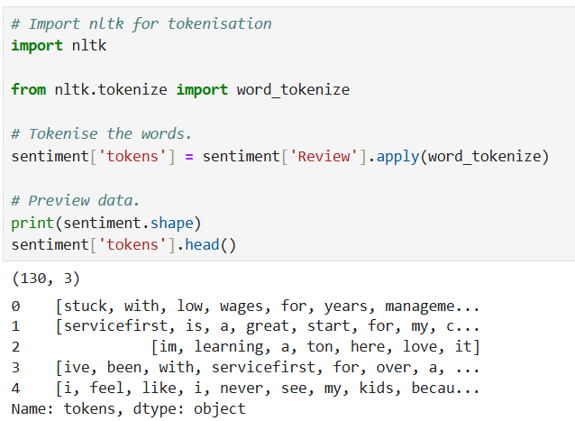
Next FreqDist is used to calculate and display the frequency distribution of tokens in a text. It helps identify the most common words or terms in a dataset, which is useful for tasks like word frequency analysis or creating word clouds.

Remove Stop words
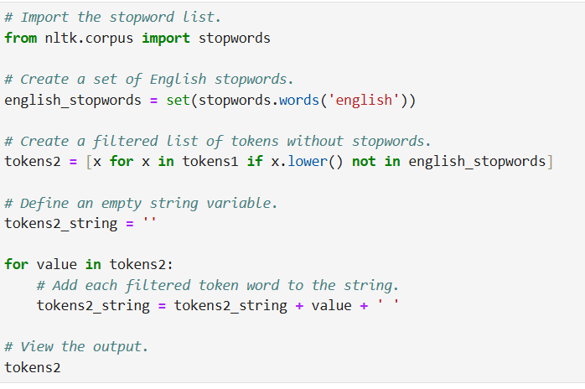

Before removing the stopwords, `the` was the most frequent word, appearing 42 times. After the stopword elimination process, `work` became the most frequent word, appearing 21 times. Stating how removing stopwords can add meaning and accuracy to the analysis.

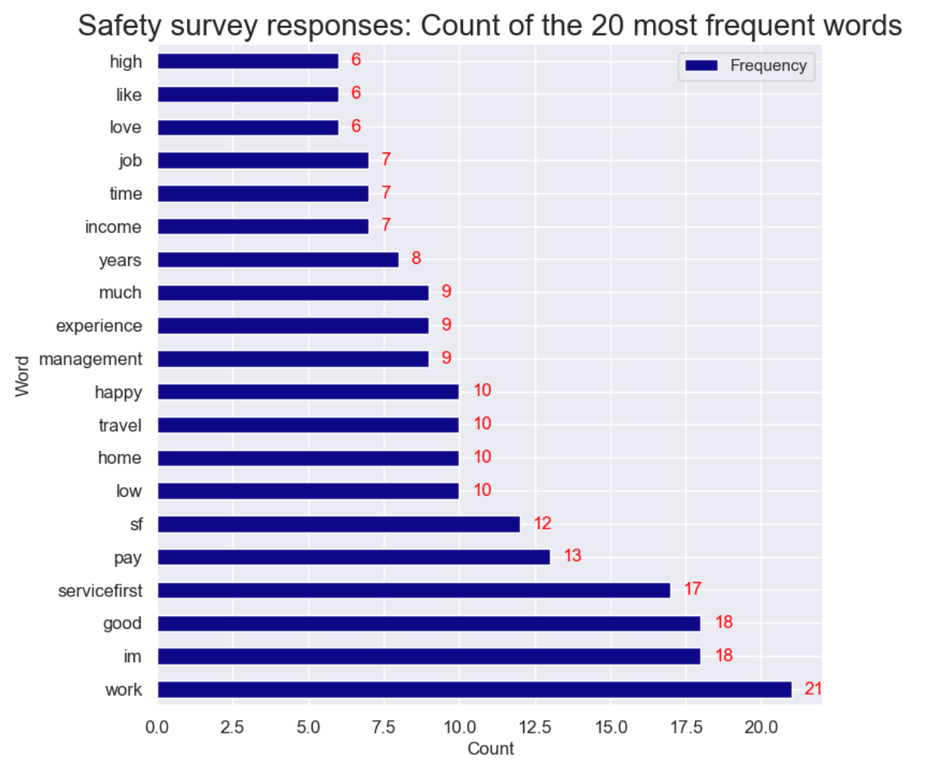
Visualise the Frequency Distribution of words

From the output, we can deduce that the token 'work' appears 21 times, while 'good' appears 18 times and 'pay' 13 times.

Polarity and Sentiment
The polarity and subjectivity were then analysed using the TextBlob library. The results were visualized and saved for future reference.
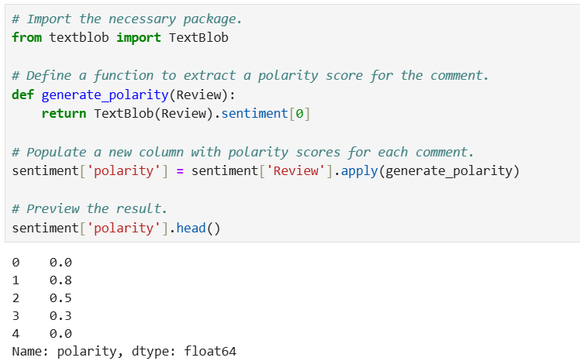

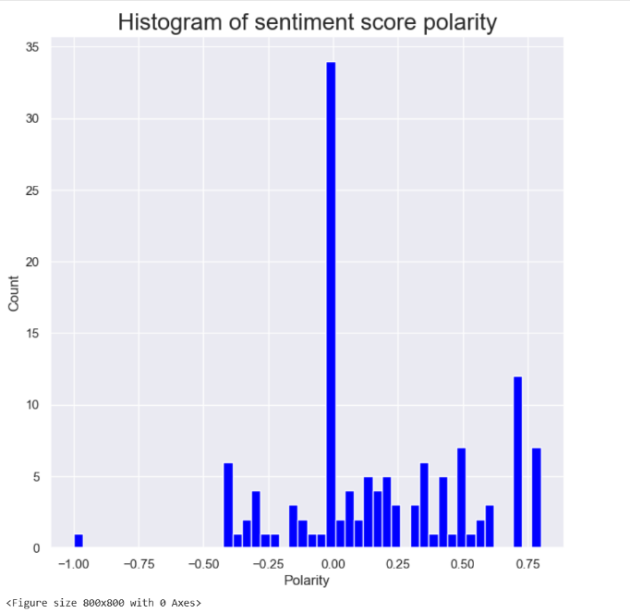
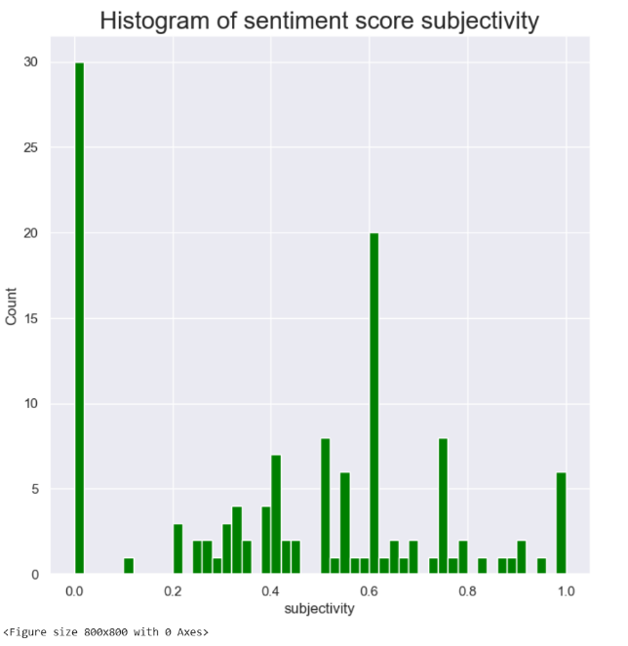
Visualised using Histogram

Histograms reveal that most Reviews are centred around zero, indicating a strong level of objectivity in the feedback. From the two histograms, we can infer that the majority of responses are neutral or show little sentiment, with a few Reviews leaning toward more positive. These observations suggest that the overall tone of the Reviews may be more balanced with a slight lean towards positive, rather than highly polarized.

Extract contextualised comments
Extracting contextualized comments helps in understanding the underlying sentiments and specific issues employees are facing. By analysing these comments, we can gain insights into the reasons behind satisfaction or dissatisfaction, leading to more tailored and actionable solutions for improving employee engagement and retention.
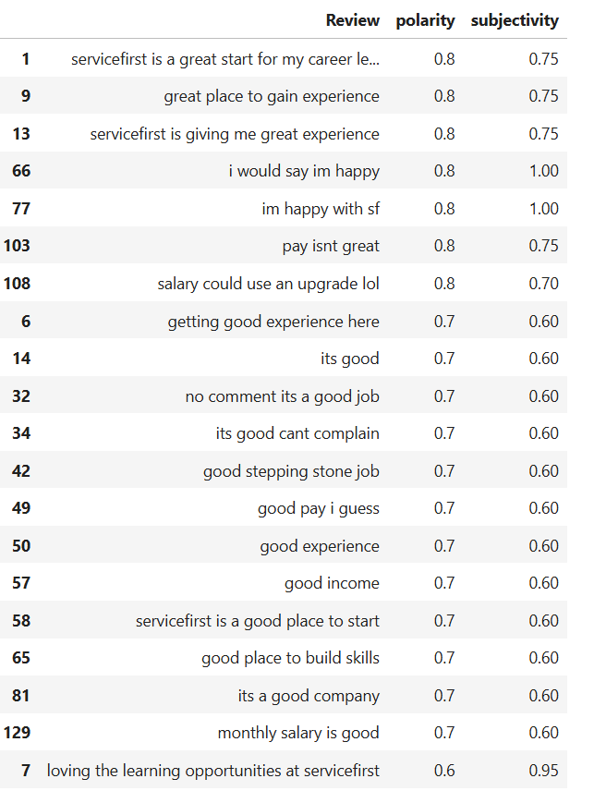
Positive Polarity (Top 20 reviews):

Based on the reviews, the major factors affecting employee satisfaction seem to be experience and pay. Phrases like "great experience," "good pay," and "salary could use an upgrade" indicate that employees appreciate opportunities for career growth and financial compensation. Positive comments such as "great start for my career," "happy with SF," and "good place to build skills" also suggest that employees value the work environment and learning opportunities.
Therefore, employee satisfaction is influenced by a combination of career development, pay, and the overall work culture at ServiceFirst.
However, mistakes like "pay isn't great" being classified as positive polarity suggest that the model may not be 100% accurate. Apart from this, the other reviews appear to be classified correctly.

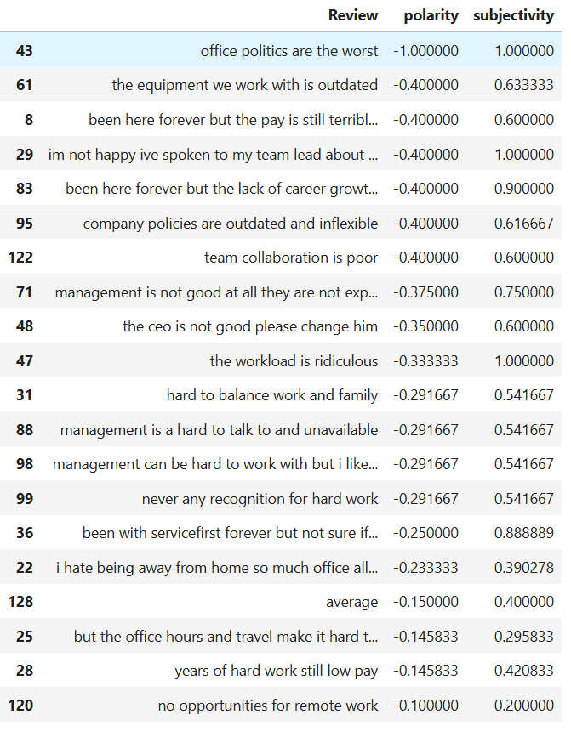
Negative Polarity (Top 20 reviews):

Management Issues: Multiple comments highlight dissatisfaction with management, such as "management is hard to talk to and unavailable," "the CEO is not good, please change him," and "never any recognition for hard work." These indicate that employees feel unsupported and undervalued by the leadership.
Workplace Conditions: Comments like "office politics are the worst," "the workload is ridiculous," and "the equipment we work with is outdated" point to frustrations with the work environment and resources.
Work-Life Balance: Statements like "hard to balance work and family" and "I hate being away from home so much" show that employees are struggling with achieving a healthy work-life balance.
Career Growth and Recognition: "Lack of career growth" and "no opportunities for remote work" suggest that employees are dissatisfied with limited professional development and flexibility in their roles.
Pay: "Years of hard work still low pay" indicates dissatisfaction with compensation, suggesting that employees feel their work is not being adequately rewarded.
These areas of dissatisfaction point to significant issues that can affect employee retention, highlighting the need for better management practices, resource allocation, and career development opportunities.
While the model seems to classify negative sentiment accurately for most reviews, there may still be some margin for improvement, as some reviews, like "average," have a very low polarity score but might still contain elements of dissatisfaction that are not fully captured by the model.

Generate a document-term matrix
A Document-Term Matrix (DTM) is generated to convert text data into a structured format, allowing for easier analysis of word frequency and relationships across documents and to help in identifying patterns. Words such as `experience` and `ServiceFirst ` have the most counts. Indication that experience (Total working years might play a role in satisfaction).
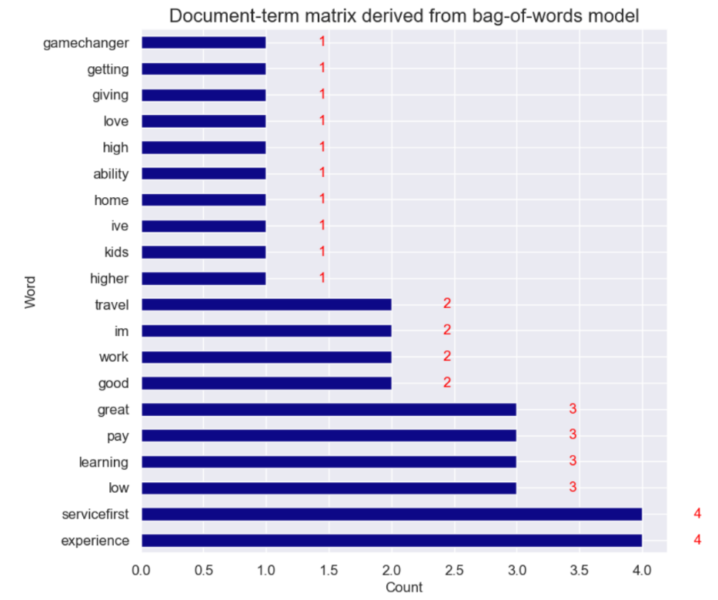

Frequent Terms: “Experience” and “ServiceFirst” are the most mentioned, indicating focus on employee experience.
Work-Related Factors: Words like “pay,” “learning,” and “work” suggest employees are concerned about compensation and growth opportunities.
Positive Sentiment: Terms like “good” and “great” reflect satisfaction with work conditions.
Personal Factors: Personal words like “home” and “kids” appear less often, indicating less focus on personal aspects.

5. Evaluation

5.1 Evaluate Results

K-Mean Clustering
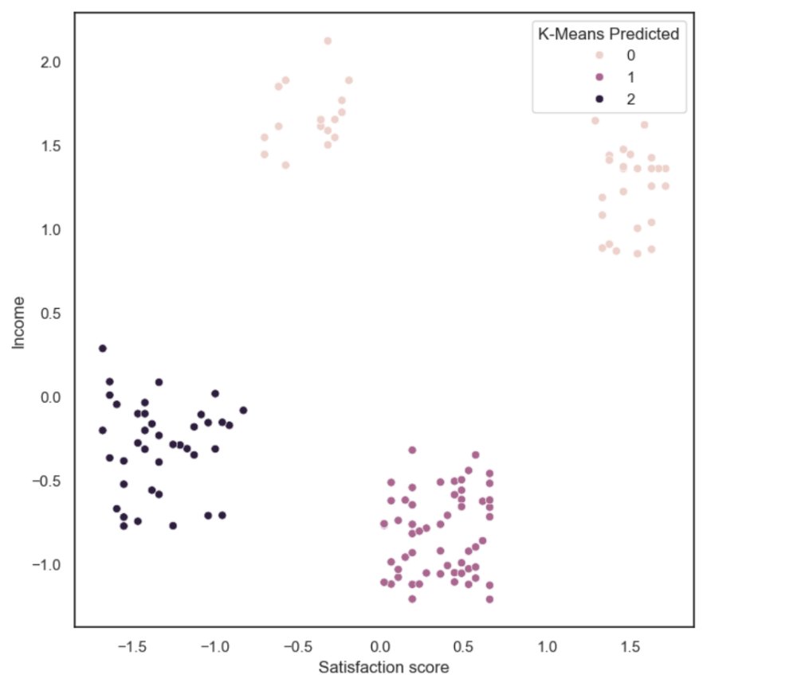
K value = 3 using Elbow method

There may be distinct patterns within the higher-income groups, with some showing low satisfaction and others high satisfaction. Splitting this cluster into two would enable more targeted retention strategies. Further segmentation of Cluster 0 could reveal meaningful insights and help address specific needs within each subgroup.
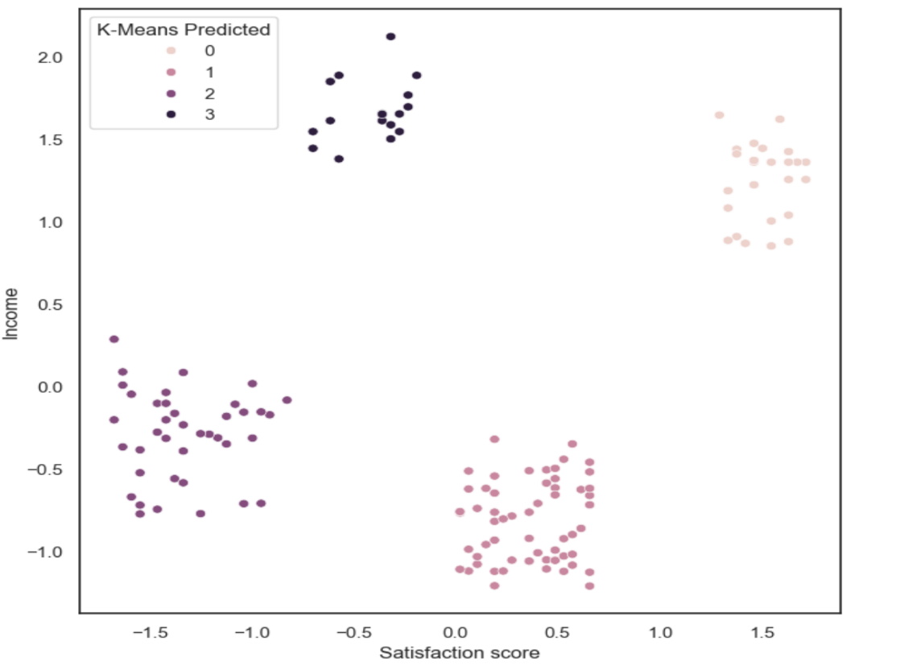
K value = 4 using Silhouette method

- Cluster 0: High satisfaction, high income (loyal employees).
- Cluster 1: Moderate satisfaction, lower income (growth opportunity group).
- Cluster 2: Low satisfaction, low income (high turnover risk).
- Cluster 3: Low satisfaction, high income (dissatisfaction despite higher pay).
The clusters are well-separated, with higher-income groups generally showing higher satisfaction scores, while lower-income groups tend to have lower satisfaction scores. However, this doesn't necessarily mean that higher income always leads to higher satisfaction.
Based on the results from both methods, the K-Means clustering algorithm was applied and visualized, with K = 4 identified as the optimal number of clusters with minimal or no soft margin.
Employees have been grouped into four distinct clusters based on their Satisfaction Score and Monthly Income.

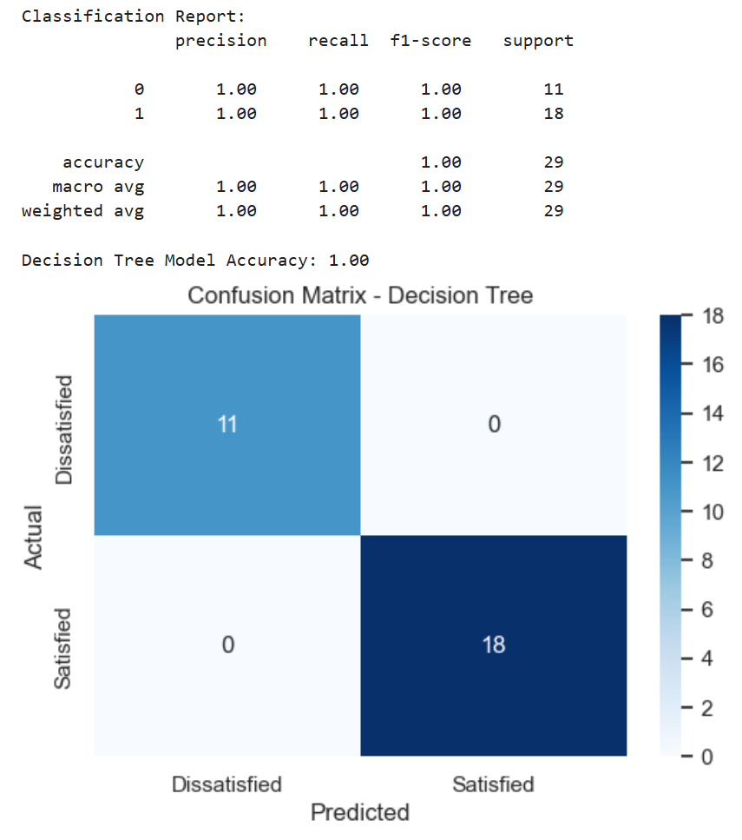
Decision Tree

The model achieved `100%` accuracy, meaning it perfectly classified employees as Satisfied (score ≥ 50) vs. Dissatisfied (score < 50) in the test set.
However, this might indicate overfitting since the dataset is relatively small and everything is perfectly `100%`. To improve generalization, we can:
Apply pruning to the tree

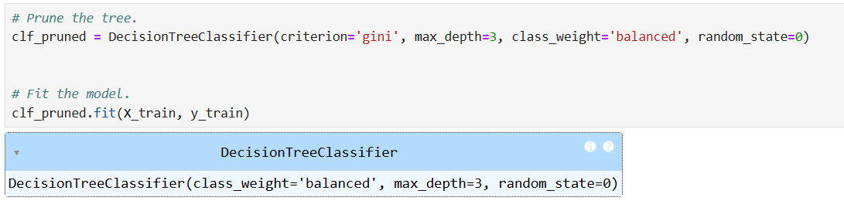

Pruning Justification:
max_depth =3: Limits the tree’s depth to avoid learning overly specific patterns and ensures better generalization, making the model easier to interpret.
class_weight = 'balanced': Adjusts the model to handle class imbalance by assigning appropriate weights to underrepresented classes, improving predictions for minority classes.
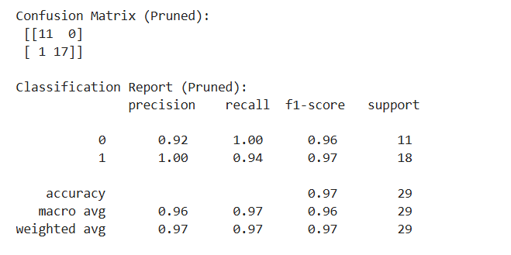

Accuracy: 97%
Macro Avg F1-Score: 0.96
Weighted Avg F1-Score: 0.97
It makes no false negatives for dissatisfied employees (Recall = 1.00 for Class 0).
It has only one misclassification for satisfied employees.
The first model uses default settings and may overfit or Favor the majority class, while the second model applies depth control and class balancing to prevent overfitting and improve fairness across classes.
Pruned vs Unpruned comparison:
Unpruned Decision Tree (Accuracy = 1.0): Achieves perfect accuracy, but risks overfitting by memorizing training data, leading to poor generalization on unseen data.
Pruned Decision Tree (Accuracy = 0.97): Has slightly lower accuracy but is more robust and better at generalizing. Pruning reduces complexity by removing unnecessary branches, focusing the model on key features.

5.2 Make Prediction
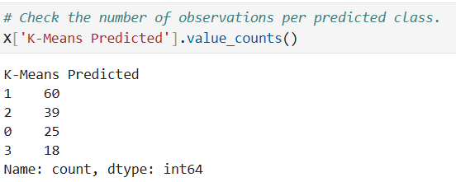
K-Mean Clustering

The output shows the distribution of observations across the different clusters predicted by the K-Means algorithm:
It seems that Cluster 1 has the highest number of observations, while Cluster 3 has the least. The imbalance between the clusters may suggest some clusters are more dominant or representative of the overall dataset, and the smaller clusters (like Cluster 3) could represent specific niche groups that may require a different approach. In this case employees with high income and yet low satisfaction.

Decision Tree

Business Travel is the top predictor — less travel links to higher satisfaction.
Younger employees and those with fewer working years are more likely to be satisfied.
Low income + frequent travel = high dissatisfaction.

6. Conclusion and Recommendations
Ethical Concerns

Bias in Data: The dataset may have biases related to age, gender, or income, which could lead to unfair predictions. It's crucial to ensure the model is unbiased.
Privacy and Confidentiality: Sensitive employee data, such as satisfaction scores and sentiments, must be protected to avoid misuse.
Transparency and Accountability: Machine learning models must be transparent, with stakeholders understanding how predictions are made, and accountability for outcomes being upheld.

Actionable Recommendations

Employee Retention Programs:
- Recognition and Growth: Continue recognizing and rewarding employees to enhance engagement and satisfaction.
- Improve Work Conditions: Offer growth opportunities, non-financial incentives, and address income disparities.
- Career Development: Provide career advancement opportunities and targeted support for employees at risk of turnover.
Refining the Decision Tree Model:
- Reduce Business Travel: Minimize unnecessary travel for junior or low-income staff, and offer remote/hybrid options for frequent travellers.
- Workplace Flexibility: Provide bonuses or time off for employees with high travel demands and create growth opportunities for younger staff.

Sentiment-Driven Insights:
- Monitor Morale: Regularly use sentiment analysis to track employee morale, focusing on managerial quality and work-life balance to improve satisfaction.
- Ongoing Surveys: Implement regular surveys and feedback mechanisms to proactively address dissatisfaction and ensure continuous improvement.

Conclusion

By using K-Means clustering, decision trees, and sentiment analysis, ServiceFirst has identified key factors affecting employee satisfaction. The results indicate that employees with lower incomes, frequent travellers, and dissatisfaction with management or work conditions are more likely to leave. Sentiment analysis highlighted concerns about workload, pay, and career growth.
- Focus on improving work conditions for specific employee groups, like offering flexible work for frequent travellers and better support for junior staff.
- Address issues related to management practices, pay, and career growth to enhance satisfaction and retention.
- Regular surveys and feedback will help track progress and ensure continuous improvement.

7.References

- IBM (2020). CRISP-DM Methodology. Retrieved from IBM Website
- McKinney, W. (2017). Python for Data Analysis. O'Reilly Media.
- Géron, A. (2019). Hands-On Machine Learning with Scikit-Learn. O'Reilly Media.
- "K-Means Clustering." scikit-learn documentation,
scikit-learn.org.
- "Decision Tree Classifier." scikit-learn documentation
scikit-learn.org.

