Designing Machine Learning Model Framework for ServiceFirst Employee Satisfaction

(Linear and Multi Linear Model)

BY
Ehsan Keikhavani

Content

1. Business Understanding
1.1 What are the business objectives?
- Background
- Business Objectives
- Business Success Criteria
1.2 Assess the Situation
- Inventory of Resources
- Requirements, Assumptions, and Constraints
- Risks and Contingencies
1.3 Determine Data Mining Goals
1.4 Produce the Project Plan
2. Data Understanding
2.1 Collect Initial Data
2.2 Describe Data
2.3 Explore Data
2.4 Verify Data Quality
3. Data Preparation
3.1 Select Data
3.2 Clean Data
3.3 Construct Data
3.4 Format Data
4. Modelling and Hypothesis
4.1 Hypothesis
4.2 Simple Linear regression
4.3 Multi Linear regression
5. Evaluation
5.1 Evaluate Results
5.2 Make Prediction
6. Conclusion and recommendation
7.Refrences

1.Business Understanding

1.1 What are the business objectives?

Background
ServiceFirst, a national equipment servicing company, employs 250 staff members, including both remote and office-based workers. Following the COVID-19 pandemic, the organization has experienced high staff turnover, leading to increased recruitment costs and the loss of experienced personnel. These issues significantly impact productivity and workforce stability.
To address these concerns, the People & Culture (P&C) team conducted an employee satisfaction survey to measure employee perceptions and organizational climate. The primary goal is to apply advanced analytics and machine learning to:
- Uncover key drivers of satisfaction
- Identify factors influencing employee retention
- Provide actionable recommendations to improve satisfaction and reduce turnover

Business Objectives
The business objectives of this project are:
- Identify key drivers of employee satisfaction.
- Establish relationships between demographic factors and satisfaction scores.
- Determine predictive factors affecting employee retention (intention to leave).
- Provide actionable recommendations to improve employee satisfaction and retention.

Business Success Criteria
- Deliver insights into the main areas of dissatisfaction.
- Build a model that can predict employees at risk of leaving.
- Provide data-driven recommendations to improve employee satisfaction and reduce turnover.

1.2 Assess the Situation

Inventory of Resources
- Data: Employee survey dataset containing demographic data, standardized satisfaction scores, an overall satisfaction score, an intention-to-quit score, and sentiment analysis codes.
- Analytics: Python (Jupyter Notebook), Pandas, Numpy, Scikit-Learn, Matplotlib, Seaborn, Sklearn-linear mode, scipy.stats , statistical libraries and CRISP-DM methodology.
“By following CRISP-DM's structured approach, from data understanding to deployment, we ensured that the insights generated were reliable and actionable, ultimately helping ServiceFirst improve its employee retention strategy” (IBM, 2020).
- People: HR Analysts, Data Scientists, and Business Decision-Makers.

Requirements, Assumptions, and Constraints
- The dataset includes responses from 142 employees who consented to research use.
- Assumption: Survey responses are honest and representative of the entire workforce.
- Constraints: The dataset may have missed or biased responses. The analysis is limited to available survey questions.

Risks and Contingencies
- Data Quality Issues: Missing values and response bias may exist.
- Business Buy-in: Insights must align with business expectations for HR adoption.
- Model Accuracy Limitations: Machine learning predictions depend on available variables.

1.3 Determine Data Mining Goals
- Identify trends and relationships between satisfaction scores and demographics.
- Develop predictive models to assess which factors contribute most to employee retention.
- Perform hypothesis testing to validate key assumptions about employee satisfaction.

1.4 Produce the Project Plan
- Data Understanding: Load and explore the dataset, identify missing values, and understand distributions.
- Data Preparation: Clean missing values, encode categorical variables, and normalize numerical data.
- Modelling: Build machine learning models (classification for predicting attrition risk, regression for satisfaction scores).
- Evaluation: Assess model performance using accuracy, precision, recall, RMSE, and correlation analysis.
- Conclusion and recommendation: Provide actionable insights and recommendations for HR interventions.

2. Data Understanding

2.1 Collect Initial Data
Began by Importing the data and necessary libraries.
Pandas is used for data manipulation and analysis because it provides powerful, flexible, and efficient tools for handling structured data.
Key reason to use Pandas:
Data Handling, easily read and write data from CSV, Excel, SQL, JSON, etc.
“The Pandas library, a crucial tool in Python for data manipulation, was used to clean, preprocess, and analyse the dataset efficiently “(McKinney, 2017).
NumPy is used for numerical computing in Python because it provides fast, efficient, and flexible operations on large datasets.

Key reasons to use NumPy:
Efficient Data Storage, uses arrays (Nd array) that are more memory-efficient than Python lists.
Fast Computations, optimized for mathematical operations, making it much faster than loops.

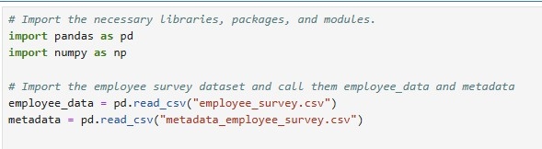

The dataset provided by ServiceFirst consists of 142 employee survey responses with 18 features, including demographic details, satisfaction scores, and sentiment analysis results.

2.2 Describe Data
- Demographic Data: Work location, length of service, managerial status.
- Survey Responses: 10 key satisfaction areas.
- Intention to Quit Score: Binary (Yes/No/Not Sure).
- Sentiment Analysis Codes: Categorical (Positive/Negative/Neutral).

2.3 Data Exploration
Conduct descriptive statistics and visualizations of key satisfaction areas.
Python libraries provided an efficient approach to handling, cleaning, and analysing the dataset. Several techniques were employed:

Exploratory Data Analysis (EDA) Methods
- Pandas (df.info (), df.describe()): Helped summarize the dataset, identifying key statistics and missing values.
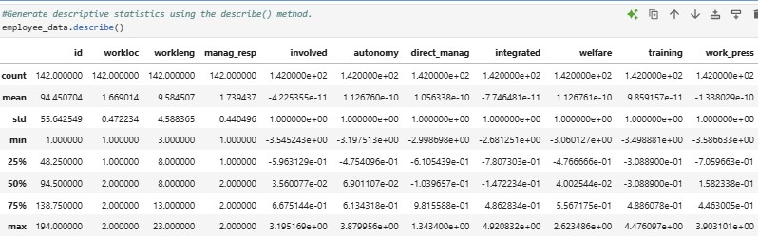

Findings:
- Overall Satisfaction Score:
  - Mean: ~0 (-0.000493)
  - Range: -11.68 to 27.82 (possible outliers)
- Intent to Quit:
  - Majority of employees are unsure or do not intend to quit.
- Sentiment Analysis:
  - Scores range from 1 to 3.
And other detailed information STD, min and max of all attributes provided in the Python report file.
- NumPy (np.mean(), np.std()): Assisted in computing statistical measures such as mean, standard deviation, and variance.
- Matplotlib & Seaborn (plt.hist(), sns.heatmap(), sns.pairplot()): Used for visualizing trends, distributions, and relationships among features.

“The Seaborn and Matplotlib libraries played a significant role in visualizing key insights through correlation matrices, histograms, and boxplots, allowing us to understand data distributions and relationships between variables” (Géron, 2019).

- corr() Method: Allowed us to examine correlations between variables, identifying key predictors of satisfaction.
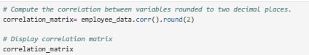

A correlation matrix (df.corr()) was created to analyse relationships between variables, revealing that Autonomy, Training, Integration, and Work Pressure were the most significant predictors of overall satisfaction.

Data Visualization
Using Matplotlib and Seaborn, we generated several visualizations to analyse the data distribution and key patterns.
Histogram
Some variables appear normally distributed (e.g. `customers`, `Autonomy` (slightly left skewed)), while others show skewed patterns (e.g. `innovative`, `direct_manag` ...).

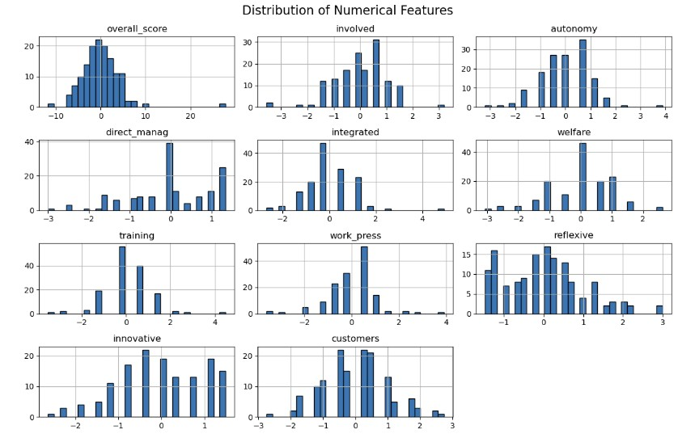
`Overall_score` has a wide range, which might indicate varied satisfaction levels among employees and the skewness to the left (possible outlier).

Histograms were used to visually assess the distribution of satisfaction factors and identify patterns in the data.

Skewness and Kurtosis:
Skewness and kurtosis are used to understand the shape and distribution of data:
Skewness – Measures asymmetry in data distribution.

- Positive skew: Tail is on the right (high values).
- Negative skew: Tail is on the left (low values).

Kurtosis – Measures tailedness (peak/sharpness of distribution).

- High kurtosis: More extreme outliers.
- Low kurtosis: Fewer extreme values.
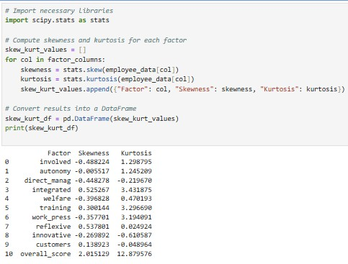
Both help in detecting outliers, data normality, and model assumption.

Check Skewness: Determine if the data is symmetrical or leans to one side (-1 to 1):
Right-skewed (positive skew): More values are concentrated on the left. ` Overall_score` (` 2.015129 `) and `reflexive` variable according to the histogram and calculation `0.447044 ` have positive skewness.
Left-skewed (negative skew): More values are concentrated on the right. Variables: `involved `, `Autonomy`, `direct_manag`, `welfare`, `work_press`, `innovative` have a slightly negative skewness but still within the range of (-1 to 1).

Near zero skew: Data is evenly distributed. Variables: `customers` show almost no or close to zero skewness.

Check Kurtosis: Measure the peakiness or flatness of the distribution (-3 to 3):
High kurtosis (>3): Sharp peak, indicating many extreme values (outliers). `Overall_score`, `work_press`, `training` and `integrated` have a sharp peak, indicating possible outliers.

Low kurtosis (<3): Flat distribution, suggesting few outliers. Variables: `work_press` 2.56, `training` 1.58 and `involved ` 1.03 have the highest Kurtosis indicating a peak distribution and their outliers. The rest of the variables are either close to 0 or 1 which indicate a flat distribution.
Using histograms along with skewness and kurtosis values helps decide if data transformations are needed to normalize distributions for better modelling performance.

Conclusion:

🔹 Skewness and kurtosis indicating possible outliers, the data needs inspection to normalise for statistical analysis which will be done in next step.
🔹After normalising data, using parametric tests (e.g., t-test, regression), the data should be fine unless the high kurtosis affects variance.

Correlation Heatmap

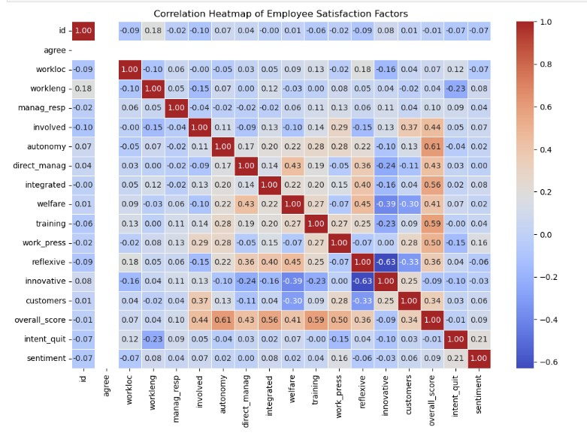
Key Findings from Correlation Analysis:
Strongest Positive Correlations with Employee Satisfaction (overall_score):
Autonomy (0.605) → Employees feeling trusted by the organization correlates highly with satisfaction.
Training (0.593) → Employees who feel they get enough training report higher satisfaction.
Integration in Teams (0.558) → Strong team dynamics contribute to overall satisfaction.
Work Pressure (-0.502) → Indicates that better work-life balance correlates with satisfaction.
Involvement in Decisions (0.440) → Feeling involved in decisions contributes positively.

Weaker or Negative Correlations:
Managerial Responsibility (0.095) and Work Location (0.070) show low correlation.
Intention to Quit (-0.014) and Innovative Culture (-0.085) have weak or slightly negative relationships with satisfaction.

Sentiment (0.089) has a low correlation, suggesting that employee sentiment alone doesn’t fully determine satisfaction.
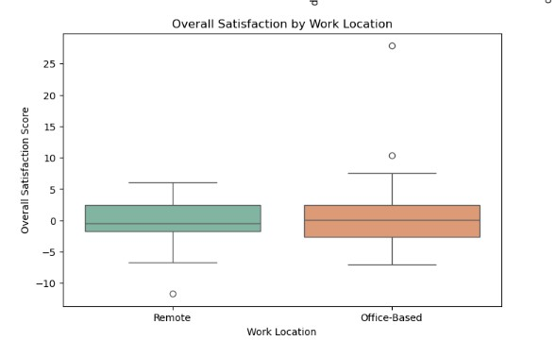
Work Location & Satisfaction:

Remote employees seem to have lower satisfaction scores than `office-based` employees.
This suggests that remote workers may feel less engaged or supported.
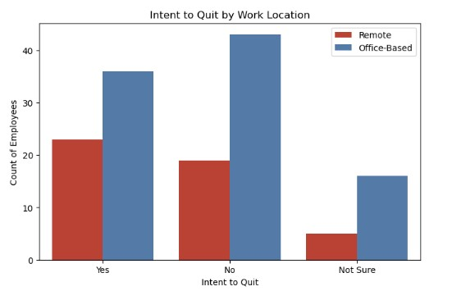
Intent to Quit & Work Location:

Remote workers are more likely to be in the “Yes" (considering leaving) and Office based in the "No" or "Not Sure" category.
Office-based employees tend to be more stable in their employment intentions.
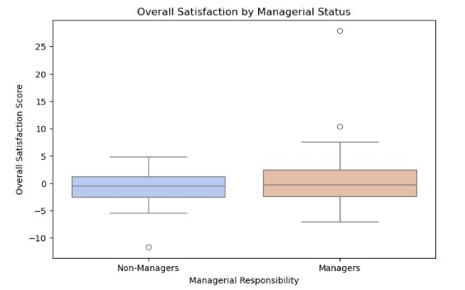
Managerial Responsibility & Satisfaction:

Managers generally report higher overall satisfaction scores compared to non-managers.
This might indicate better engagement, career growth, or resources for managerial roles.
These visualizations helped us identify patterns and detect potential multicollinearity between features, allowing us to refine model selection.

2.4 Verify Data Quality
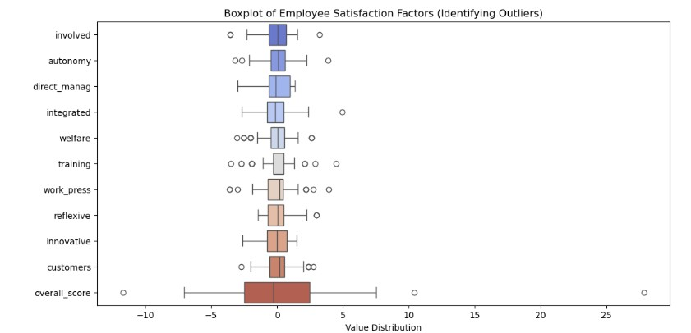
Check for missing values and outliers.

Using the (IQR) method for outlier detection, all factors fell within the range of `-5` to `5`. Among them, `Training` and `Welfare` had the highest number of outliers. Additionally, `Overall Score`, which represents the sum of all factors, had three outliers, with one being extremely high (Over 25).

Despite these observations, the decision was made to delete the extreme one and retain the 2 closer to the range since they still fall within the expected range of -50 to 50where -50 represents extreme dissatisfaction and 50 represents extreme satisfaction. This range is reasonable, given that the sum of 10 factors, each ranging from -5 to 5, naturally falls within (-50, 50).

Determine if there are missing values
Why Check for Missing Values?
Detect Data Gaps – Identifies columns with missing (NaN) values.
Understand Data Quality – Helps assess completeness before analysis
Plan Data Cleaning – Determines if missing values should be removed or imputed.
Avoid Errors – Prevents issues in calculations, visualizations, and machine learning models.
Using `isnull()`provides a quick summary of missing values in each column, ensuring data reliability.
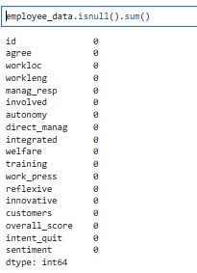
No missing value detected.

Why Identify Duplicate Rows?
Ensures Data Integrity – Avoids biased or misleading analysis.
Prevents Data Redundancy – Eliminates unnecessary duplication.
Improves Model Accuracy – Ensures unique data points for training.
Optimizes Performance – Reduces dataset size and enhances processing speed.
Apply `duplicated () ` Method to the dataset.
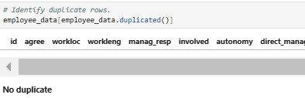 No duplicate row detected.

3. Data Preparation

3.1 Select Data
- Data that previously was imported now include relevant features: Demographics, Satisfaction Scores, Sentiment Analysis, Intention to Quit.

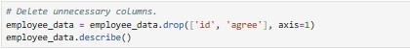

Dropping Id and Agree columns (using drop () method) that are not needed at this stage and keeping the relevant columns.

3.2 Clean Data

- Handle missing values using imputation or removal which previously has been inspected and nothing was detected.
Handling Outliers
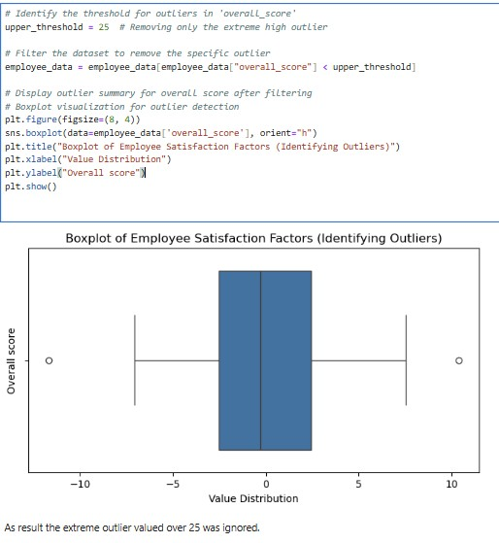
- Using the IQR method, Outlier were detected. Training and Welfare had the highest number of outliers. Additionally, Overall Score had three extreme outliers, with one significantly deviating. The extreme outlier (over 25) was removed to prevent skewed analysis.

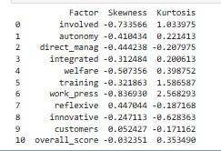
This outlier was deleted to prevent the data from skewing to the sides. By removing it the insights will be more accurate from data analysis.

The data has been re-evaluated, confirming that no further skewness or kurtosis issues are present. The dataset is now normally distributed and ready for analysis.

3.3 Construct Data
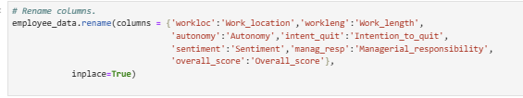
Rename the columns for better readability. Using the `rename () ` method.

3.4 Format Data
Normalize numerical values for modelling purposes.
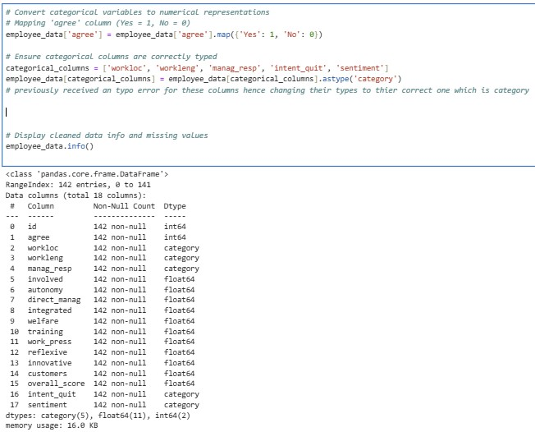

Convert categorical variables into their correct format (encoding).
Why Convert Categorical Variables?
- Prepares Data for Analysis & Modelling – Many machine learning models and statistical techniques require numerical inputs.
- Improves Consistency – Standardizes categorical responses for easy interpretation.
- Avoids Errors – Ensures categorical columns are correctly typed to prevent processing issues.

4. Modelling and Hypothesis

4.1 Hypothesis Testing:
    - Test whether work location (remote vs office) significantly affects overall satisfaction score.
    - Test whether intent to quit is significantly related to overall satisfaction score.
    - Compare remote vs office-based workers to see if there is a significant difference in intent to quit.
- Test whether managers vs non-managers is significantly related to overall satisfaction score.

For all Hypothesis consider:
- CI = 95%
- a (level of significance) = 0.05

scipy.stats:
- Part of the SciPy library, which provides statistical functions and hypothesis testing methods.
- Used for probability distributions, statistical tests, correlation analysis, and more.
- Common methods include ttest_ind (), chi2_contingency (), etc.
Chi-Square Test (chi2_contingency)
- Used for categorical data to test independence between two variables.
- It determines whether observed frequencies in a contingency table differ significantly from expected frequencies.
- If p-value < 0.05, variables are not independent (i.e., they are related).
T-Test
- A parametric test used to compare the means of two independent groups.
- Determines if the difference between group means is statistically significant.
- If p-value < 0.05, the difference is significant.

Four hypotheses were tested using A/B Testing (t-tests, N>30) and Chi-Square Tests:
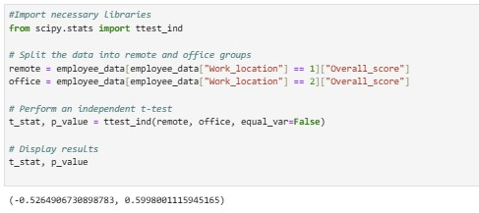
- Remote vs. Office-Based Employees: No significant difference in overall satisfaction.

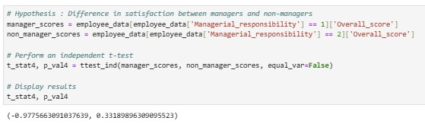
2. Managers vs. Non-Managers: No significant difference in satisfaction.

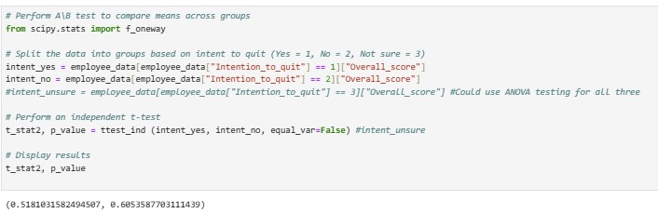
3. Employees Who Intend to Quit vs. Stay: No significant difference in satisfaction.

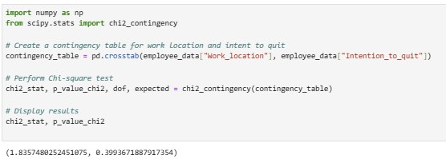
4. Intent to Quit by Work Location: No statistically significant difference between remote and office-based employees.

Results:
- P-values greater than 0.05 for all tests indicate no statistically significant differences.
- While no strong categorical effect was found, other variables (e.g., Autonomy) may influence satisfaction and retention.

Select the Modelling Technique

Regression Models for predicting employee satisfaction scores.
To assess the impact of key predictors on overall satisfaction, two regression models were developed.

4.2 Simple Linear Regression:
The dataset was split into a 70:30 train-test ratio, and a Simple Linear Regression model was trained to assess goodness of fit.
Autonomy was selected as the independent variable due to its strongest correlation with the overall score and its well-balanced data distribution, making it the most suitable predictor for analysis.
Scikit-Learn (sklearn) is a Python library has been used in this project for machine learning, including data preprocessing, model training, evaluation, and prediction. It supports classification, regression, clustering, dimensionality reduction, and model selection.

- Predictor Variable (X): Autonomy
- Dependent Variable (Y): Overall Satisfaction Score
- R-squared Values:
Train: R2 = 0.25
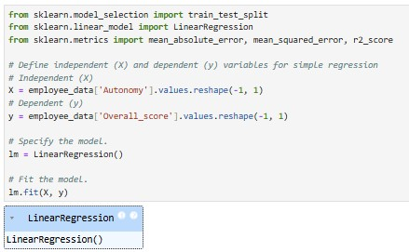
Test: R2 = 0.32 (indicating a weak relationship)
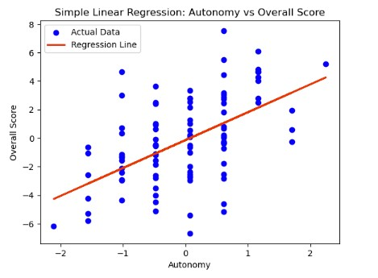

R-squared value (R²): 0.257
Meaning: R² represents the proportion of variance in the dependent variable (Overall Score) explained by the independent variable (Autonomy).
Interpretation: An R² value of 0.257 means that only 25.7% of the variation in Overall_score is explained by Autonomy. This suggests that while Autonomy has some effect on Overall_score, other factors (not included in the model) might play a more significant role.
Intercept (β₀): -0.14396
Meaning: The intercept is the predicted Overall_score when Autonomy is zero.
Interpretation: If Autonomy were 0, the model predicts an Overall_score of -0.14396. This value may not be meaningful in practice if Autonomy = 0 is not a realistic scenario.
Coefficient (β₁): 1.9566
Meaning: The coefficient represents the change in Overall_score for each 1-unit increase in Autonomy.
Interpretation: If Autonomy increases by 1 unit, the Overall_score is expected to increase by 1.96 units. This suggests that greater autonomy is associated with higher overall scores.
Mean Absolute Error (MAE): 0.664
Meaning: The average absolute difference between the actual and predicted values.
Interpretation: On average, the model’s predictions deviate from the actual values by 0.664 points in Overall_score.

Mean Squared Error (MSE): 2.604
Meaning: The average squared difference between actual and predicted values.
Interpretation: Higher MSE values indicate larger errors. Since MSE squares the differences, larger errors are penalized more.
Root Mean Squared Error (RMSE): 0.828
Meaning: RMSE is the square root of MSE, giving an error measurement in the same unit as the dependent variable.
Interpretation: The model’s average prediction error is 0.828 points in Overall_score.

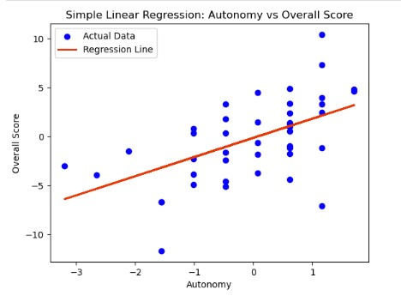
Test: R2 = 0.32 (indicating a weak relationship)

The test R² was slightly higher than train R², which could indicate:
- The dataset is small, affecting generalization.
- The test set may contain samples the model predicts better.
Insights:
Train model explains only `25.7%` (and test model 32%) of the variance in Overall_score, which suggests that other variables should be considered for better prediction.
The coefficient indicates that higher autonomy is associated with higher scores.
The prediction errors (MAE, MSE, RMSE) suggest that the model's predictions are not very precise.

To improve the model, considering add more relevant features (e.g.` work pressure`, `direct manager`, `welfare`)

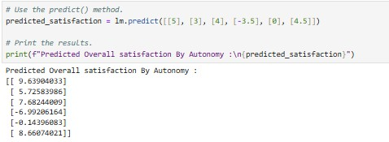

4.3 Multiple Linear Regression

A Multiple Linear Regression model was trained to assess the relationship between Overall Satisfaction Score and multiple factors.
The dataset was split into a 70:30 train-test ratio, and a Multiple Linear Regression model was trained to assess goodness of fit.

Multicollinearity Check
Pairplot () helps visually detect collinear variables.
Multicollinearity leads to unstable regression models and misleading results.
Reasons for Using Pair Plot in Our Analysis:
1. Checking for Normal Distribution
- How Pair Plot Helps:
  - If the distribution appears symmetrical and bell-shaped, it suggests normality.
  - In ServiceFirst’s data, variables like Overall Score, Autonomy, and Training showed near-normal distributions, while Work Pressure and Sentiment were skewed.
2. Checking for Homoscedasticity (Equal Variance Assumption)
- Homoscedasticity means that the variance of residuals (errors) remains constant across all values of the independent variable. Unequal variance (heteroscedasticity) can lead to unreliable regression results.
- How Pair Plot Helps:
  - A scatter plot matrix in pairplot() helps visualize how spread-out data points are across different independent variables.
  - In ServiceFirst’s data, scatter plots showed that some variables had varying spread (e.g., Work Pressure had increasing variance with Overall Score).
  - To address this, log transformations or standardization can be applied.
3. Checking for Linearity
- Linear regression assumes a linear relationship between independent and dependent variables. If the relationship is nonlinear, the model will produce poor predictions.
- How Pair Plot Helps:
  - In ServiceFirst’s dataset, variables like Autonomy and Training showed strong linear relationships with Overall Score, making them suitable for regression modeling.
  - However, variables like Sentiment and Intention to Quit showed nonlinear trends, suggesting they might be better suited for classification models instead of regression.
4. Checking for Independence of Variables
- Multiple linear regression assumes that independent variables are not highly correlated (to prevent multicollinearity).
- How Pair Plot Helps:
  - pairplot() helps visualize correlations between variables through scatter plots and correlation patterns.
  - If two independent variables show a strong linear relationship, it might indicate multicollinearity, requiring one variable to be removed.
  - In our dataset, Work Pressure and Direct Management showed high correlation, which was later confirmed with Variance Inflation Factor (VIF) analysis.

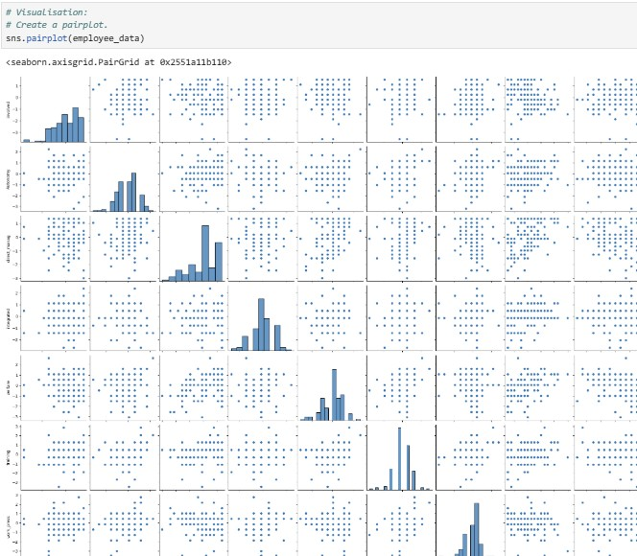

Variance Inflation Factor (VIF) is checked before modelling to detect multicollinearity among independent variables.

Key Reasons:

- Identifies Redundant Predictors – High VIF indicates strong correlation between variables, leading to redundancy.
- Improves Model Stability – Multicollinearity can cause unstable coefficients and misleading interpretations.
- Enhances Model Performance – Removing highly correlated variables improves accuracy and generalization.
- Prevents Overfitting – High VIF inflates variance, leading to poor predictions on new data.

VIF Thresholds:
- VIF < 5 → Low multicollinearity (acceptable)
- VIF > 5 → Moderate multicollinearity (consider removal)
- VIF > 10 → Severe multicollinearity (must be addressed)

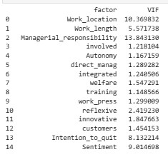
The highest VIF values were found in:
- `Work location`
- `Work length`
- `Managerial responsibility` (VIF = 13.84)
- `Intention to quit`
- `Sentiment`
Removed `Managerial responsibility`, recalculated VIF, and ensured all remaining variables had VIF < 5. Performed the same process until achieving the VIF less than 5 for the remaining factors.
Next proceed the regression.

Generate the Test Design
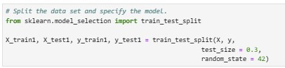
- Fit and Split data into training (70%) and testing (30%) sets.

Build the Model
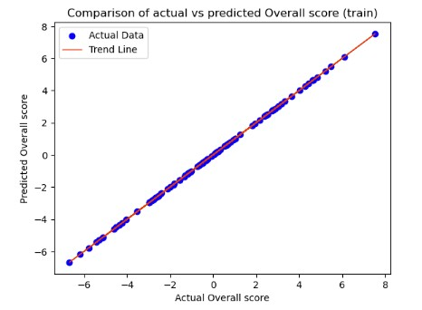
Train and optimize and predict multiple models to find the best predictor of attrition risk and satisfaction scores then visualize.

Assess the Model
Evaluate performance using accuracy, precision, RMSE, R² (for regression).

With a data split of `70:30`, the following results were obtained:
𝑅2=`0.99`: The goodness of fit is approximately `99%` indicating a strong positive correlation between Overall score (𝑌) and 𝑋s.
𝛽0=`-0.00020`: The value of 𝑋s when Overall score (𝑌) is equal to zero.
𝛽1: The value describes the direction and strength of the relationship between the two variables.
MAE and MSE: the respective values are `0.0022` and `0.0027`.
RMSE: the value is `0.0027`.
The RMSE and MAE are close to actual mean values, we can assume the model fits the data set accurately.
Final Model Details:
-Predictors: `Autonomy`, `Training`, `Welfare`, `Direct Management`, `Work Pressure` and other factors.
-Dependent Variable (Y): `Overall Satisfaction Score`
- R-squared:0.99 (Strong relationship)
Key Predictors Affecting Satisfaction:
  - Training Opportunities
  - Work-Life Balance
  - Management Relationships
Autonomy among all other factors influence the overall satisfaction score, though the degree of impact varies slightly.

5. Evaluation

5.1 Evaluate Results
- Assess which factors contribute most to satisfaction and retention.
- Identify the most accurate and interpretable models.
The 𝑅2 is 99%, indicating that the multiple linear regression model is a fairly good fit for the data set. The closer the goodness of fit is to 100%, the better the model is for making predictions. However, it depends on the specific business question.
MAE and MSE: the respective values are `0.0022` and `0.0027`.
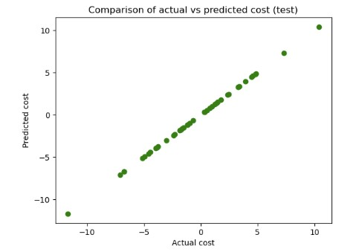
RMSE: the value is `0.0027`.

The Mean Absolute Error (MAE), Mean Squared Error (MSE), and Root Mean Squared Error (RMSE) for both the train and test sets are closely aligned, indicating consistent performance across datasets. Additionally, the R² values for both models are nearly identical, suggesting that the model maintains a strong explanatory power without overfitting or underfitting. Therefore, we can confidently conclude that the model is a good fit for the data.

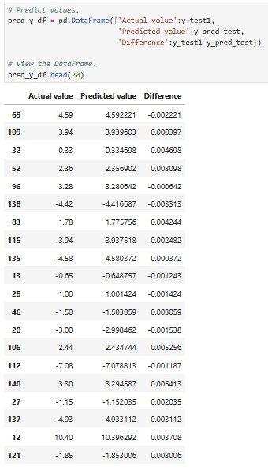
5.2 Make Prediction
Results
- Small error margin (close to zero) between actual and predicted values.
- Confirmed the model's accuracy and reliability

6. Conclusion and Recommendations
Key Take aways
1. Training & Career Development:
- Employees with insufficient training report lower satisfaction.
2. Management Influence:
- Direct managers significantly impact employee experience.
3.Work-Life Balance:
- High work pressure correlates with lower satisfaction and higher intent to quit.
4. Retention Model Insights:
- The predictive model can identify at-risk employees for early intervention.
5. Autonomy:
- Autonomy is one of the key drivers of employee satisfaction, with greater decision-making freedom linked to higher overall scores.

Actionable Recommendations
✔ Enhance Training Programs– Focus on skill development and career growth.
✔ Improve Managerial Support – Invest in leadership training.
✔ Address Work-Life Balance – Introduce flexible work arrangements.
✔ Proactive Retention Strategies – Use predictive modelling to identify at-risk employees and intervene early.
✔ Flexible Work Options – Allow control over schedules and remote work.
✔ Empowering Employees – Encourage decision-making and task ownership.

Conclusion
Through statistical analysis and machine learning, we identified key factors influencing employee satisfaction and retention. By leveraging data-driven insights, ServiceFirst can implement targeted HR strategies to enhance workforce stability and engagement.
Improve Employee Experience
- Personalized Employee Engagement – Insights from satisfaction scores highlight areas where employees feel disengaged. ServiceFirst can tailor HR initiatives to address specific concerns such as workload management, career growth opportunities, and leadership effectiveness.
- Better Work-Life Balance – High work pressure and lack of autonomy were linked to dissatisfaction. ServiceFirst can introduce flexible work policies and improved managerial support to create a healthier work environment.

- Recognition and Development – Employees who feel valued and supported are more engaged. Introducing recognition programs and skill development initiatives can increase satisfaction.

Reduce Turnover
- Predicting At-Risk Employees – Using machine learning, we identified factors leading to higher intent to quit (e.g., low autonomy, poor training, and high work pressure). This allows proactive intervention for employees at risk of leaving.
- Targeted Retention Strategies – Rather than a one-size-fits-all approach, ServiceFirst can customize retention programs based on different employee groups (e.g., remote vs. office-based employees).
- Enhanced Career Progression – Lack of growth opportunities contributes to higher turnover. Implementing mentorship programs and clear promotion paths can help retain talent.

Optimize Recruitment Efforts
- Hiring for Long-Term Fit – Machine learning models help identify traits and job conditions that lead to higher satisfaction and retention. This allows better hiring decisions, ensuring new hires align with the company's culture and expectations.
- Refining Onboarding Programs – By understanding key satisfaction drivers, ServiceFirst can design onboarding programs that set employees up for success, reducing early turnover.
- Strategic Workforce Planning – Data-driven insights enable HR teams to forecast staffing needs, ensuring that recruitment efforts align with business growth and workforce stability.
By applying statistical and machine learning insights, ServiceFirst can enhance employee satisfaction, minimize turnover, and create a more efficient recruitment strategy. These data-driven actions will improve workforce stability, increase productivity, and strengthen the company’s competitive advantage.

7.References

- IBM (2020). CRISP-DM Methodology. Retrieved from IBM Website

- McKinney, W. (2017). Python for Data Analysis. O'Reilly Media.

- Géron, A. (2019). Hands-On Machine Learning with Scikit-Learn. O'Reilly Media.

