MAKIT-THT Soldering Kit
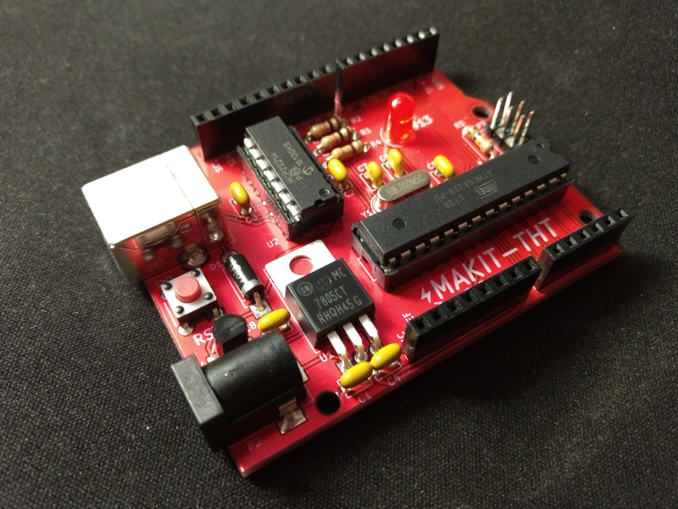

Assembly Instructions


ESD Note: The MAKIT-THT uses static sensitive ICs, and it is important to observe proper ESD safety when assembling the board. For most people, this will mean grounding themselves by touching a metal faucet or desk before starting work on their kit.

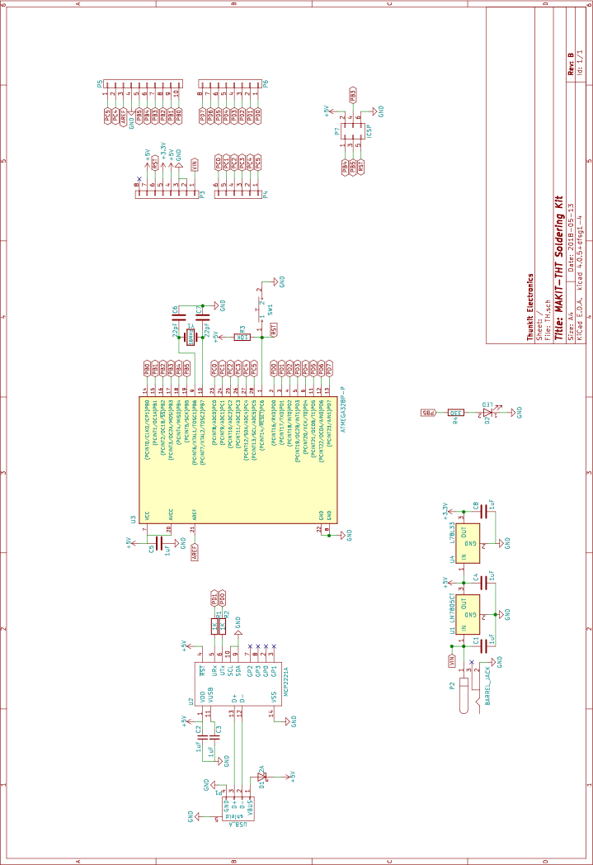

Step 1: Solder the resistors paying close attention to the color code of each:
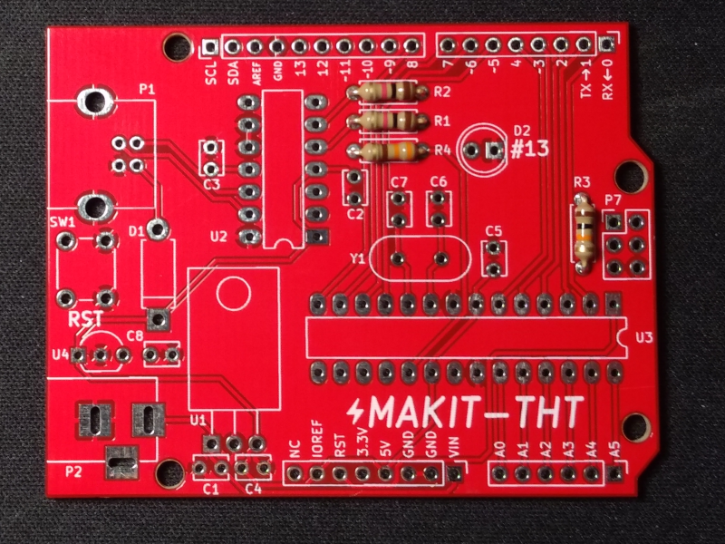
Step 2: Solder the 22pF ceramic capacitors:
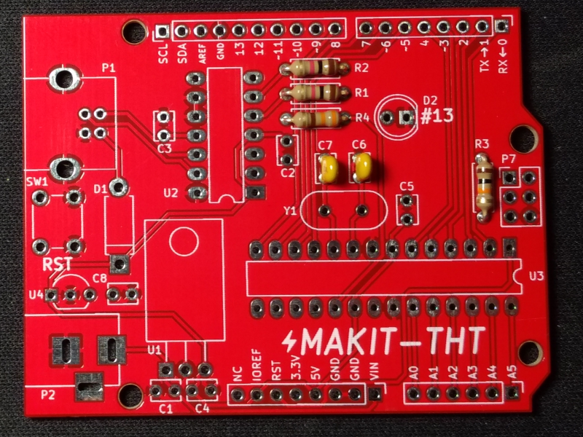
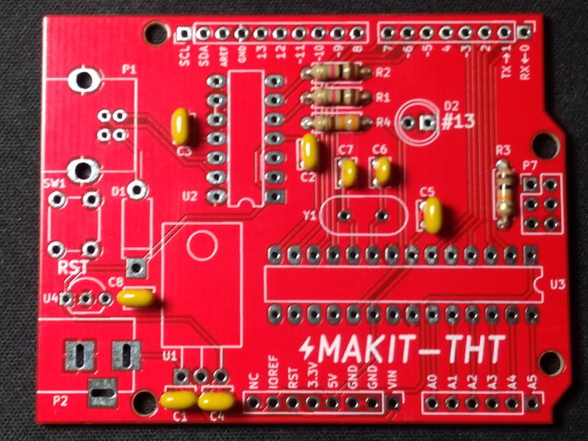
Step 3: Solder the remaining 0.1uF ceramic capacitors:
Step 4: Solder the schottky diode paying close attention to the white stripe on the diode:
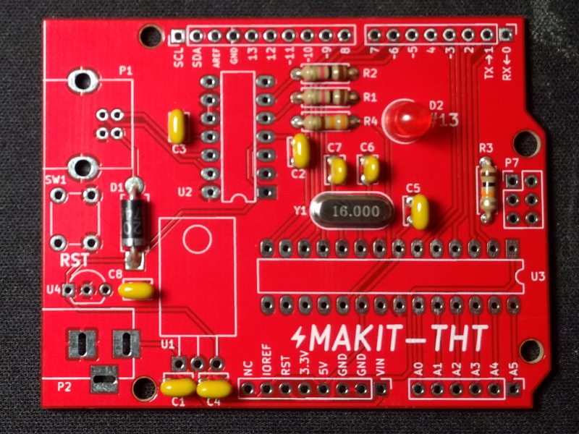
Step 5: Solder the 16MHz crystal:
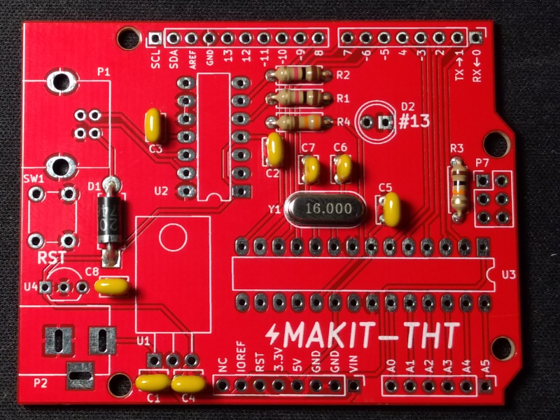
Step 6: Solder the red LED paying close attention to the flat side of the LED:

Step 7: Solder the tactile switch:
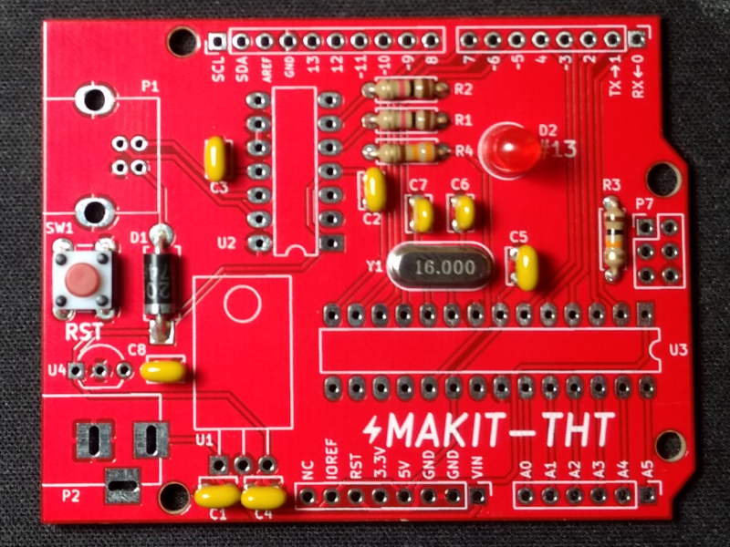

Step 8: Solder the 3.3V linear regulator paying close attention to the flat side of the regulator:
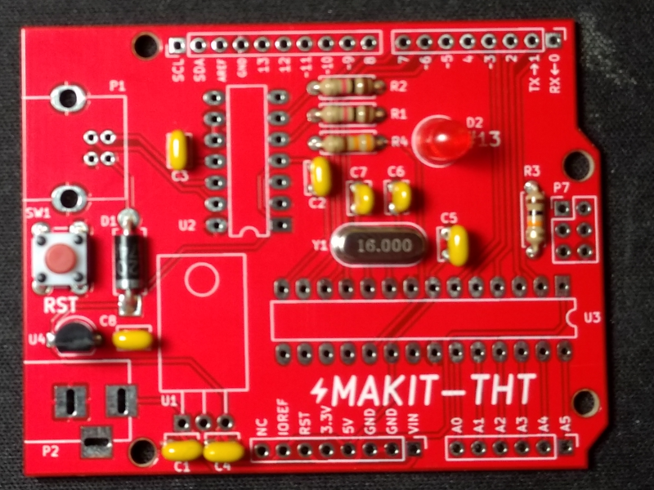
Step 9: Bend the leads of the 5V linear regulator as shown:
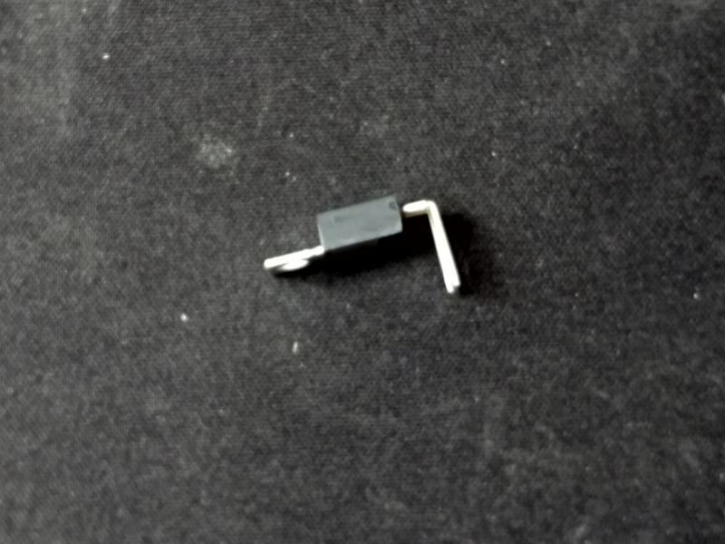

Step 10: Solder the 5V linear regulator:
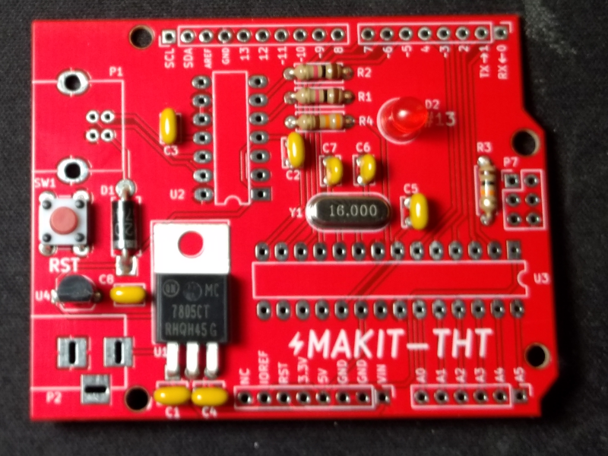

Step 11: Solder the USB and barrel jack connectors:
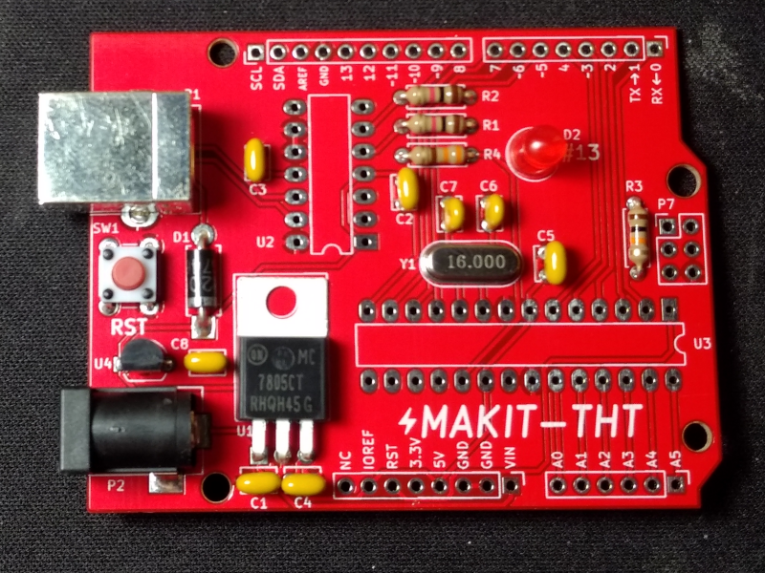
Step 12: Solder the socket for the MCP2221A paying close attention to the notch in the socket:
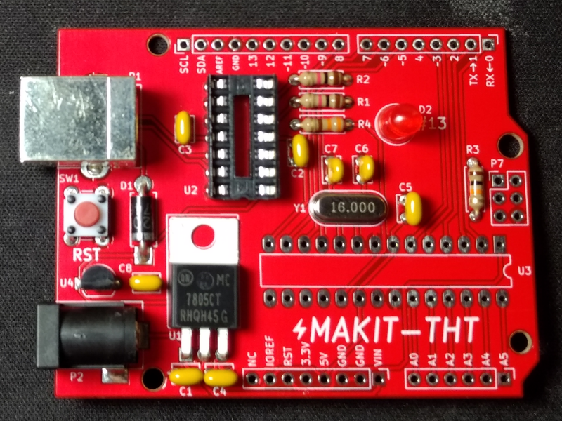

Step 13: Solder the socket for the ATmega328p paying close attention to the notch in the socket:
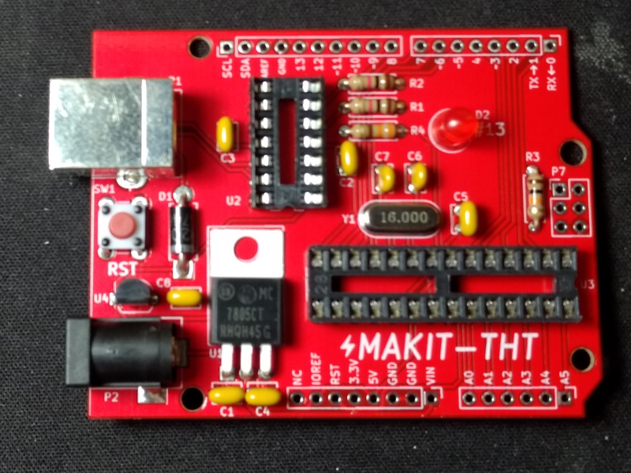
Step 14: Solder the Arduino style pin headers to the board.
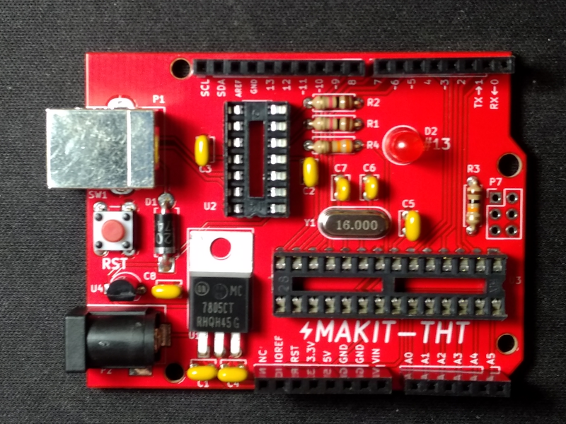
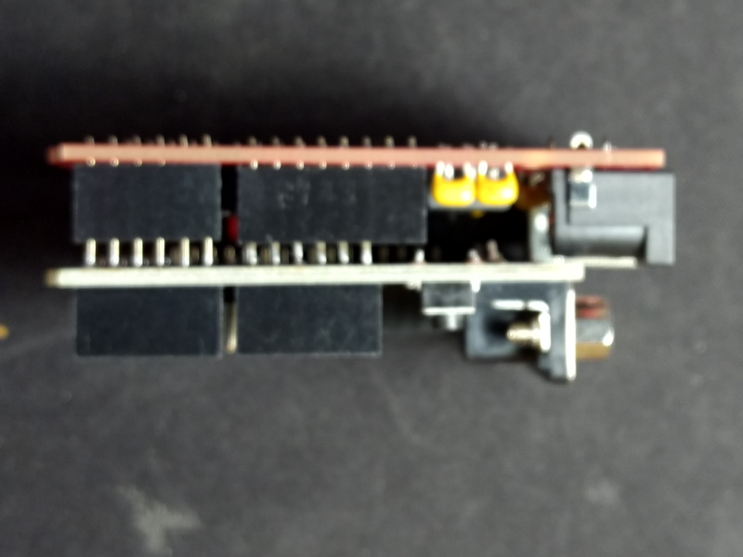
Step 14(cont.): Tip: If you have an Arduino shield, use the shield to help align the headers while soldering.

Step 15: Snap the male pin headers into two sets of three and solder them to P7 on the board:
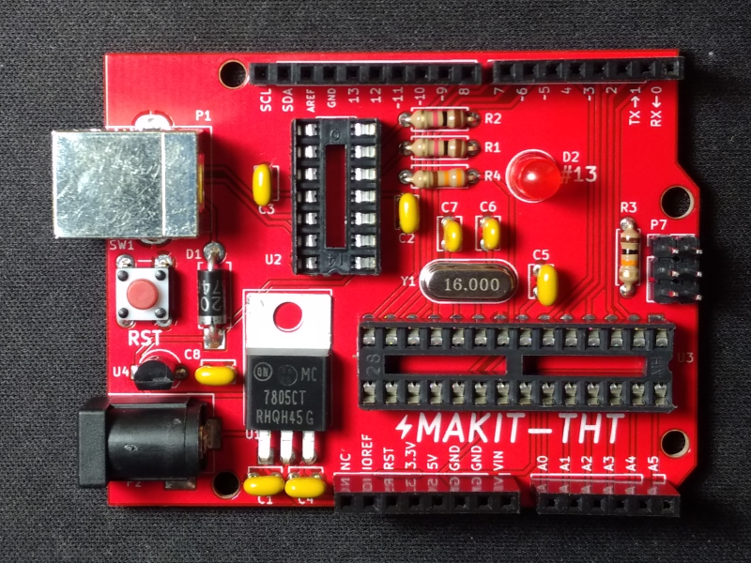
Step 16: Clean the flux residue from the bottom of the board with ± 91% Isopropyl Alchohol:
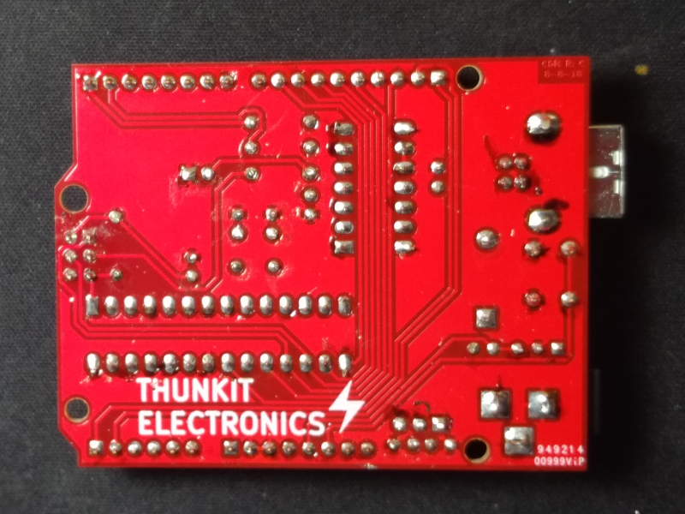
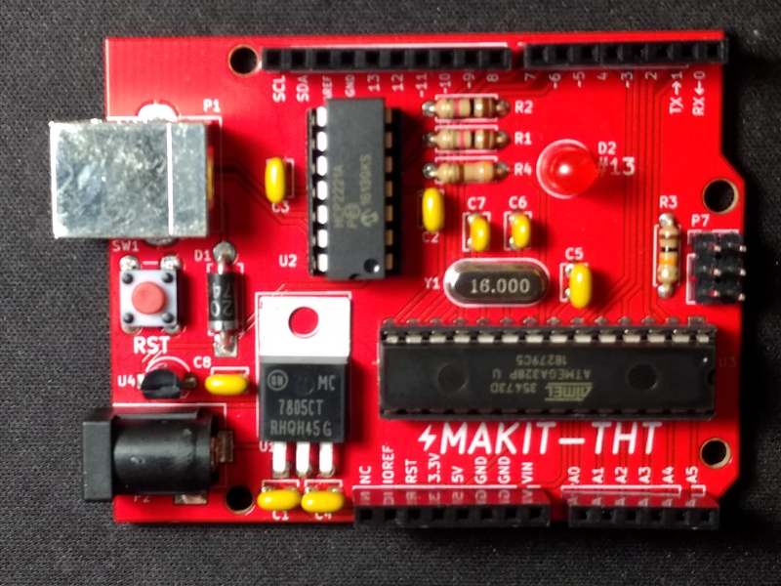
Step 17: Install the MCP2221A and the ATmega328P carefully into the sockets paying close attention to the notch. The pins of the ICs may need to be bent slightly inwards to fit inside of the socket:

Troubleshooting

The MAKIT-THT Soldering Kit is a beginner friendly kit, however it is possible to miss a few details that cause it not to work properly. Follow the steps below for any symptom that the assembled kit exhibits.

LED doesn't blink: check value of C6 and C7, check for 5V on Arduino header, check LED polarity, check for solder bridges or unsoldered pins.
Not recognized by PC: Check soldering of C3, U2, and P1. Check polarity of D1. Check for 5V on U2.
Sketch upload not working: Enable verbose logging in Arduino IDE for upload and compilation. Press the reset button on the board moments before the IDE starts the upload process. Perform a loopback test by shorting RX and TX on the Arduino header with a wire and open the serial monitor in the Arduino IDE. Be sure to select the correct COM port. Send a message using the IDE, if this is successfully, you should recieve the same message you sent. If not, double check the COM port and the soldering of R1 and R2.

