System Design Document
GraduPredict Graduate Placement Prediction System
BS Computer Science Final Year Project
Version 1.0 | October 2026

Design Overview
GraduPredict uses a small layered design that one student can implement, explain, test, and deploy. The interface gathers input, the prediction module applies stored Logistic Regression parameters, and SQLite records only the final result and essential identifiers.

1 Architecture
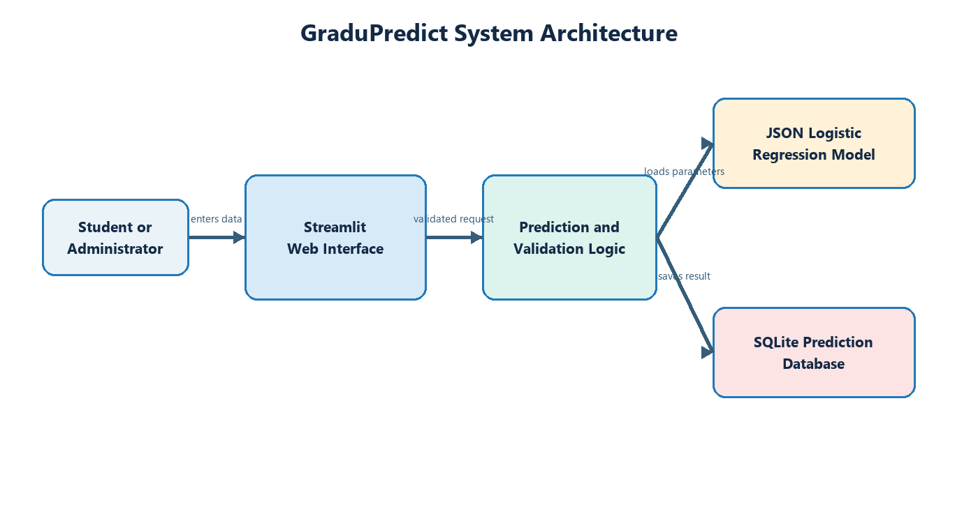
Layer | Files | Responsibility
Presentation | app.py and Streamlit configuration | Navigation, forms, messages, metrics, tables, and downloads.
Prediction | prediction.py | Model loading, standardization, probability calculation, and classification.
Training | train_model.py and notebook.ipynb | Dataset loading, reproducible split, fitting, evaluation, and JSON export.
Persistence | SQLite database | Prediction ID, student ID, outcome, probability, risk, and timestamp.
Configuration | requirements.txt and placement_model.json | Runtime dependencies, feature order, scaling values, weights, threshold, and metrics.

2 Component Design

2.1 Prediction Pipeline
The training pipeline loads ordered features, performs an 80 percent training and 20 percent test split, calculates scaling statistics from the training partition, fits binary Logistic Regression by gradient descent, evaluates held-out predictions, and writes parameters to JSON. Runtime prediction applies the same feature order, mean, and scale before the sigmoid calculation.

2.2 Interface Flow
Step | User action | System response
1 | Open application | Dashboard and navigation appear.
2 | Open New Prediction | Validated student form appears.
3 | Enter values and submit | System calculates probability, outcome, and risk.
4 | Review and save | System inserts the result into SQLite.
5 | Open history | System shows, filters, and exports records.
6 | Open About Model | System explains the algorithm, metrics, dataset note, and limitation.

3 Database Design
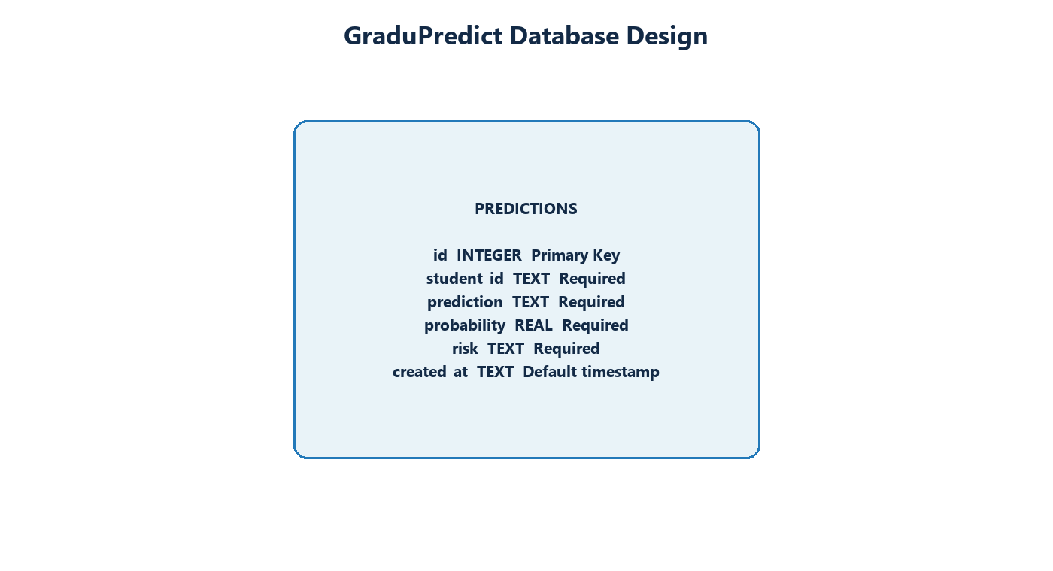
A single table is sufficient because the project does not manage user accounts or long-term student profiles. This reduces privacy exposure and keeps the scope appropriate for one student.

4 Detailed Prediction Design
Element | Design
Input vector | Eleven numeric values in the exact feature order stored in JSON.
Preprocessing | Subtract training mean and divide by training standard deviation.
Score | Weighted sum of standardized features plus intercept.
Probability | Sigmoid of the score.
Outcome | Likely placed at or above the selected threshold; otherwise At risk.
Risk | Low at 0.70 or above, Medium from 0.45 to below 0.70, and High below 0.45.
Storage format | Plain JSON to avoid scikit-learn pickle compatibility failures.

5 Security Privacy and Ethics
The form uses a project student identifier and excludes names, phone numbers, addresses, photographs, gender, ethnicity, religion, and disability. The result is an academic counseling estimate. The interface states that it must not determine hiring eligibility. Deployment should restrict database access and avoid publishing real student records.

6 Error Handling
Condition | Response
Blank student ID | Display an error and do not save.
Out-of-range value | Prevent entry through bounded controls.
Missing database | Create the table automatically.
Missing or malformed model file | Stop with a visible application error and restore or retrain the model.
No history records | Show an empty table and zero dashboard metrics.

7 Testing Design
Test level | Coverage
Unit | Probability range and classification boundaries.
Integration | Form to prediction module and save to SQLite.
System | Dashboard, entry, result, history, export, and model-information workflow.
Usability | Single user completes the viva flow with no assistance.
Data | Required columns, numeric ranges, target values, duplicates, and missing values.

8 Deployment Design
Local deployment uses a virtual environment followed by installation from requirements.txt and the command streamlit run app.py. Streamlit Community Cloud deployment uses a GitHub repository containing app.py, prediction.py, requirements.txt, model JSON, database directory, and configuration. Real student records should not be committed to a public repository.

9 Project Structure
The root contains application, prediction, training, requirements, README, and notebook files. Data, model, database, tests, documents, diagrams, and screenshots use separate named folders. This structure maps directly to the implementation responsibilities and simplifies viva explanation.

